DISHES AND THEIR ALLERGEN CONTENT – Firehouse Glasgow

DISHESBurgers | 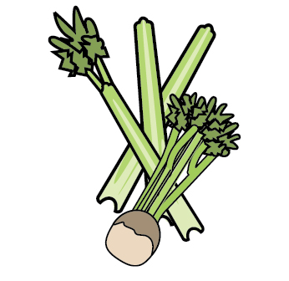 | 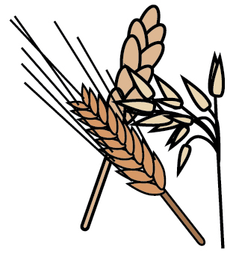 | 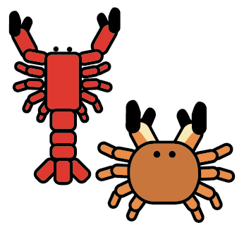 | 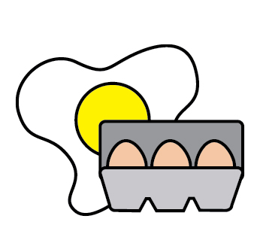 |  |  |  | 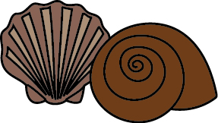 | 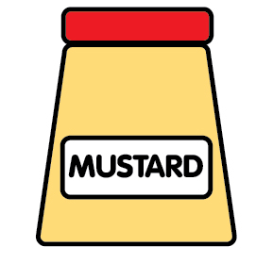 | 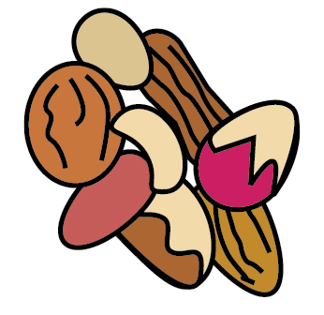 | 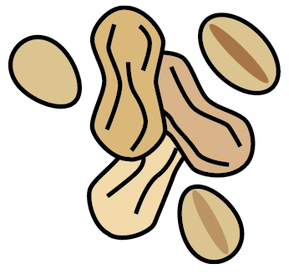 | 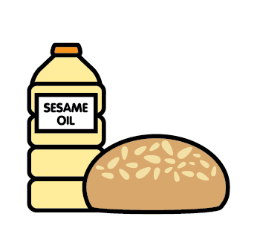 |  | 
 | Celery | Cereals containing gluten | Crustaceans | Eggs | Fish | Lupin | Milk | Mollusc | Mustard | Nuts | Peanuts | Sesame seeds | Soya | Sulphur Dioxide
Tuna Salad [example] | ✓ |  |  | ✓ | ✓ |  | ✓ |  | ✓
Smash Burger |  | X |  | X |  |  | X
Porky pig |  | X |  | X |  |  | X |  | X
The Heifer |  | X |  | X |  |  | X |  | X
The Hen |  | X |  | X |  |  | X
The Beast |  | X |  | X |  |  | X |  | X
Jackfruit |  | X |  | X |  |  | X |  | X
Mac Daddy |  | X |  | X |  |  | X |  | X
Remarks - The Brioche style roll our burgers are served in contain milk & Egg – The House BBQ sauce contains Mustard

Review date: | 08.09.25 | Reviewed by: | J.Reid |  | You can find this template, including more information at www.food.gov.uk/allergy

