DISHES AND THEIR ALLERGEN CONTENT – Firehouse Glasgow

DISHESSides | 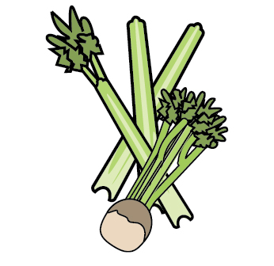 | 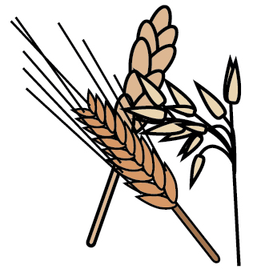 | 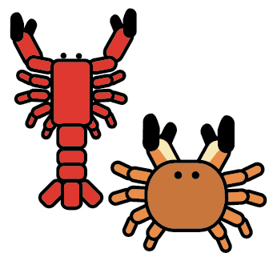 | 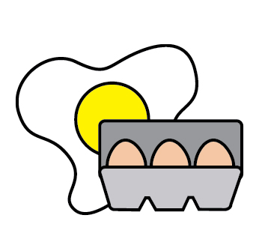 |  | 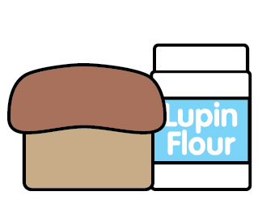 |  | 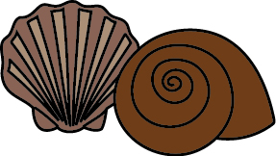 | 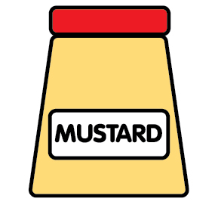 | 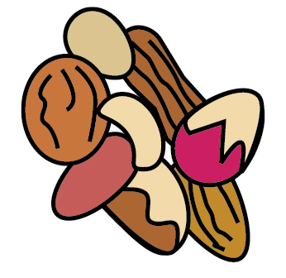 | 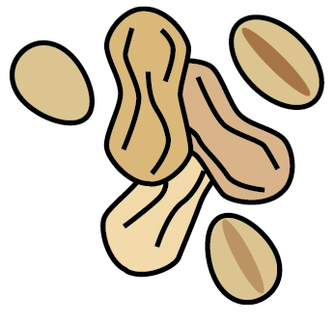 | 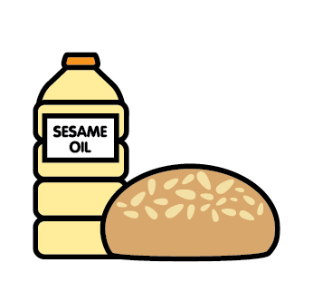 |  | 
 | Celery | Cereals containing gluten | Crustaceans | Eggs | Fish | Lupin | Milk | Mollusc | Mustard | Nuts | Peanuts | Sesame seeds | Soya | Sulphur Dioxide
Tuna Salad [example] | ✓ |  |  | ✓ | ✓ |  | ✓ |  | ✓
Mac N Cheese |  | X |  |  |  |  | X |  | X
Corn Bread |  | X |  | X |  |  | X
Frickles |  | X
Half Corn |  |  |  |  |  |  | X
Parmesan Fries |  |  |  |  |  |  | X
BBQ Beans |  |  |  |  |  |  |  |  | X |  |  |  | X
House Slaw |  |  |  | X |  |  |  |  | X
Corn Ribs
Seasoned Fries

Review date: | 08.09.25 | Reviewed by: | J.Reid |  | You can find this template, including more information at www.food.gov.uk/allergy

