DISHES AND THEIR ALLERGEN CONTENT – Firehouse Glasgow

DISHESFixings | 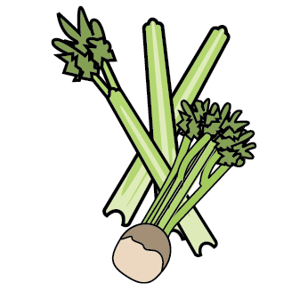 | 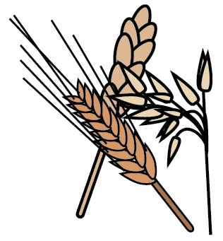 | 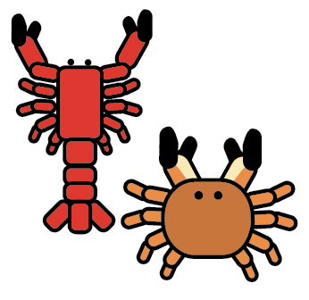 | 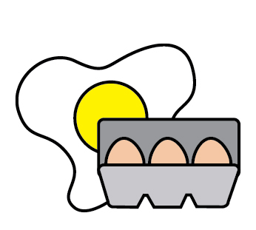 | 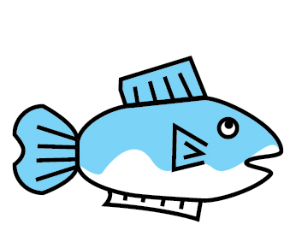 | 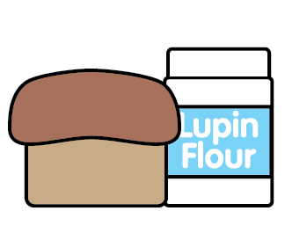 | 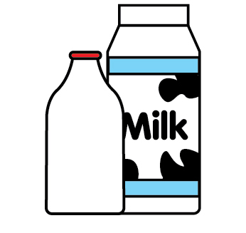 | 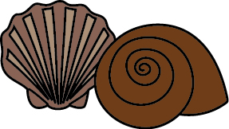 | 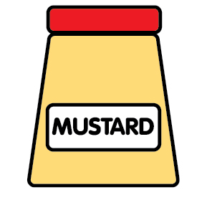 | 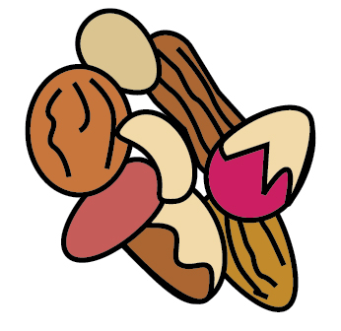 | 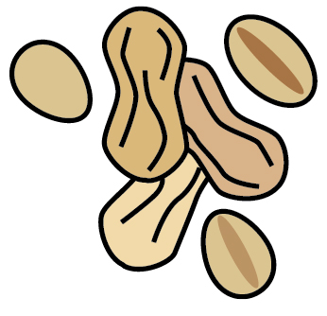 | 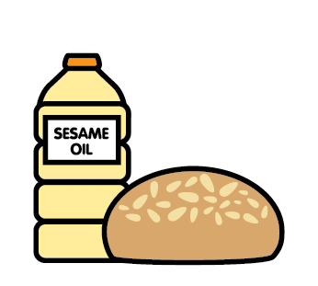 | 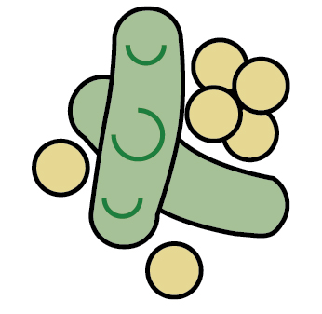 | 
 | Celery | Cereals containing gluten | Crustaceans | Eggs | Fish | Lupin | Milk | Mollusc | Mustard | Nuts | Peanuts | Sesame seeds | Soya | Sulphur Dioxide
Tuna Salad [example] | ✓ |  |  | ✓ | ✓ |  | ✓ |  | ✓
Dirty Fries - Pork |  | X |  |  |  |  | X |  | X
Dirty Fries - Brisket |  | X |  |  |  |  | X |  | X
Dirty Fries - Jackfruit |  | X |  |  |  |  | X |  | X

Review date: |  | Reviewed by: |  |  | You can find this template, including more information at www.food.gov.uk/allergy

