## Board Meeting Meet 20221008

Present: Ronald, Mable, Rowenna, Beckie, Winnie, Prahbu, Josphen, Suseelo, Joy,

Absent : Steve, Vera,

Fundraiser must be approved by the Board and must have full disclosure on monthly reports

Opened meeting with Pray on Zoom 596 648 8008 pw 089544

1. Open Prayer 08:08 Director of Prayer Pastor Joseph
2. Old Minutes are the responsibility of Board Members to read
   1. All are posted on the Ministry Facebook Page and website
3. **Financial Statement** : Financial report given by Pastor Ron
4. **GLI** –
5. See Attached Spread Sheet
6. Financial Report
   1. Financial Assistance
   2. Income
      1. Pay Check $ 00.00
      2. VA Disability $ 1529.95
      3. Unemployment $ 317.00
7. TOTAL INCOME $ 1846.95
8. Pastor Ron Tithe $ 1846.95
9. Remaining balance From July $ 14475.05
   1. Expenses – $ 15.381.96
   2. Available $ 3178.46
   3. Finical- accepted - Yes accepted
10. Fundraiser –
    1. Facebook Fundraiser
       1. $500.00 for Sept
       2. The Donation Button is working On Facebook pages, Both on our College page and on our Main GLI Page!!!!
    2. Google Ads
       * 1. Up and running see report brought in $58.63
    3. Book Royalties
       1. 1 book sold total royalties – $.29
    4. Fundraising Coordinator open all countries
    5. Grants –
       1. Grants.Gov-
          1. India Disaster Relief - No one was awarded the funds they have pushed them off for a year, state lack of funds at this time.
          2. Started writing HHAA Grant for the County/City and STCU to Partner with running the Shelter AT 924/930 2ND AVE. Meeting on with the Mayor on Monday the 12th, supposed to be hearing from the City Grant team.
11. Ministry Reports
    1. India work on expanding current church and building the new
       1. Praise Report
       2. The homeless received their land and have started on building their homes- have already 5 houses started –
    2. Working on Orphanage -NA
12. Proposal
    1. No Reports Given by any Country other than USA
13. Financial statements from Every Member
    1. We need accounting of all organization
    2. Reports Due 1st Monday of Every Month
       1. Monthly Word Document report, narrative of Month Activities, Monthly Budget Report, Request for the following months budget
       2. Time Sheet
       3. Monthly Excel Document Report- Daily activities report-includes small narrative of daily activities that makes up the Monthly Word Document report. Along with daily Ministry numbers that make up the Yearly/ Monthly Summary Report
       4. Yearly/Monthly Report-Excel Document- takes the totals at the bottom of the Monthly/Daily Report and place in the appropriate column in the Yearly/Monthly Report!!!!
14. Director of International relations /Vice President report
    1. Nothing to report
15. Meeting rules:
    1. Please mute (turn off) mikes unless talking as the back ground noise was to much today
    2. Wait at least 2 seconds from the last sound heard before speaking as it will preventing walking on another speaker
    3. Let us all ensure we are promoting God’s Love in everything we do
16. Bible College
    1. No Students
17. New Business Ministry
    1. Wedding Plans-moved to August 6th
    2. Received a cash offer on the house with a close date of 07/16/2022

**Prayer Request** – God to be with us and bless the new HQ, provide for all our needs, Prayer for Vera, Joy and Joseph health , Pray for the Ministry in India remodeling first of Next Year

Meeting 2nd Saturday of Every Month at 08:00 PST

**Closed** Director of Prayer Joseph Katalila, 09:16!!!!!

Ministry and Financial Reports

**India**

1.Gas :- 100 dollars

2.grosseries :-7000rupees(100)$

3.rice and water :-2000rupees(30$)

4.television ministry :-2500 ( 32 dollars )

5.Medical bills of mine and suseela:- 100$

6 television service 50$

7. Joy pregnancy hospital bill 9000 ( 120 $)

8. Mate for church 200$

Total spend 730$

500$ offering from u.s.a head quarters

Remaining fund : 380$

**India other branches andhra Pradesh 21 branches**

**Gas: 520dollars**

**Groceries :1600dollars**

**Medicines :1550 dollars**

**Education :650dollars**

**Food Bank :750**

**Love feast 700**

**Available 800dollars**

**Total spend 5820$**

**Received from offerings 5570**

**Kenya**

**Pakistan**

1. Gas: - 28 dollars

2. groceries my home :-(30)$

3. Rice and water :-(15$)

4. Television ministry :-(nil )

5. Medical bills me and wife :- $

6 . Traveling 50$

7. Pastors and evangelist $(Nil)

8. Praise and worship meetings 50$

9. Widows help (two Widows60 usd

Total expenses 223 usd

Offering =60 usd

Tithes: = 60 usd

Gli International contribution: 40(remaining previous month) usd.

Offering and tithes = 120usd

Total = 120 usd

Monthly expenses =223usd -160

Extra: = 63USD my own contribution.

We can’t give food in meetings. We are supporting only two widows, we identified 10 needy widows, living in extreme poverty. These widows are young and their 23 children school going due to lack of money they can’t go. We need 30usd for each widows for utilities .

**Uganda**

**GOD’ LOVE INTERNATIONAL FORT-PORTAL, UGANDA**

**OPERATIONS PERFORMANCE MOTHLY REPORT 1st TO 30th SEPTEMBER 2022.**

| **Item** | **Date** | **Activities Carried out** | **Challenges** | **Plans for improvement** |
| --- | --- | --- | --- | --- |
| **Held widows meeting and Prayers session..** | 7th/September 2022 | Preached and encouraged widows to trust in God.  27 widows attended | We have a challenge of transport where by hiring a motorcycle is costly, we trust God to have our own bike soon. | Continuous follow up of the widows and encourage them to trust God.    To carry out training for 40 widows to give them skills in tailoring, hair making, soap making. |
| **Held Counseling session for 30 youths** | 14th/September 2022 | We held counseling sessions for youths and Children who were emotionally, spiritually and physically down. | We need to hire professional counselors to help in handling children suffering for depression. | Continuous visit of youths and children in schools and universities to encourage people and learners |
| **Held Home fellowship (HF)** | Every Tuesday | Opened 2 HF where 30 people attended  Fellowships are held every Tuesday. | No challenge | Continuous inviting people to attend home fellowship.  Training of Home fellowship leaders and hosts. |
| **Preached the gospel in primary schools.** | 17/September 2022 | Encouraged over 80 children to trust in God and stay in school. | Transport is a problem where by hiring a motorcycle is costly, we trust God to have our own bike soon. | Hold Crusades and preach the gospel in schools, universities and win souls for Christ. |
| **Fed 60 Orphans** | Ongoing | Purchasing   * 20 Kg of Sugar * 50 Kg of Rice | No Challenge | Continuous feeding and supporting orphans and vulnerable kids. |
| **Welfare (supported community church to repair their speakers.** | On going | This is still ongoing, | No Challenge | Continuous support of God” work no matter the cost.  Support orphans, widows, single mothers and vulnerable people. |
| **Participated in soccer tournament** | 21st September 2022 |  | We lack soccer materials like balls, nets, training kits and jerseys | Use soccer to win souls for the kingdom of God  Use soccer to rescue youths from Drugs and sex slavery. |

|  |  |
| --- | --- |
| **EXPENDITURE PER EXPENSE LINE SEPTEMBER 2022** | |
| **Expense Category** | **Sum of Amount** |
| Airtime to coordinate GLI activities | 50,000.00 |
| Cleaning materials for Agape Love Home (Soap, Omo, Jik,) | 140,000.00 |
| Church Tithe | 160,000.00 |
| Fuel for generator to pump water at Agape Love Home | 50,000.00 |
| Monthly Internet bundles for communication, | 30,000.00 |
| Transport to participant in soccer tournament | 100,000.00 |
| Office errands/transport to meet widows, orphans and youths | 150,000.00 |
| 20 Kg of Sugar for volunteers and Orphans at Agape Love Home | 120,000.00 |
| 50 Kg of Rice for volunteers and Orphans at Agape Love Home | 200,000.00 |
| Stationery & Other scholastic supplies for Orphans | 250,000.00 |
| Uniforms for Orphans who stay at Agape Love home | 248,000.00 |
| Refreshments for Volunteers | 30,000.00 |
| Welfare (supported community church to repair their speakers ) | 200,000.00 |
| **Grand Total** | **1,728,000.00** |

**Gallery:**

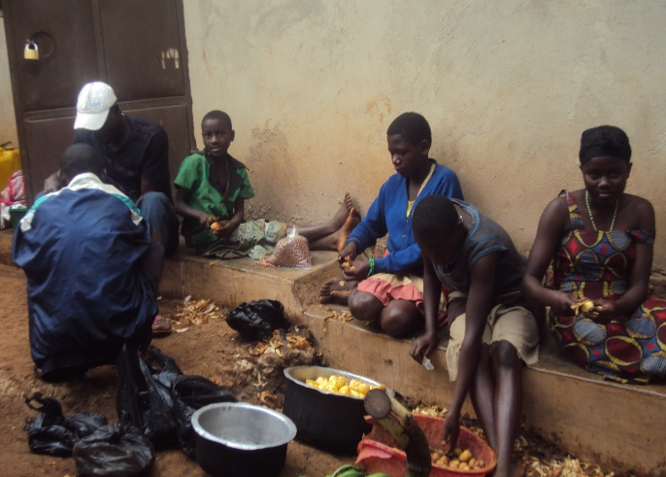 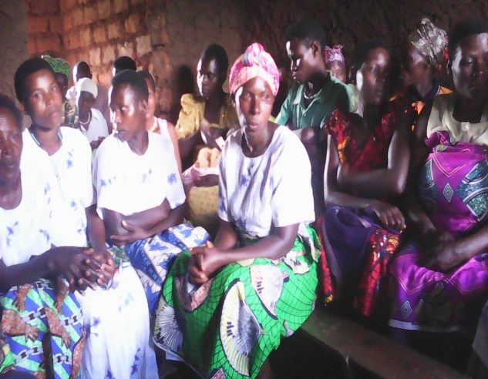 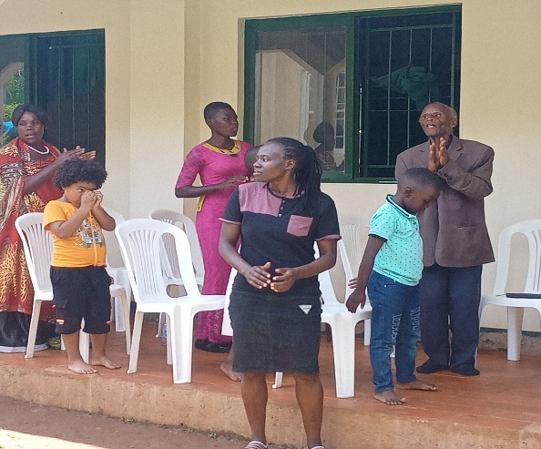

**Feeding orphans, Meeting with Widows, Meeting with youths and community**

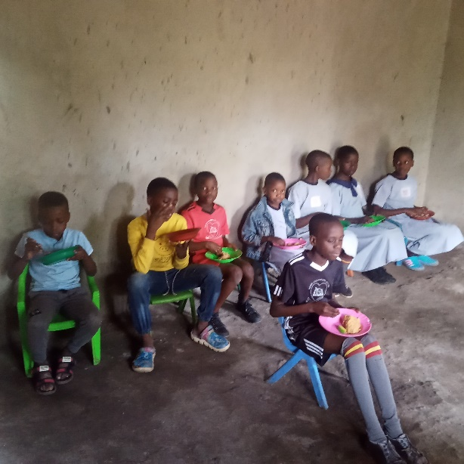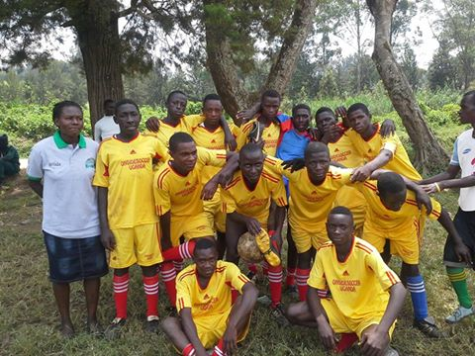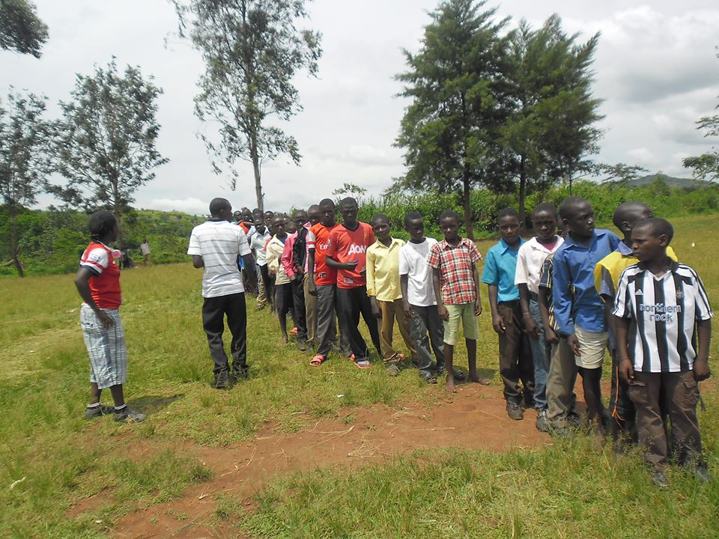

**Feeding Agape love Kids, Involved youths in Soccer for health and physical empowerment & meeting with youths**

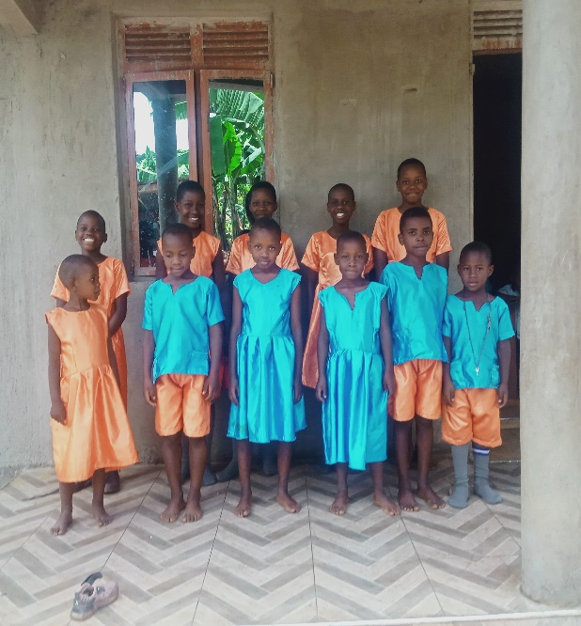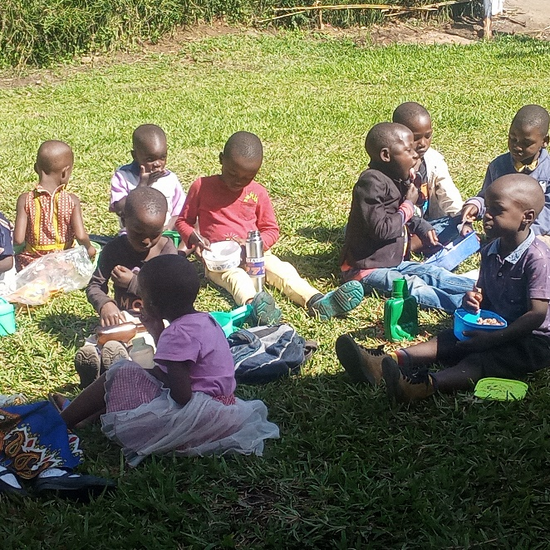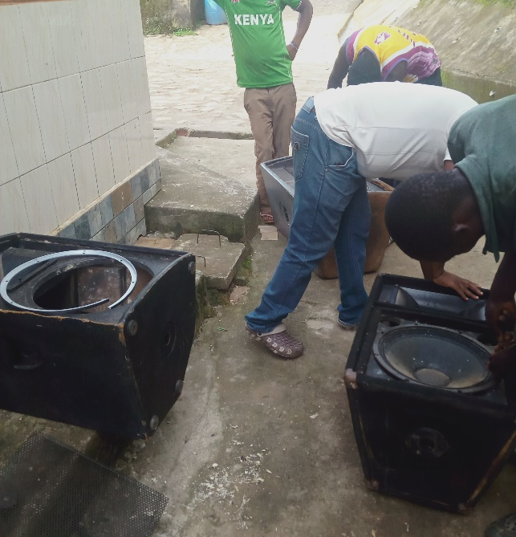

**Agape Love uniform for kids staying at agape love home, feeding more orphans in the community and supported community church to repair speakers.**

Proposed Budgets

**India**

Required 200$ for food banks

Church sound system for out reach 1000$

**Kenya**

                                  TO THE PRESIDENT GOD'S LOVE INTERNATIONAL IN DEER PARK USA.

Dear sir, hope this mail finds you well. Kindly there are two orphans who were sent home last week because of school fees and they are going to sit for their final form four exams this year in the coming weeks. Orphans are namely Phenny Akinyi of Sangoro secondary school and Safina Adhiambo of Koru secondary school respectively. The total amount needed for the orphans is USD 180,,,,, that is 100 and 80 USD respectively.

I humbly submit this to your office for consideration and support, may God bless you and keep you.

**Pakistan**

Needs: Multimedia for teaching and sound system Cost 1000$

**Uganda**

|  |  |  |  |  |  |
| --- | --- | --- | --- | --- | --- |
| **ITEM** | **UNIT OF MEASURE** | **QUANTITY** | **UNIT COST** | **TOTAL COST (monthly)** | **$US** |
| **OFFICE EXPENSES** |  |  |  |  |  |
| Supporting Orphans and widows with basic needs | Clothes, Soap and Salt | 50 | 20,000 | 1,000,000 | 313 |
| Transport to communities to encourage people and win souls |  | 1 | 200,000 | 200,000 | 63 |
| Internet and Airtime | Bundles | 12 | 20,000 | 80,000 | 25 |
| Fuel for Generator | Fuel | 10 | 7,000 | 70,000 | 22 |
| Toilet liquid Soap (To wash hands) | Soap | 12 | 3,500 | 42,000 | 13 |
| Feeding youths, children and widows | Posho and beans | 20 | 100,000 | 2,000,000 | 625 |
|  |  |  | **Total** | **3,392,000/=** | 1,061 |
|  |  |  |  |  |  |