Board Meeting Meet 20230513

Present: Ronald, Rowenna, Mable, Beckie, Prahbu, Josphen, Suseelo, Joy, Sheilla,
Absent : Sheilla,
Fundraiser must be approved by the Board and must have full disclosure on monthly reports
Opened meeting with Pray on Zoom 596 648 8008 pw 089544

- Open Prayer 08:00 Director of Prayer Pastor Joseph
- Old Minutes are the responsibility of Board Members to read
  - All are posted on the website
- Financial Statement : Financial report given by Pastor Ron
- GLI –
- See Attached Spread Sheet
- Financial Report
  - Financial Assistance :
    - Patricia Sawo (Kenya) from Beth Thorton
    - India
    - Agape Love
    - Mable
    - Total Assistance
  - Income
    - Pay Check $ 00.00
    - Donation Cash Box $ 0.00
    - PayPal
      - Laura Yorba $
      - Beth Thorton $
    - VA Disability $ 1804.06
    - Tithe Ro $
    - Tithe Pastor Ron $
- TOTAL INCOME $ 1804.06
- Remaining balance From Feb $ -719.61
- Total Available Funds $ 1085.06
  - Expenses – $ -1701.54
  - Available $ -616.48
  - Finical- accepted - Yes accepted
- Bills that Need Paying
  - Avista 6150.00-As much as Possible
  - City 940.00
  - Century Link 374.00
  - Direct TV 355.56

- Fundraiser –
  - Google Ads
      - Up and running see report brought in 7.48 in March total of 76.05 Now
  - Book Royalties
    - 1 books sold total royalties – $. .49
  - Fundraising Coordinator open all countries

  - Grants –
    - Grants.Gov-
    - Working on Shelter and Food Bank Grant 75 Million paid our over 5 years, for food, clothing, transportation, salary, benefits, mortgage or rental assistance, education, or an barrier preventing permanent housing, Motion also made and carried to back pay Mable and I from July 22 to present monthly salary. Still waiting to hear did email the VA and Food and Drug to check on it no word back yet Request from review committee to turn in form SF 424 Waiting to hear back
    - VA Counselor Grant- 300000 for next 5 years, sent email from VA grant Per diem committee to apply for this grant I am working on it is due March 6th Wait to hear
    - Uganda educational grant -waiting to hear back
    - All other grants have been declined

- Ministry Reports
  - Uganda - Feeding of 30-40 youth daily, breakfast, lunch and dinner
  - Farming our own garden
  - We now have 210 children in the school
  - Did some Evangelist and home fellowship
  - Also holding Church Fellowship meeting
  - Stoke part in radio hosting -so spoke on the radio twice last month
  - Sheila was able to publish here story on Facebook,
  - Mable is able to teach the word of God to the 150 students

- Director of International relations /Vice President report
  - Started our greatest mission, speaking with the government, but the homeless are being housed in their nre homes.
  - Building an orphanage, and the property will farm the land for their food,
  - Distributed feed 150 food packets yesterday
  - Also distributed clothes to 30 families yesterday
  - Will be doing a thanksgiving feast for Joy and Charard to 500 -700
  - Ministry meeting will be held as well

- Proposal
  - See Reports for India Pakistan, and Uganda

- Financial statements from Every Member

  - We need accounting of all organization
  - Reports Due 1st Monday of Every Month
    - Monthly Word Document report, narrative of Month Activities, Monthly Budget Report, Request for the following months budget
    - Time Sheet
    - Monthly Excel Document Report- Daily activities report-includes small narrative of daily activities that makes up the Monthly Word Document report. Along with daily Ministry numbers that make up the Yearly/ Monthly Summary Report
    - Yearly/Monthly Report-Excel Document- takes the totals at the bottom of the Monthly/Daily Report and place in the appropriate column in the Yearly/Monthly Report!!!!
- Meeting rules:
  - Please mute (turn off) mikes unless talking as the back ground noise was to much today
  - Wait at least 2 seconds from the last sound heard before speaking as it will preventing walking on another speaker
  - Let us all ensure we are promoting God’s Love in everything we do
- Bible College
  - No Students
- New Business Ministry :
  - No Business

Prayer Request – God to be with us and bless the new HQ, provide for all our needs,, Joy and Joseph health , Pray for the Ministry in India
Meeting 2nd Saturday of Every Month at 08:00 PST
Closed Director of Prayer Joseph Katalila, 08:30!!!!!
Ministry and Financial Reports
India
1.Gas :- 100 dollars
2.grosseries :-7000rupees(100)$
3.rice and water :-2000rupees(30$)
4.television ministry :-2500 ( 32 dollars )
5.Medical bills of mine and suseela:- 100$
6 television service 50$
7. Joy hospital bill 1500$

Total spend 1912$ Received from church offering received
Remaining fund : 100$

India other branches andhra Pradesh 21 branches
Gas: 520dollars
Groceries :1600dollars
Medicines :1550 dollars
Education :630dollars
Food Bank :1800$
Love feast 1000
Available 1250dollars
Total spend $9000

Pakistan
1. Gas: 30dollars
2. Groceries my home :-( 25) $
3. Rice and water :-( 25$)
4. Television ministry :-( nil )
5. Medical bills me and wife: - $
6 . Traveling60$
7. Pastors and evangelist $(Nil)
8. Praise and worship meetings 21$
9. Widows help (two Widows70 usd
Total expenses 231 usd

Offering =55 usd
Tithes: = 60 usd
Gli International contribution: 0
Offering and tithes = 115 usd
Total = 115 usd
Monthly expenses =231 usd -115= 116
Extra: = 116USD my own contribution.
We can’t give food in meetings. We are supporting only two widows, we identified 10 needy widows, living in extreme poverty. These widows are young and their 23 children school going due to lack of money they can’t go. We need 30usd for each widows for utilities .

Uganda
ITEM | QUANTITY | UNIT COST | TOTAL COST (monthly)
Food to Feed the orphans | 1 | 1 | 400,000
Total |  |  | 400,000

Item | Activities Carried out | Challenges | Plans for improvement
Sharing Goals and vision of GLI with community members | Introducing GLI to community. | No Challenge | Continuous sharing of the Vision and goals to as many people as possible  Hold Crusades and preach the gospel in schools, universities and win souls for Christ.
Feeding over 50 Orphans per day | Purchasing of food and looking for support from community members | No Challenge | Continuous feeding and supporting orphans and vulnerable kids.
Cultivating Gardens | Planted Maize, beans and Banana. | No Challenge | Continue cultivating and growing food.
Home fellowship (HF) | Started (2) HF. |  | Continuous training of Home fellowship leaders and hosts.
Soul winning | Hosted live on radio to preach the word of God. | Movements are hard due to lack of motorcycle to help us move. | Continuous preaching on daily basis using different ways, like door to door evangelism.  We kindly request for a motorcycle to ease evangelism
Held church fellowships | Preaching the gospel and winning souls for Jesus. | No challenge | Continuous preaching on daily basis using different ways, like door to door evangelism.  We kindly request for a motorcycle to ease evangelism

Photos
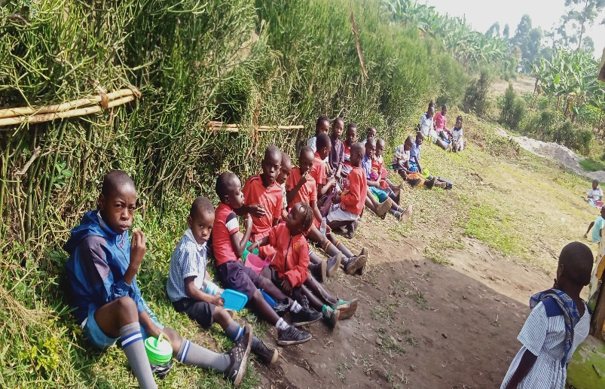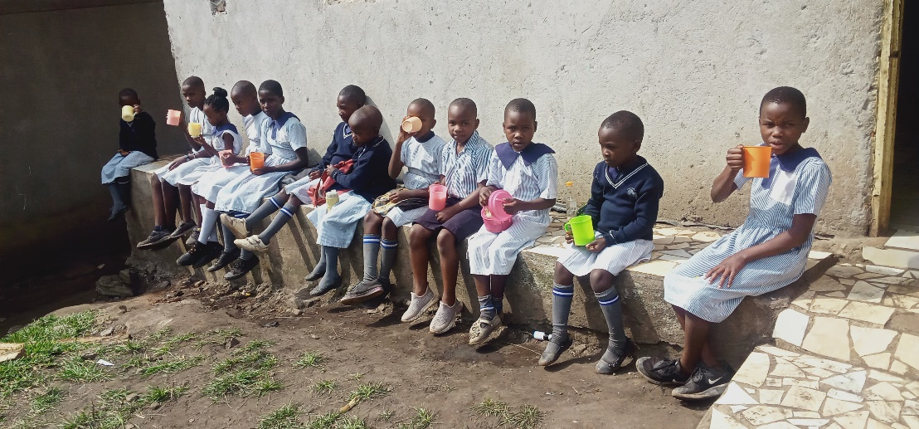
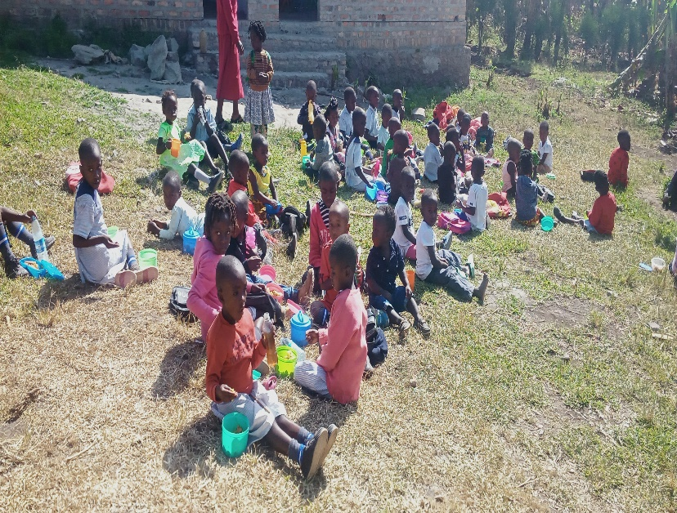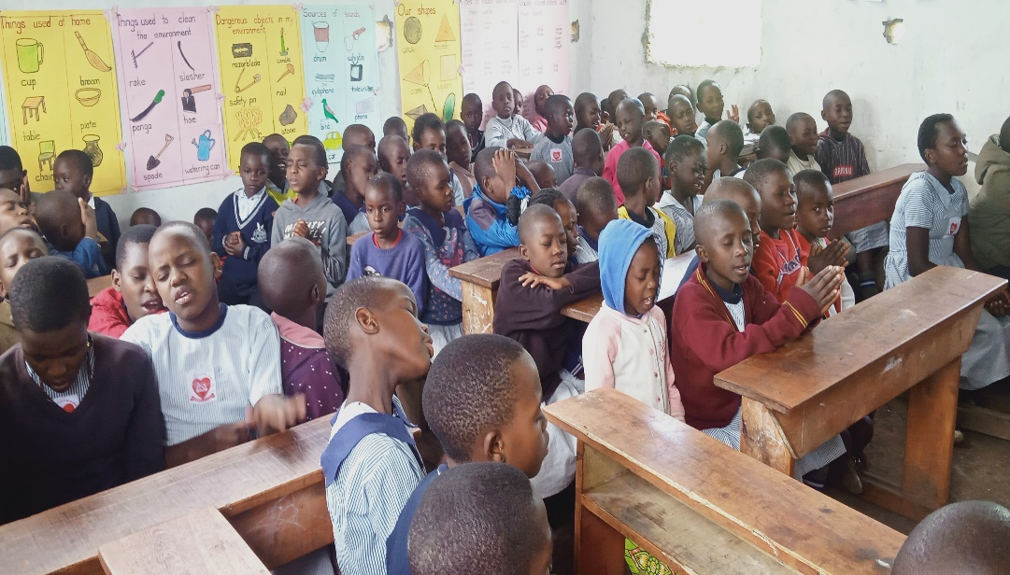
Feeding program of Children and prayer time

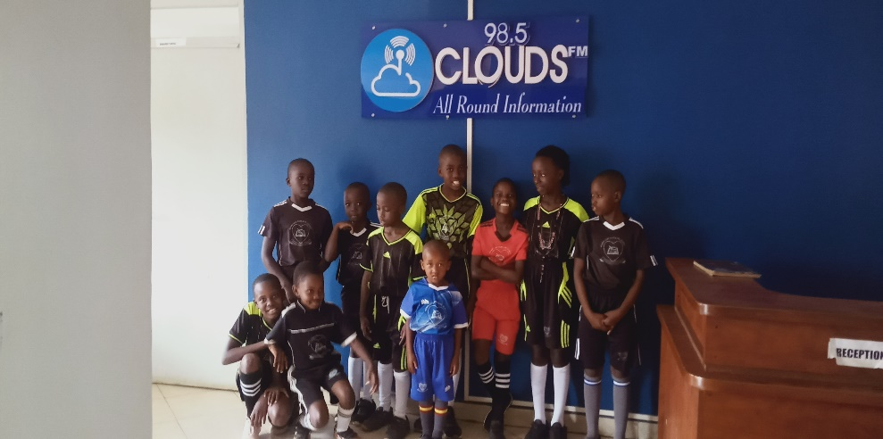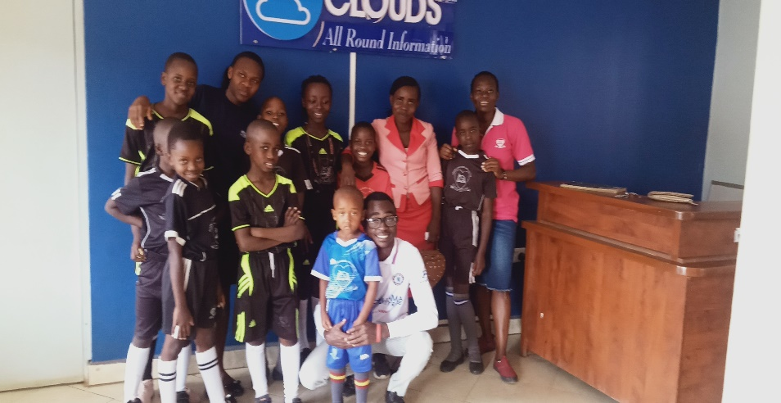
Radio program with Kids to share the gospel

Proposed Budgets
India
Ministry proposals : Required 200$ for food banks 175$ for amplifier

Proposals
Bibles 800$
Sound system 1000$

Pakistan
Multimedia for teaching and sound system Cost 1000$

Uganda

May BUDGET FOR GLI UGANDA 2023
ITEM |  | QUANTITY | UNIT COST |  | TOTAL COST (monthly)
Food (Rice, posho, beans, firewood, cooking oil, soap, firewood ETC |  | 1 |  |  | 800,000
Scholastic materials |  | 1 | 1,000,000 |  | 400,000
Transport to win souls for Christ |  | 6 | 30,000 |  | 200,000
Internet and Airtime |  | 1 | 100,000 |  | 100,000
Tithe |  | 1 | 160,000 |  | 150,000
Total |  |  |  |  |  | $ 500 =1,650,000

