Board Meeting 20210814

Present: Ronald, Prahbu, Josphen, Austin, Mercy, Suseelo, Vera, Stephen, Mable, Beckie
Absent, Rowenna.
Fundraiser must be approved by the Board and must have full disclosure on monthly reports
Opened meeting with Pray on Zoom 937 7511 6429 pw 398599

- Open Prayer 07:04 Pastor Joseph
- Old Minutes are the responsibility of Board Members to read
  - All are posted on the Ministry Facebook Page and website
- Financial Statement : Financial report given by Pastor Ron
- GLI –
- See Attached Spread Sheet
- Financial Assistance
    - 0
- Income
  - Pastor Ron
    - SNAP HCOS 1034.19
    - VOA YAS 945.40
    - Disability 1444.71
  - Total 3836.93
- Expenses – 4474.92
- Available – - 637.99
- Finical- accepted - Yes accepted

- Fundraiser –
  - Facebook Fundraiser
      - No Donations
  - Google Ads
      - Up and running see report brought in $58.26
  - Book Royals All 19 books are now published
    - 6 books sold total royalties – $29.07
  - Fundraising Coordinator open all countries
    - Mable and Beckie
- Ministry Reports
  - India work on expanding current church and building the new
    - Praise Report
    - The homeless going to receive there legal land documents postponed to August 15th
  - Working on Orphanage -Mercy is working on an orphanage in Nigeria
    - Trying to open a Worship Center
- Proposal
  - See Attachments
  - Proposal accepted provide God provides the funds
  - All Proposal where approved for the Month of May

- Financial statements from Every Member
  - We need accounting of all organization

- Director of International relations /Vice President report
  - Working on walls
  - 12 homeless families

- Meeting rules:
  - Please mute (turn off) mikes unless talking as the back ground noise was to much today
  - Wait at least 2 seconds from the last sound heard before speaking as it will preventing walking on another speaker
  - Let us all ensure we are promoting God’s Love in everything we do
- Bible College
  - No Students
- New Business Ministry
  - Time Sheet not being filled out correctly

Prayer Request –
Meeting 2nd Saturday of Every Month at 08:00 PST
Closed in prayer by Pastor Joseph at 08:00 PST

Ministry and Financial Reports
India
1.Gas :- 100 dollars
2.grosseries :-7000rupees(100)$
3.rice and water :-2000rupees(30$)
4.television ministry :-1000 (15 dollars )
5.Medical bills of mine and suseela:- 100$
6 television service 50$
7 food bank love feast 200
8. Church building paints , tiles 1200$ lights 200$
Total spend 1995$
1295 from special offering and offering from church
Remaining 500$
Ministry proposals : Required 1500$ for doors ,windows and sound system, fans

India other branches andhra Pradesh 21 branches
Gas: 520dollars
Groceries :1670dollars
Medicines :1550 dollars
Education :650 dollars
Food Bank :700$
Available 500dollars
Total spend 5090
Received from offerings 4990$ from head quarters 100$
Kenya
This financial report tends to highlight on Church income, expenses, assets and liabilities.
Income
Tithes Collected ………………………………………………………………KES. 8,000.00 (80.0USD)
Total Income ………………………………………………………………KES. 8,050.00 (80.5USD)

Expenses
Administrative Expenses…………………………………………………. KES. 3,724.00 (37.2USD)
Maintenance …………………………………………………………………. KES. 1,100.00 (11USD)
Furniture Equipment ……………………………………………………… KES. 1,330.00 (13.5USD)
Rent …………………………………………………………………………… KES. 2,000.00 (20USD)
Registration ………………………………………………………………….. KES. 756.00 (7.5USD)

Nepal
- Gave fund to small child Raj Pun's Mother = Rs 2,000
- Gave small fund to Stephen's mother = Rs 3,000
- Gave some gift to Sunday Class Children = Rs 5,000
Net Total = Rs 10,000
Source of Fund
The fund was given by my wife and my sister.
Nigeria
Tor Tiv Donation for License (Local Chief) - 20 dollars
Total income – 1400 dollars

- Health and Food for Mom and Thomas - 320 dollars
- Health and Food for the Orphanage - 420 dollars
- Purchase of Data - 150 dollars
- Food for Family and Friends - 500 dollars
Total - 1330 dollars
Available Balance - 30 dollars

Pakistan
Tanzania
No. | ITEMS | ITEMS AMOUNT | TOTAL
1 | Rice 600 Kg | $1 | $600
2 | Beams 300 Kg | $1 | $300
3 | School fees 25 Kids per Month | $1 | $250
 | TOTAL |  | $1,150

Uganda
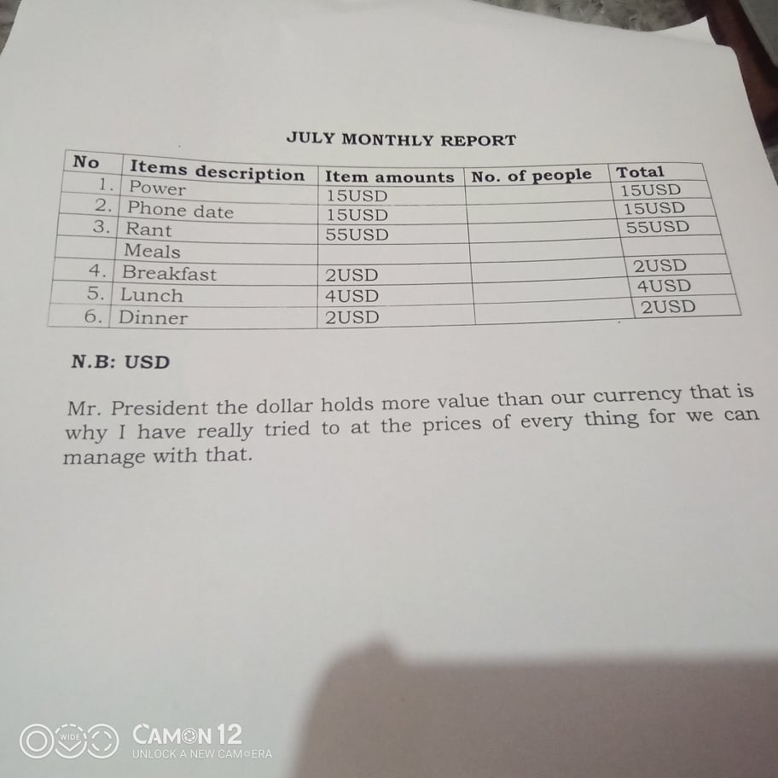
Proposed Budgets
India
Ministry proposals : Required 1500$ for doors ,windows and power supply
Branches
Children free education books 100$
Church construction 300$
Bibles 5×300 = 200$

Kenya
NO | ITEM DESCRIPTION | PRICE IN USD | NUMBER OF KIDS | TOTAL
1 | SHOES | 2 USD | 30 | 60USD
2 | BOOKS | 3 USD | 1 kid requires 3  3X3 = 9USD X 30 = 270 for each kid | 270USD
3 | MEALS | 1 SACK COST 20 USD | 1 Sack per weekX4 weeks = 4 Sacks per month  1 Sack costs 20USD X 4 Sacks in a month = | 80USD
4 | CLOTHES | 1 PAIR COST 3 USD PER KID | 1 Pair per kidX30X30USD = 90 | 90USD
5 | BLANKETS | 1 BLANKET COST 4 USD | 1 Blanket per kid X 30 Kids X 4USD = 120 | 120USD
6 | MATTRESSES | 1 MATTRESS COST 10 USD | 1 Mattress per 2 kids = 30/215 mattresses required 450 X 10 USD for each Mattress = 150 | 150USD
7 | SANITARY TOWELS & PADS |  | 185 | 185USD
 | TOTAL |  |  | 955USD

Nepal
Me and my wife we are praying for church building so please remember in your prayer also, we need about $21,000 US Dollar to complete building, now we don’t have any fund just we are praying. We are doing service in lease and contract is just going to be finished. After the contract is finished where we do service. So please raise fund for me for service.
a. Stone 6 trucks = $370 US Dollar
b. Bricks 30,000 pieces = $ 4300 US Dollar
c. Cement 230 pieces = $ 1890 US Dollar
d. Iron rod 10000 kg = $4500 US Dollar
e. Labors 10 persons = $ 8500 US Dollar
f. Door, Windows = $ 400 US Dollar
g. Colors = $ 400 US Dollar
h. Miscellaneous = $ 500 US Dollar
Net Total = $ 20,860 US Dollar

Nigeria
NO. | ITEM | PRICE IN US DOLLARS | TOTAL
1. | Projector and Camera | 2000 USD | 2000
2. | Orphanage visitation | 1000 USD | 1000
3. | T shirt for programs | 1000 USD | 1000
4. | Family visitation | 1000 USD | 1000
5. | Internet purchase | 500 USD | 500
6. | GLI Nigeria Land for Building Headquarters | 20,000 USD | 20,000
7. | License Renewal for GLI Nigeria | 350 USD | 350
 |  | Total | $26, 050

Tanzania
No. | ITEMS | ITEMS AMOUNT | TOTAL
1 | Rice 600 Kg | $1 | $600
2 | Beams 300 Kg | $1 | $300
3 | School fees 25 Kids per Month | $1 | $250
 | TOTAL |  | $1,150

Uganda

