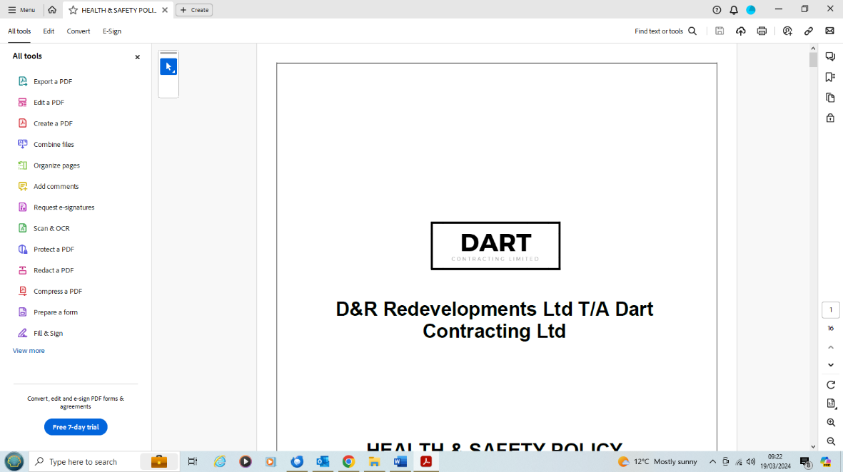

Equality & Diversity Policy

March 2024

This manual is a controlled document and is the confidential property of:

**Dart Contracting t/a D & R Redevelopments Ltd.** This document has been developed in accordance with the Equality Act 2010

**Equality Objectives**

D & R Redevelopments Ltd t/a Dart Contracting are committed to achieving equality throughout the organisation. We support and promote an inclusive positive working environment, which will embed diversity and equality in all areas of our service and the way we provide it.

**Equality**

Equality ensures that everybody receives fair and equal treatment at all times.

Equality of opportunity relates to the recruitment, retention and development of our staff and also how we deliver our services to our clients.

**Diversity**

Everybody is different and we all have different requirements and needs, we speak different languages and have different skills and beliefs, diversity is the mix of difference within organisations and communities.

'Diversity is about valuing individual difference'

**Statement of General Policy**

Dart Contracting is an Equality & Diversity Employer.

The aim of this policy is to provide Equality & Diversity to all in employment, irrespective of their gender, race, ethnic origin, disability, age, nationality, national origin, sexuality, religion, marital status and social class. We oppose all forms of discrimination.

All employees and job applicants, whether part time, full time or temporary, will be treated fairly and equally. Selection for employment, promotion, training, transfer or any other benefit will be on the basis of aptitude, ability, merit, qualification and fitness for the job.

All employees will be helped and encouraged to develop their full potential and the talents and resources of the workforce will be fully utilised to maximise the efficiency of the organisation.

Policy Implementation

The Managing Director, **Mr David Middlemiss**, has specific responsibility for Equality & Diversity matters and will ensure that the Policy is communicated to all employees and if possible to all job applicants.

Dart Contracting has developed procedures, which supported by the Companies Organisational structure will best suit its particular needs and requirements. By adopting this approach it is believed that the Company will create and promote the adoption of Equality & Diversity at work, and ensure that all those employed or under its control become familiar with their Statutory Obligations under the current legislation.

The Company will provide all employees with training and guidance which may improve their prospects within the company, and which will enhance their understanding of the need for an Equality & Diversity Policy.

Periodically Dart Contracting will review selection criteria and procedures to maintain a system which ensures that individuals are selected, promoted and treated solely on the grounds of their merits and abilities which are appropriate for the job.

The Company will regularly monitor staff to identify any signs of inequality in recruitment, grading, pay and career progression, and take positive action to redress them.

Dart Contracting expects all management and employees to conform to this policy and accept responsibility to accept their personal involvement in the practical application of this Policy. The Company is committed to a programme of action to make this policy effective. Breaches of our equal opportunity policy will be regarded as misconduct and could lead to disciplinary proceedings and dismissal.

The policy will be monitored and reviewed annually.



|  |  |  |
| --- | --- | --- |
| Name: Mr David Middlemiss | Signature: | Position: Managing Director |
| Date: 9th March 2024 | Review date: 8th March 2025 | |

**Programme of Action**

Dart Contracting aims are:

To recruit employees on a fair and non-discriminatory basis

* Use a wide range of organisations to advertise its vacancies (e.g. job centres, local press, career offices, specialist publications) with the aim to attract interest of a wider community
* Ensure that the wording of job adverts does not place unfair restrictions or requirements on a particular group or groups which are not necessary for the effective performance of the job for example: We are committed to Equality & Diversity and welcome applications from all sectors of the community.
* Ensure that the adverts include wording demonstrating the Company’s commitment to equality of opportunity and encouraging application from unrepresented groups for jobs with the company for example: Applications for this position are particularly welcome from people with an ethnic minority background and people with disabilities, as they are currently under represented in our workforce.
* Recruitment only by “word of mouth”, which is unlawful, will not be practised by the company since may restrict diversity.
* All persons responsible for recruitment, selection, promotion and transfer of staff will receive ongoing training in Equality & Diversity to stay current with legislation and to develop the necessary skills to translate Equality & Diversity in employment policy into practice.

To select employees on a fair and non-discriminatory basis

* The Company will measure the suitability of each applicant/candidate against the requirement for the job.

To promote employees on a fair and non-discriminatory basis

* Promotion criteria are based specifically on the individual’s aptitude, ability, merit, qualification and fitness for the job. The Company will periodically review promotion procedures. Records will be kept.

Where necessary, to transfer employees on a fair and non-discriminatory basis

* The Company will not automatically transfer employees who complaint of racial discrimination. The Company will periodically review its criteria for transferring employees. Records will be kept.

Ensure that all its employees have equal access to training and development opportunities. Records will be kept.

**Unacceptable Behaviour**

Every employee is entitled to a working environment which promotes dignity and respect to all. No form of intimidation, bullying or harassment will be tolerated.

Any behaviour that does not respect the rights of others, or that harasses, vilifies or discriminates against others, including threatening or violent behaviour is unacceptable at Dart Contracting and serious action will be taken against those responsible. Unacceptable behaviour will be regarded as misconduct and could lead to disciplinary proceedings and dismissal.

**Harassment**

Harassment is a type of direct discrimination if the victim can show that the behaviour caused injury to feelings.

Harassment is broadly defined as any behaviour which is uninvited, unwelcome, unreciprocated, unreasonable, and embarrasses, offends, humiliates, intimidates or threatens the recipient.

Whether the action was intended to cause offence or not does not matter – if the employee being subjected to the behaviour finds it unacceptable and he or she feels damaged or harmed by it, this constitutes potential harassment.

Harassment is normally characterised by more than one incident of unacceptable behaviour, but in some circumstances just one instance may constitute harassment if it is sufficiently serious.

All harassment is intolerable, but it is also against the law to harass a person or group of people on the grounds of their race, including colour, nationality, ethnic, ethno-religious or national origin. Dart Contracting will not tolerate harassment.

**Sexual Harassment**

Sexual harassment is unwelcome physical, verbal or non-verbal conduct of a sexual nature. Sexual harassment by staff of customers and by customers of staff will not be permitted.

Sexual harassment can include:

* Avoid comments about the way the person looks
* Refrain from indecent remarks
* Questions or comments about the person's sex life
* Requests for sexual favours
* Sexual demands
* Any conduct of a discriminating, demeaning or sexual nature which creates an intimidating, hostile or humiliating environment.
* It is most often women who are subjected to sexual harassment, but men too can be sexually harassed.
* It is the person at the receiving end of any such behaviour that will decide whether she or he finds it unacceptable.

Dart Contracting will not tolerate Sexual harassment.

**Bullying**

Bullying is when someone keeps doing or saying things to have power over another person. Examples of bullying other people are by:

* Calling them names
* Saying or writing nasty things about them
* Leaving them out of activities
* Threatening them or not talking to them
* Making them feel uncomfortable or scared
* Taking or damaging their things
* Hitting or kicking them
* Making them do things they don't want to do

Dart Contracting will not tolerate Bullying.

**Vilification**

Vilification is generally any act that happens publicly as opposed to privately, and that could encourage or stir up others to hate, have serious contempt for, or severely ridicule a person, or a group of people, because of their race, nationality, decent, ethnic or ethno-religious background, or because they are thought to be of these backgrounds.

Dart Contracting will not tolerate Vilification.

**Victimisation**

Victimisation occurs when you are treated less favourably than others because you acted in good faith to assert your rights under the Sexual Discrimination Act or Equal Pay Act.

It is unlawful to victimise any individual who has pursued, complaint or alleged discrimination.

Dart Contracting will not discriminate against employees who have taken a case of sex discrimination, marriage discrimination or equal pay and/or people who have helped by giving evidence or providing information to a Tribunal.

Dart Contracting will not tolerate Victimisation.

**Complaints Procedure**

Many grievances can be dealt with informally by an immediate manager. Encouraging members of staff to raise their concerns in this way, as a first step, often leads to a quick solution, without the need for intervention by senior members of the company. Both manager and employee will keep a note of their meeting.

If an employee is harassed by a customer, client, supplier, sub-contractor or member of the public then the immediate manager will take proper and immediate steps to protect the employee.

The procedure for dealing with complaints of discrimination covers both the employee and the customer. The procedure will be treated seriously and sympathetically. The Company will ensure that any complaint is dealt with promptly and carefully. The investigation should be carried out objectively and independently, and by someone with sufficient authority to be able to handle the matter effectively. Records should be kept.

If a complaint is upheld and the harasser is an employee, the harasser should be dealt with under the disciplinary procedure.

Employees should complaint formally to the immediate manager. If the grievance is against the immediate manager, it should be raised with a more senior manager.

Managers will invite the employee to a hearing to discuss the grievance.

Wherever possible the company will provide for a manager of the same sex as the complainant to hear the complaint.

If dismissal is a possible outcome, it is important that the usual procedures should be followed i.e. an investigation and a proper hearing at which the alleged harasser can comment on the case.

The Organisation will ensure that any panel set up to investigate the complaint has at least as many women as men on it.

The firm will ensure that procedures set out a time frame for the investigation. The complainant and the alleged harasser should be told at the outset how long the investigation is likely to take and who will be communicating with them. Complainants should be kept well-informed at every stage.

If informal discussions are not successful, procedures for dealing with complaints of discrimination, grievances and disciplinary measures including resignations, redundancies and dismissals are covered in our grievances and disciplinary procedures.

**Disciplinary Procedure**

**Purpose and scope**

The Company’s aim is to encourage improvement in individual conduct. This procedure sets out the action which will be taken when disciplinary rules are breached.

**Principles**

a) The procedure is designed to establish the facts quickly and to deal consistently with disciplinary issues. No disciplinary action will be taken until the matter has been fully investigated.

b) At every stage you will have the opportunity to state your case and be accompanied, if you wish, at the hearings by a shop steward if appropriate, or by a fellow employee.

c) You have the right to appeal against any disciplinary penalty.

**The Procedure**

Stage 1 – Oral warning

If your conduct or performance is unsatisfactory you will be given an ORAL WARNING, which will be recorded. The warning will be disregarded after 12 months satisfactory service.

Stage 2 – Written warning

If the offence is serious, if there is no improvement in your standards, or if a further offence occurs, you will be given a WRITTEN WARNING which will include the reason for the warning and a note that, if there is no improvement after 12 months, a final written warning will be given.

Stage 3 – Final written warning

If your conduct or performance is still unsatisfactory, a FINAL WRITTEN WARNING will be given making it clear that any recurrence of the offence or other serious misconduct within a period of 12 months will result in dismissal.

Stage 4 – Dismissal  
  
If there is no satisfactory improvement or if further serious misconduct occurs, you will be DISMISSED.

**Entry into the procedure can be at any of the above stages depending on the seriousness of the offence.**

**Disciplinary Procedure Continued**

**Gross misconduct**

If, after, investigation, it is confirmed that you have committed one of the following offences (the list is not exhaustive), you will normally be dismissed:

* theft
* fraud
* physical assault
* gross insubordination
* damage to company property
* incapacity for work due to being under the influence of alcohol or illegal drugs

While alleged gross misconduct is being investigated, you may be suspended, during which time the normal hourly rate will be paid. Any decision to dismiss will be taken by your employer only after a full investigation.

**Appeals**

If you wish to appeal against any disciplinary decision, you must do so within two working days. Your employer will hear the appeal and decide the case as impartially as possible.

**Grievance Procedure**

It is Company policy to ensure that any employee with a grievance has access to a procedure which can lead to a speedy resolution of the grievance in a fair manner.

Stage 1

If you have a grievance about your employment, you should first raise it orally with your immediate supervisor, who should give you a reply within two working days.

Stage 2

If the reply given at stage 1 does not satisfactorily resolve the grievance, you should detail the grievance in writing. The written grievance will then be submitted to the office manager.

Stage 3

If the matter is not resolved satisfactorily within five working days, you may elect to appeal to the managing director, who will give a decision within five working days. This decision will be final.

**Entry into the procedure can be at any of the above stages depending on the seriousness of the offence.**

.

**Promoting Equality & Diversity**

This policy is fully supported by senior management and has been agreed with employee representatives.

Dart Contracting will aim to:

* Treat each other with respect
* Try to understand others beliefs
* Aim to give everyone equal access to work
* Promote a fair and equal society
* Consider if our actions and decisions could affect some groups differently and make them worse off
* Report harassment or discrimination
* Treat every complaint of harassment seriously and investigate it sensitively
* Make our working and living environment welcoming to everybody

**Communication**

Dart Contracting will ensure:

* A copy of the Equality & Diversity Company Policyand relevant literature is displayed on the Notice Board at the main office, it is available in our company intranet system and website
* The provision of information, instruction, training and supervision of new employees and ensure the availability of for suitable and sufficient information
* All employees will be issued with a copy of the Equality & Diversity for their reference. A receipt will be obtained and held in the Office files
* Records of all Equality & Diversity training are kept in the Office files
* The Company will ensure that the information and guidance given within the manual is continually reviewed and updated. Additional procedures and guidance notes will be issued to cover new fields of activity not previously covered
* In addition, information posters will be displayed in the workplace where necessary

**Receipt of Equality & Diversity Policy Manual**

Dart Contracting is an Equal Opportunity Employer.

Dart Contracting have compiled an Equality & Diversity policy manual and the aim of this policy is to provide Equality & Diversity to all in employment, irrespective of their gender, race, ethnic origin, disability, age, nationality, national origin, sexuality, religion, marital status and social class.

It is the organisation’s policy to issue each employee with a copy of the Equality & Diversity policy manual. It is important that you read and understand the details written within this manual prior to signing your name at the bottom of this page.

I confirm that I have read and understand the contents of the Equality & Diversity policy manual.

Date………………………………………………

Name …………………………………………….

Signature………………………………………….

Please return this form to Head Office.