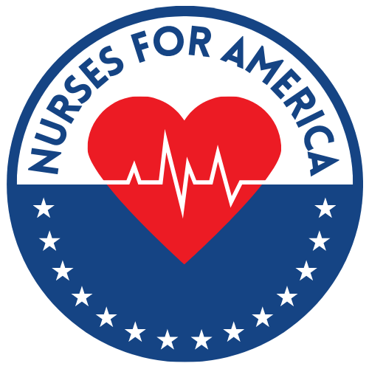 March 15th, 2022. The Power of the Pen. Save the date, please.

What is it?
*Virtual zoom event for Nurses for America to write letters to editors, op eds thru
a relaxed, assisted format

What will our writing LTEs and Op-eds do?

*Amplify President Biden’s accomplishments with the American Rescue Plan and the bipartisan Infrastructure Bill plus highlight the huge budget surplus he was able to accomplish in 2021.

*Influence the public and Congress on the stalled Build Back Better initiative that lowers drug pricing, continues Child Tax Credit, completes Obamacare and expands Medicaid coverage in 12 non-expansion states and nursing education

* Tell the story of how the nursing profession shortage exists and how we need Build Back Better which provides $500 million for nursing education

What if you prefer not to write?

* Our facilitators will record (video or audio) your story of the impact of
today’s health care climate (pandemic, hospital layoffs, salary disparities, etc. on your work as a nurse
Why nurses?
* Because “OUR OPINIONS COUNT”
* Because Nurses are the most trusted profession in the US for 20 years running
* Because Erin Hartnett, DNP, the founder of NursesforAmerica, is a member of the White House Key Allies Group and will be sharing what we write with the Biden administration to keep them informed about nurses concerns and help shape health care policies for the Biden Administration

How will the event be run?

* It’s virtual, by zoom, with other nurse members of NursesForAmerica, it’s free and fun
* Breakout rooms will be led by facilitators who have published

What will come out of the Power of the Pen virtual writing event?

*Our goal is to help you draft your own writing from model letters and op eds so
you may submit them to your community print media and various social media platforms.

