CHALLENGER

Owner's Manual
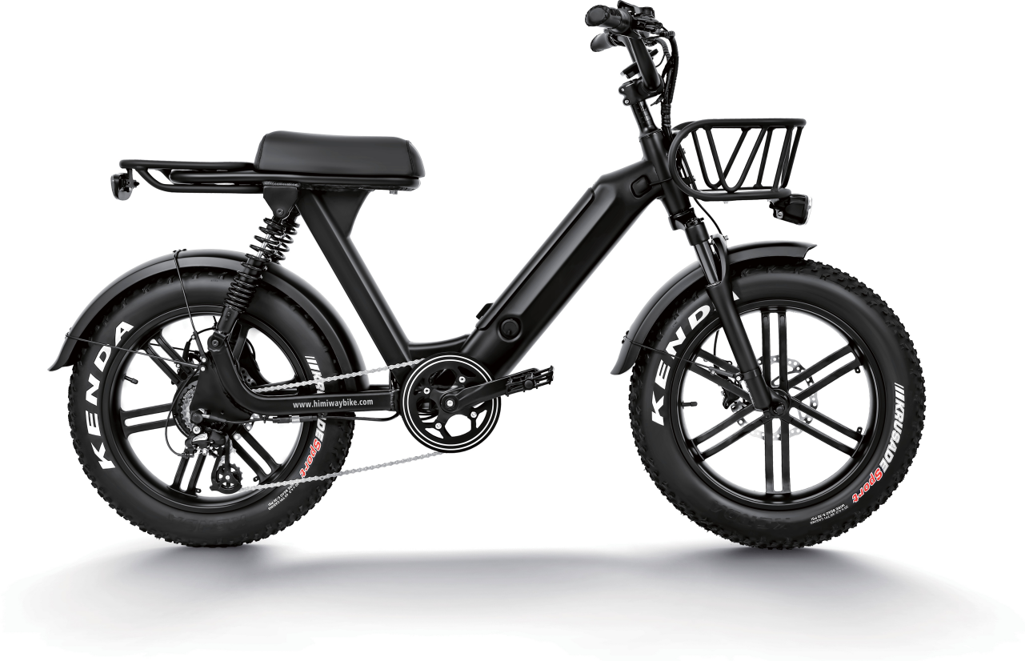

About Manual
This manual contains details of the product, and information on its operation and maintenance and other helpful tips for owners. Read it carefully and familiarize yourself with the CHALLENGER before using it to ensure safe use and prevent tragic accidents. Be sure to retain this manual as your convenient CHALLENGER information source.

This manual contains many Warnings and Cautions concerning the safe operation and consequences if safe setup, operation and maintenance are not performed. All information in this manual should be carefully reviewed and if you have any questions you should contact CHALLENGER Bike immediately. The notes, warnings and cautions contained within the manual and marked by this triangular Caution Symbol should also be given special care.
!
Users should also pay special attention to information marked in this manual beginning with NOTICE.

Because it is impossible to anticipate every situation or condition which can occur while riding, this manual makes no representations about the safe use of bicycles under all conditions. There are risks associated with the use of any bicycle which cannot be predicted or avoided, and which are the sole responsibility of the rider. You should keep this manual, along with any other documents that were included with your bicycle, for future reference, however all content in this manual is subject to change or withdrawal without notice. Visit www.CHALLENGERbike.com to download the latest version. CHALLENGER Bike makes every effort to ensure accuracy of its documentation and assumes no responsibility of liability if any errors or inaccuracies appear within. Assembly and first adjustment of your CHALLENGER Bike requires special tools and skills and it is recommended that this should be done by a trained bicycle mechanic if possible.

Product Specification

 | 48v 14Ah Samsung Lithium Battery |  | Front Suspension & Hydraulic Lockout
 | 750W High Speed Brushless Geared Motor |  | 20” * 21” AL6061 M Model
 | KDS-KD51C+USB LCD Display |  | Hydraulic Disc 180mm
 | Shimano-Altus-7 Speed |  | US Standard 2.0A Smart Charger
 | 20 MPH |  | Shimano 7 Speed
 | 40+ Miles |  | Velo
 | Intelligent 5 Level Pedal Assist |  | Shimano-Tourney-ysp
 | Half Twist Throttle |  | Kenda 20” x 4”
 | 6~7 Hours |  | 92 Ibs
 | 5.2” ~ 6.4” |  | 330 Ibs

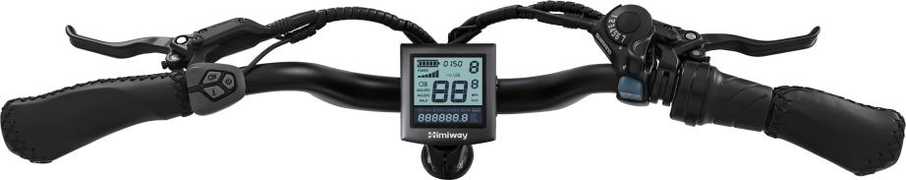
On/Off Switch
LCD Display
Shimano Shifter
Brake
Handle LED Light Switch
Throttle

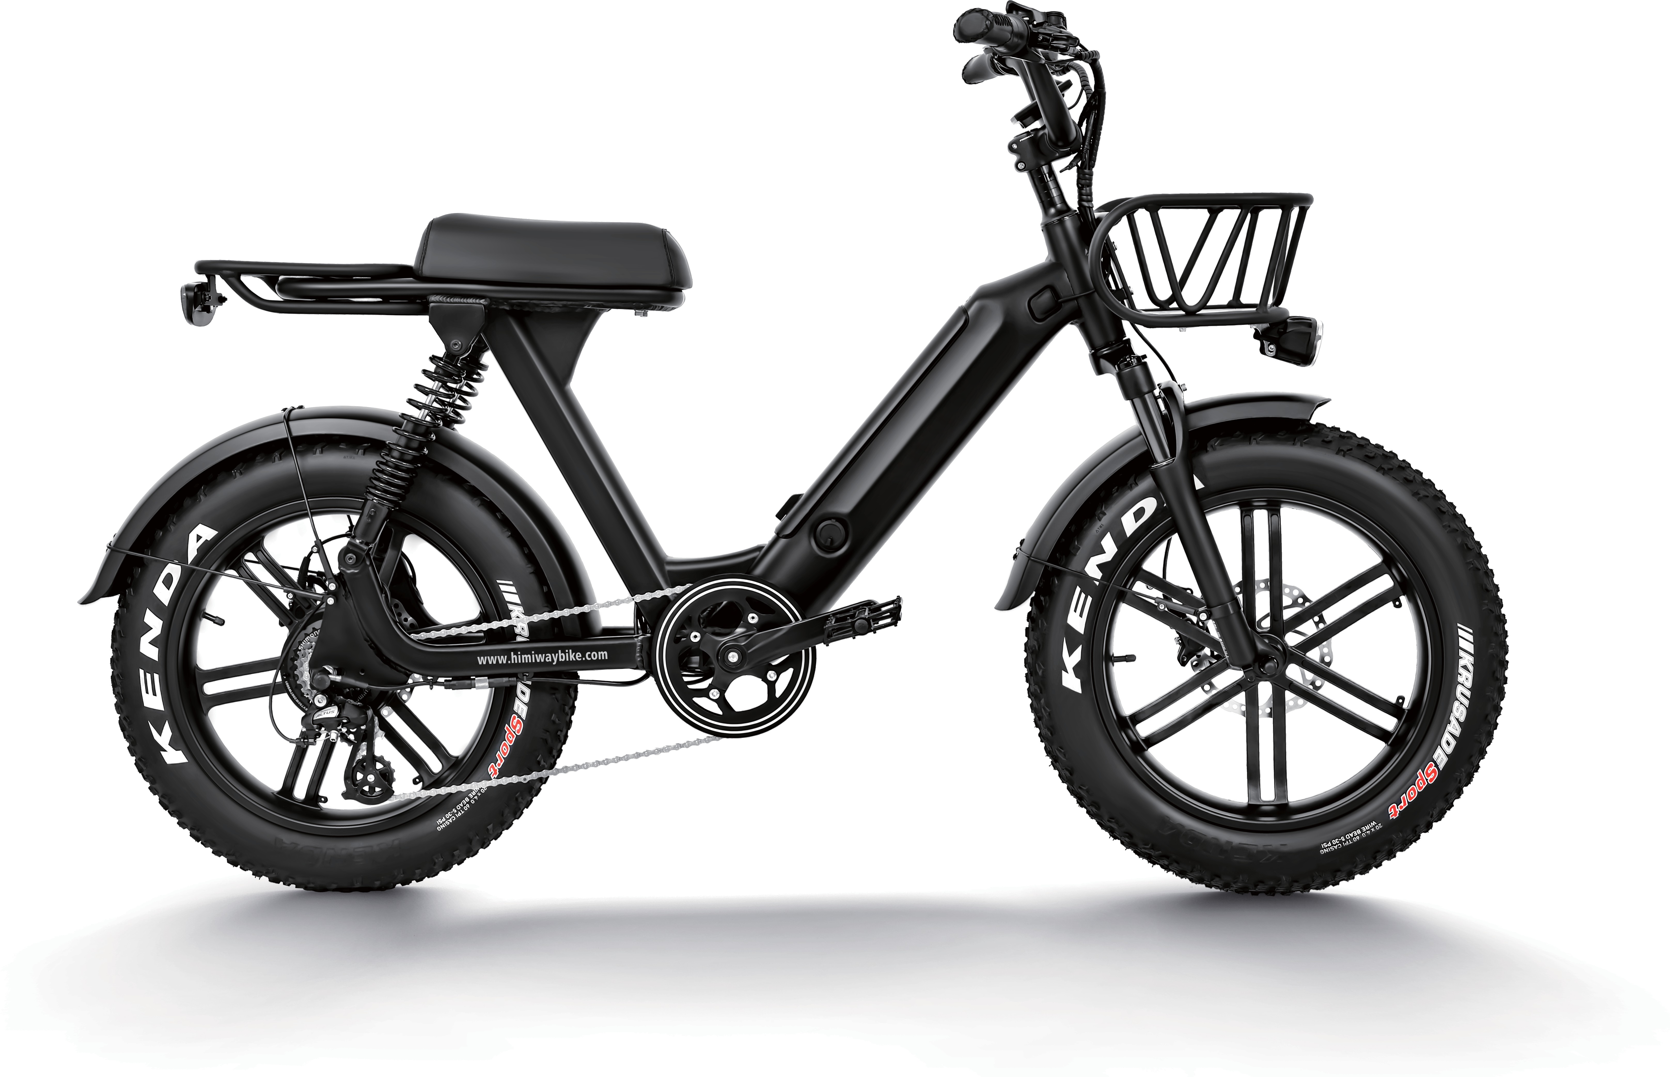

Saddle
Frame
Battery

LED Rear Light

Rear Shock Absorption

LED Head Light

Front Fork

Motor Tire
Rear Derailleur

Controller Pedal
Front Brake

Maximum Load Capactiy

330 LBS
Wheelbase

43.7 inch

Seat Height Total Length

32 INCH
69 inch

Tires

20 X 4
Handlebar Reach

24 inch

Motor

750W

Safety Checklist

NOTICE: Before every ride it is important to carry out the following safety checks.

Brakes | - Ensure front and rear brakes work properly.  - Ensure brake pads are not over worn and are correctly positioned in relation to the rims.  - Ensure brake control cables are lubricated, correctly adjusted and display no obvious wear.  - Ensure brake control levers are lubricated and tightly secured to the handlebars.
Wheels and Tires | - Ensure tires are inflated to within the recommended limits displayed on the tire sidewalls.  - Ensure ties have tread and have no BULGES OR EXCESSIVE WEAR.  - Ensure rims run true and have no obvious wobbles or kinks.  - Ensure all wheel spokes are tight and not broken.
Steering | - Ensure handlebar and stem are correctly adjusted and tightened, and allow proper steering.  - Ensure the handlebar is set correctly in relation to the forks and the direction of travel.
Chain | - Ensure the chain is oiled, clean and runs smoothly.  - Extra care is required in wet or dusty conditions.
Cranks and Pedals | - Ensure pedals are securely tightened to the cranks.  - Ensure the cranks are securely tightened and are not bent.
Derailleurs | - Check that the derailleur(s) are adjusted and functioning properly.  - Ensure shift and brake levers are attached to the handlebar securely.  - Ensure all brake and shift cables are properly lubricated.
Motor Drive Assembly and Throttle | - Ensure hub motor is spinning smoothly and the motor bearings are in good working order.  - Ensure all power cables running to hub motor are secured and undamaged.  - Make sure the hub motor axle bolts are secured and all torque arms and torque washers are in place.
Battery Pack | - Ensure battery is charged before use.  - Ensure there is no damage to battery pack.  - Lock battery to frame and check to see that it is secured.

Assembly Instructions

NOTICE: The following assembly steps are only a general guide to assist in the assembly of your CHALLENGER Bike and is not a complete or comprehensive manual of all aspects of assembly, maintenance and repair. We recommend you consult a certified bicycle mechanic to assist in the assembly, repair and maintenance of your bicycle. For detailed instructions please view the CHALLENGER Assembly video and Quick Release Installation video found at www.CHALLENGERbike.com.

Step 1 : Install the handle bars. Remove the four screws from the stem, ensuring the linear markings on the handlebars are centered and handlebars are adjusted to the comfortable position. Finally, tighten the screws with the assembly tool.

Step 2 : Install the headlight. Use a socket wrench to hold the nut and loosen the screw with a screwdriver and remove the screw. Install the screw pass through headlight and the bracket and adjust the headlight properly for riding conditions.

Step 3 : Remove the plastic guard from the front fork being sure not use the brake levers until the wheel is installed.
Install the front wheel and make the axle go through the centre of the wheel. Tighten the nut on each side with the wrench included.
Install the plastic cap on each side of the axle.
Remember to verify all items are tight and torqued properly after your first couple of rides.

Step 4 : Use a bike pump with a press gauge to Inflate tires to desired PSI. The recommended pressure for this mode is 20 PSI (1.379 Bar). Do not overinflate or underinflate tires.

Step 5 : Install the pedals. The left and right pedals are marked on both ends. First, install the right pedal by tightening the pedal in clockwise direction. The left pedal is tightened by turning the pedal in counterclockwise direction. Both pedals should be tightened to 35 Newton meters by using a torque wrench.

Step 6 : Install the optional rear rack. Align the holes in the rear rack with the holes in the frame and tighten with screws.

Step 7 : Check the battery pack is locked into the frame of the CHALLENGER . When you want to take off the battery, insert the key and turn to release the battery pack. The battery pack can be removed and charged separately. This is the charging port. Align the battery pack to the battery holder carefully and push until when you hear it click into the place.

NOTICE: Ensure all hardware is tightened properly and all safety checks in the following sections are performed before first use. Contact CHALLENGER Bike if you have any questions regarding the assembly of your bike. If you are not able to ensure all the assembly steps in the assembly video are performed properly, or you are unable to view the assembly video please consult a certified local bicycle service provider for assistance in addition to contacting CHALLENGER Bike for help.

Recommended Torque Values

Hardware Location | Torque Required (Nm)
Handlebar | 18-20
Stem | 18-20
Saddle | 18-20
Front Wheel (For Bikes with Bolt on Front Wheel) | 16-25
Rear Wheel | 35-40
Bottom Bracket Parts | 35-55
Pedals | 35
Disk Mounting Bolts | 6
Disk Caliper Mount | 10
Crank Bolts | 40
Rear Derailleur Cable Pinch | 6
Front Derailleur Clamp | 7

Start-Up Procedure
After the bike has been properly assembled following the unboxing video and all components are secured correctly, you may now proceed to start up the vehicle and select the power level following the next steps.
- Hold down the centre mode button on the display remote for 2 seconds then release, the display should turn on.
- Select your desired level of pedal assistance between level 0 through 5 using the up and down arrows on the display remote. Level 1 corresponds to the lowest level of pedal assistance, and level 5 corresponds to the highest level of pedal assistance. Level 0 indicates pedal assistance will be inactive.
- To turn on the headlight once the LCD display are on, hold down the top and middle button located on the left side of the handlebars for 2-3 seconds.
- With the proper safety gear and rider knowledge and understanding you may now proceed to operate your CHALLENGER Bike. You can begin by pedaling the bike in the appropriate drivetrain gear with or without pedal assistance. You may also use the throttle to accelerate and maintain your desired speed.

Display Features
The image shows the various features and information displayed on the Display.

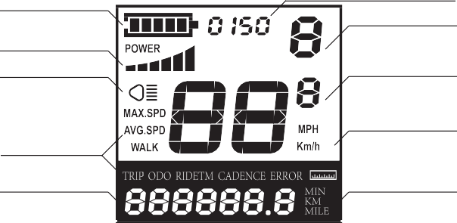
Battery Indicator Power Output Indication
Push-assistance Level Indication Area

Power Indicator The Lighting Indicator

Function List Text Indication

Speed Indication Speed Unit
Range / Time Unit

Routine Operation
After pressing the power button for seconds, the meter starts to work and provides the working power of the controller. In the power-on mode, press and hold the power button to turn off the electric bikes power supply. In the off mode, the meter no longer uses the battery's powersupply, and the meter's leakage current is less than 1uA.
If the electric bike is not used for more than 10 minutes, the meter will automatically shut down.

When the meter is turned on, the meter displays the real-time speed and total mileage (km) by default. Short press the “i” button to display the information in real time speed (km/h), average speed (km/h), maximum speed (km/h), single mileage (km), total mileage (km) .

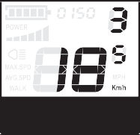
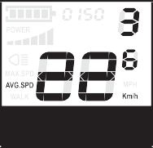
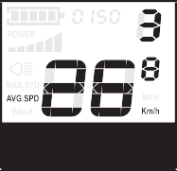

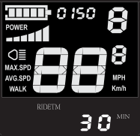
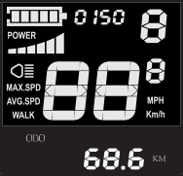
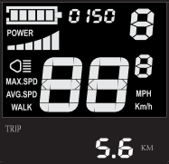

Press and hold the “—” button to hold it down. After 2 seconds, the electric bike enters the power assist mode. The electric bike travels at a constant speed of 6 kilometers per hour. At the same time, the screen displays “WALK”. Release the “—” button and the electric bike will immediately stop the power output and return to the state before the boost.
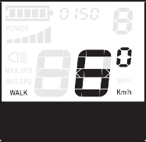
The power-saving function can only be used when the user pushes the electric bike. Do not use it while riding.
!

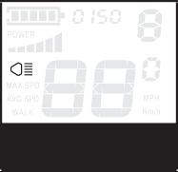
Press and hold the “ ” button for 2 seconds, the instrument backlight is turned on, and the controller is notified to turn on the headlights. When the external light is insufficient or driving at night, the LCD backlight can be turned on. Press and hold the “ ”button again for 2 seconds to turn off the LCD backlight and notify the controller turns off the headlights.

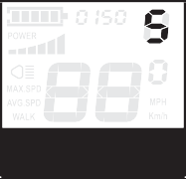
Press the “+” or “—” button to switch the power assist position of the electric vehicle and change the output power of the motor. The default output power range of the meter is 0-5, the 0 position is the stop power output, the 1st gear is the lowest power, and the 5th gear is the highest power. When the 5th gear is reached, press the “+” button again, the interface will still display 5, and the 5 flashings will indicate that it is the highest. After the assisted downshift reaches 0, press the “—” button again, the interface will still display 0, and flash with 0 to indicate that the current is the lowest. The default gear position for the instrument is 1 file.

The display on the handlebar of your CHALLENGER Bike features a battery capacity gauge (much like the fuel gauge on an automobile). It is recommended that users charge the bike as soon as possible once one bar is left on the display. Once the battery is fully depleted, the last remaining bar will begin to flash, communicating to the user that they should cease operation immediately.

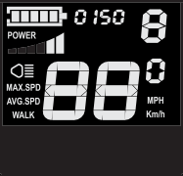
The motor output power can be known through the meter. The display mode is as shown below.

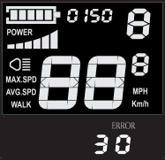
Your CHALLENGER Bike is equipped with an error detection system integrated into the display and controller. In the case of an electronic control system fault an error code should display. The following error codes are the most common and can aid in troubleshooting.

21 | Abnormal Current | 24 | Motor Hall Defect
22 | Throttle Fault | 25 | Brake Failed or Brake Applied While Turning On
23 | Motor Phase Problem | 30 | Abnormal Communication
When the error code is displayed, please promptly remove the fault. After the fault occurs, the electric bike will not be able to ride normally.

General Settings
Press and hold the power button to turn it on. In the power-on state, while the vehicle is stationary, press and hold the “+” and “-” buttons simultaneously for more than 2 seconds, and the meter enters the normal setting state.
Each setting item needs to be carried out while the e-bike is stationary.

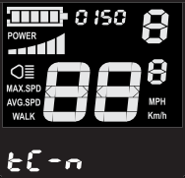
TC stands for clearing a single mileage. Y/N can be selected by pressing the “+” or “-” button, and Y means clearing the single riding mileage. N means that the single riding distance is not cleared. Short press the “i” button to confirm and enter the backlight brightness setting state.

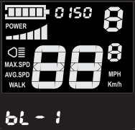
The single mileage clear operation interface bL represents the backlight. Parameters 1, 2, and 3 can be set to indicate backlight brightness, 1 is the darkest, 2 is the standard brightness, and 3 is the brightest. The factory default value is 1. Press the “+” or “-” button to change the backlight brightness parameter. Short press the “i” button to confirm and enter the metric unit conversion setting state. Press and hold the “i” button to confirm and exit the general setting state.

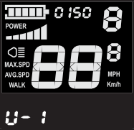
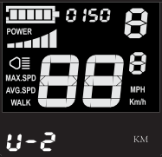
- I
U stands for unit, 1 stands for imperial system, and 2 stands for metric system. The speed and mileage units can be converted by the “+” or “-” buttons. Press the “i” button to confirm. Press and hold the “i” button to confirm and exit the normal setting. The default unit of the meter is metric.

General Parameter Settings
Press and hold the “+” and “-” buttons simultaneously for more than 2 seconds to enter the normal setting state. Press and hold the “-” and “i” buttons simultaneously for more than 2 seconds to enter the wheel diameter setting interface.

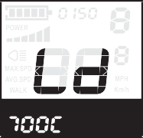
LD stands for wheel diameter and can be set to 16, 18, 20, 22, 24, 26, 700C, 28. Use the “+” or “-” buttons to select the wheel diameter corresponding to the e-bike to ensure the accuracy of the meter speed display and mileage display. The factory default wheel diameter value is 26inch. Short press the “i” button to enter the speed limit setting interface.

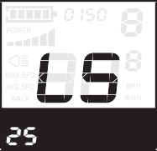
Wheel diameter setting interface
The default value of the highest riding speed of the instrument is 25 km/h. Change this value to set the maximum riding speed of the electric vehicle. When the electric motor exceeds the set value, the controller will stop supplying power to the motor to protect the rider.
Driving safety: LS means speed limit, the maximum speed setting value can be selected from 12 km/h to 40 km/h, can be adjusted by + or “-” button; press “i” button confirm and exit the setup status.

Driving Range
The range of your CHALLENGER Bike is the distance the bike will travel on a single full charge of the onboard battery pack. The range values in this manual are estimates based on expected usage characteristics. Some of the factors which effect range include changes in elevation, speed, payload, and acceleration, number of starts and stops and ambient air temperatures. Tire pressure and terrain are also important variables to consider.

We suggest that you select a lower assistance level when you first get your CHALLENGER Bike to get to know your bike and travel routes. Once you become familiar with the range requirements of your travel routes, and the capabilities of your CHALLENGER Bike you can then adjust you riding characteristics if you so desire.
The following table provides general estimates and outlines various factors effecting range and their combined estimated effects on range. This table is meant to help owners understand the factors that can increase of decrease range, but CHALLENGER Bike makes no claims to the range that individual users might obtain.

Best Practices for Extending Range and Battery Life
  - Do not climb hills steeper than 15% in grade.
  - Pedal to assist the motor when climbing hills and accelerating from a stop.
  - Avoid sudden starts and stops.
  - Accelerate slowly.

NOTICE: It is recommended that users pay close attention and ride within the following limitations to ensure the hub motor does not overheat or become damaged from excessive loading.

Parking Storage and Transport
Please follow these basic parking, storage and transport tips to ensure your bike is well cared for on and off the road.
- When pushing the vehicle manually, turn off the power to avoid accidental acceleration from the motor.
- It is recommended to park indoors.
- Switch the power off, and any lights to conserve battery. Remove the key from the bike and ensure the battery is locked to the frame or
removed and brought with you for security.
- In public places, your CHALLENGER Bike must be parked in accordance with local rules and regulations.
- If you must park outdoors in rain, or wet conditions you should only leave your CHALLENGER Bike outside for a few hours and proceed to park the bike in a dry location afterwards to allow all the systems to dry out. Much like a regular bike, use in wet conditions mandates a more regular maintenance schedule to ensure your bike does not become rusty, corroded and to ensure all systems are always working safely.
- Do not park, store, or transport your CHALLENGER Bike on a rack that is not designed for the size and weight of the bike.
- Wide tires, as used on CHALLENGER Bike, cannot fit into all bike racks, please select an appropriate rack for the width of tires used on your bike.
- Locking up your bike is recommended to ensure your bike is secure and the chance of theft is reduced. CHALLENGER Bike makes no claims or recommendations on the proper lock hardware or procedures to secure your bike, but we do recommend you take the appropriate precautions to keep your CHALLENGER Bike safe from theft.
- When storing your bike or carrying your bike on a rack for transport, you can remove the battery pack to reduce the weight of the bike
and make lifting and loading easier.

Carrying Loads
The total maximum weight limit of the CHALLENGER includes the weight of the rider as well as clothing, riding gear, cargo, etc. The kickstand is not designed to be used for loading cargo. You MUST hold onto the bike whenever loading cargo. Do not assume the bike is stable and balanced when using the kickstand, always hold onto the bike when cargo is being loaded or in place.
Total maximum payload: 125 Kilograms.

Carrying Cargo
Carrying a cargo load involves additional risks which need to be paid close attention to, users should practice riding on a flat and open area with light cargo before attempting to carry heavier loads. You must become accustomed to the braking, steering, and operational adjustments required to safely operate the CHALLENGER with cargo. Braking, acceleration, and balancing are all significantly affected by the addition of cargo loaded on the CHALLENGER .

The following bulleted list provides important tips for the safe operation of the CHALLENGER when used for carrying cargo.
- Plan your route accordingly as your hill climbing ability, steering and braking are all impacted when cargo is loaded on the CHALLENGER . Hills that are normally easy to climb and descend without cargo can become challenging and dangerous once cargo is loaded.
- Cargo should be loaded as low as possible to lower the center of gravity and improve stability, but ensure that cargo does not interfere with any moving components or the ground.
- Ensure your loads are properly secured and periodically check that nothing loosens.
- Get a feel for the cargo load in a flat and open area before riding on roads.

Do not use the front brake by itself, always apply the rear brake first followed by the front brake and be sure to use both brakes for all braking operations. Front fork failure or loss of control are plausible when the front brake
is operated independently for slowing at high speed with cargo loads.
!

The kickstand is not designed to be used for loading cargo. You MUST hold onto the bike whenever loading cargo. Do not assume the bike is stable and balanced when using the kickstand, always hold onto the bike
when cargo is being loaded or in place.
!

Charging Procedure
Follow these steps for charging your CHALLENGER Bike:
  - Turn the battery pack off using the key switch.
  - Remove the rubber cover on the charging socket on the opposite side of the battery switch.
3 .With the battery on or off the bike, place the charger in a flat, secure place, and connect the DC output plug from the charger (round barrel connector) to the charging port on the side of the battery pack.

- Then connect the input plug (110/220-volt plug) to the power outlet, charging should initiate and will be indicated by the LCD charge status light on the charger turning red.
- After charging, indicated by the charging indicator light turning green, unplug the charger from the wall outlet first and proceed to remove the charger output plug from the bike charging port.

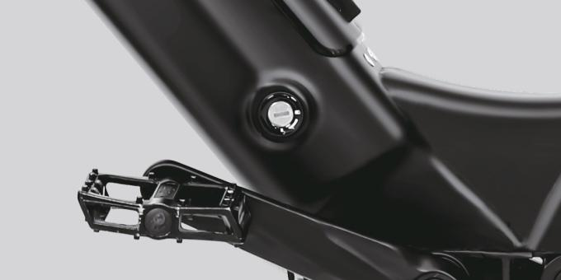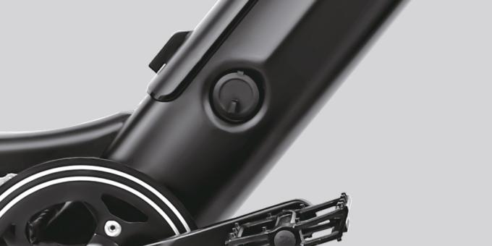
BATTERY ON/OFF
TURNING
LOCKING AND
GHARGE PORT

Always charge your battery in temperatures between 10 and 26 degrees Celsius and ensure the battery and charger are not damaged before initiating charge. If you notice anything unusual while charging, please
discontinue charging and use of the bike and contact CHALLENGER Bike for help.
!

Basic Battery Charging Tips
- The battery should be recharged after each use. There is no memory effect, so you can charge the battery after short rides without damage.
- The battery can be recharged on or off the bike.
- Remove the battery by turning the key and then pulling the battery forward and up until the battery detaches from the mating receptacle.
- The charger will automatically stop charging when the battery pack is full.
- Always charge in dry locations and indoors away from direct sunlight, dirt or debris.
- Do not cover up the charger when plugged in or charging, it air cools and needs to be left in an open space. Do not charge with the charger
in the inverted position which can inhibit cooling and reduce the charger’s life.
- Check the charger cables, charger and battery for damage before beginning each charge.
- The light on the charger will turn green when charge is complete and stay red while the battery charges.
- Charging normally takes 6~9hours, however it can take longer when you first receive the bike since the battery pack is balancing.

When the Battery Is Removed
- Do not touch the “+” and “- “ terminal contacts on the bottom of the battery when the battery is removed from the bike.
- Be careful not to drop or damage the battery pack when loose from the bike.

When Installing the Battery onto the Bike
- Do not force the battery onto the receptacle, slowly align and push battery down into the receptacle.
- Ensure the key is in the locked position before riding and check that the battery has been properly secured to the bike before each use by
pulling upwards and testing the security of the pack.

Charging Time
When the input and output plugs of the charger are connected properly, and the battery is not fully charged, the red charging indicator light should illuminate, showing that the battery is charging. The time that the battery takes to fully charge the battery is dependent on various factors including distance traveled, riding characteristics, terrain, payload, and battery age.

NOTICE: The battery pack can take longer to charge when fully depleted and when the battery is new. As your battery ages you might also experience increased charging times, but this is only expected after 3-5 years of regular use. If your battery does not seem to be charging normally, and taking longer to charge than expected, please discontinue charging and contact CHALLENGER Bike immediately.

Charger Safety Information
◆ Keep charger in a safe place away from children.
◆ Fully charge the battery before each use to extend the life of the battery and help to reduce the chance of over- discharging the battery pack.
◆ Do not charge the battery with any other chargers than what was originally supplied with your CHALLENGER Bike or a charger purchased directly
from CHALLENGER Bike for use with your specific bike serial number, as approved by CHALLENGER Bike.
◆ The charger works on 110/220 V 50/60 Hz standard home AC power outlets, do not open the charger to select voltage input, the charger
automatically detects and accounts for incoming voltage.
◆ Avoid charger contact with liquids, dirt/debris or metal objects.
◆ Store the charger in a location where it cannot suffer damage from falls/impact.
◆ The charger should only be used indoors in a dry ventilated area.
◆ If you notice a strange smell or the charger or battery are overheating, please stop charging immediately and contact CHALLENGER Bike.
◆ Do not yank or pull on the cables of the charger. When unplugging carefully remove both the AC and DC cables by way of pulling on the
plastic plugs, not pulling on the cables.

Please take special care in charging of your CHALLENGER Bike in accordance with the above procedures and safety information. Failure to follow proper charging procedures can result in damage to your CHALLENGER Bike, charger,
personal property and/or serious injury or death.
!

Bicycle Care
To ensure safe riding conditions you must ensure your bike is properly maintained. You should follow these basic guidelines and see your certified bicycle mechanic at regular intervals to ensure your bike is safe for use.

- Properly maintain batteries by keeping them fully charged when not in use.
- Never immerse the bike or any components in water as the electrical system may be damaged.
- Periodically check wiring and connectors to ensure there is no damage and the connectors are secure.
- To clean, wipe the frame with a damp cloth soaked in a mild non-corrosive detergent mixture. Dry with a cloth.
- Store under shelter; avoid leaving it in the rain or exposed to corrosive materials. If exposed to rain, dry your bicycle afterwards and apply anti-rust treatment to chain and other unpainted steel surfaces.
- Riding on the beach or in coastal areas exposes your bicycle to salt which is very corrosive. Wash your bicycle frequently and wipe or spray all unpainted parts with anti-rust treatment. Damage from corrosion is not covered under warranty so special care should be given to extend the life of your bike when used in coastal areas or areas with salty air or water.
- If the hub and bottom bracket bearings have been submerged in water, they should be taken out and re-greased. This will prevent accelerated bearing deterioration.
- If the paint has become scratched or chipped in the metal, use touch up paint to prevent rust. Clear nail polish can also be used as a preventative measure.
- Regularly clean and lubricate all moving parts, tighten components and adjust as required.
Your cables, spokes and chain will stretch after an initial break in period of 80-160 km, while bolted connections can loosen. Therefore, always have a certified bicycle mechanic perform a tune-up on your CHALLENGER after your initial break-in period of 80- 160 km (depending on total weight, riding characteristics and terrain). Regular inspec-
tions and tune-ups are particularly important for ensuring that your bicycle remains safe and problem-free.
!

Basic Troubleshooting

It doesn’t work | - Insufficient battery power  - Faulty connections  - Battery not fully seated in tray  - Improper turn on sequence  - Brakes are applied | - Charge the battery pack  - Clean and repair connectors  - Install battery correctly  - Turn on bike with proper sequence  - Disengage brakes
Irregular acceleration and/or reduced top speed | - Insufficient battery power  - Loose or damaged throttle | - Charge or replace battery  - Replace throttle
When powered on the motor does not respond | - Loose wiring  - Loose or damaged throttle  - Loose or damaged motor plug wire  - Damaged motor | - Repair and or reconnect  - Tighten or replace  - Secure or replace  - Repair or replace
Reduced range | - Low tire pressure  - Low or faulty battery  - Driving with too many hills, headwind, braking, and/or excessive load  - Battery discharged for long period of time without regular charges, aged or damaged  - Brakes rubbing | - Adjust tire pressure  - Check connections or charge battery  - Assist with pedals or adjust route  - Replace the battery
The battery won’t charge | - Charger not well connected  - Charger damaged  - Battery damaged  - Wiring damaged | - Adjust the connections  - Replace  - Replace  - Repair or replace
Wheel or motor makes strange noises | - Damaged motor bearings  - Damaged wheel spokes or rim  - Damaged motor wiring | - Replace  - Repair or replace  - Repair or replace motor

As a parent or guardian, you are responsible for the activities and safety of your child. The CHALLENGER is not designed for use by children.
The following safety notes provide additional information on the safe operation of your CHALLENGER Bike and should be
closely reviewed. Failure to review these notes can lead to serious injury or death.
!

◆ All users must read and understand this manual before first use. Additional manuals for components used on your bicycle may also be
provided and should be read before use in addition to this manual.
◆ Ensure that you comprehend all instruction and safety notes/warnings.
◆ Ensure the bike fits you properly before first use. You may lose control or fall if your bike is too big or too small.
◆ Always wear an approved bicycle helmet whenever using this product and ensure that all helmet manufacturer instructions are used for fit
and care of your helmet. Failure to wear a helmet when riding may result in serious injury or death.
◆ Ensure correct tightening and setup is performed on your bicycle before first and checked regularly.
◆ It is your responsibility to familiarize yourself with the laws and requirements of operation of this product in the area(s) where you ride.
◆ Ensure handle bar grips are not damaged and properly installed. Loose or damaged grips can cause you to lose control and fall.
◆ Do not use this product with standard bicycle trailers, stands or bicycle racks. Contact CHALLENGER Bike to check if your equipment will work
with the bicycle.
◆ Off-road riding requires close attention and specific skills and presents variable conditions and hazards which accompany the conditions.
Wear appropriate safety gear and do not ride alone in remote areas. Check local rules an regulations if off-road riding is allowed.
◆ Engaging in extreme riding is extremely dangerous and should be avoided. Although many articles/advertisements/catalogues depict
extreme riding this is not recommended nor permitted, and you can be seriously injured or killed if you perform extreme riding.
◆ Bicycles and bicycle parts have strength and integrity limitations and extreme riding should not be performed or you risk damaging the
components or becoming seriously injured or killed.
◆ Failure to confirm proper installation, compatibility, proper operation or maintenance of any component or accessory can result in serious
injury or death.

- After any incident, you must consider your bike unsafe to ride until you consult with a certified bicycle mechanic for a comprehensive
inspection.
- Failure to properly charge, store or use your battery will void the warranty and may cause a hazardous situation.
- Extreme care should be taken when using the pedal assistance sensor and throttle on this product. Ensure you understand and are prepared
for the power assistance to engage as soon as pedaling is underway.
- You should check the operation of the brake inhibitor switches before each ride. The brake system is equipped with an inhibitor which shuts
down the power to the electric motor whenever the brakes are engaged. Check proper operation of brake switches before riding.
- User must understand the operation of the twist throttle and pedal assistance sensors before using, and take ample care in their usage in respect to traveling at speeds appropriate for usage area and user experience level. Always use the lowest assist level until you are comfort able with the bike and feel confident in controlling the power.
- Any aftermarket changes to your CHALLENGER Bike not expressly approved by CHALLENGER Bike could void the warranty and create an unsafe riding
experience.
- Because electric bicycles are heavier and faster than normal bicycles, they require extra caution and care while riding.
- Take extra care while riding in wet conditions. Feet or hands can slip in wet conditions and lead to death or serious injury from a fall.
- Do not remove front or rear reflectors, pedal reflectors or bell.

Warranty Info
Every bike is covered under a manufacturer's two-year all-inclusive warranty for the original owner against all manufacturing defects. CHALLENGER Bike warrants this product, including all individual components against defects in material or workmanship as follows:

CHALLENGER Bike bicycle components including frame, forks, stem, handlebar, headset, seat post, saddle, brakes, lights, bottom bracket, crank set, pedals, rims, spokes, wheel hub, freewheel, cassette, derailleur, shifter, motor, throttle, controller, wiring harness, LCD display, kickstand, reflectors and hardware are warranted to be free from manufacture defects in materials and/or workmanship for a 2-year period from the date of original purchase.

Wear and tear is not covered under warranty. CHALLENGER Bike lithium ion batteries are warranted to be free from manufacturing defects in materials and/or workmanship for a 2-year period from the date of original purchase. The battery warranty does not include damage from power surges, use of improper charger, improper maintenance or other such misuse, normal wear or water damage.

The Following are Also Excluded from the Warranty:
  - Liability for material defects does not cover normal wear which occurs from the manufacturers intended use of the product. Components such as the battery pack, motor system, braking system, drivetrain system, saddle, grips and pedals are all subject to intended use-related wear and are not covered under the warranty from normal wear.
  - Damage arising from the use of the bike in a competition or other applications outside of normal intended use.
  - Damage arising by improper tools or inadequate maintenance performed on the bike.
  - Damage resulting from adding non-standard equipment, parts or technical modifications.

Additional Warranty Terms
This warranty does not cover any damage or defects resulting from failure to follow instructions in the owner’s manual, acts of God, accident, misuse, neglect, abuse, commercial use, alterations, modification, improper assembly, wear and tear, installation of parts or accessories not originally intended or compatible with the bicycle as sold, operator error, water damage, extreme riding, stunt riding, or improper follow-up maintenance. This warranty does not include consumables or normal wear and tear parts (tires, tubes, brake pads, cables and housing, grips). CHALLENGER Bike will not be liable and/or responsible for any damage, failure or loss caused by any unauthorized service or use of unauthorized parts. In no event shall CHALLENGER Bike be responsible for any direct, indirect or consequential damages, including without limitation, damages for personal injury, property damage, or economic losses, whether based on contract, warranty, negligence, or product liability in connection with their products. All claims to this warranty must be made through CHALLENGER Bike. Proof of purchase may be required with any warranty request.

Additional Information on Wear
Components of the CHALLENGER are subject to higher wear when compared to bicycles without power assistance. This is because the CHALLENGER can travel at higher average speeds than regular cycles and has a greater weight. Higher wear is not a defect in the product and is not subject to warranty. Typical components affected are the tires, brake pads, suspension forks, spokes/wheels and battery pack.
When the useful life of a component is surpassed it can cause unexpected loss of function. This can result in serious injuries or even death. Therefore, pay attention to wear characteristics such as cracks, scratches or changes in the color or operation of components which could indicate useful life has been exceeded. Worn
components should be immediately replaced.
!

Thanks for Riding CHALLENGER Bike!

