Dear Customer,
Thanks for choosing Varla Pegasus Scooter!
We sincerely hope you could enjoy the fun and freedom of riding Varla Scooter.
Please spend some time reading and understanding this entire manual before you ride.

safety always comes first. You will work out how to ride your electric scooter quickly, however, remember to practice riding in a safe place with
limited obstacles. Here are some key points to keep in mind when riding:

- wear flat shoes. Please do not wear flip flops or sandals while riding.
- Please wear a helmet during the riding, as well as other protective equipment, such as, elbow and knee protectors and padded gloves which will allow a firmer grip on the handlebars.
- Please look ahead while riding! This may sound a little bit silly but people could be distracted by their surroundings. Be careful!
- Make sure you’re familiar with the scooter’s functions.
- DO NOT play your phone while riding.
- D0 N0T ride your scooter in the heavy rain or wet conditions as this could damage the battery and it will not be covered by the warranty for
water damage.
- D0 N0T violently hit the deck and other parts deliberately as this could damage the battery and frame and it will not be covered by the
warranty.
- 1f you ride in the dark, please wear visible and reflective clothing.

These are some basic tips, now start your learning of the Pegasus scooter in details!

Safety Warnings 1
Product specifications 3
Product Dimensions 4
Electric Scooter Parts 5
Assembly 6
General Operation 11
Accessing Settings 13
Pre-Ride Checklist 19
Warranty and Contact Information 20

☆ Riding an electric scooter does present potential risks and caution is required. Like any vehicle, an electric scooter has inherent hazards associated with its use (for example, falling off or riding it into a hazardous situation).

☆ The recommended minimum rider age is 16 and older. Any rider unable to fit comfortably on the scooter should not attempt to ride it.

☆ Keep this product away from small children and remember that it is intended for use only by persons who are, at a minimum, completely comfortable and competent while operating the scooter.

☆ Do not exceed the weight limit of 127 kg. Rider weight does not necessarily mean a person,s size is appropriate to fit or maintain control of the scooter.

☆ Check and maintain scooter conditions. Before use, check to confirm that covers and guards are in place and in serviceable condition. The scooter should be maintained and repaired in accordance with the manufacturer,s specifications, using only the manufacturer,s authorized replacement parts, and should not be modified from the manufacturer,s original design and configuration.

☆ Obey the local laws or regulations.
Always check and obey any local laws or regulations which may affect the locations where the electric scooter may be used. Keep safely away from cars and
motor vehicle traffic at all times. 0nly use where allowed and with caution.

☆ wear proper protective equipment while riding.
Always wear proper protective equipment, such as an approved safety helmet (with chin strap securely buckled), elbow pads and knee pads. A helmet may be legally required by local law or regulation in your area.

1 2 3

  - Please wear a helmet during the riding and other protective gear, such as elbow and knee protectors.

4

  - Charge the battery with the original charger, and someone needs to be nearby to avoid accidents when charging.
5

  - Do not ride on bumpy and slippery roads, such as dirt road, gravel road, snow-piled and gathered water road.

6

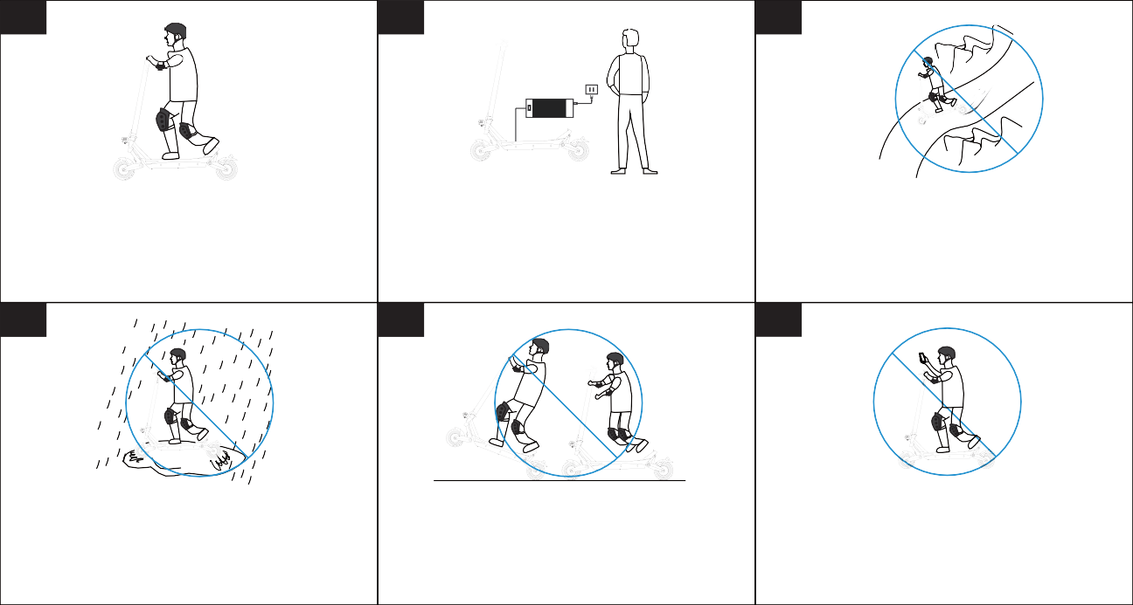
  - Do not ride your scooter in the heavy rain or wet conditions as this could damage the battery.

  - Dangerous actions are prohibited while riding.

  - Do not ride with one hand.

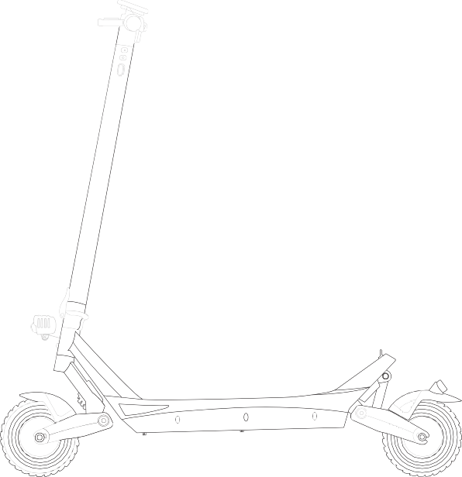
Rated Motor | 2x500W
Top Speed | 20km/h
Climbing Angle | 25 degrees
Battery | 48V/15.6Ah Battery
Max Range | 45 km (depends on riding condition)
Brake | Dual Disc Brake
Tire | 8 inches Fat Tire
Display | LCD Display
Frame Material | Aluminum+Magnesium Alloy
Suspension | Dual Spring Suspension
Throttle | Thumb Throttle
Payload Capacity | Max. 127 kg  Recommended 113 kg
Self Weight | 29.9 kg
Deck Pad Material | Silicone
Light | Headlight & Taillight

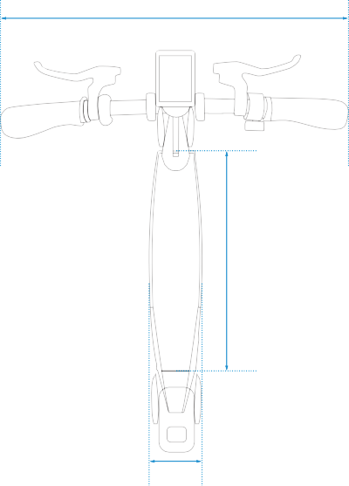
52.8cm
Handlebar Length
50.0cm
Deck Length
17.0cm
Deck Width

125.9cm
Overall Height

99.8cm
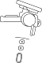
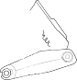
Standing Height

48.0cm
Folded Height

119.8cm
Overall Length

To improve quality and safety of the produCt, the speCifiCation might be Changed without prior notiCe.

Handlebar

Thumb Throttle

LCD Display

Steering Bar Brake

Front light

Folding Clamp

Deck Lock

Rear Caliper

Deck mat

Front Fender Front Motor

Kickstand

Taillight Rear Fender

Rear Motor
Deck

Charging Port

Front

Solid Tire

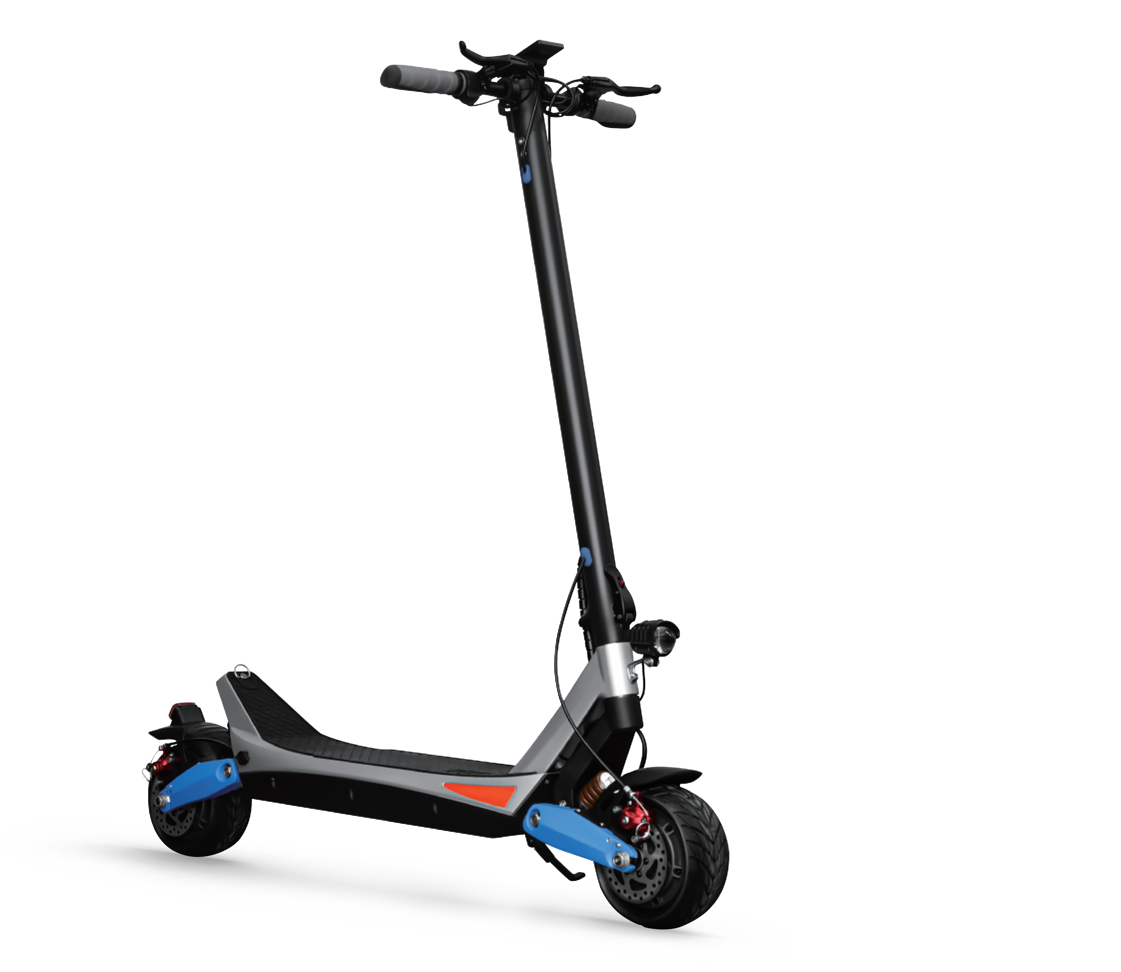
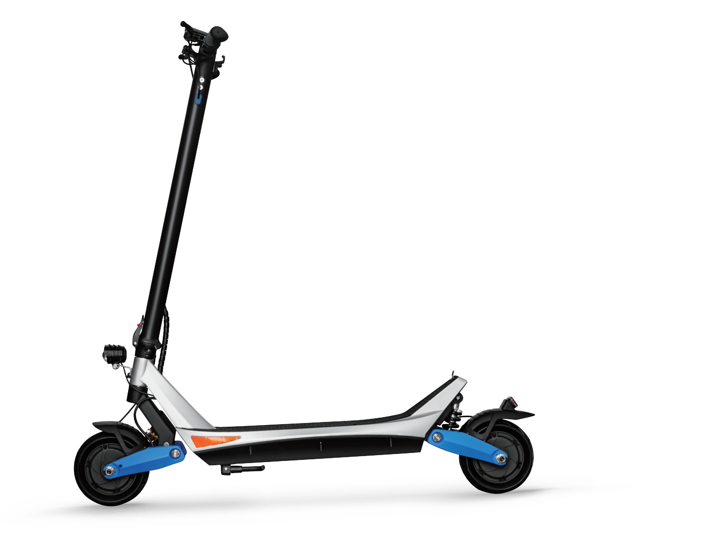
Front Suspension

Rear Suspension
Rear Solid Tire

Front Caliper

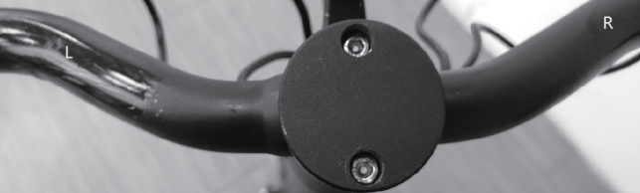
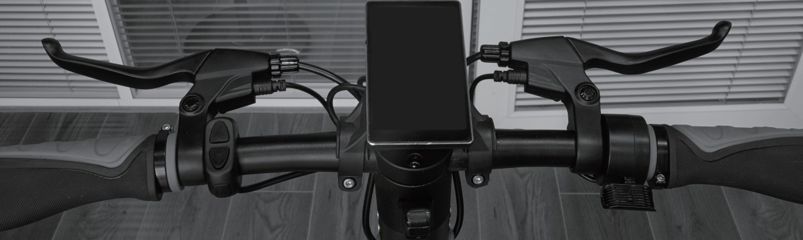

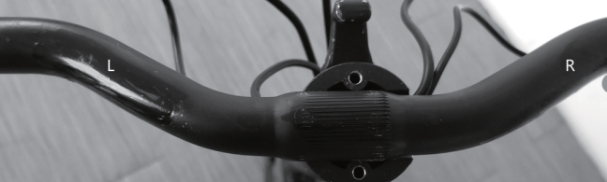
Put the handlebar on the stem, align center.
1

2
Put the cover and tighten the screws at both ends.

3
1nstall the LCD display, adjust to appropriate angle, and tighten the fix screws.

4
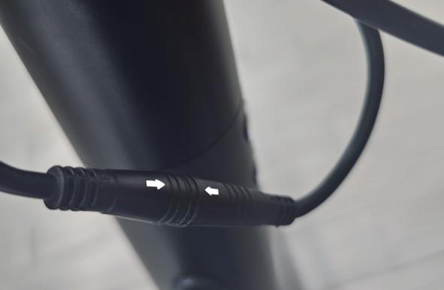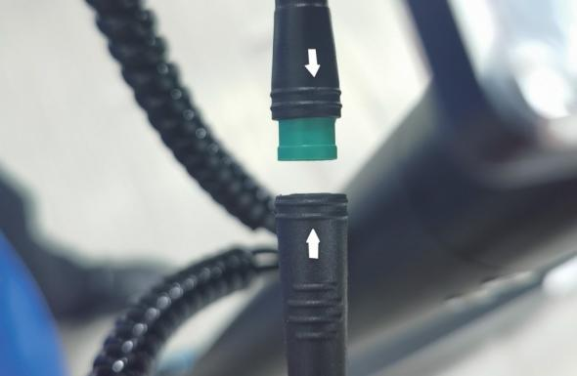

When connecting these two connectors, the arrow must be aligned with the arrow.
You can turn on the power only when the assembly is completed.

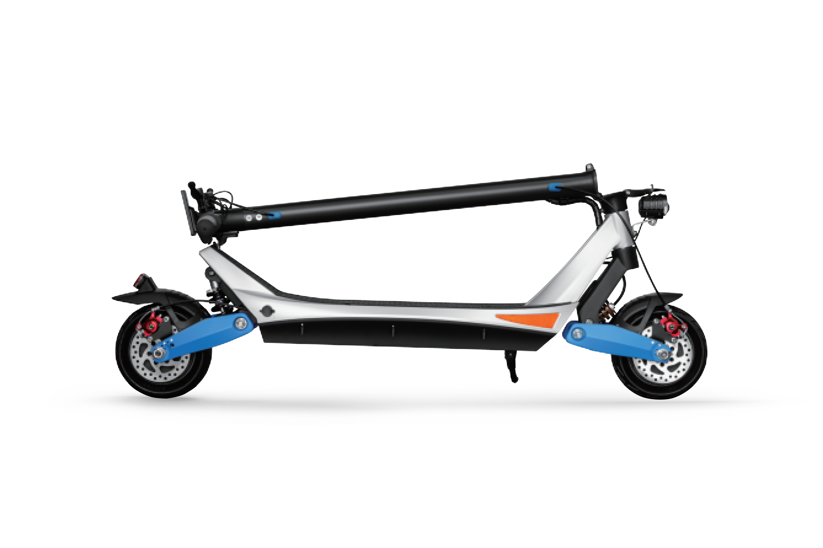
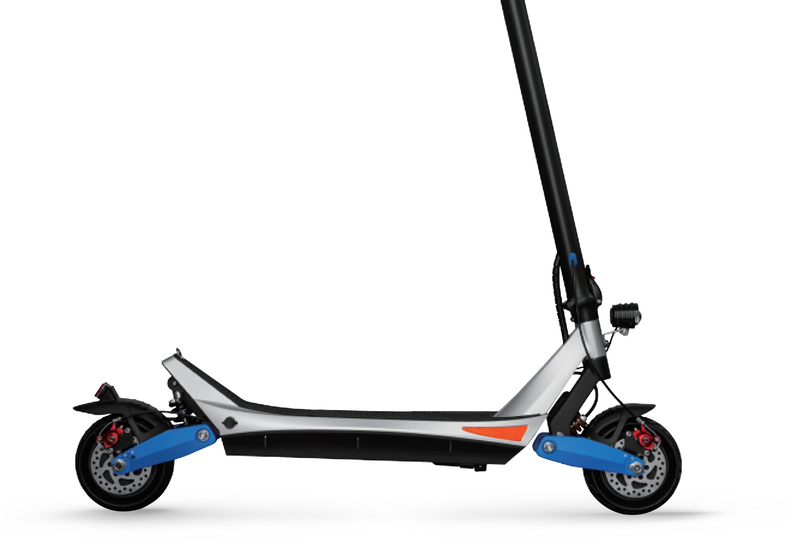
How to Unfold the SCooter
1
l.UnloCk the Clamp

2
2.Lift up the main rod

3
3.LoCk the Clamp

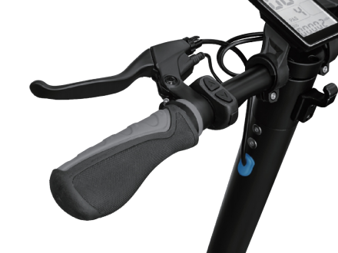
How to Fold the Scooter
1
Step 1: Power off

2
Step 2: UnloCk the Clamp

3
Step 3: Put down the main rod

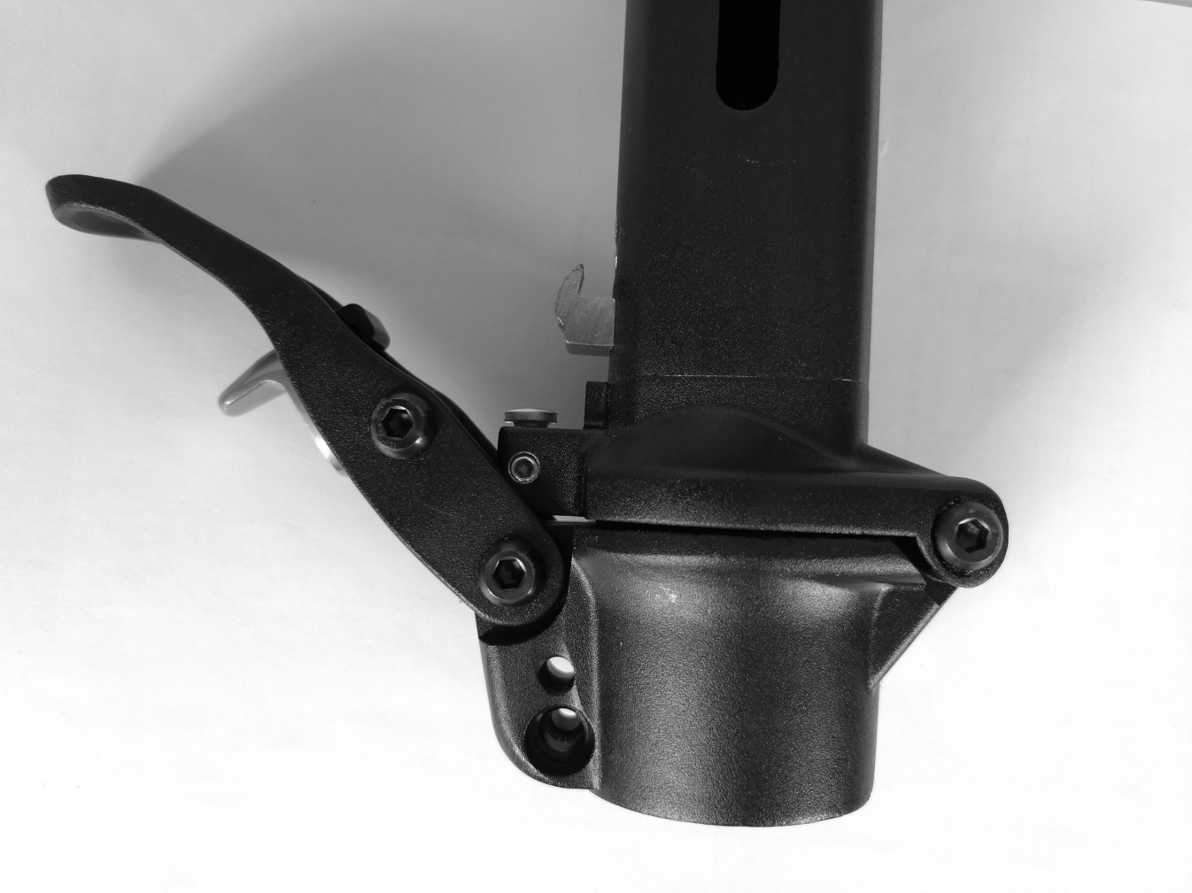
Screw
Nut

*Please check if the folding buckle is fastened before you go. If it is loose, please adjust the nut and screw.

BATTERY LEVEL INDICATOR
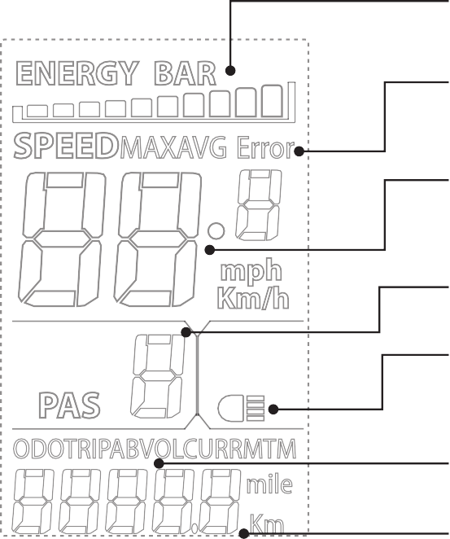
(Current / Max / Average)

ERROR CODE INDICATOR
(1n the Event of a Problem)

SPEED INDICATOR
(3 LEVELs 0F Ass1sT)

5 LEVELS OF ASSIST
(0: No Assist. 5: Max Assist)

BACKLIGHT INDICATOR
(0n / 0ff)

V0LTAGE 0UTPUT INDICAT0R
(Real.Time)

DISTANCE INDICATOR
(Current Trip / system Mileage)

☆ Riding Methods
When the power is on, it will show PAS 1, the top speed is 10 mph; Press the UP button, it will show PAS 2, the top speed is 16 mph; Press the UP button twice, it will show PAS 3, the top speed is 28 mph;

☆ Power Switch
Press and hold the M button for 3 seconds to turn on the LCD Display.

☆ Dual/Single Motor Switch
when it shows "MAx" (Dual Motor Mode) on the display, press and hold D0wN button for 2 seconds to enter single Motor Mode, then the "MAx" doesn!t
show on the display.

☆ Headlight
Long press and hold UP button for 2 seconds to turn on/off the headlight.

☆ Lifetime odometer reset
Enter P.setting . P16, then Long press UP button for 6 seconds to reset to 0.

☆ Battery
Balance the charge protection: balance the cell voltage automatically to protect the battery.
0vercharge protection: overcharge would damage the battery severely. 0ur battery would stop charging after been fully charged.
Charging temperature protection: when the charging temperature is below 5 degrees celsius or over 40 degrees celsius, it will harm the battery, and may
cause the battery to not be used normally.
Charging over current protection: High current charging will seriously damage the battery.
Short circuit protection: when the battery detects a short circuit, it will cut output to protect the battery.

Battery sleep protection: when the battery is on, but there,s no connection to any electrical equipment. Battery life can vary depending on proper maintenance and usage of the scooter.
Please only use the recommended charger.

☆ Charger
Make sure the power is turned OFF before you charge it. Step 1 Plug the charger into wall outlet.
Step 2 Plug the charger into the charger port. The light on the charger should turn red during charging. The light will turn green again when charging is complete.

Battery of the electric scooter Charger Plug

☆ Note:
Charger getting warm during use is normal. If your charger does not get warm during use, it does not mean that it is not working properly. Don’t charge the scooter immediately after a long-distance ride. Please wait for at least 30 minutes.
Continue charging the scooter even if light turns green prior to 12 hours.
Before you ride, check the current voltage on the display. when the voltage is lower than 41V, it needs to be charged above 48V.

*Battery can deplete over time. Periodically recharge battery once per month when not in use for a long time.

Long press the UP and D0wN button at the same time to access the P.setting menu.
Press the M button to toggle through P-settings.
Use the UP/D0wN button to adjust the value.
To save settings, allow the LCD display to timeout (8 seconds) or long press UP and D0wN button to exit the menu.

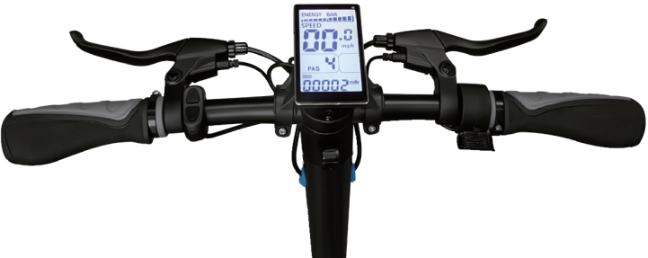

Setting | Feature | Notes
P1 | Backlight brightness | 1: low  2: mid  3: high  Default: 1
P2 | Speedometer units | 0: kph  1: mph  Default: 0
P3 | Battery voltage (do not adjust) | From 24V to 60V Default: 48V
P4 | Auto-off time | 0: not set  60: 60 min  Default: 5
P5 | Gear number | 0: 0-3 gears  1: 0-5 gears  2: 0-9 gears  3: 0-4 gears  4: 0-6 gears  Default: 0
P6 | Rim size (do not adjust) | From 0-50  Default: 8.0

Setting | Feature | Notes
P7 | Motor magnets (do not adjust) | Higher value means lower speed.  Default: 15
P8 | Power level | 1: slowest  100: fastest  Default: 100 km/h
P9 | Start mode | 0: zero start 1: kick to start Default: 0
P10 | Running mode (do not adjust) | 0: only PAS, no throttle  1: only electricity no pas mode 2: PAS and throttle both work Default: 2
P11 | PAs start sensitivity (do not adjust) | From 1-24  1: lowest  24: highest  Default: 3
P12 | PAs start strength (do not adjust) | From 1-5  1: weak  5: strong  Default: 1

Setting | Feature | Notes
P13 | PAs sensor type (do not adjust) | Value: 5/8/12 Default: 12
P14 | Controller limit (do not adjust) | From 10-20  The value should be higher than the minimum voltage  Default: 20A
P15 | Controller voltage protection (do not adjust) | From +/. 6V of default setting value  Default: 40
P16 | Lifetime odometer reset | Long.press Up button for 6s to reset to 0
P17 | Cruise control | 0: off  1: on  Default: 0  Keep riding on a certain speed for 6s will enter cruise mode
P18 | speed indication ratio (do not adjust) | From 50%-100%  Default: 100

Setting | Feature | Notes
P19 | 0 gear setting | 0: no 0 gear  1: has 0 gear  Default: 1
P20 | Communication protocol (do not adjust) | 0: no 2 protocol  1: 5s agreement  2: standby  3: standby  Default: 0

- Battery under voltage
- Motor faulty
- Throttle faulty
- Controller faulty
- Communication receive faulty 011 Communication sending faulty 013 Headlight faulty

ERROR CODE INDICATOR
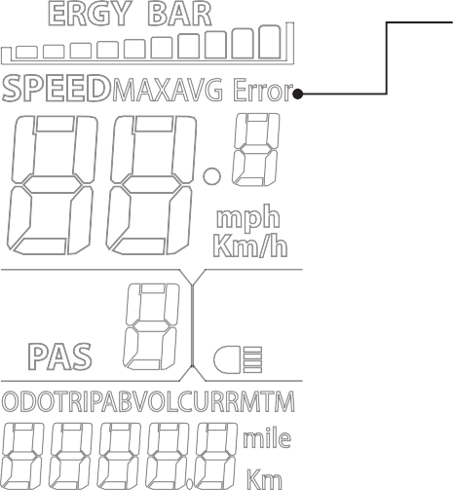
(1n the Event of a Problem)

☆ Brake
Check the brake options for proper function. when you pull the brake lever, the brake should provide positive braking action.

☆ Tire
Periodically inspect the tires has sufficient tread remaining.

☆ Battery
Before you ride, check the current voltage on the display. when the voltage is lower than 41V, it needs to be charged above 48V.

☆ Frame and handlebar
Check for cracks or broken connections. Although broken frames are rare, it is possible for an aggressive rider to run into a curb or object and wreck, bend
or break a frame.

☆ Safety gear
Before the ride, please wear your helmet, gloves, elbow protection, waist protection and other protective gears.

☆ Law and regulations
Always check and obey any local laws or regulations.

☆ Storage
Exposure to UV rays, rain and other bad weather may damage the materials, store cool and dry indoors when not in use.

Your purchase includes the following warranty.
The warranty would be registered automatically when the initial purchaser ordered it in the online shop. The warranty is 0NLY under the 1N1T1AL PURCHAsER. The 2.year warranty would be started since the initial owner receives it.

Affected Part | Warranty Period | service Content
Throttle | 24 months | Free maintenance
Controller | 24 months | Free maintenance
Frame | 24 months | Free maintenance
Motor | 12 months | Free maintenance
Battery | 12 months | Free maintenance
Charger | 12 months | Free maintenance
Kickstand | 1 Month or 100KM | Free replacement
Fenders | 1 Month or 100KM | Free replacement
Aesthetic Damage | Not Covered | -

1f you believe your Varla scooter has a warranty issue, your first point of contact should be your store where you purchased. 1f you purchased directly from Varla 0nline store, please contact our customer service team: customer@varlascooter.eu.

Warranty Notes
During the warranty period, any damage caused by the following reasons will not covered by the warranty:
  - Failure to follow this instruction manual for maintenance.
  - 1ncorrect use or traffic accident or other accidental collision damage.
  - Use damaged or other accidental collision when driving on abnormal condition roads.
  - Rapid aging and malfunction due to a long time sun exposure or leave the scooter outdoors for a long time.
  - The use of electric scooters for other purposes to perform dangerous actions such as special effects, which leads to rapid aging and malfunc- tion of this product.
  - Natural disasters, man.made irresistible reasons cause vehicle damage.
Note: Please visit Varla,s official website for the latest after.sales, return policy, warranty information, etc. 0fficial website:
EU www.varlascooter.eu UsA www.varlascooter.com

WARRANTY CARD

WARRANTY CARD
Please complete the following details.

Owner’s Name:

Address:

State:
City:
Zip Code:

Serial
Order Number(s):
number(s):

Date of Purchase:

Phone number: Email:

