NAKTO ELECTRIC BICYCLE

LCD-M5 display Control Panel Instruction

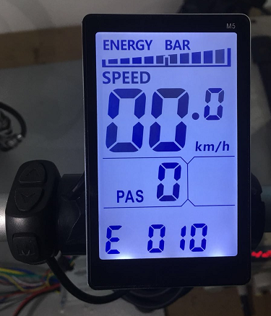

Size（unit：mm）
Case：ABS & Meta& glass
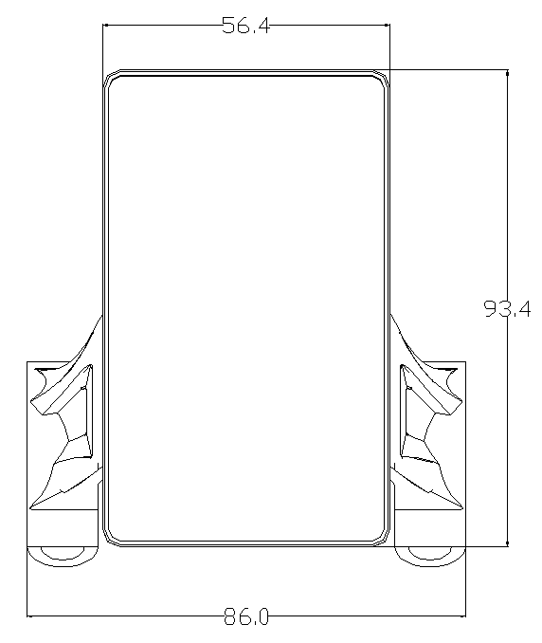 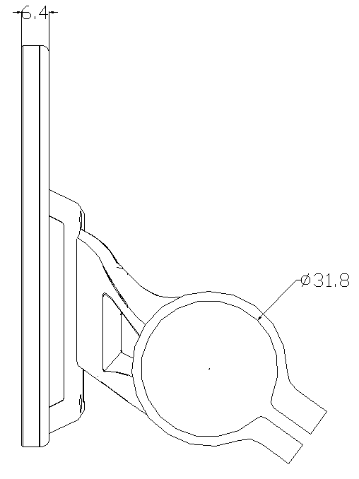 Front Side
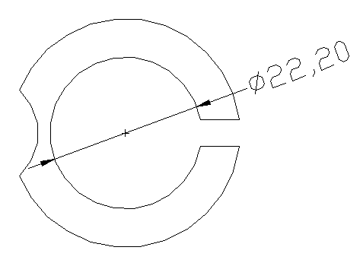31.8mm Rack
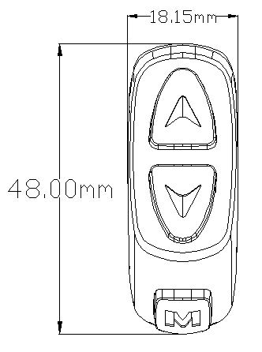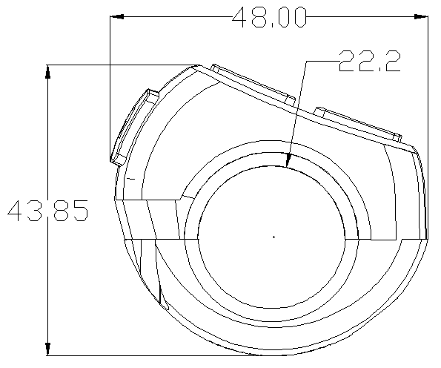
Front switch side

Voltage and Wiring
- Voltage：DC24V、36V、48V、60V、64V
- Wiring
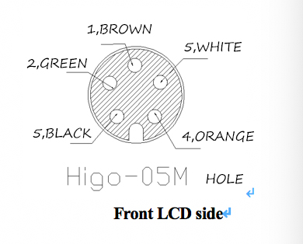
Front LCD side

No. | Color | Function
1 | brown（VCC） | Power source
2 | Green（RX） | Data receiving
3 | Black（GND） | Ground
4 | Orange（K） | Power switch for controller
5 | white（TX） | Data Sending

Introduction for display marks:
All displays:
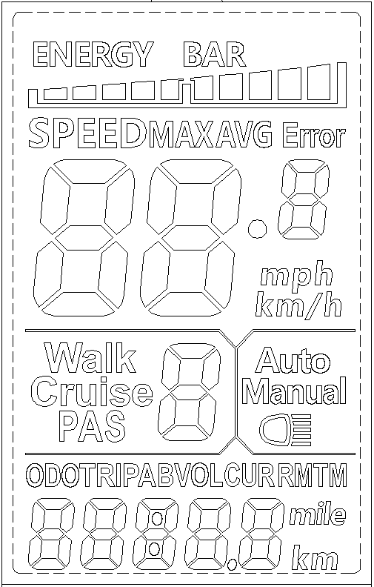

Introduction for display marks:
1. Head light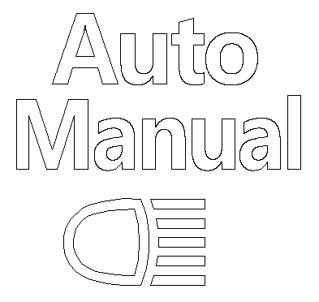
2. Battery Level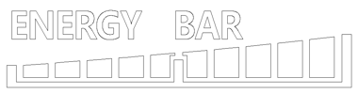
3.Multi-function area
Total Range ODO、Single Range TRIP A、Single Range TRIP B、Voltage VOL、Currency CUR、miles left RM； Running time TM

4. Running Model

Walk: assistant walking ；Cruise：Cruiser model ；PAS：pedal assistant:0~9 levels

5. Speed display area 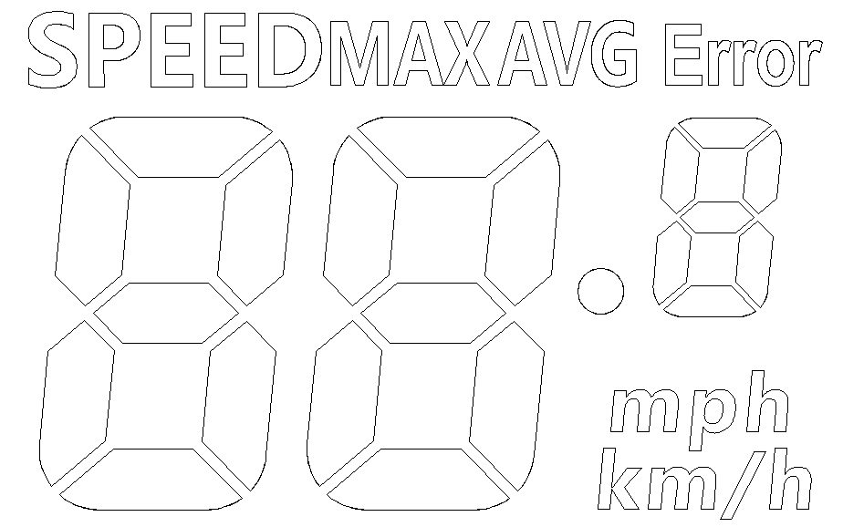
Unit MPH, KM/H
6. Bike Status display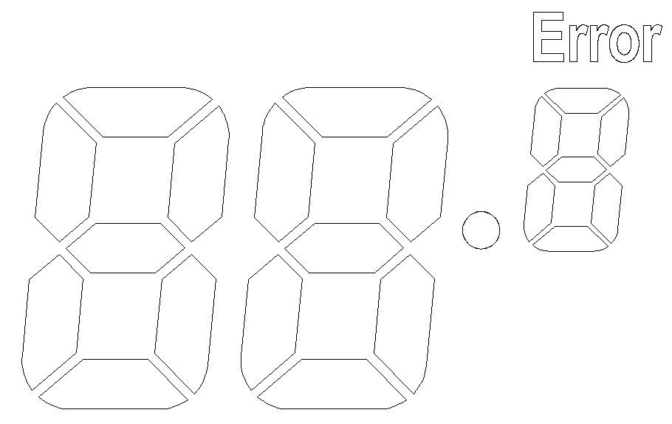
Codes ：
Code | Meaning | Notes
0 | Normal
1 | Stay
2 | Brake
3 | PAS sensor
4 | 6KM/H Cruiser
5 | Cruiser
6 | Low voltage
7 | Motor breakdown
8 | Throttle error
9 | Controller error
10 | Signal receiving error
11 | Signal sending error
12 | BMS communication
13 | Head light error

33 | Currency abnormal
34 | Throttle Error
35 | Motor lost one phase
36 | Motor Magnet error
37 | Brake Error
30 | Communication Error

7. Settings

P01：Background lightness :

1dark，2 normal, 3lightest；

P02：Distant unit，
0：KM；1：MILE；

P03：Battery Voltage：
24V，36V，48V，default 36V；

P04：Sleeping time：
0，unlimited； 1-60 minutes；

P05：PAS Level:
0: 3 levels model :
Level 1: 2V，
Level 2: 3V，
Level 3: 4V；
1,: 5 levels model:
Level 1:2V(12MPH),
Level 2: 2.5V(13.1MPH)，
Level 3: 3V15.7(MPH)，
Level 4: 3.5V(16.3MPH)，
Level 5:4V(19MPH);

P06: Wheel diameter：
Unit: inch；

P07: No of magnet steel for speed measurement： 1-100；

P08：Speed limit：Range 0-50 km/h，50 means no limit

P09：Setting for zero/none zero start: 0：zero start ；1：none zero start；

P10：Powering Model settings:
0 : PAS(throttle disabled, output power is corresponding to PAS levels)。
1 : Throttle(PAS disabled, output power is controlled by throttle turning, top speed it corresponding to PAS level settings)。
2 : PAS & Throttle(In P9, the setting has to be 1)。

P11：PAS sensitivity： Range 1-24；

P12：PAS starting intensity：Range 0-5；

P13：Magnet steel model for PAS: 5，8，12 three models

P14：Currency limit for controller : Range：1-20A , default 12A

P15：Controller low voltage value

P16: ODO reset (Push and hold up button for 5 sec)

P17：0：Cruiser disabled，1：Cruiser abled

P18：Displayed Speed ratio adjust. range：50%~150%，

P19：0 effectiveness 0：yes，1：no

P20： Protocols

Buttons:

The buttons can be used with press or press and hold for 3 seconds for the function to be activated.
1.
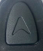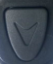
Press to increase/decrease the PAS level to control the top speed
Press and hold both buttons to enter/exit to settings.
2. /Press and hold “M” to turn on and off LCD display and Power
3. + Push and hold to change the display of speed unit

Settings
- Set/Cancel 4MPH Cruiser, headlight, ODO reset
During the stop of the bike, Push and hold ，To enter 4MPH Cruisermodel. Release the button to stop
Press and hold for 2 secs to Switch on/off the headlight.
On P16 status, Press and hold for 5 Sec，ODO reset。

- Turn on/ off LCD screen
Press and Hold “M” to Turn on/off the LCD creen.

- Switch between Multi-functional displays
Click “M” to switch between function displays

- Press and hold + to enter setting:
Use ，or to increase or decrease the value, or push and hold ，or To change the value faster.

Press “M” to switch between settings；
- Press and hold + to exit settings and save value，or you can leave it for 8secs and it will exit and save values.

