LCD-P9Hand Control Panel Operation Instruction
2017Latest Edition-V1.2
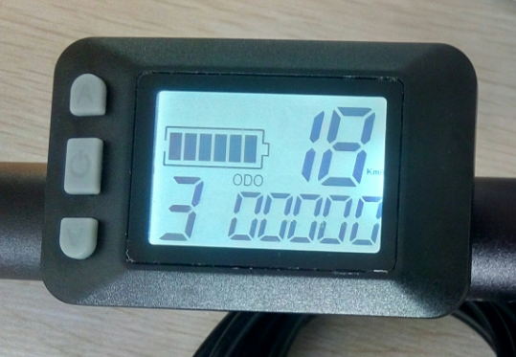
- Out shell Size and Material
Out shell material is ABS, Liquid crystal transparent window material is high hardness acrylic, which hardness is same as toughened glass.
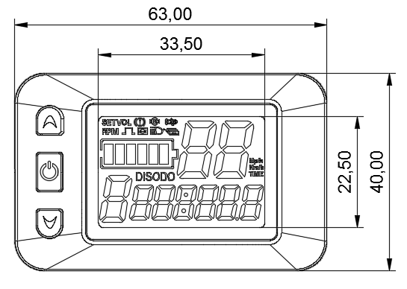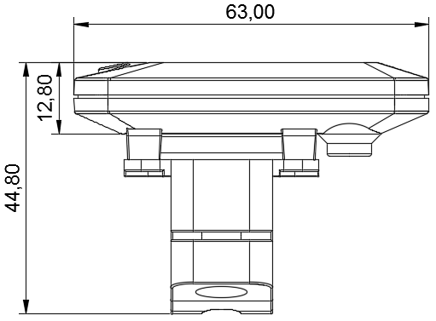
Front view Side view
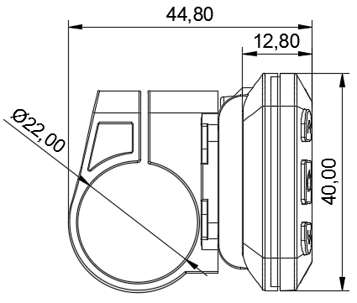
Bracket view
- Specifications and wiring
1、Specifications
※ 24V，36V，48V，60Vpower supply
※ Instrument rated operating current 10mA
※ Maximum working current of the meter 30mA
※ Shutdown leakage current<1uA
※ Supply of operating current at the end of the controller 50mA
※ The maximum working current of the headlamp 200mA
※ Use of temperature ：-18~65℃
※ Storage temperature ：-30~80℃

- connection mode
Line sequence of the label connector
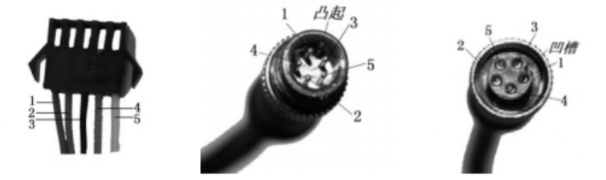

Connected to the controller Meter outlet end To the terminal

Table: Line sequence of the label connector table
Order of line | Color of line | Function
1 | Red(VCC) | Meter wire
2 | Blue(k) | wire of Controller
3 | Black(GND) | Meter earth wire
4 | Green(RX) | Meter data receiving line
5 | Yellow(TX) | Meter data transmission line

Note:The lead wire of some products uses the waterproof connector, and the user cannot see the lead color in the wire harness

- 3．Functional description：
Function：
- 1.Display function
- Speed display, power indication, fault indication, total mileage and single mileage.
- 2. control and setting function
- Power switch control, wheel diameter setting, idle automatic sleep time setting。
- Setting the backlight brightness, setting the start mode, setting the drive mode, setting the voltage level and setting the controller's current limit.
- 3. communication protocol: UART
- The full content of the display (full display in the boot 1S)

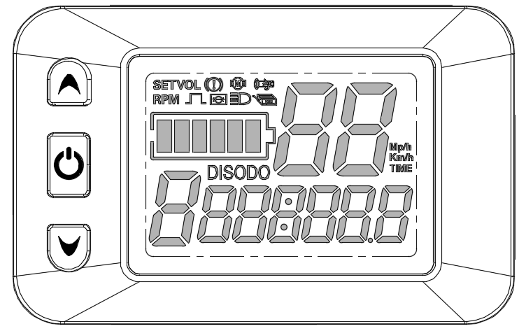
Display content introduction
3.1 Voltage state level POWER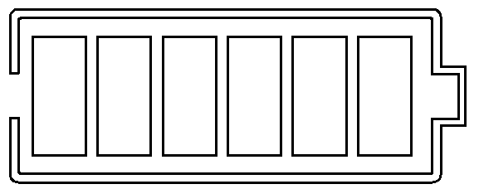
3.2 Multifunction display area 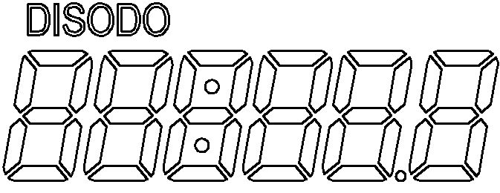
Single mileage DIS and total mileage ODO (unit: mile, KM).
3.3Speed display area 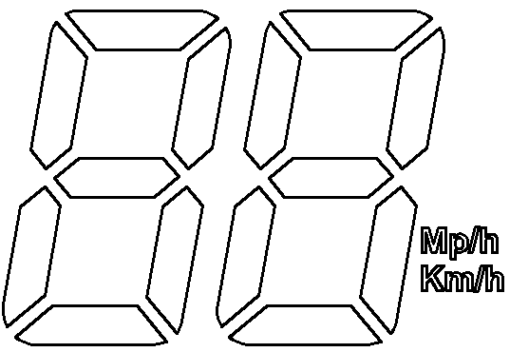
Unit Mp/h, km/h
The speed signal is taken from the Holzer signal in the motor and sent to the instrument by the controller. (a single Holzer cycle time, unit: 1MS) instrument will calculate the real speed according to the wheel diameter and signal data (the number of magnetic steel should be set up by the motor Holzer).
3.4 Vehicle support gear adjustment 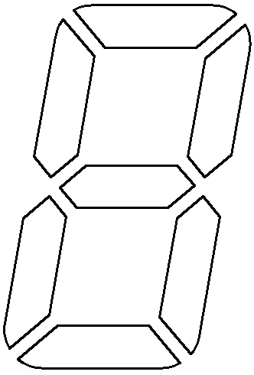,There are 1, 2, 3 adjustable ；
3.5 Vehicle state display area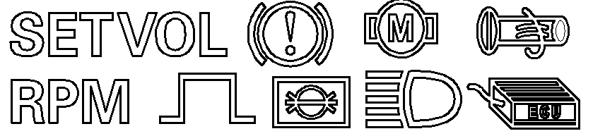
:Setup mode；:Current voltage； :Brake cue ；:Motor failure ;
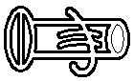:Malfunction ； :Wheel diameter; :The headlamps；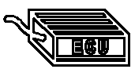:Controller fault 。
3.6The instrument is equipped with three, respectively with the symbol 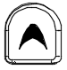key(Alternative text UP )、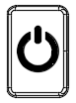key(Alternative text SW )andkey(Alternative text DOWN)express 。
- Setting up menu introduction
P01：The luminance of the backlight, the darkest at the 1 level, and the brightest of the 3 level.

P02: public and British units, 0:KM; 1:MILE;

P03: voltage level: 24V, 36V, 48V, 60V, 64V 36V.

P04: dormancy time: 0, no dormancy; the rest number is dormancy time, range: 1-60; unit minute.

P05: support gear: 0, 3 gear mode:

1, 5 gear mode:

P06: wheel diameter: unit, inch; precision: 0.1;

This parameter is related to the display speed of instrument, and needs to input correctly.
P07: Speed magnetic steel number: range: 1-100;

This parameter is related to the display speed of instrument, and needs to input correctly.

If it is a common hub motor, directly input the number of magnetic steel.

If it is a high-speed motor, it is also necessary to calculate the reduction ratio, the input data = the number of magnetic steel and the reduction ratio.

For example, the number of magnetic steel in motor is 20, and the deceleration ratio is 4.3: the input data is: 86=20 * 4.3.
P08：Maximum riding speed setting: range 0-100km/h, 100 for speed limit.

The input data here represents the maximum running speed of the vehicle, for example, input 25, indicating that the maximum speed of the vehicle does not exceed 25km/h; the drive speed is maintained at the set value,

Error: + 1km/h; (assisting, turning the speed limit)

Note: the value here is based on a kilometer. When the unit is set from a kilometer to a mile, the speed value of the display interface automatically converts to the correct mile value, but the speed limit data set at this menu in the mile interface does not change, which is not consistent with the actual speed limit of the mph.
Note: the P09-P15 menu is valid only in the communication state
P09: zero start, non zero start setup, 0: zero start, 1: non zero start.

P10: drive mode set 0: boost drive, decide the output power through the power shift, and turn it off.

1: electric drive (by turning the drive, then the auxiliary gear is invalid).

2: both power drive and electric drive coexist simultaneously
P11: power sensitivity setting range: 1-24;

P12: the setting range of power booting strength: 0-5;

P13: help the magnet plate type set 5, 8, 12 magnetic steel three types.

P14: the controller's current limit is set to the default 12A range: 1-20A.

P15: the undervoltage value of the controller

P16: ODO zero setting long press top key for 5 seconds ODO clean

P17:0: do not enable cruising, 1: enable cruising; automatic cruise optional (only for protocol 2).

P18: the speed range of the display speed is 50%~150%.

P19:0 gear position, 0: 0 gear, 1: No 0 gear

P20:0: 2 protocol 1: 5S protocol 2: standby 3: standby.

4、Keystroke operation

- Turn on and turn off
Long presskey，turn on；again long press key，turn off。When the vehicle stops running and does not operate on the instrument for 10 minutes continuously, the instrument will automatically turn off and turn off the power source of the electric vehicle.
2、Display interface 1
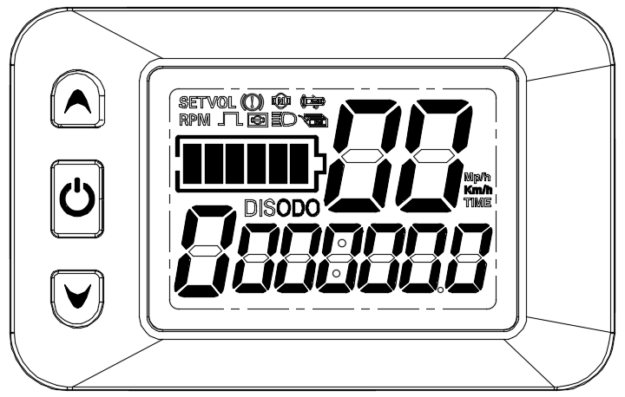
Long presskey，turn on，Enter the display interface one
。

2.1 Turn on and close the lights
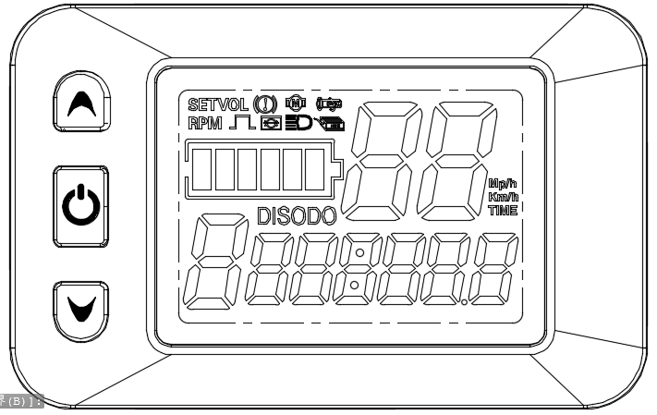
Long presskey，turn on the light；again long presskey，close the light。

2.2 Power shift switch
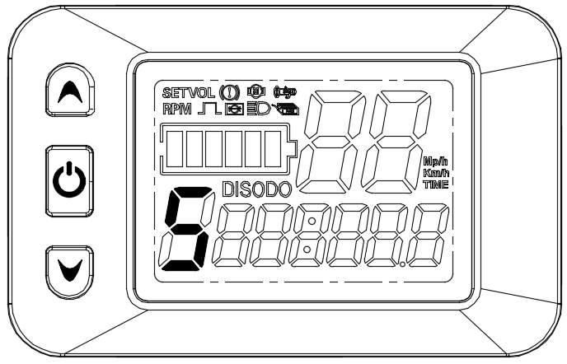
Short pressandkey，Switch 1-5. 1 gear minimum power gear, 5 gear highest power gear. The default 1 files are automatically restored every time they start. The 0 gear has no power function.
2.3 6KM/H Promoting function
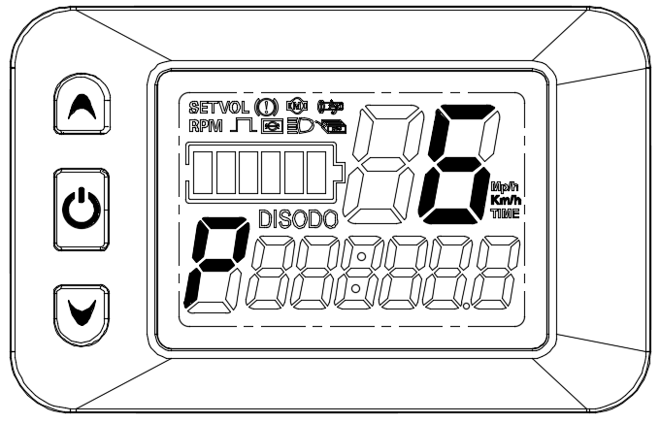
Presskey，The sign in the gear area indicates that the vehicle runs at a speed not greater than 6Km/h. Release keys, function revocation.
2.4 Cruise function
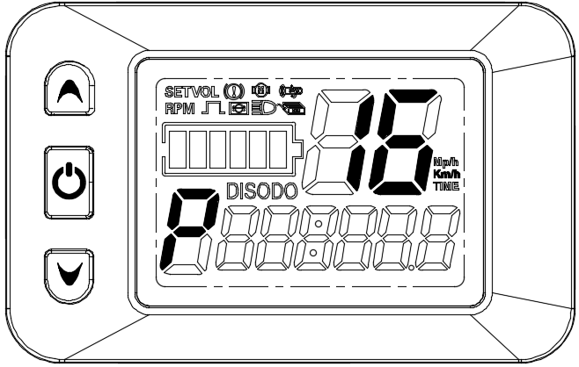
When riding speed is greater than 7 km / h，Pressthe key，Enter the cruise state at the same time 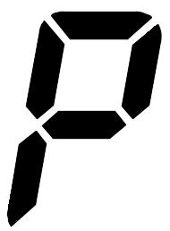Symbol。 Brake or again long press Key revocation 。
3、Display interface II

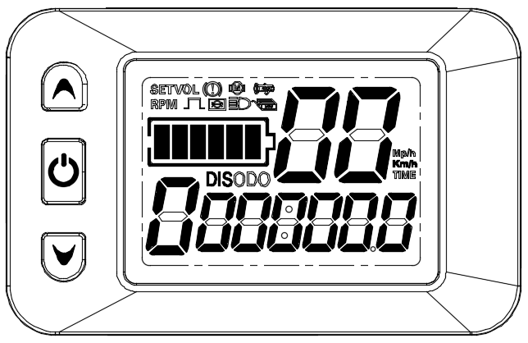
In the display interface I，short presskey，enter the display interface two。

4、Display interface III
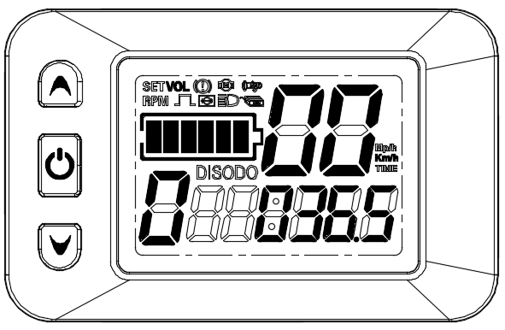
In the display interface II，short presskey，enter the display interface three。

5、Display interface IV
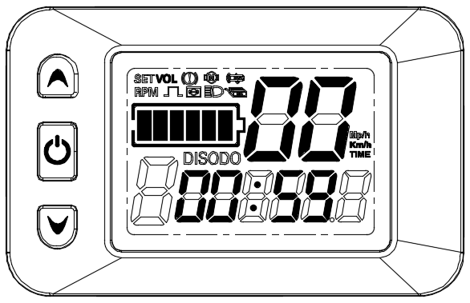
In the display interface III，short presskey，enter the display interface four。

6、Display interface V
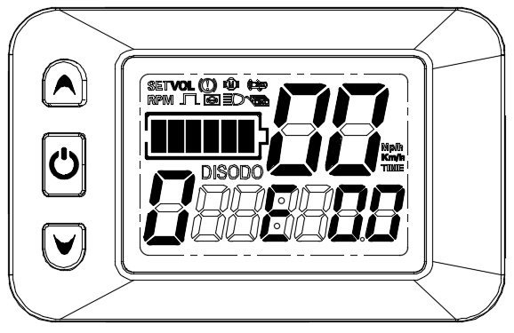
In the display interface IV，short presskey，enter the display interface five。If the electronic control system fails, the instrument will automatically jump to the display interface and display the corresponding fault code.
The meaning of the fault code is shown in the table below：
Status code(decimal) | State meaning | remarks
0 | Normal status
1 | retain
2 | Brake | Not here
3 | Helps sensor failure(riding signs) | Not here
4 | 6KM/H cruise | Not here
5 | Real time cruise. | Not here
6 | Batteries under pressure
7 | Electrical failure
8 | Turn it off.
9 | Controller malfunction.
10 | Communication reception failure
11 | Transmission fault.
12 | BMS communication failure
13 | Headlight malfunction

5、Menu Item Settings

1、背光亮度设置360翻译字数限制为600字符，超过600字符的内容将不会被翻译
1.Backlight brightness settings（P01）
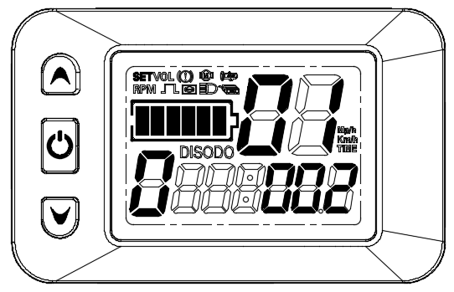
After boot，Press simultaneouslyandkey，enterP01menu，set backlight brightness。Short pressorkey，Adjust backlight brightness After adjustment，short presskey，go to next parameter settings。
2、Common English Unit Settings（P02）
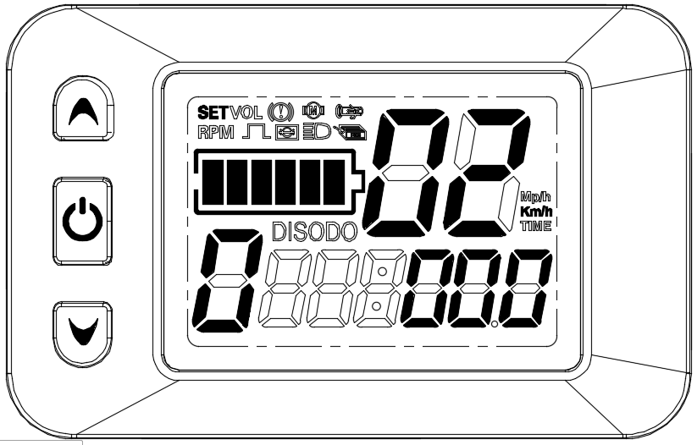
Short pressorkey，Adjusting metric units(synchronizing mileage and speed units)。After adjustment，short presskey，go to next parameter settings。
3、Voltage Level Settings（P03）
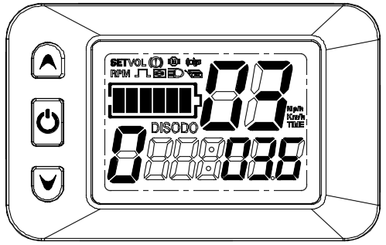
Short pressorkey，Adjusting Voltage Level，24V，36V，48V，60VOptional。After adjustment，short presskey，go to next parameter settings。
4、Dormancy Time Settings（P04）
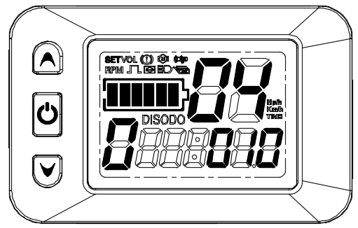
Short pressorkey，Adjust hibernation time，0-60Minute adjustable(0: not dormant)。After adjustment，short presskey，go to next parameter settings。
5、Power File Settings（P05）
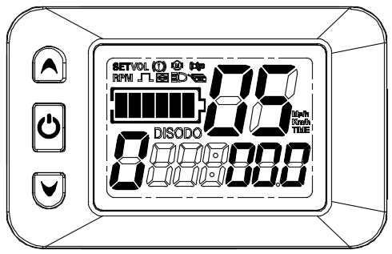
Short pressorkey，Adjust the number of files(0: 3, 1: 5, 3: 9).After adjustment，short presskey，go to next parameter settings。
6、Wheel Path Settings（P06）
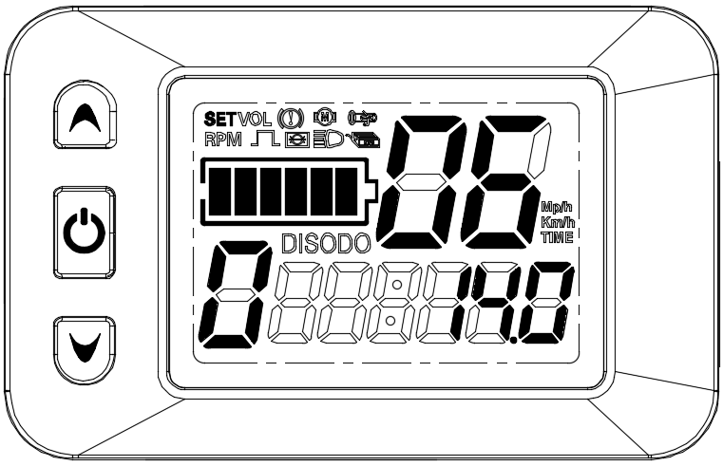
Short pressorkey，Adjusting wheel diameter(in inch, range: 5.0-50 .0)，After adjustment，short presskey，go to next parameter settings。

7、Set the number of measuring magnetic steel（P07）
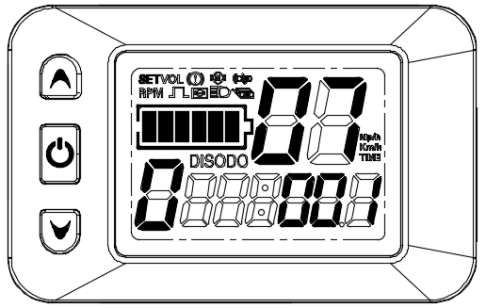
Short pressorkey，Adjusting the values of measuring speed magnetic steel(in sheets, range: 1-255)
。After adjustment，short presskey，go to next parameter settings。
8、Maximum riding speed settings（P08）
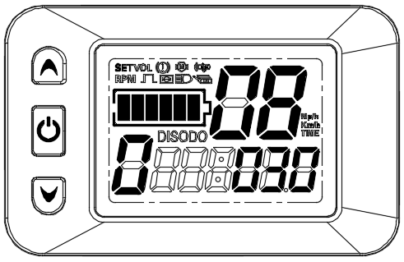
Short pressorkey，Adjusting maximum riding speed(range: 0-100)。After adjustment，short presskey，go to next parameter settings。
9、Zero start, non-zero start settings（P09）
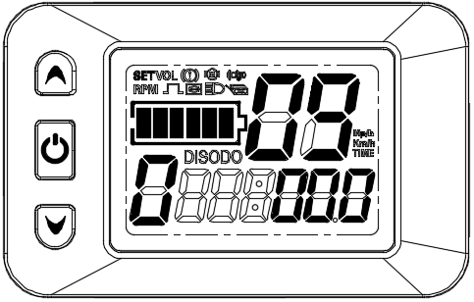
Short pressorkey，Adjusting zero start/non-zero start（0：zero start，1：non-zero start）。After adjustment，short presskey，go to next parameter settings。

10、Drive Mode Settings（P10）
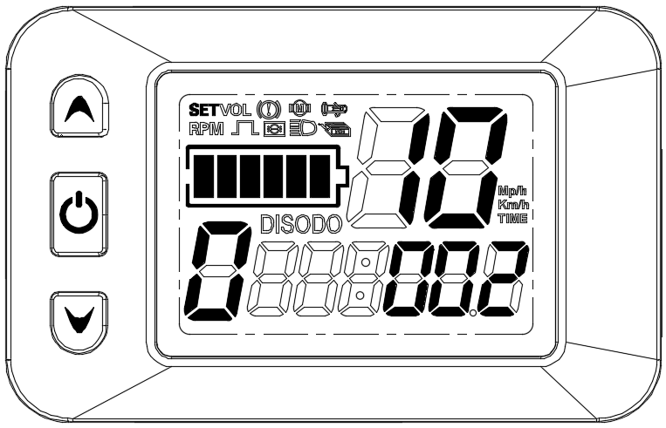
Short pressorkey，Adjusting drive mode （0：Only driving force is effective ，1：Only turn the drive to be effective，2：Both power and transfer drive are effective ）。After adjustment，short presskey，go to next parameter settings。
11、Enabling sensitivity settings（P11）
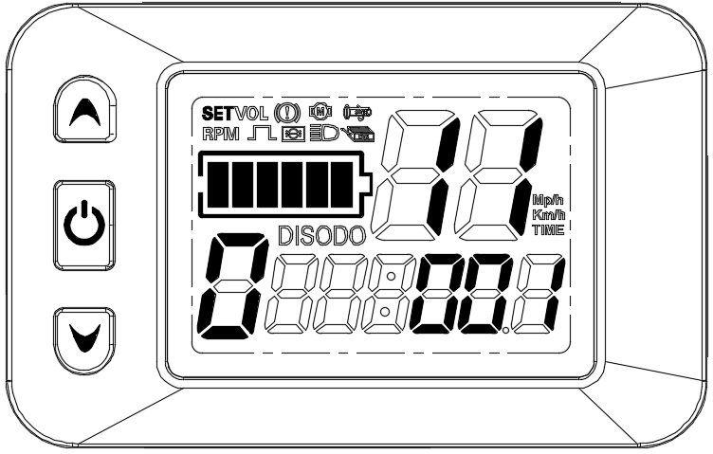
Short pressorkey，Adjusting enabling sensitivity（Range ：1-24）。After adjustment，short presskey，go to next parameter settings。

12、Power Start Strength Settings（P12）
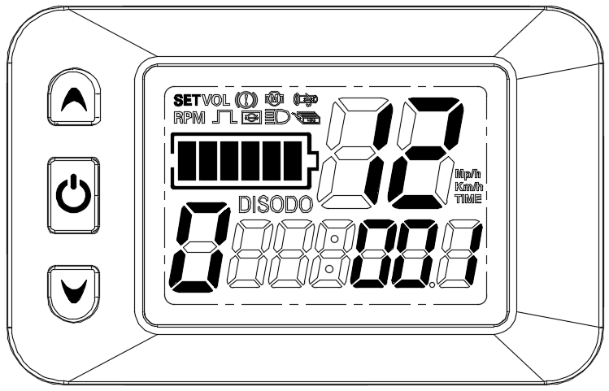
Short pressorkey，Adjusting Power Start strength（Range：1-5）。After adjustment，short presskey，go to next parameter settings。
13、Helped Magnetic Steel Disk Type Settings（P13）
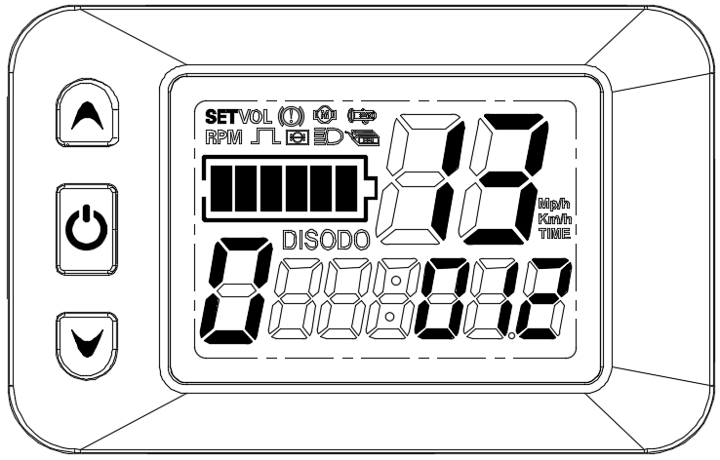
Short pressorkey，Adjusting helped magnetic steel disk type（Range：5,6,7,8,9,10,11,12grain
8 types of magnetic steel plates）。After adjustment，short presskey，go to next parameter settings。
14、Controller limit value settings（P14）
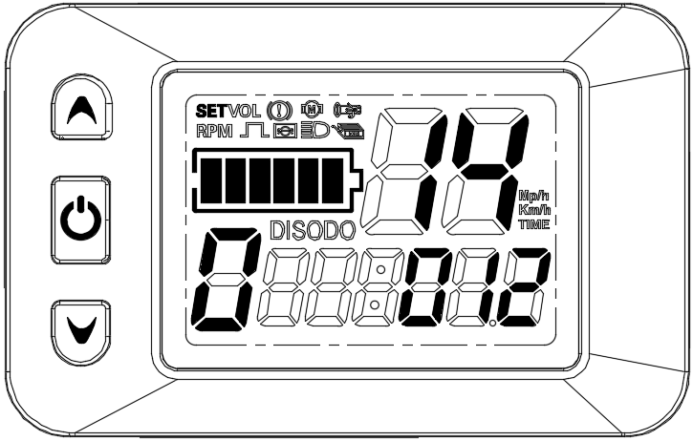
Short pressorkey，Adjusting controller limit value（Range：1-20A）。After adjustment，short presskey，go to next parameter settings。

15、Controller default value settings（P15）
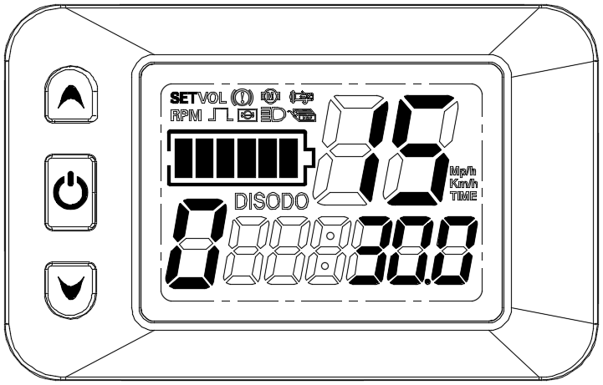
Short pressorkey，Adjusting controller default value（Range：5V adjustable）。After adjustment，short presskey，go to next parameter settings。
P16、ODO zero settings （P16）
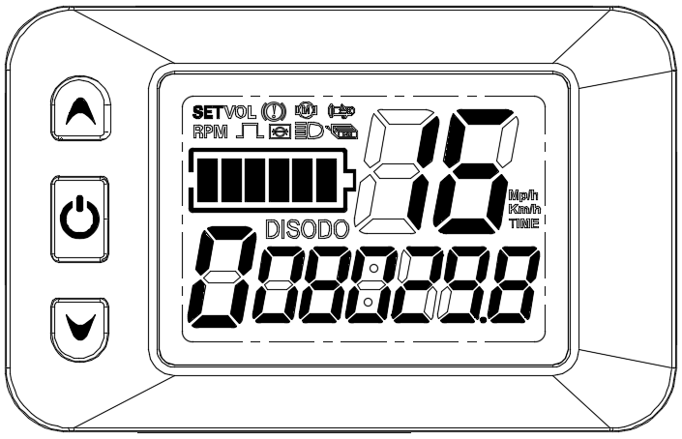
Long presskey 5seconds，ODO complete zero operation，After adjustment, short presskey，go to next parameter settings。
P17、Automatic Cruise Enabling Settings（P17）
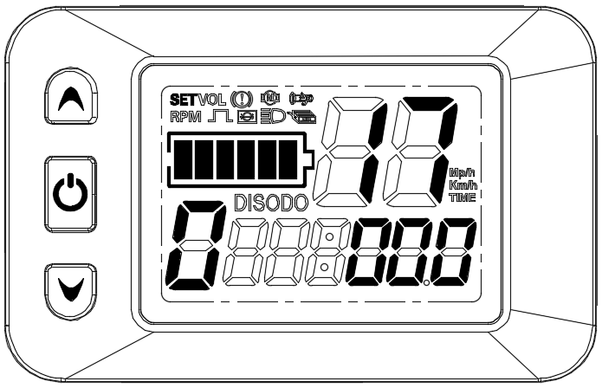
Short pressorkey，Adjust automatic cruise enabled value（0：Can not enable automatic cruise,
1：Enable automatic cruise）。After adjustment，short presskey，go to next parameter settings。
P18、Show speed scale adjustment（P18）
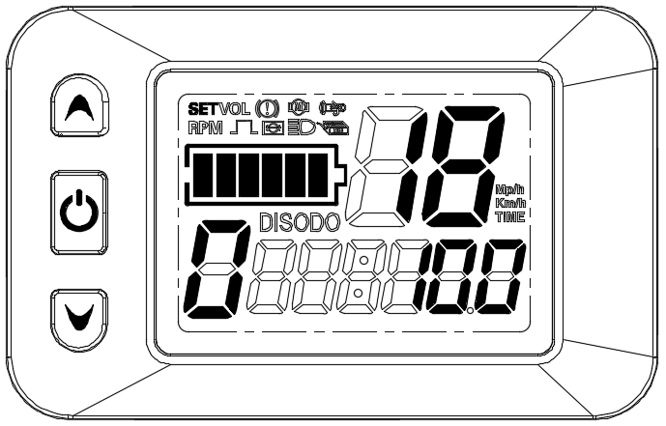
Short pressorkey，Adjusting speed ratio
（Range：50%-150%）。After adjustment，short presskey，go to next parameter settings。

P19、0 File Enabling Settings（P19）
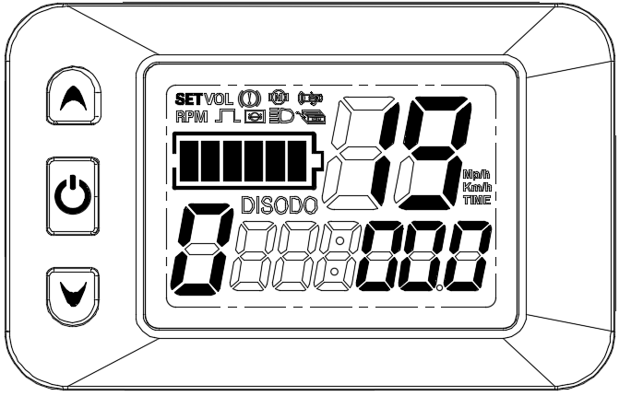
Short pressorkey，adjusting 0 files making energy value（0：contain 0 files，1：Not included 0 files）。After adjustment，short presskey，go to next parameter settings。
P20、Communication Protocol Selection Settings(P20)
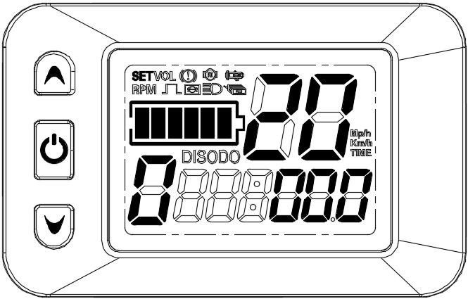
Short pressorkey，Adjust communication protocol options
（0：Agreement No. 2，1：Agreement No. 5，2：Agreement J-LCD，3standby）。After adjustment，Short presskey，Go to P01 parameter setting

P1-P20 menu settings except ODO zero settings(P16),the other menu long pressorkey，Can be adjusted rapidly continuously。

- Exit menu item settings
After the menu is set，Press simultaneouslyandkey，Exit the menu interface, return to bounded one, and set the value to be saved.
At each setting interface, if the button operation is not implemented for more than 8 seconds, the display interface will be returned automatically and this setting value will be saved.
6.Use Note
Be careful to drive safely while in use, avoid the instrument bump. Try not to use in bad environment, such as heavy rain, snow, sun exposure. Try not to use it under pressure to avoid damaging the battery.
When the temperature is below-10 ℃, the screen will darken as the temperature decreases and will return to normal when the temperature rises.

7.Frequently Asked Questions and Answers
1) Q: Why can't you turn it on?
Answer:Check that the instrument bundle is in good contact with the controller's plug-in.
2) Q: How should the instrument display fault code respond?
Answer: To the after-sale agency in time for maintenance.

- Quality assurance and warranty coverage
After the instrument comes out of the factory, the casing is cut and damaged. The lead is cut and broken without repair; The circuit function is lost, the warranty period: 12 months from the instrument factory.

- Version Changes
Upgrades to the company's products may show up in parts of your product that differ from the instructions, but will not affect your normal use.

