Shanghai Hidong Intelligent Technology Co., Ltd.
http：www.hd-ebike.com
1 Jindi Plaza, Jiuting Town, Songjiang District, Shanghai, China
Contact:bruce∣Tel:315 888 2138 ∣E-mail:info@hd-ebike.com
Product picture |  |  |  | Performance |  |  | Main components
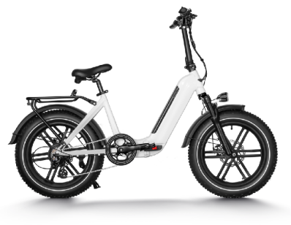 |  |  |  | Max speed | 25MILES/H |  | Frame | 6061 aluminum alloy suspension frame
 |  |  |  | Range | 40-50MILES |  | Tyres | KENDA 20*4.0
 |  |  |  | Max load | 120KG |  | Rim | ALLOY RIM
 |  |  |  | Net weight | 36KG |  | Front fork | Aluminum alloy suspension with mechanical lockout
 |  |  |  | Gross weight | 40KG |  | Front brake | TEKTRO aries disc 180mm
 |  |  |  | Dimension |  |  | Front brake | TEKTRO aries disc 180mm
 |  |  |  | Wheelbase | 27.5"MM |  | Rear Shock | NONE
 |  |  |  | Packing size | 1520*260*850MM |  | Rear derailleur | SHIMANO ACERA
Product Highlight |  |  |  | Container |  |  | Front derailleur | N/A
New lightweight folding |  |  |  |  |  |  | Shifter | SHIMANO
 |  |  |  | Climbing slope | 8°-250Wmotor | 10°-350Wmotor | Gears | SHIMANO 14-28T
 |  |  |  | Recharge cycles | 7-8H 48V25A |  | Hub | REAR HUB
 |  |  |  | Charge time | About 1000times |  | Chainring Crank | N/A
Basic information |  |  |  | Electric system |  |  | Handlebar | PROMAX ALLOY SSABK
Model | HD-006 | Certificatio n |  | Motor: (Optional) | 750W (rear hub) |  | Stem | PROMAX MA-400 SSABK
CN Name | 灵动 | Color: (Optional) | WHITE/BLUE |  | N/A |  | Seat post | N/A
EN Name | agility |  | N/A |  | DC 51 malti function |  |  | KMC Chain
System NO. | N/A |  | N/A | Meter(LCD) |  |  | Chain
Factory | Wuxi， Jiangsu | Recreationa l sports style |  | Battery: (Optional) | PowerPack 48V14Ah |  | Chain wheel | ALLOY SSABK
spoke | 13G-Stainless |  |  |  | SAMSUNG/LG |  | Mudguard | N/A
Price: (Optional) | FOB USD 860 |  |  | Charger | US standard 3.0 A smart charger |  | Saddle | SR
Warranty： | Frame | Lifetime |  | Controller | 48V multi-function integrated controller |  | Pedal | ALLOY PREDAL
 | Battery | 2 years |  | PAS | sensor |  | Headsets/B.B | N/A
 | Controlle r | 2 years |  | Throttle | Adjustable uniform throttle |  | Lighting | LED Headlight
 | Parts | 1 year |  | Carrier | NONE |  | Reflector | NEW LAN PMMA material
 |  |  |  |  |  |  | Rear light | SELLE ROYAL REAR SADDLE LIGHT

