Investment Summary

Property Address: 123 Investor Ln. City, State Zip

Picture of Property
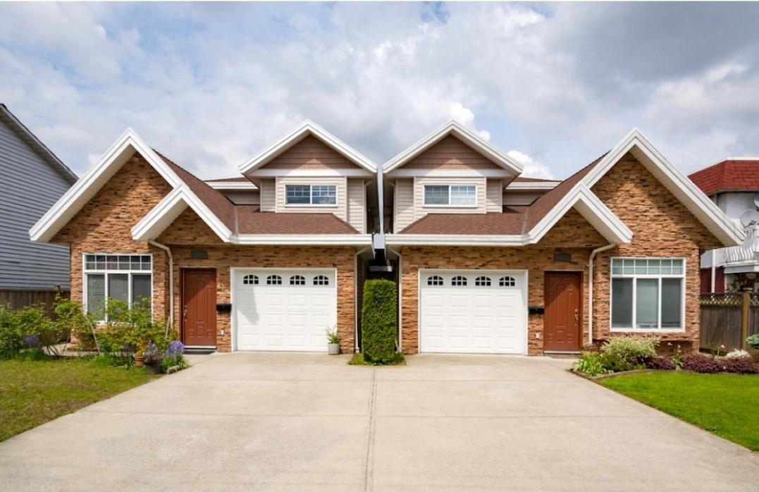
Link to Property: Zillow or Similar Link Here
Photos: Google Drive link if you have photos

Investment Overview
Purchase Price
Repair Budget
Expected ARV After Repairs
Current Rents
Expected Rents
Stabilized DSCR

Property Details
- Type of Property (Upper Lower Duplex)
- Bed/Baths (2/1 upper and 2/1 lower)
- Utility Situation (All utilities split; owner pays water)
- _____ sq ft
- Other Key Items if applicable – (flood zone, well, septic, etc)

Project Overview

[ Purpose of the Project Overview - Your goal is to show you are knowledgeable about the project, understand timelines, and complications that could happen. You are showing you have done due diligence and give your financing source confidence in you and the project.

Provide an overview of:
- The property
- The location
- Finances
- Repairs
- Use Plans / Exit Strategies ]

Example:
This upper/lower duplex is on a quiet street in ______, but a short drive downtown and many other amenities. This is a rental in a family neighborhood which makes it appealing. The property had been coasting along, under rented, and in need of cosmetic repairs. It is a 2/1 in each unit, with a simple layout and good parking. The challenge to this project will be getting rents to market, but we plan on giving the tenants plenty of notice and establishing rapport with them upon closing.

Market rent for the lower is 895 and the upper is 795. Currently, the property is being rented at 600 for each unit. We plan on vacating both units with a 60 day notice, in order to complete some cosmetic repairs and go for these target rents, while improving the asset. At market rents, this unit will cash flow $332/month after all expenses.

As far as the condition goes, both units only require cosmetic work, and you can find an overview of our rehab scope below. Interior repairs will be completed by March 2022. Exterior (as weather permits) by end of April 2022. The goal is to have both units re-rented at market rate by June 1, 2022.

We intend to rent these units long term and hold them, progressively continuing to increase value over time.

Rehab
(Include a scope of work in some form. You can use what your contractor gives you, use the contractor sheet from DuplexUniversity.com, or whip up something like this quick as a summary. You can attach it all here, or just include it as a separate doc to obtain financing)

Paint- Both Units | $4,000
Flooring LVP - Both Units | $7,000
Light Fixtures, Outlets, and Switches | $1,100
Paint Kitchen Cabinets and new pulls | $1,700
Doorknobs and Misc | $500
Landscaping Backyard, by porch, and tree cleanup | $1,000
Unexpected Repairs | $1,500
Total Rehab | $16,800

Property Financial Analysis

(Copy and Paste your Analysis in here or include it in your email to obtain financing, if you want a free calculator, head to DuplexUniversity.com)

Property Analysis
Property | Name |  |  | Sample Estates
Property | Address 1 |  |  | 123 Main Street
Property | Address 2 |  |  | Green Bay, WI 54304
Property | Purchase Price |  |  |  | $ 100,000.00
Units | Beds | Baths |  | Current Rent/Mo | Market Rent/Mo
1 |  |  |  | $ 600.00 | $ 895.00
2 |  |  |  | $ 600.00 | $ 795.00
3 |  |  |  | $ - | $ -
4 |  |  |  | $ - | $ -
Total Rent |  |  |  | $ 1,200.00 | $ 1,690.00
 |  |  |  | As-Is Analysis | Stabilized Analysis
Item |  |  |  | $/Mo | $/Mo
Total Rent |  |  |  | $ 1,200.00 | $ 1,690.00
Property Management |  |  |  | $ 96.00 | $ 135.20
Property Taxes |  |  |  | $ 166.67 | $ 166.67
Insurance |  |  |  | $ 75.00 | $ 75.00
Owner Utilities/Misc |  |  |  | $ 75.00 | $ 75.00
Vacancy |  |  |  | $ 60.00 | $ 84.50
Maintenance and Cap X |  |  |  | $ 168.00 | $ 236.60
Total Op Expenses |  |  |  | $ 640.67 | $ 772.97
Monthly NOI |  |  |  | $ 559.33 | $ 917.03
DSCR |  |  |  | $ 0.96 | $ 1.57
Monthly Cashflow |  |  |  | $ (25.37) | $ 332.33
Cash On Cash % |  |  |  | -2.03% | 9.97%

Owner Expenses
Property Taxes |  | $ 2,000.00 |  | per year
Electric |  | $ - |  | per month
Gas |  | $ - |  | per month
Water |  | $ 75.00 |  | per month
Misc Expense |  | $ - |  | per month
Lawn/Snow/HOA |  | $ - |  | per month
Insurance |  | $ 75.00 |  | per month
Management |  | 8.00%
Vacancy |  | 5.00%
Maintenance + Cap X |  | 14.00%
Repair Budget To Stabilize |  | $ 25,000.00
Loan
Loan Term |  | 20 |  | years
Down Payment |  | 15.00%
Interest Rate |  | 5.50%
Purchase Price |  | $ 100,000.00
Loan to Value |  | 85.00%
Down Payment |  | $ 15,000.00
Loan Total |  | $ 85,000.00
Mortgage |  | $584.70 |  | per month

