**Will McNeal Racing**

109 E. Church Street

Muir, Pennsylvania 17957

717-215-3391 [willmcnealracing@gmail.com](mailto:willmcnealracing@gmail.com)

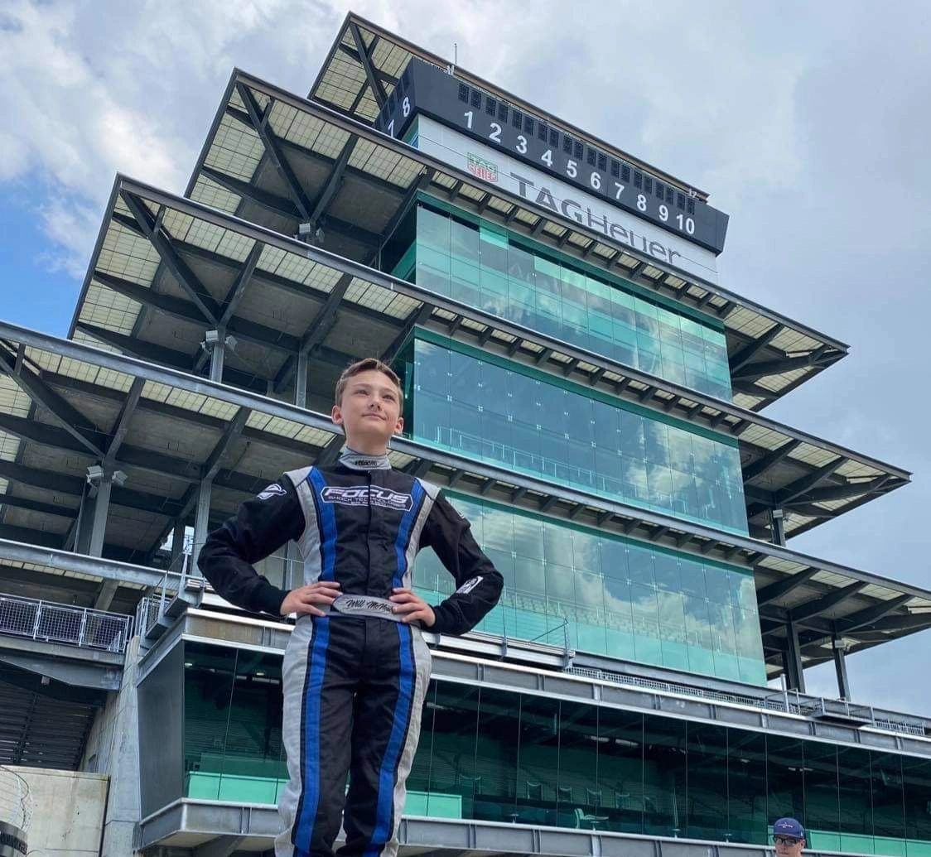

2022 SPONSORSHIP PROPOSAL

Thank you for taking the time to review our proposal and for considering our race team for sponsorship. I know you have many options in many markets when it comes to advertising your business. I am also aware that it is important for you to get the most from your advertising dollar and to get a good return on your marketing investments. Our race team has marketing options that will suit both your budget and marketing demographics. With our race team you will be exposed to thousands of fans, casual observers and potential customers throughout Maryland, Pennsylvania, Delaware, New Jersey, Virginia, and the mid-west! As a sponsor you have the option to put your logo on the racecar, Facebook page, website, flyers, t-shirts, hats, hero cards and Will’s race suit. Your business may also use our racecar and driver for your advertisements, promotions and special events or appearances as our schedule allows. I have included in this package information about our driver and race team accomplishments and sponsorship options. I strongly feel that this relationship can be very beneficial for both your business and our race team. If you have any questions or insights regarding sponsorship or this proposal, feel free to contact our race team via telephone at 717-215-3391 or email at tabathamcneal@gmail.com or [willmcnealracing@gmail.com](mailto:willmcnealracing@gmail.com).

Regards,

Tabatha McNeal – Team Manager

DRIVER/RACE TEAM PROFILE

When thirteen-year-old Will McNeal approached his father/team owner Billy McNeal before the 2015 racing season and told him that he wanted to compete it came as no surprise. Billy was a successful racecar driver, Selinsgrove Speedway Road Runner driving championship in 2002 and raced 358 Sprint Cars from 2002 to 2011, so Will has spent most of his life around the sport. What did come as a surprise was the amount of success the young driver earned during his career! At the wheel of the family’s number 2W cars, Will astonished all enthusiasts and racing veterans by winning many feature races including the prestigious “Winner's Classic” and finishing third in the overall championship standings during his first ever season! During that first season Will raced at the Norlebco Quarter Midget Club at Linda's Speedway near Jonestown, Pennsylvania and Susquehanna Outback Track near York Haven, Pennsylvania. Will's racing star shined even brighter in 2016 as he earned eight feature race wins including a second victory in the “Winner's Classic,” finished third in the championship point race at the Linda's Speedway and second in the point race at the Susquehanna Speedway! Will took a giant career step in 2017 as he entered USAC (United States Auto Club) competition at Hagerstown Quarter Midget Racing Association in Maryland. He also competed in the prestigious “Fast Five” series at Hagerstown, Phoenixville Quarter Midget Racing Club, West End and South Jersey Quarter Midget Association. He also traveled to Eldora Speedway in Rossburg, Ohio for a national event. His rookie USAC season earned him two main event wins and a fifth in overall points! All this success in just three seasons and before his 9th birthday! In 2018, Will moved to the senior Honda division, senior animal division and light 160 division. He raced hard all season and gained several wins in all three cars. In 2019, Will became competitive and was able to secure multiple wins thorough out the season and finished 5th in National Points. The 2020 and 2021 race season were hindered by the pandemic and many large even races were cancelled. The 2022 race season will hold a lot of firsts! Will will be competing in the outlaw kart class at various raceways while continuing to attend as many sprint car races as possible.

SPONSOR BENEFITS

Many businesses are not aware of the opportunity of advertising with the ever-growing sport of auto racing. With a growing popularity in all forms of motorsports sponsors have an opportunity to reach a larger target audience of potential customers. Today’s grassroots racing that leads the way for NASCAR is becoming ever more popular every season. Many forms of grassroots racing have launched the careers of some of today’s brightest racing stars in series such as NASCAR and Indy Car Racing. A.J. Foyt, Jeff Gordon and Joey Lagano are among the many nationally recognized drivers who started their careers in open cockpit racing! Will McNeal Racing offers you the opportunity to sponsor one of the area’s bright young racing stars for a fraction of the cost of a regional or national NASCAR team. With thousands of miles traveled a year to races and appearances our racecars and hauler easily have the potential to reach thousands of your potential customers each weekend! AT THE TRACK With your logo on the racecars it has the potential to be seen by over 50,000 spectators from many different states who are potential customers. By becoming the team’s title sponsor the racecars and enclosed hauler can fly your company colors and display large company logos attracting prospective customers.

After each race spectators are welcomed into the pit area to get an up-close look at the cars and meet the drivers and team members. Our race team can help promote your product and/or service by handing out samples or literature during the races and after the events in pit area meet and greets. The team is also able to set up a display booth in our pit area to help promote and sell your product. Our race team also promotes all sponsors through pre and post-race interviews, hero cards, media releases and social media marketing.

SPONSORSHIP PACKAGES

Your sponsorship / donation helps us offset the costs of safety equipment, parts, entry fees, maintenance expenses, and all the associated costs of conducting our race season. We supply all simple vinyl cut decals for the car, banner and trailer. All location of logo on car is based on first come first service basis. If a package sponsorship does not work for you at this time but you still would like to help, we are grateful for any level of contribution to our general fund. We also consider product sponsorship.

Triple Gold Crown levels (we have 3 options at Triple Gold Crown Level)  
**Level 3** $5000 ($1000 saving) This is a 4 Year sponsorship deal  
Everything in the winner’s circle but at a discounted price.  
**Level 2** $3900 ($600 saving) This is a 3 Year sponsorship deal  
Everything in the winner’s circle but at a discounted price.  
**Level 1** $2600 ($400 savings) This is a 2 Year sponsorship deal  
Everything in the winner’s circle but at a discounted price.

Winner’s Circle… $1500   
Company logo displayed on the racecar, team banner, t-shirts, and race suit, company logo displayed on the trailer, website link on social media/website, 10 Team t–shirts, plaque with picture of car and driver

Signature Sponsor…. $850  
Business name and link to your website on our team website, company logo on Will’s race suit, thank you Plaque and Will McNeal Racing sponsor decal, company logo on car and banner (prominently displayed on a high profile area), company logo on our t-shirts (4 Team T-shirts for your company).  
To be placed on race suit your sponsor check must be received NO LATER than 2/15/2019.

Gold Sponsor…. $500  
Business name and link to your website on our team website, Will McNeal Racing Sponsor decal, thank you plaque, company logo on car and banner (Secondary real-estate), company logo on our t-shirts, 2 Team T-shirts.

Silver Sponsor… $300  
Business name and link to your website on our team website, Will McNeal Racing Sponsor decal, picture of driver and car, and company logo on car and banner (Limited real-estate)  
  
Bronze Sponsor …$125  
Business name and link to your website on our team website and banner and picture of driver and car.

