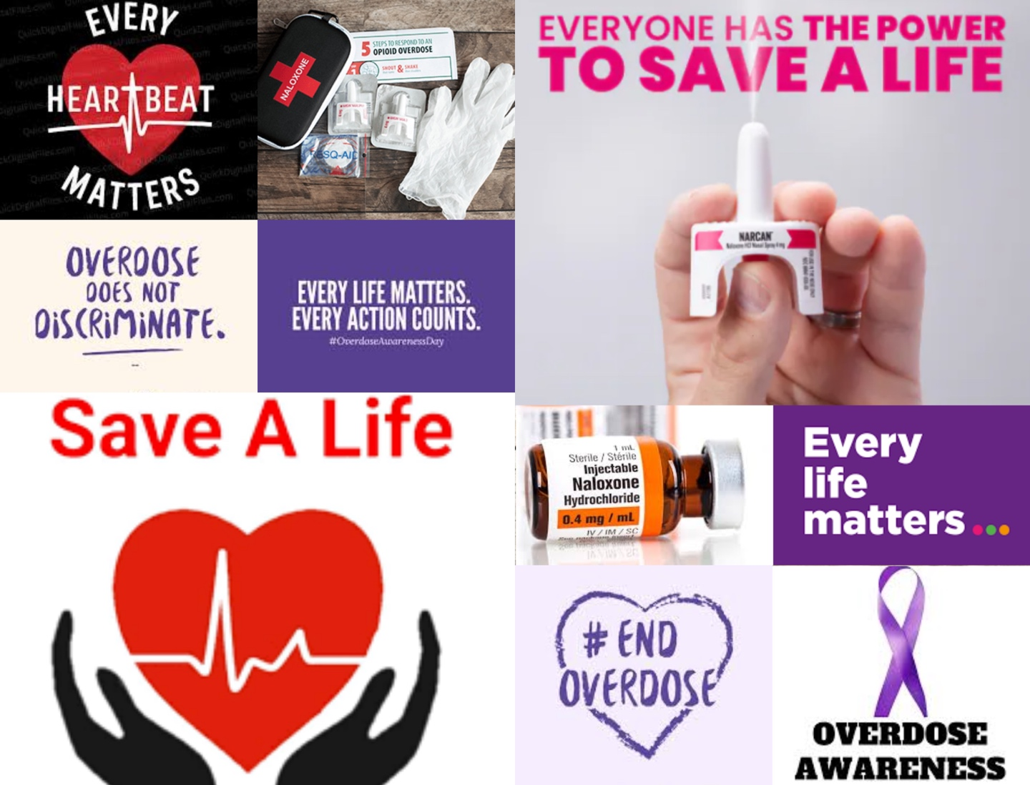
From Learner to Leader:
Naloxone Trainers Guide

Table of contents
Introduction |  | 3
Becoming an Effective Trainer |  | 4
Step-by-Step Guide to Running a Naloxone Training Session |  | 6
Check List |  | 7
 | What you need | 7
 | Where to get supplies | 9
 | Certificate Template | 11
 | Poster Template | 12
 | EventBrite | 13
Event Location Suggestions |  | 14
Estimated Cost |  | 14
Frequently Asked Questions |  | 16
How to Become a Distribution Centre |  | 18
Contact/Resource Sheet |  | 20

Introduction
Congratulations! By becoming a Naloxone trainer, you’re playing a vital role in preventing opioid overdoses in your community. This guide will help you:
- Confidently teach others how to recognize and respond to opioid overdoses
- Demonstrate proper Naloxone use
- Empower communities for life-saving action
Roles & Responsibilities
- Educator: Explain what Naloxone is, how it works, and when to use it
- Demonstrator: Show correct administration techniques
- Mentor: Support participants as they practice skills and answer questions
- Advocate: Promote awareness of opioid overdose prevention in the community
Key Trainer Skills
- Knowledgeable about opioids and overdose signs
- Comfortable demonstrating Naloxone administration
- Patient, approachable, and supportive
- Able to handle sensitive topics respectfully
** Charging a fee for the kit itself or its core materials is prohibited, as the resources were provided with the expectation that they would remain publicly accessible without monetary barrier. Any attempt to charge for these publicly funded materials may be in violation of the terms set forth by the funding authorities, and could result in legal consequences**
Becoming an Effective Trainer
Be Prepared
- Know your material inside and out: Review Naloxone use and overdose signs
- Practice demonstrations: Rehearse both nasal and injectable administration techniques so you can show them confidently
- Have backup resources: Bring extra training kits, and handouts in case of unexpected issues
Engage with your Audience
- Use interactive methods: Encourage participants to ask questions, share experiences, or role-play scenarios
- Break content into chunks: Teach in clear, manageable sections to avoid overwhelming participants
- Include real-life examples: Stories or scenarios make the training relatable and memorable
Communicate Clearly
- Use simple, concise language: Avoid technical or specialized language that might be hard for people to understand unless it’s well explained
- Repeat key points: Reinforce essential safety steps and administration techniques
- Check for understanding: Ask participants to demonstrate or explain back what they learned
Encourage Hands on Practice
- Prioritize skill building: Let participants practice with trainer kits multiple times
- Provide constructive feedback: Correct gently and reinforce what they are doing well
- Stimulate real scenarios: Encourage participants to respond to a “mock overdose” to build confidence
Foster a Supportive Learning Environment
- Be approachable: Make it easy for participants to ask questions
- Respect different learning styles: Some learn by watching, some by doing, some by listening
- Acknowledge nervousness: Reassure participants that mistakes during practice are part of learning
Stay Calm and Confident
- Model composure: Demonstrate confidence even in tricky situations; it reassures participants
- Handle unexpected questions gracefully: Admit if you don’t know the answer, then follow up later with accurate information
Encourage Follow-Up and Continuous Learning
- Share resources: Slides, videos, and handouts help participants review later
- Offer support: Be available for questions after the session
Reflect and Improve
- Seek feedback: Use evaluation forms and informal observations to see what works
- Adapt your approach: Modify exercises or explanations based on participants needs
- Celebrate successes: Recognize your participants progress and your own growth as a trainer

Step-by-Step Guide to Running a Naloxone Training Session
Checklist
- Naloxone trainer kits (to hand out to each participant at the end)
- Naloxone practice kits
- Demo kit (usually expired ones)
- Squeeze balls (best ones at Doller Tree)
- Printed certificates of completion
- Printed PowerPoint slides with space for participants to take notes
- Snacks and refreshments
- Evaluation forms
- Pens/pencils for participants
- Laptop with slide show presentation
- Breakers (1 per person)
- Saline vials
- Syringes
- Pamphlets
- Sharps container
- Testing strips
- Bring 20% extra supplies as a just in case

What you need
- Naloxone trainer kits (to hand out to each participant at the end)
- Naloxone practice kits (1 breaker, 1 syringe, 1 saline vial)
- Demo kit-usually expired ones
- Squeeze balls (best ones at Doller Tree)
- Printed certificates of completion
- Printed PowerPoint slides with space for participants to take notes
- Snacks and refreshments
- Evaluation forms
- Pens/pencils for participants
- Laptop with slide show presentation
- 20% extra supplies as a just in case
- Pamphlets & resources
- Sharps container
- Testing strips & pamphlet

Where to get Supplies
- Naloxone practice kits (for hands on learning)
  - Order through the health authority (Email: mail to: Payton.Klitch@saskhealthauthority.ca)
  - Let them know how many people you will be training and how many of each supply you would like (syringes, vials, breakers)
- Kits to hand out
  - Order through the health authority (Email: mail to: Payton.Klitch@saskhealthauthority.ca)
  - Request the number of people you will be training, plus about 20% as people can take more than one kit
  - You can also take expired kits and drop them off at the same location or at any pharmacy.
- Demo kit-usually expired ones
  - Create your own with saline vials or keep an old kit you have been given
- Squeeze balls
  - Best ones @ Doller Tree but any stress ball will do
- Pamphlets
  - You can order free pamphlets to any address from CATIE: https://orders.catie.ca/
- Sharps container
  - Can be picked up from public health offices, can also buy them from any pharmacy (Costco has them for free)
- Testing strips
  - Not required however, they are nice to have. These are available through the public health office. You can just go there and provide your name and health number to get these supplies for free. You can tell them you are a naloxone trainer and they will provide you with them.

Certificate Template
https://www.canva.com/design/DAGxGOwQOg0/tuyK2tfEAmKWUJP3vhcccQ/edit?utm_content=DAGxGOwQOg0&utm_campaign=designshare&utm_medium=link2&utm_source=sharebutton

Poster Template
https://www.canva.com/design/DAGxMV_9qU8/SNvvRY1of_mmTE8KOyCwcw/edit?utm_content=DAGxMV_9qU8&utm_campaign=designshare&utm_medium=link2&utm_source=sharebutton

EventBrite
Eventbrite is a great tool for creating a centralized registration page where individuals can sign up in advance, allowing organizers to track attendance and estimate participants numbers ahead of the event.
- Quick guide to creating an event on Eventbrite:
  - Sign in or create an account
    - https://www.eventbrite.ca
  - Enter event details
  - Set date, time and location
    - Choose in person, online, or hybrid
    - Add address or meeting link for online course
  - Ticketing & registration
    - Choose the type of ticket
      - Free (no charge)
      - Paid (set a price)
      - Donation
    - Add quantity limits if needed
  - Event description & media
    - Write a clear description with who, what, when, where, and why
    - Upload images or posters
  - Publish & share
    - Click “publish” when ready
    - Share the link via email, social media, or posters with QR codes
Event Location Suggestions
- Saskatoon Public Library
- Saskatoon Public Schools Facilities
  - Gyms
  - Classrooms
- Meeting rooms around the city
Estimate of Event Cost
- The average public library space to host events in the city of Saskatoon is available to rent for $30/hour. Each event is estimated to take 3 hours (including set-up and take-down time). $90/event
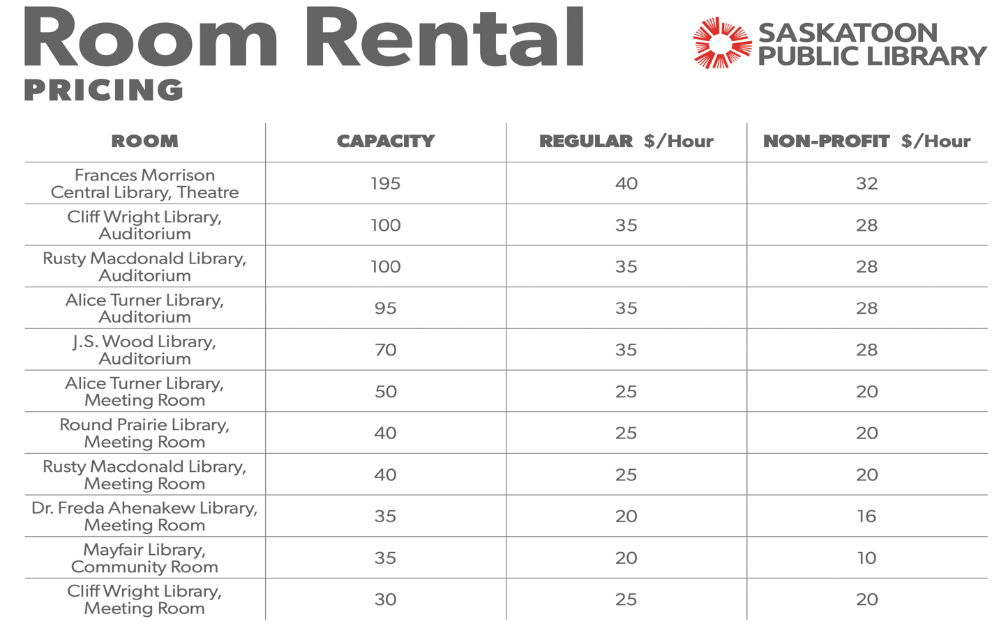
*The below is based on an event size of 25 people*
- Food: optional
  - Approx. $50 per session
    - Sweet snack
    - Salty snack
    - Beverages (water/pop)
- Materials:
  - Approx. $60 - Squeeze balls

Frequently Asked Questions
- Q: Is naloxone safe?
  - A: Yes. It only works if opioids are in the body. If given to someone not experiencing an opioid overdose, it will not cause harm.
- Q: Can naloxone be addictive?
  - A: No. Naloxone is not addictive and has no potential for misuse. It only enables breathing.
- Q: How long does naloxone take to work?
  - A: It usually works within 2–5 minutes after administration.
- Q: How long does it last?
  - A: Naloxone lasts about 30–90 minutes, but opioids can last longer in the body. Always call 911, as more doses may be needed.
- Q: What if one does doesn’t work?
  - A: Give a second dose after 2–3 minutes if there is no improvement, while continuing rescue breathing or chest compressions if trained.
- Q: Can naloxone fail to work?
  - A: Yes, if the overdose involves very strong opioids (like fentanyl or carfentanil) or a mix of drugs. That’s why calling 911 is critical.
- Q: Can I get in trouble for giving naloxone?
  - A: No. Good Samaritan laws in Canada protect people from simple drug possession charges when calling for help during an overdose.
- Q: Are there side effects?
  - A: The main side effect is withdrawal symptoms (nausea, sweating, irritability) in the person revived. These are uncomfortable but not life-threatening.
- Q: is it safe for children or pregnant people?
  - A: Yes. Naloxone is safe for all ages and in pregnancy.

How to Become a Distribution Centre

W: https://redcap.rqhealth.ca/apps/surveys/index.php?s=HNA339NPN8

Step 1: Initial Contact & Assessment
- Fill out the RedCap form above.
- Also contact the Saskatchewan Health Authority – Take Home Naloxone Program / Mental Health & Addictions branch (THN@health.gov.sk.ca)
- Express interest: you want to set up a site that distributes naloxone kits, provides training (or referrals to training), and possibly does “train the trainer”.
Ask them:
- What current criteria are used for adding new sites.
- If there is a formal site registration form or agreement.
- What training for staff is required (e.g. certification, e-learning, in‐person).
- How boxes / kits are supplied / restocked; how to order; cost (if any).
- Reporting requirements: how many kits distributed, cases of use, tracking etc.

Step 2: Ensure Internal Capacity
Your organization should have:
- A staff member (site coordinator) responsible for managing the program at your location.
- One or more staff/trainer(s) who can deliver the overdose recognition + naloxone education. They must receive required training.
- A secure location for storing the kits.
- Inventory tracking system.

Step 3: Training
- Staff need training on overdose prevention, recognition, response, and proper use of naloxone.
- Possibly also about stigma, safe communication, etc.
- If you will do “train the trainer”, your trainers may need extra training / more in‐depth certification.

Step 4: Formal Agreement / Registration
- Fill out the site registration form (if SHA has one) or equivalent (they may ask for the details of your site, hours, storage, staff, etc).
- Sign any agreements required by SHA about following protocols, data reporting, liability, supply ordering.

Step 5: Set Up Supply & Inventory
- Arrange to receive naloxone kits through SHA.
- Establish process for refilling / replacing kits used.
- Ensure you have the required storage conditions, expiration tracking, disposal plan.

Step 6: Promote & Monitor
- Promote your services (publicizing that people can receive free kits + training at your location).
- Track and report distributions, training numbers, overdose reversals (if known).
- Follow up with SHA as needed with reports or requests.

Contact/ Resource Sheet

Saskatoon / Saskatchewan Contact & Resource Sheet

1. Naloxone Trainers
Name | Role | Contact
Barb Fornssler | Trainer | E: barb.fornssler@usask.ca
Maryellen Gibson | Trainer | E: maryellen.gibson@usask.ca
Kayla Irvine | Trainer | E: kai022@usask.ca

2. Naloxone Programs & Harm Reduction
Organization | Role / Service | Contact / Link
Prairie Harm Reduction | Community naloxone distribution & harm reduction | E: engagement@prairiehr.ca | P: 306-242-5005
Saskatchewan Health Authority (SHA) | Re-order kits, reporting, training resources | E: THN@health.gov.sk.ca | THN Training Guide PDF
Training & Distribution Site Registration Form | Registration of new THN sites | https://redcap.rqhealth.ca/apps/surveys/index.php?s=HNA339NPN8
Online Reporting for Kit Distribution | Reporting distributed kits | THN@health.gov.sk.ca
Online Reporting Tutorial | Instructions for kit reporting | https://www.youtube.com/watch?v=zzN-2G1jWvI
Practice Site | Training practice location | https://is.gd/PRACTICEthn
Towards the Heart Training Website | Naloxone training resources | https://towardtheheart.com/
SHA THN Backgrounder | Program overview & guidelines | Backgrounder PDF
Saskatoon Tribal Council (STC) Health Center | Indigenous health & naloxone distribution | E: healthcentreadmin@sktc.sk.ca | P: 306-956-0345

3. Indigenous & Community Crisis Support
Service | Purpose | Contact
Metis Nation Saskatchewan Mental Health & Addictions Crisis Line | Crisis support for Métis individuals | P: 1-877-767-7572
Indian Residential Schools Crisis Line | Support for residential school survivors | P: 1-800-721-0066
Hope for Wellness Helpline | Indigenous peoples in Canada; mental health & cultural support | P: 1-855-242-3310 | Chat: hopeforwellness.ca
Talking Stick App | Text-based peer support for Indigenous Canadians | App-based, confidential

4. Overdose & Emergency Hotlines
Service | Purpose | Contact
National Overdose Response Service | Peer support to prevent overdose; call for emergency assistance | P: 1-866-688-6677
Poison and Drug Information Service | Clinical overdose advice, 24/7 | P: 1-866-454-1212
911 | Emergency medical response | Call 911

5. Mental Health & Crisis Support
Service | Purpose | Contact
988 Suicide & Mental Health Crisis Line | Call or text | 988
Saskatoon Crisis Intervention Services (Mobile Crisis) | 24/7 local mental health crisis support | P: 306-933-6200
Canadian Suicide Prevention & Support | National support & information | P: 1-833-456-4566
8-1-1 Healthline Saskatchewan | 24/7 health & mental health support | Call 8-1-1
Call 2-1-1 Saskatchewan | Connects to human services in SK | sk.211.ca
Farm Stress Line | Support for farmers & ranchers | P: 1-800-667-4442

6. Counselling & Therapy Services (Saskatoon)
Service | Population / Focus | Contact
Family Service Saskatoon | Individuals, couples, families, children & youth | P: 306-244-0127
The Hive Mental Health Services | Affordable counselling, virtual & in-person | thehiveyxe.com
Summit Outreach & Counselling | Youth / young adults, Indigenous & marginalized clients | indigenous.sk.211.ca
Canadian Mental Health Association (CMHA) | In-person & virtual support groups | P: 306-655-4590
Counselling Connect Sask | Rapid access counselling across SK | counsellingconnectsask.ca
Affordable Therapy Network Canada | Low-cost/sliding scale virtual counselling | affordabletherapynetwork.com

7. Online Mental Health & Education Resources
Resource | Purpose | Link
Depression 101 Course (CAMH) | Guide to depression for youth/caregivers (~20 min) | Global Learning Academy
Your Journey with Mental Health (NAMI) | Understanding & navigating mental illness | Free, online
Here to Help BC | Mental health & substance use information, education, Q&A | heretohelp.bc.ca

