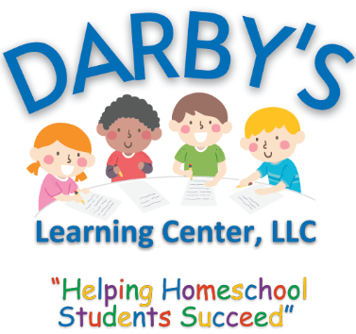
CONTRACT & LIABILITY RELEASE

I, the legal guardian of my child, WAIVE, RELEASE, and DISCHARGE Darby’s Learning Center, LLC (Releasee), its owners, officers, directors, employees, members, agents, assigns, legal representatives and successors, and all business associates and partners involve, from all liability for or by reason of any damage, loss or injury to person and property, even injury resulting in the death of the Releasor and/or family members.
I hereby acknowledge and agree that I have carefully read this Waiver and Release agreement, that I fully understand same, and that I am freely and voluntarily executing same.
By signing this release I and my family members will be forever prevented from suing or otherwise claiming against the Releasee for any property loss or personal injury that I or my family members may sustain while participating in or preparing for the above noted activity(s). This agreement is effective for the entire duration of my participation with this group.
I have been given the opportunity, if desired, to seek independent legal advice prior to signing this Liability Release. I understand that this Waiver and Release agreement is binding on me, my spouse, my heirs, my executors, administrators, personal representatives and assigns.
This release contains the entire agreement between the parties to this release and the terms of this release are contractual and not a mere recital. This Waiver and Release Agreement will be construed in accordance with and governed by the laws of the State of Arizona, and it is acknowledged by the Releasor to be as broad and inclusive as permitted by the laws of this jurisdiction.
I HAVE READ AND UNDERSTAND THIS AGREEMENT, AND I AM AWARE THAT BY SUBMITING THIS AGREEMENT I AM WAIVING CERTAIN LEGAL RIGHTS WHICH I OR MY HEIRS, NEXT OF KIN, EXECUTORS, ADMINISTRATORS AND ASSIGNS MAY HAVE AGAINST THE RELEASEE(S).

