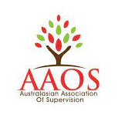
Alison Hood
Certified & accredited Counsellor Supervisor:
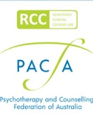
- Psychotherapy & Counselling Federation of Australia (PACFA)
Certified Supervisor (22304)
- Australian Counselling Association (ACA) Supervisor (Level 4, CoS81839)
- Australasian Association of Supervision (AAOS) Reg. 0803211
- IAAN Certified Neuropsychotherapy Practitioner
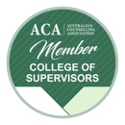
alison.insightworks@gmail.com
www.alisonhood.com.au
ABN 84647121617

Supervision Services Agreement (individual / group)
I have read and understood the Supervision Services Terms & Conditions and the Privacy Policy posted on the website (Bookings/Enquiries page). I am fully qualified and accredited in my discipline. I agree to undertake individual and/or group supervision with Alison Hood.

My signature:
Date signed:

Full name & preferred name
Pronouns
Date of birth
Email address
Mobile phone number
Residential address
Emergency contact’s
full name & relationship with you
Emergency contact’s
mobile phone number(s)
Qualification(s) with date(s)
& years of experience
Accreditation(s) e.g.
PACFA, ACA, AAOS
Insurances | I confirm I hold a valid Certificate of Currency relevant to my private practice and / or I am insured through my employer.
Modality(ies) / Approach(es)

Aims & requirements for supervision
Individual appointments – preferred frequency | Fortnightly / monthly / bi-monthly

Please let me know of any allergies, health issues or other information of which you would like me to be aware.

