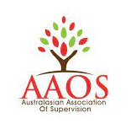
Alison Hood
Certified & accredited Counsellor Supervisor
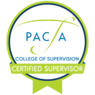
- Psychotherapy & Counselling Federation of Australia (PACFA)
Certified Clinical Supervisor Reg. 22304
- Australian Counselling Association (ACA) Supervisor (Level 4, CoS81839)
- Australasian Association of Supervision (AAOS) Reg. 0803211
- IAAN Certified Neuropsychotherapy Practitioner
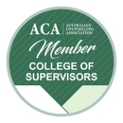
alison.insightworks@gmail.com
www.alisonhood.com.au
ABN 84647121617

Supervision Services Agreement (individual / group)
I have read and understood the Supervision Services Terms & Conditions and the Privacy Policy posted on the website (Bookings/Enquiries page). I am fully qualified, certified and insured as relevant to my discipline. I agree to undertake individual / group supervision with Alison Hood.

Full name & pronouns
Preferred name
Date of birth
Email address
Mobile phone number
Residential address
Emergency contact
full name & relationship with you
Emergency contact
mobile phone number
Qualification(s) with date(s)
& years of experience
Current certification(s) and level e.g. PACFA Provisional,
ACA Level 3, AAOS Supervisor
Insurances | I confirm I hold a valid Certificate of Currency relevant to my private practice and / or I am insured through my employer.
Key modality(ies) / approach(es)

Aims & requirements for supervision
Individual appointments – preferred frequency | Fortnightly / monthly / bi-monthly
Please let me know of any allergies, health issues or other information of which you would like me to be aware

Signature:
Date signed:

