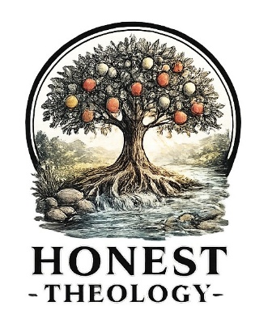
“Heaven” Scriptures To Think About

Part 6 of my “Searching for Heaven” Series

For this post, I’ve decided to just give the three key Scriptures I will use for my thesis. All have to do with “life after life after death” (my preferred “heaven” term). Without me telling you anything specific about where I am headed for my research, just read these three Scriptures. As you read them, consider these questions:
- What stands out to you in the way of surprise, interest, puzzlement, or curiosity?
- If you could ask the author/speaker questions, what would you ask?
- Can you see any interesting common threads in these three passages?
- Romans – written by Paul as an epistle (aka a letter), during the “middle” time of the formation of Christianity.
- Matthew – spoken/taught by Jesus in the Gospels (it’s part of the “Lord’s Prayer”), at the “very beginning” of the formation of Christianity.
- Revelation – written by John as prophecy, during the “later” times of the formation of Christianity.

Romans 8:19-23: ¹⁹ For the creation waits with eager longing for the revealing of the children of God, ²⁰ for the creation was subjected to futility, not of its own will, but by the will of the one who subjected it, in hope ²¹ that the creation itself will be set free from its enslavement to decay and will obtain the freedom of the glory of the children of God. ²² We know that the whole creation has been groaning together as it suffers together the pains of labor, ²³ and not only the creation, but we ourselves, who have the first fruits of the Spirit, groan inwardly while we wait for adoption, the redemption of our bodies.

Matthew 6:10: May your kingdom come.
May your will be done
on earth as it is in heaven.
Revelation 21: 1-5: Then I saw a new heaven and a new earth, for the first heaven and the first earth had passed away, and the sea was no more. ² And I saw the holy city, the new Jerusalem, coming down out of heaven from God, prepared as a bride adorned for her husband. ³ And I heard a loud voice from the throne saying, “See, the home of God is among mortals.
He will dwell with them;
they will be his peoples,
and God himself will be with them and be their God;
⁴ he will wipe every tear from their eyes.
Death will be no more;
mourning and crying and pain will be no more,
for^{[e]} the first things have passed away.” ⁵ And the one who was seated on the throne said, “See, I am making all things new.” Also he said, “Write this, for these words are trustworthy and true.”

I want you to picture me sitting quietly and intently, waiting for you to finish reading, so we can get talking! LOL.

PLEASE NOTE: There are no right or wrong answers to my questions. Those three questions I asked you to consider are vital tools to help one “dig down” into Scripture and discover things that are there that we sometimes miss or choose to skip. I wish we could get together and talk about what you see and think and want to ask! Write to me!

Please be patient. There is much more to come. Have you heard that old adage: How do you eat an elephant? One bite at a time!!
Bibliography notes:
- For the majority of my ‘Heaven’ posts, I will be using the New Revised Standard Version, Updated Edition. Copyright © 2021 National Council of Churches of Christ in the United States of America. Feel free to research your own translation or look up the many translations that are available on Bible Gateway.
What are your thoughts about this post? What are your questions? Email me and let me know!
honesttheology@gmail.com

I am available on many platforms, if you’d like to read more from me:
- Substack (You can subscribe!)
- Facebook
- Instagram
- Honest Theology Website
- Pinterest

