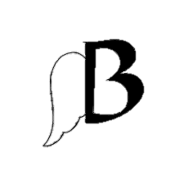

Flying B Equine’s Buyers Guide

We are so excited that you’ve found a horse that you would like to purchase! Now you may ask “What do I do next?”, below is all the information and a check list of information that we will need from you! (This is after virtual or in person trial appointments.)
- Contact Flying B Equine personally to claim the horse.
  - Cell – (330) 243-5233
  - Email – FlyingBEquine@gmail.com
- Sign a customized Bill of Sale sent from the office
- Payment – Wire transfer or cash only. Wiring information will be sent with bill of sale.
- Arrange pickup / Shipping – A list of references of reputable shippers is available on the website under the Buyer’s page.
- Fill out transportation document with all information.
- Boarding contract if horse is staying more than 3 days with Flying B Equine
- Receive and enjoy your new family member!

Please make sure to read all of our documents and forms. It is important that all information is filled out correctly! Please do not hesitate to call Bailey at the office. (330) 243-5233 or email her at Flyingbequine@gmail.com

