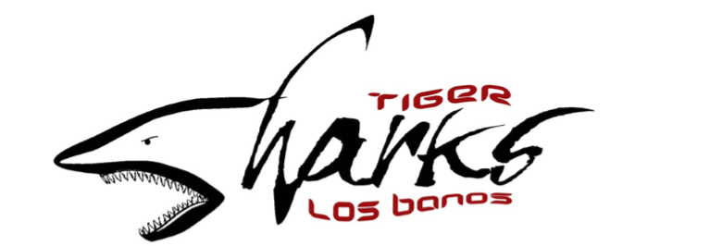
Junior Coach Application
Date

Name Age DOB
Address Phone #
Email:

How many years have you swam for Tiger Sharks? CPR certified?
Have you been a Junior Coach with Tiger Sharks before? How Many Seasons?
Are you currently on the high school swim team? Years?
Following are the days of the week I CAN work:
(Please check all that apply)
MODAY TUESDAY WEDNESDAY THURSDAY FRIDAY SAURDAY SUNDAY
Are you able to work from 3:30p-7:00pm on practice days?
Are you able to make all swim meets and stay until completion?

Please list any dates that you will be UNAVAILABLE between April 16th and July 21st?
(This will factor greatly into the selection process as availability and punctuality is essential to a successful season)

Why do you want to be a Junior Coach?

What do you think you can contribute that will benefit the team?

Please list any past experiences in working with children
(i.e. babysitting, coaching, swim lessons, etc.):

***Applications are to be turned in on Monday April 15th at 6:00pm during the Parent Meeting on the pool deck.***
JUNIOR COACH RESPONSIBLITIES

- All Junior Coaches need to have experience in swimming, demonstrate leadership skills, and be a positive role model on and off the pool deck throughout the season.
- Junior Coaches are required to be at all practices and meets as well as their own practice. Absences must be pre-approved by coaches and board members. A no call no show could lead to termination.
- Junior Coaches will report to the Head Coach and Assistant Coach.
- Junior Coaches will train swimmers on the four strokes as well as sportsmanship and team building.
- Junior coaches will be given the practice plan each day from the Coach or Assistant Coach. Junior Coaches will ensure the high school volunteers follow the practice plan.
- Junior Coaches need to know that their main job is to be true roles models/mentors for all younger swimmers. This means showing respect to all Coaches, swimmers, parents, board members and officials.

SWIM MEET RESPONSIBILITIES

- Junior Coaches will be assigned to shifts and will be given appropriate breaks. These shifts will be a sequence of ‘Events’ during the meet.
- Junior Coaches will ensure that each all swimmers are at the staging area on time.
- Junior Coaches will report any missing swimmers or other issues directly to the Head Coach or Assistant Coach.
- Junior Coaches will assist their volunteers at the staging area.

_
Print Sign Date

