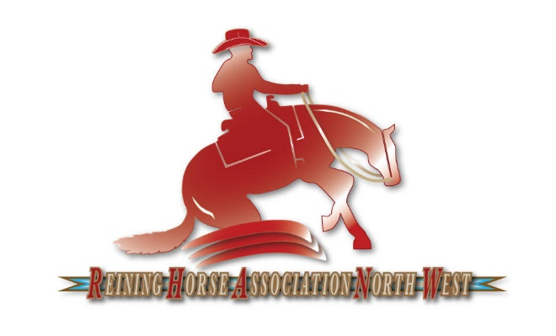
2023 SPONSOR INFORMATION

DIAMOND SHOW SPONSOR - $2000+
- Recognition as the named sponsor of a specific show or event
- Diamond Sponsors will be provided 1 stall per show
- Logo/info and link on Sponsorship page of www.rhanw.com and our Facebook page
- Business card size ad on Sponsor page of www.rhanw.com
- Recognition throughout the year at shows, clinics, and all club activities, including promotion by announcers at shows.
- Display of banner at shows, clinics, and other events.
- Premium placement on the collective Sponsor Show banner displayed at all shows and RHANW events

PLATINUM SPONSOR – $500+
- Recognition as the named sponsor or co-sponsor of a high-profile class
- Logo/info and link on Sponsorship page of www.rhanw.com and our Facebook page
- Business card size ad on Sponsor page of www.rhanw.com
- Recognition throughout the year at shows, clinics, and all club activities, including promotion by announcers at shows.
- Display of banner at shows, clinics, and other events.
- Placement on the collective Sponsor Show banner displayed at all shows and RHANW events

GOLD SPONSOR – $100+
- Logo/info and link on Sponsorship page of www.rhanw.com and our Facebook page
- Recognition throughout the year at shows, clinics, and all club activities, including promotion by announcers at shows.
- Display of your banner at shows, clinics, and other events.
- Placement on the collective Sponsor Show banner displayed at all shows and RHANW events

CLASS AWARD – $125
- Logo/info and link on Sponsorship page of www.rhanw.com and our Facebook page
- Name/Business and class sponsored announced at all shows
- Business card size ad on Sponsor page of www.rhanw.com
- Display of your personal banner at shows, clinics and other events.
- Placement on the collective Sponsor Show banner displayed at all shows and RHANW events

***Sponsorship Funds must be received by March 31st to be included on the Sponsor Show banner***
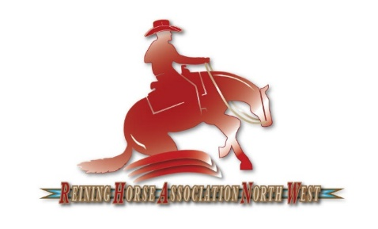

2023 RHANW SPONSOR FORM
RHANW
PO Box 55
Rockford, WA 99030
rhanwreining@gmail.com
Form can also be filled out at www.rhanw.com

BUSINESS OR FAMILY NAME
PRIMARY CONTACT PERSON
ADDRESS
CITY, STATE, ZIP
PHONE
EMAIL
WEBSITE

I am sending a check in the amount of $___________________ to be a (please select the appropriate level below)
- Diamond Show Sponsor - $2000+
- Platinum Sponsor - $500+
- Gold Sponsor - $100+
- Class Award Sponsor - $125
- Other (please specify) __________________________________
Will you be providing a banner to be displayed at events?
- Yes
- No
Please name the preferred class or show for this sponsorship:

Please provide information about your business/family that we can share with the public.:

Email business card, logo, or artwork for advertising purposes to rhanwreining@gmail.com
Sponsorship checks should be made payable to RHANW and mailed to the club Treasurer at:

RHANW
PO Box 55
Rockford, WA 99030
Thank you for your support!

