**Presentation Title (12pt, bold centered)**

First Author1, Second Author2 and Last Author1,2,*

*1University of City, City, Country*

*2State Research Institute, City, Country*

*last.author@ucity.edu

(blank line, please remove this text but maintain the spacing)

The followings are instructions for the preparation of a “camera-ready” abstract. Not respecting the template may lead to the rejection of the abstract.

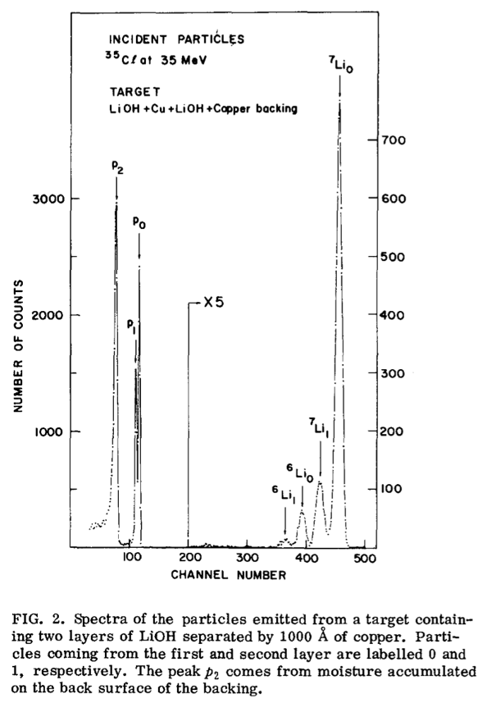

**Fig. 1**. Elastic recoil detection spectrum from Ref. 1. This caption is inside a text box joined to the figure.

* It must fit in one (1) US Letter (8.5" x 11") page with 1" (2.54 cm) margins *all around*.
* The title should be typed in 12 pt boldface Times New Roman or compatible font and centered at the top of the page.
* The title is followed by the author list, which should be in 10 pt Times New Roman or compatible font. The name of the presenting person should be underlined.
* The author list is followed by the affiliation(s) also in 10 pt Times New Roman or compatible font, and in italic. If the authors do not share the exact same affiliation(s), use superscript numbers to relate an affiliation to its related author(s).
* On the next line, write the email address of the corresponding author, identified by an asterisk (“*”).
* The email address is followed by a blank line.
* The body of the abstract, in 10 pt Times New Roman or compatible font, should be in one-column format. It can include equations and references at the bottom.
* The body can also include one (1) single-panel figure with its caption. It should not overlap the top section (title, authors, affiliations and space line) nor the references, and should remain within margins. As the abstracts will be distributed electronically, it can be a color figure. When the figure consists of lines and symbols rather than an image, please try to generate the figure using vector graphics (e.g. PDF, EPS, SVG) rather than JPEG, before including it in the abstract. The figure should include a caption (here inside a textbox grouped with the figure) with a figure number, and the text should refer to the figure number.
* Please do NOT add a page number.

The file must then be converted into a PDF with a maximum file size of 1 Mb for submission. Before submitting it, check that the PDF looks as desired. The text of the abstract should refer to the figure in the text (see Fig. 1). The abstract can also include equations

|  |  |
| --- | --- |
| $$y=\frac{-b±\sqrt{b^{2}-4ac}}{2a},$$ | (1) |

for which each symbol is defined, e.g., in Eq. (1), $a, b$ and $c$ are the coefficients in the quadratic equation $y=ax^{2}+bx+c$. Here, the equation is included inside a table without edge/line color for proper alignment of the equation number and to avoid “small fonts” in the equation when there is text on the same line in MS-Word Equations. For the references, please use the Nucl. Instrum. Meth. convention with numbers in brackets.

**Reference**

[1] J. L’Écuyer, C. Brassard, C. Cardinal, J. Chabbal, L. Deschênes, J. P. Labrie, B. Terreault, J. G. Martel, R. St.‐Jacques, J. Appl. Phys. **47** (1976) 381.