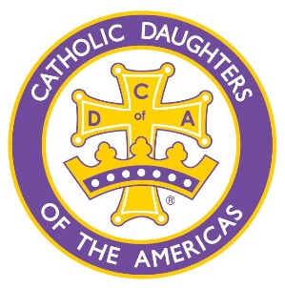
The Spirit
Issue 48 – April 2025
18511 Klein Church Road, Spring, TX 77379
www.catholicdaughters2731.com


Announcements
Next month we’ll meet at CGS on
Thurs., May 1 at 6pm for a rosary in the church prior to the monthly meeting at 7pm.

*Be women of faith
*Encourage spiritual growth
*Increase membership
*Promote the motto of “Unity and Charity”

Mission Statement
Catholic Daughters of the Americas strives to embrace the principle of faith working through love in the promotion of justice, equality and the advancement of human rights and dignity for all.
*Be women of faith
*Encourage spiritual growth
*Increase membership
*Promote the motto of “Unity and Charity
Patrice Hampton
Regent
patrice_hampton@hotmail.com (662)352-4291

Lori Maldonado
Vice Regent
lorilou6599@outlook.com
(281)413-9272

Kathy Kietur
Recording Secretary bambini49@yahoo.com (281)844-7919

Jean Philpot
Financial Secretary jeanphilpot@hotmail.com (713)515-4334

Olivia Berger
Treasurer
oberger@yahoo.com
(832)326-8536

Deacon Stacy Millsap
Court Chaplain
smillsap@cgscc.church
(346)236-6467

Christine Maniscalco
District Deputy #54
Christinemaniscalco1@gmail.com
(713)515-6342

Court Officers

Court Regent Message
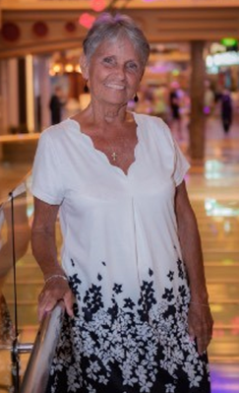
Patrice Hampton, Court Regent - Elect
We celebrated our 8th anniversary on February 5th at our monthly meeting on February 6th by praying the rosary together before attending mass where our Court Chaplin gave us the most beautiful blessing. After a Court picture at the altar, we had a short meeting and celebration.
As for me and our Court, I have been out of town a great deal on a family matter but am trying my best to stay abreast of all happenings here. So far, I’ve made it home for monthly meetings and officer meetings but haven't been to all the events as much as usual and missing those are hard for me. Our court is blessed, and I don't worry about anything but I sure do miss participating in all we do.
Semi-annual COL reports have been completed and mailed, and national and state charities have been taken care of. However, Financial Review and Convention are upon us and we have a busy spring ahead with Lent and our weekly Fish Fry’s, the budget committee working on and presenting the budget for next year, the Cahill Golf Tournament, the first part of May and a big bake sale at the end of May. At least the weather should be pretty and make all more enjoyable!
With heartfelt thanks to all our members who have worked so hard and diligently this year to keep our Court an amazing and productive one. Looking forward to the rest of the term and eventually getting back home sometime. Leading/managing two lives in two different states since mid-January has been a journey I never knew I would experience but one that I know with every fiber of my being that it is what God wanted and expected me to do.
There are no words to express my appreciation for the support and many continuous prayers for my family and myself May God bless and keep you and yours always in his loving care wishing everyone a beautiful spring a fun and restful summer and here's to a new year come fall.

With love & a hug,
Patrice Hampton
Regent
Court Chaplain Message
Deacon Stacy Millsap, Court Chaplain

Easter commemorates the resurrection of Jesus Christ, three days after he was crucified by Romans around 30 A.D. The particular day of the week on which Christ rose from the dead would have been Sunday, the first day of the week after the Jewish Sabbath. Early Christians celebrated every Sunday like it was Easter. There was no annual commemoration of Easter early on, but by the second and third centuries, there came to be an annual celebration of Easter, and the celebration later grew.
Easter marks the last day of Holy Week, which consists of several days that each carry their own significance. These include:
- Palm Sunday: commemorating when Jesus entered Jerusalem
- Holy Thursday: commemorating the Last Supper and washing of feet
- Good Friday: commemorating Jesus' crucifixion and death
- Easter Sunday: commemorating the resurrection of Jesus
Easter Mass is one of the longest iterations of the Catholic Mass. For our parish, the Easter Vigil begins after sunset on Saturday night and includes many special elements, such as blessing a fire in the plaza and consecrating a new Christ candle, which is lit from the blessed fire.
Then we follow the newly lit Christ candle, which is being carried by a deacon, and process with unlit candles into a darkened church. Once we’re all inside, we experience the spreading of the Light of Christ throughout the church as we light our individual candles from the Christ candle. Once all are in place, and with our candles burning, we listen as the Exsultet is sung/proclaimed and salvation history is recounted through various scriptures, songs, and prayers. After the Liturgy of the Word, we then move into the Rites of Initiation for those who have been preparing through the Order of Christian Initiation of Adults (OCIA) for the past several months.
This year we are blessed to have 30 people being baptized! Having been given the necessary authority to do so by our Archbishop, Fr. James will confirm all 30 of these people, and now, fully Catholic, they will join the rest of the Body of Christ in the Liturgy of the Eucharist, where they will receive the Body, Blood, Soul, and Divinity of our Lord and Savior Jesus Christ for the very first time.
As you might imagine, this is a long Mass, but oh, what a glorious experience! I would love to see as many of our sisters as humanly possible attend all of the magnificent, deeply spiritual liturgies of Holy Week. It is the high point of the entire year!


As is sung in the Exsultet:
Exult, let them exult, the hosts of heaven,
exult, let Angel ministers of God exult,
let the trumpet of salvation
sound aloud our mighty King's triumph!

Be blessed!
---Deacon Stacy Millsap

Court Happenings
Manna Bags – January 6, 2025
For several years, CDA sisters have supported the Hope Center which is a local center for homeless individuals. Twice monthly CDA makes manna bags which the Hope Center distributes to the visitors. Upcoming manna bag assembly dates are below.
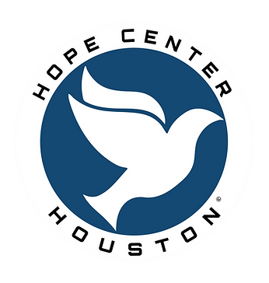
- Mondays at 7pm – 4/7, 5/5, and 6/2
- Thursdays at 3pm – 4/24, 5/15, and 6/12
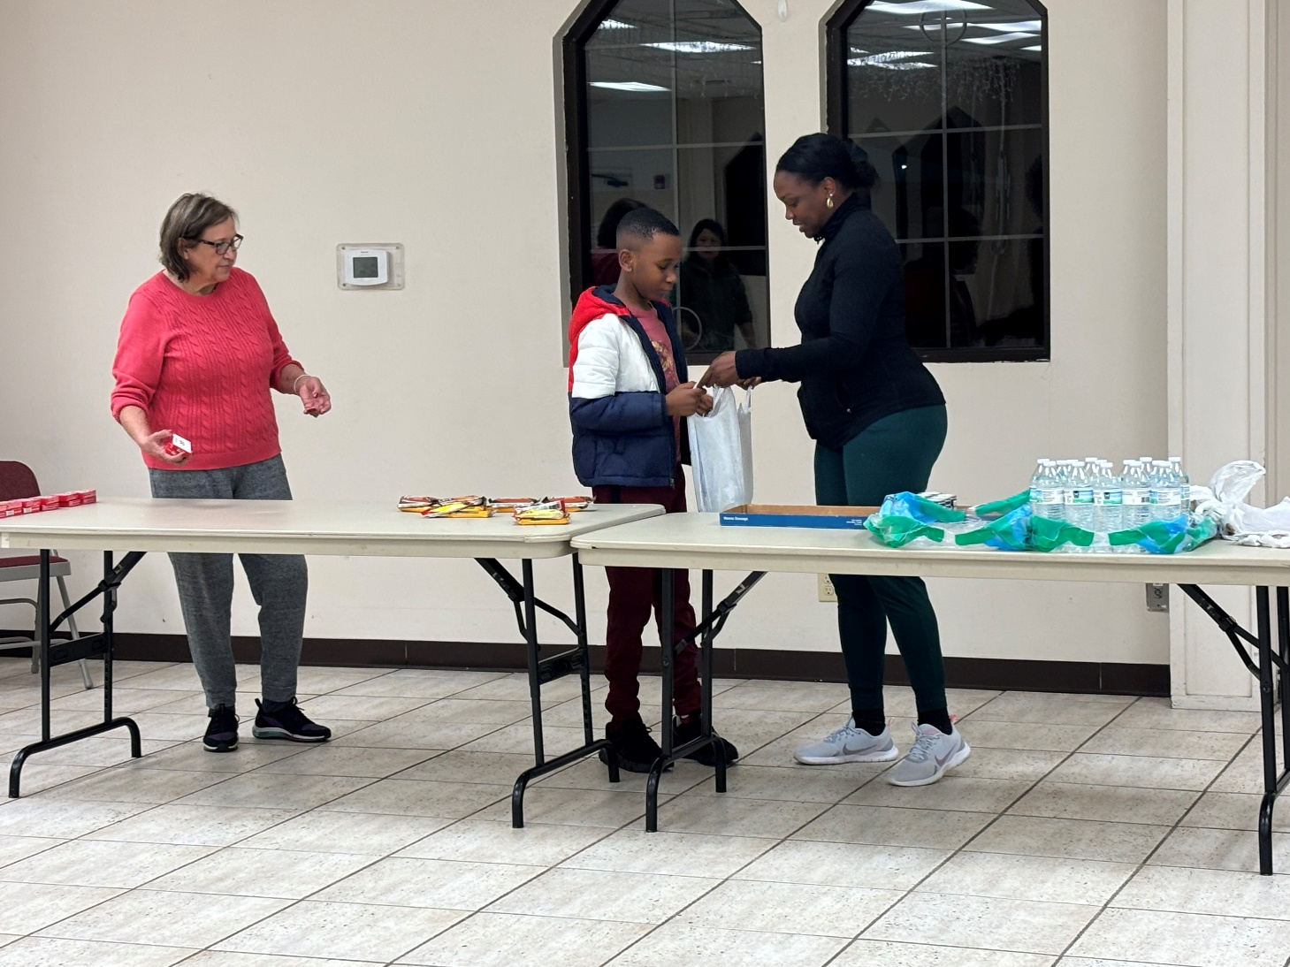

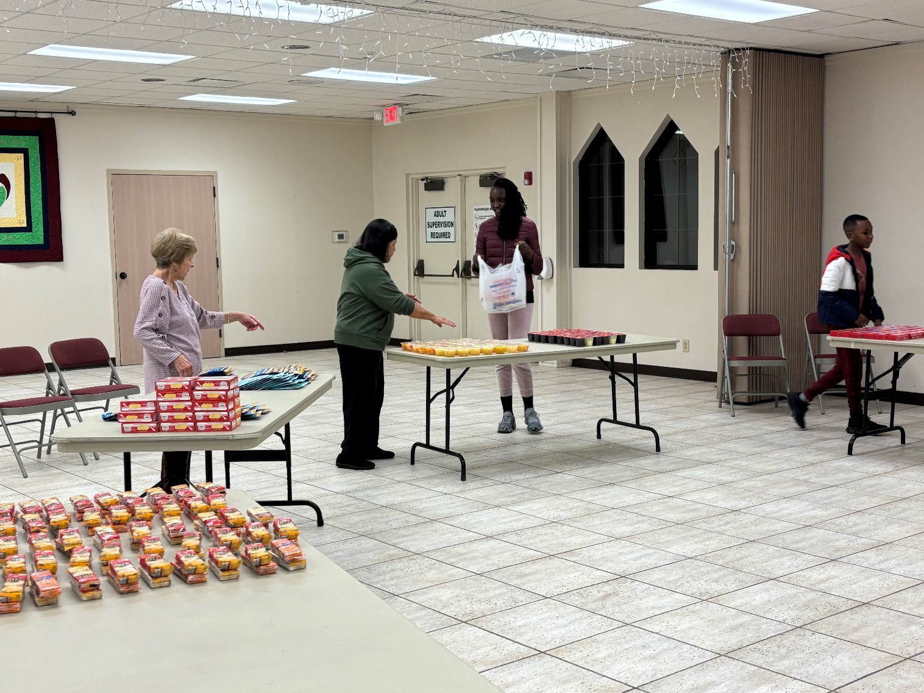

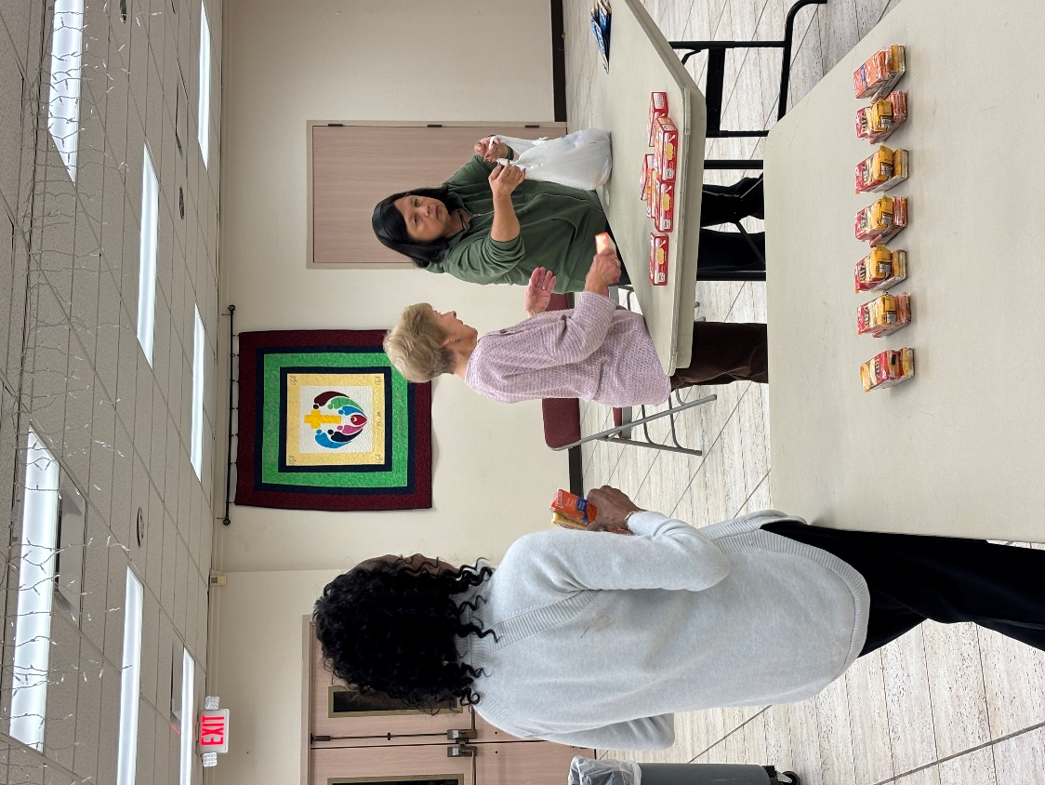

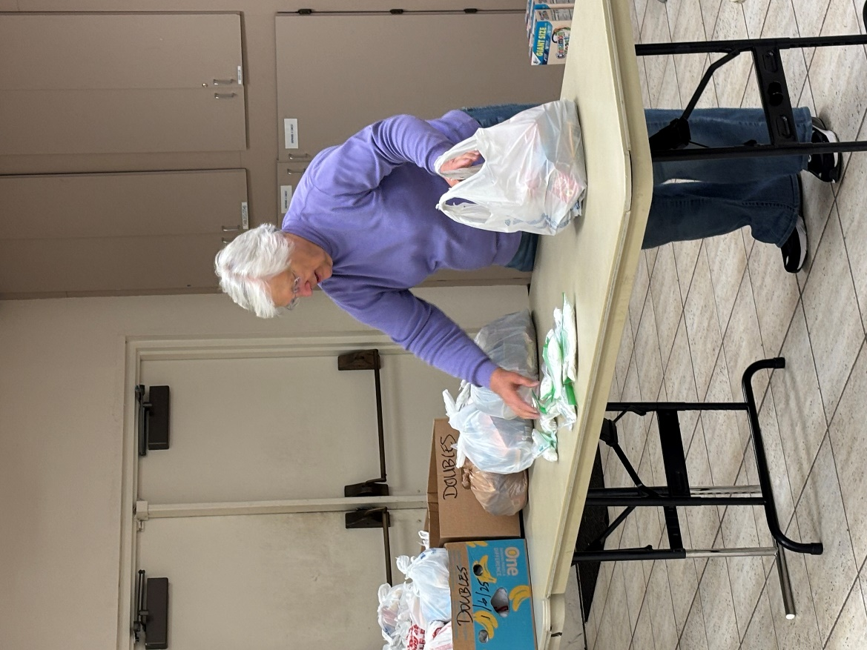

Sandwich Making – January 16, 2025
Besides making manna bags, another way CDA supports the Hope Center is by making 50 peanut butter and jelly sandwiches on a monthly basis. In January, Priscilla and Karen joined to make the sandwiches which were taken to the Hope Center for distribution. Thanks to those who donated the food as well as the sandwich makers for coming together and being a blessing to our homeless brothers and sisters!

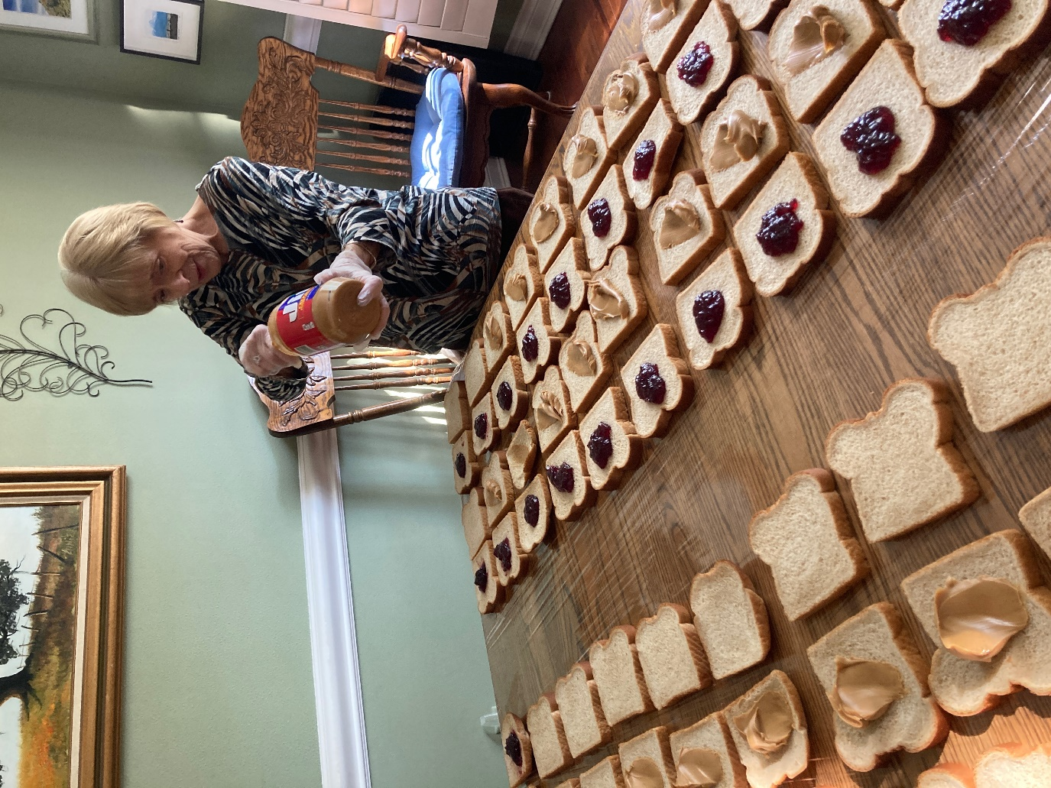



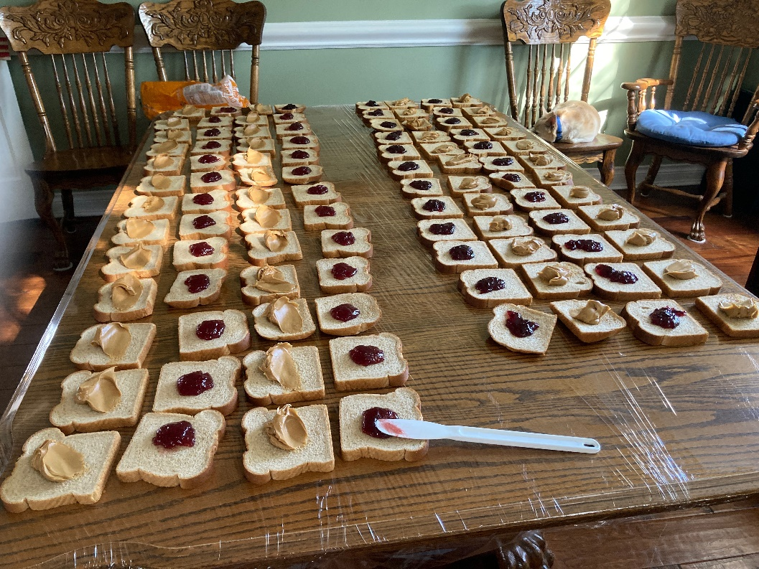


Valentine Bake Sale – January 26, 2025
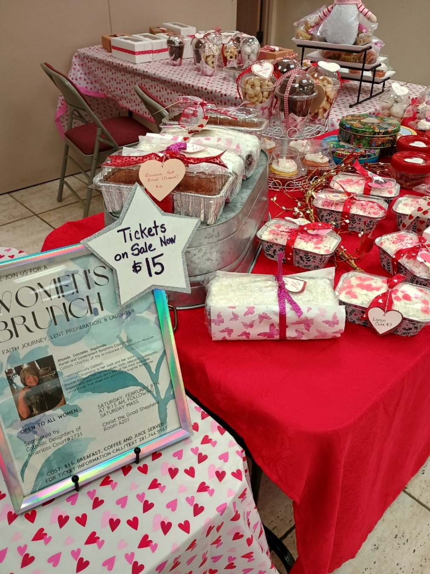
Our Valentine’s Bake Sale raised over $800. Thanks to all the CDA members who baked their hearts out for this event! Special thanks to Melody Barr and Nancy Williams as ‘Ways & Means’ coordinators. What a great showing of love and means of fundraising for those we choose to support throughout the year!
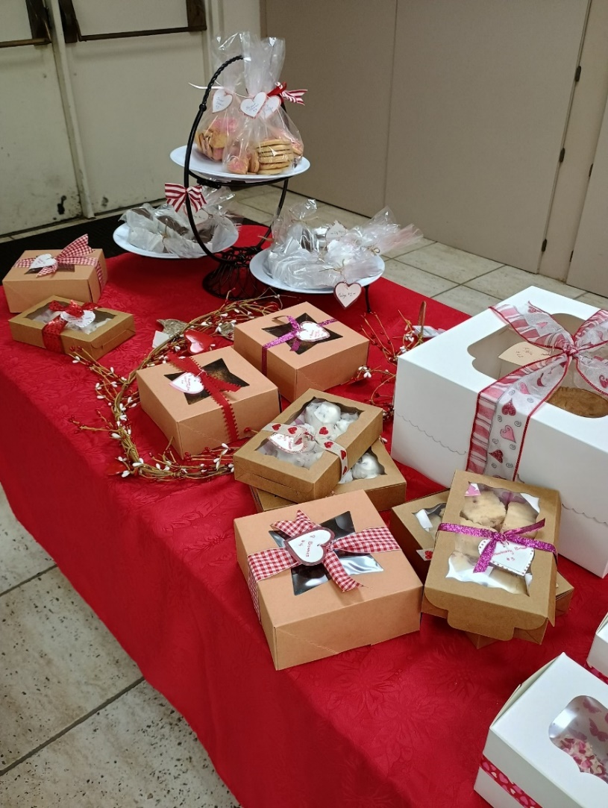

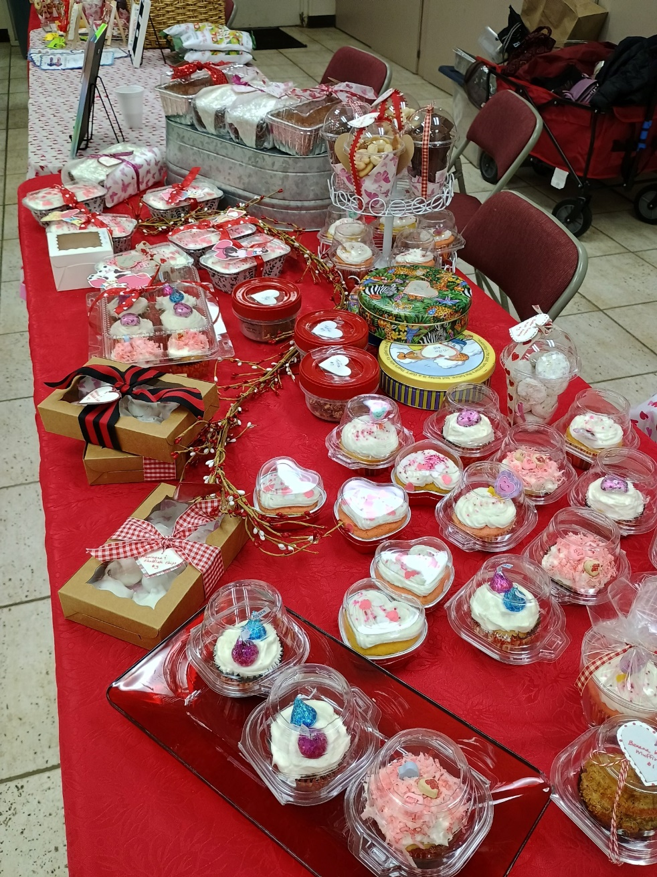

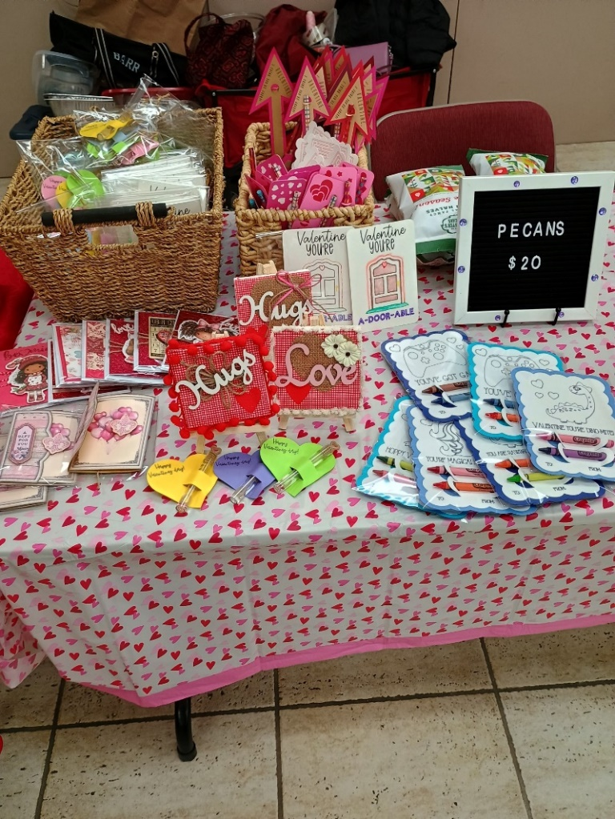

JCDA Interest Meeting – January 30, 2025
To ascertain the amount of interest in establishing a JCDA group, a gathering was hosted and the results were positive—24 attended the meeting and 13 membership applications were submitted. Thanks to everyone for supporting this endeavor and a special thanks to Sade Effiong for working hard to coordinate all of this.
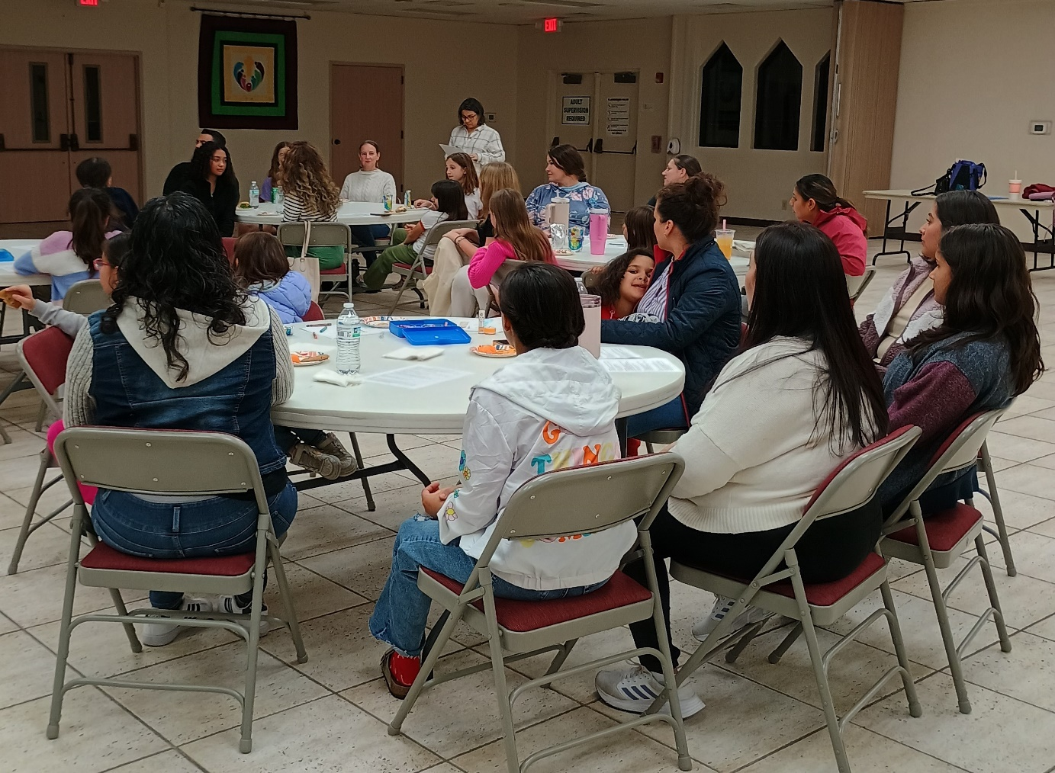
Court Anniversary – February 6, 2025
Happy 8th anniversary to CGS Shephard #2731! The court was established on February 5, 2017 and celebrated our court’s anniversary with a rosary, mass and reception. What a rich blessing in so many ways! Thanks be to God.

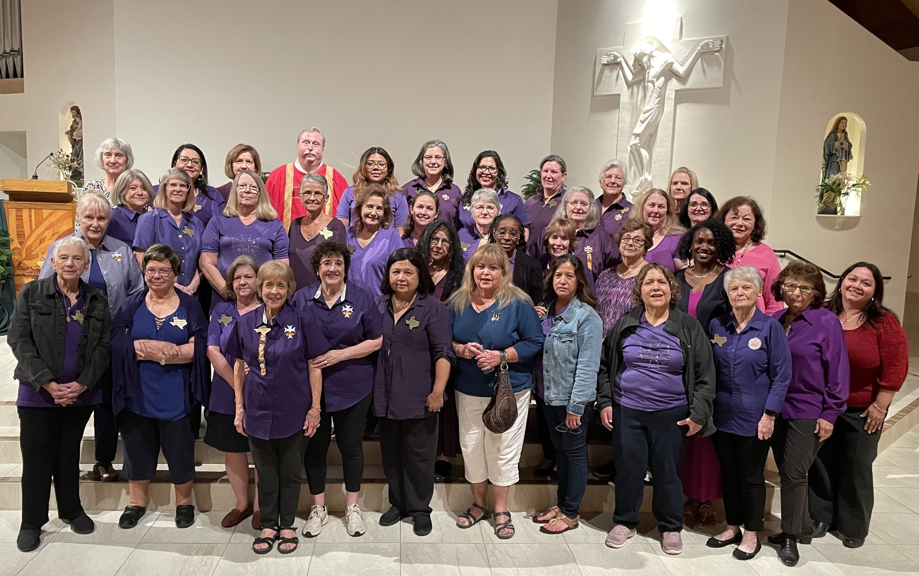
Let us not become weary in doing good, for in due time we shall reap our harvest if we do not give up. –Galatians 6:9

Women’s Brunch – February 8, 2025

On Saturday, February 8, CDA hosted a women’s brunch open to all CDA members and non-members as well. The event provided an opportunity to prayerfully prepare for Lent while enjoying fellowship with other women!
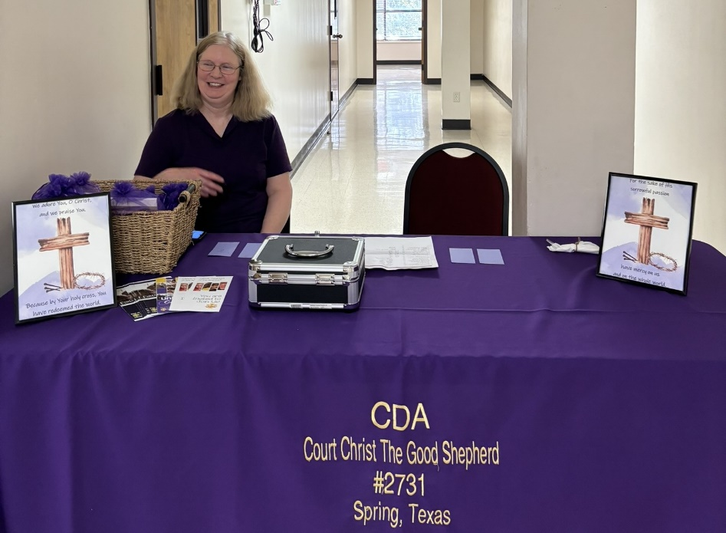

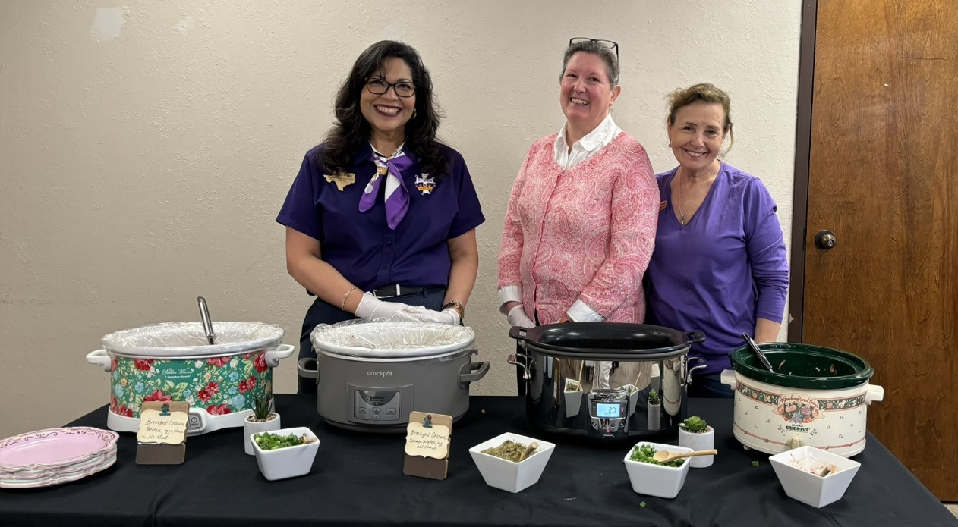

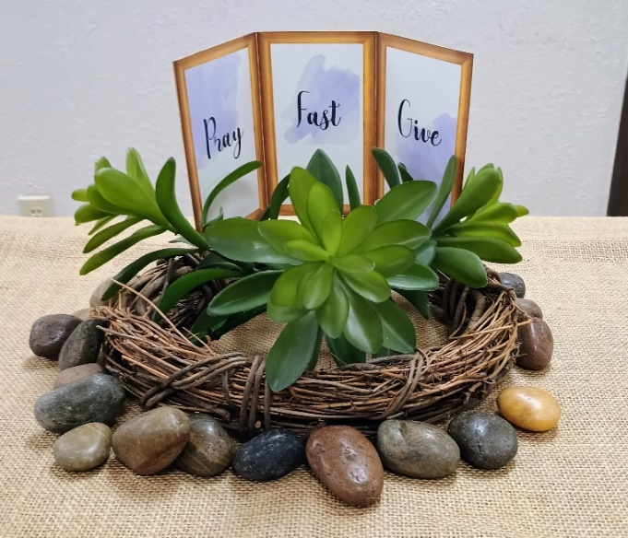

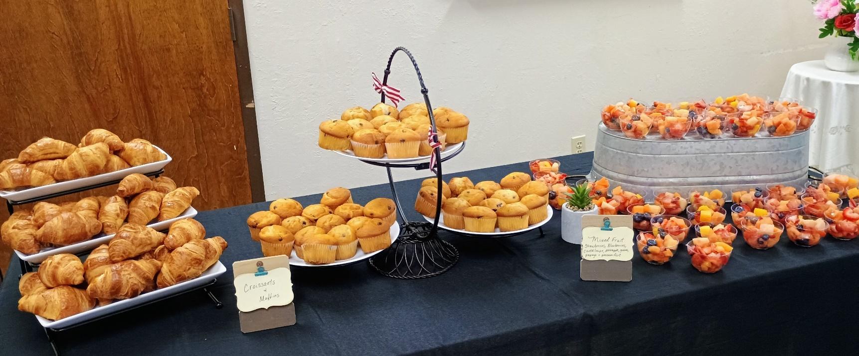

Women’s Brunch (continued)…

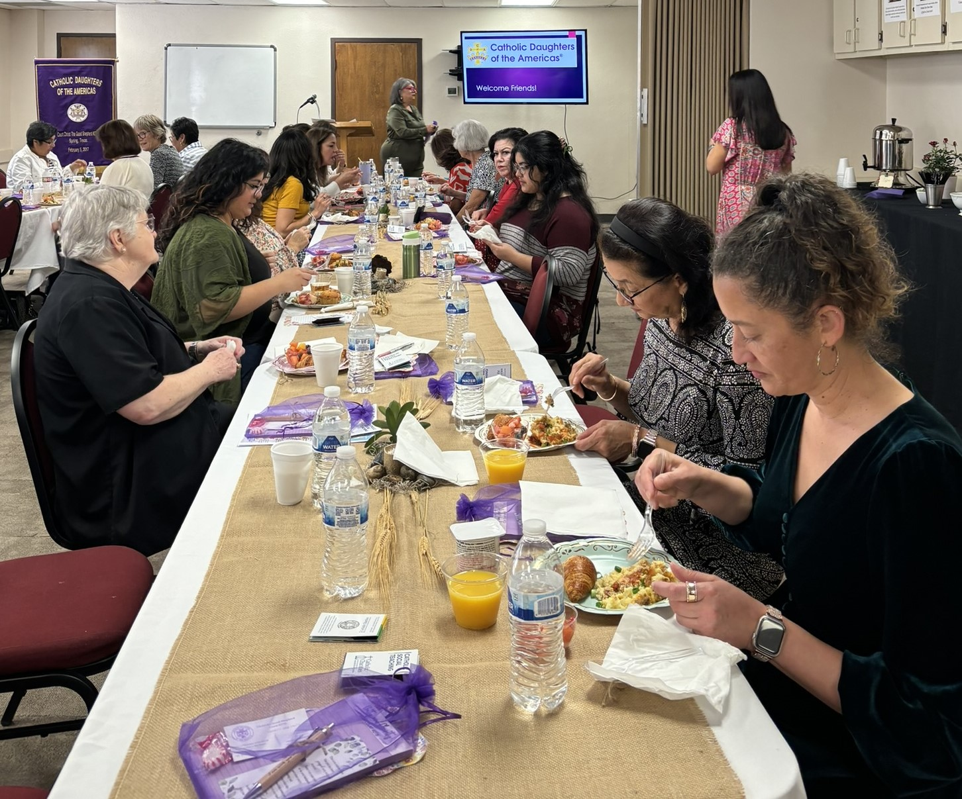

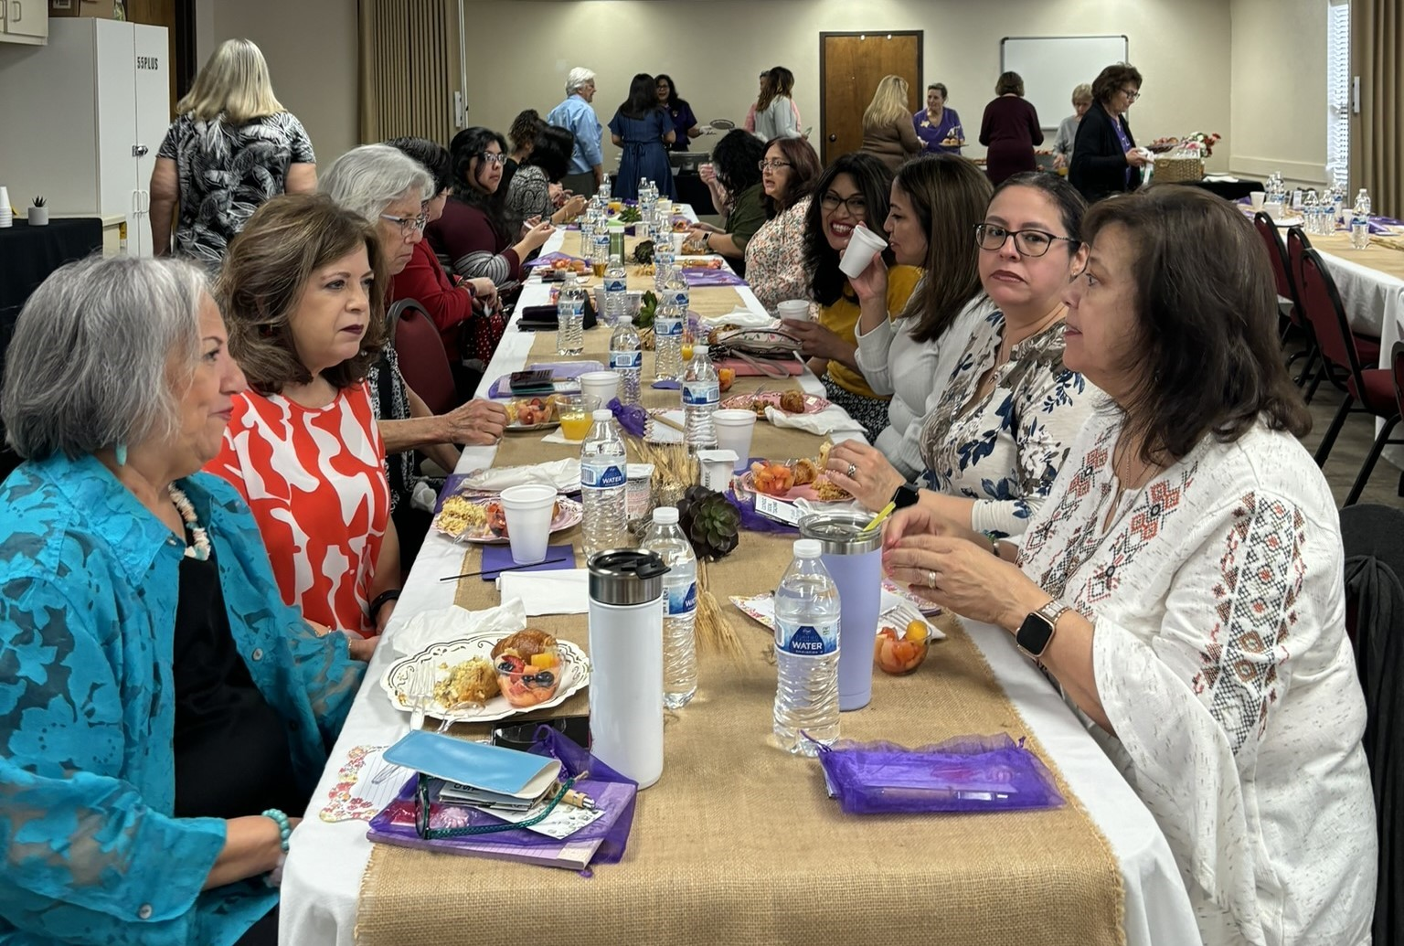

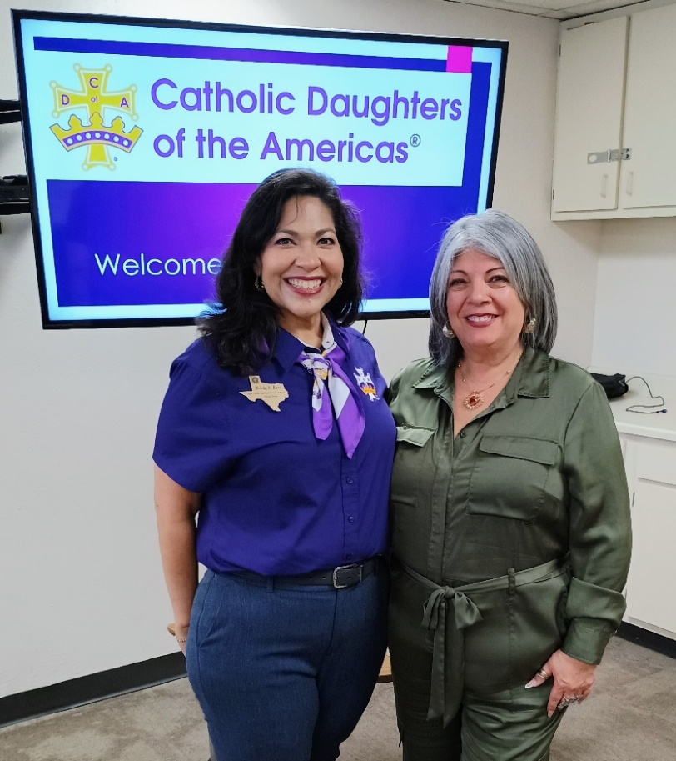

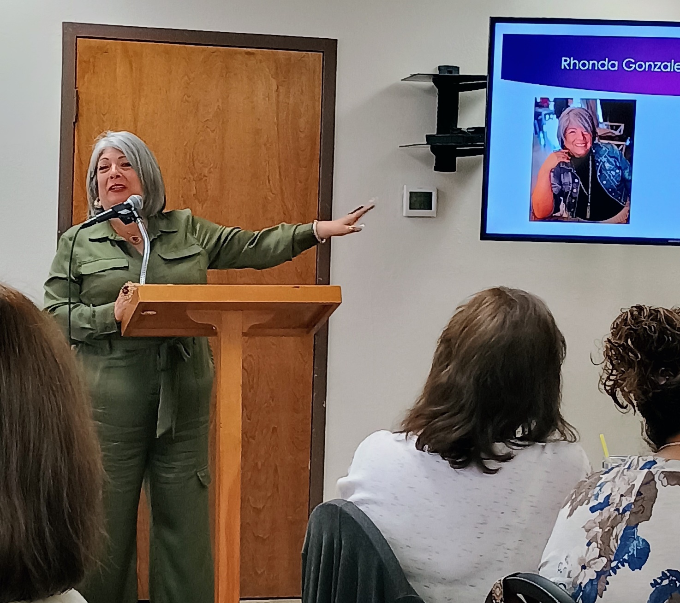

Manna Bags – February 10, February 20 & March 3, 2025
CDA remains devoted to making Manna Bags with food items and delivering them to the Hope Center. Below are pictures from recent bag assembly days. Thanks to Karen Doolittle for sending reminders about meeting dates and items needed.
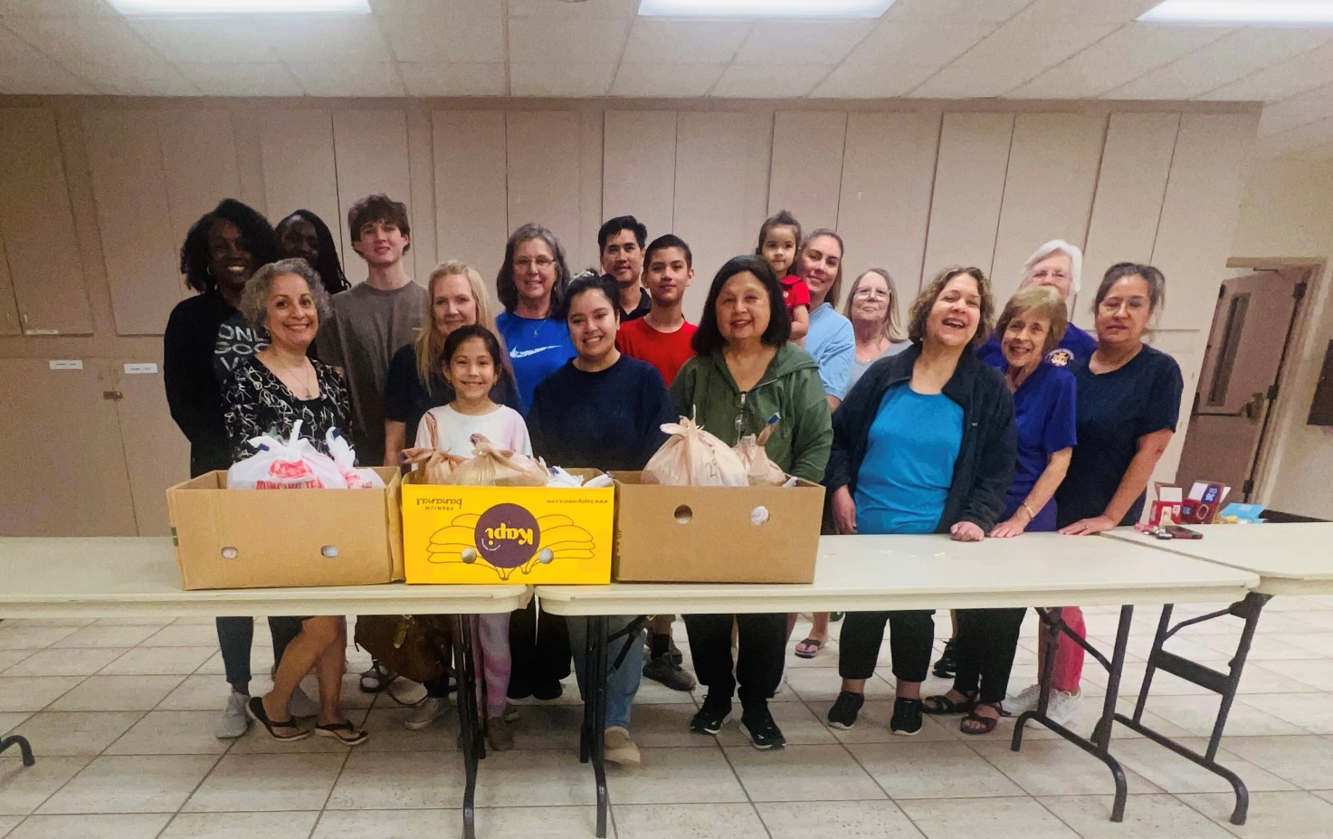
February 10

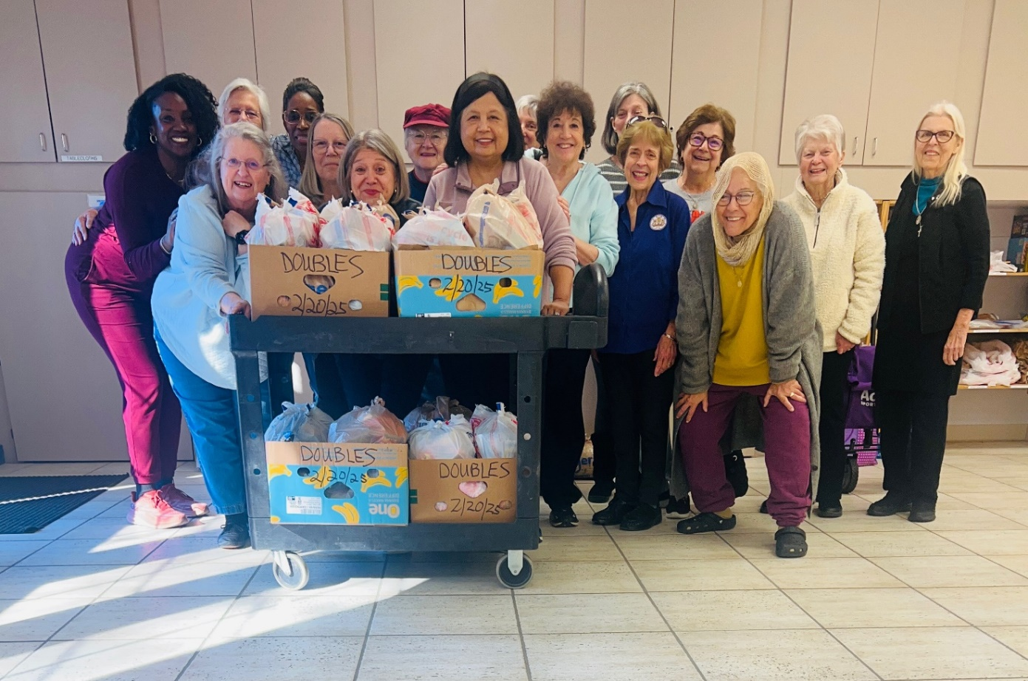
February 20

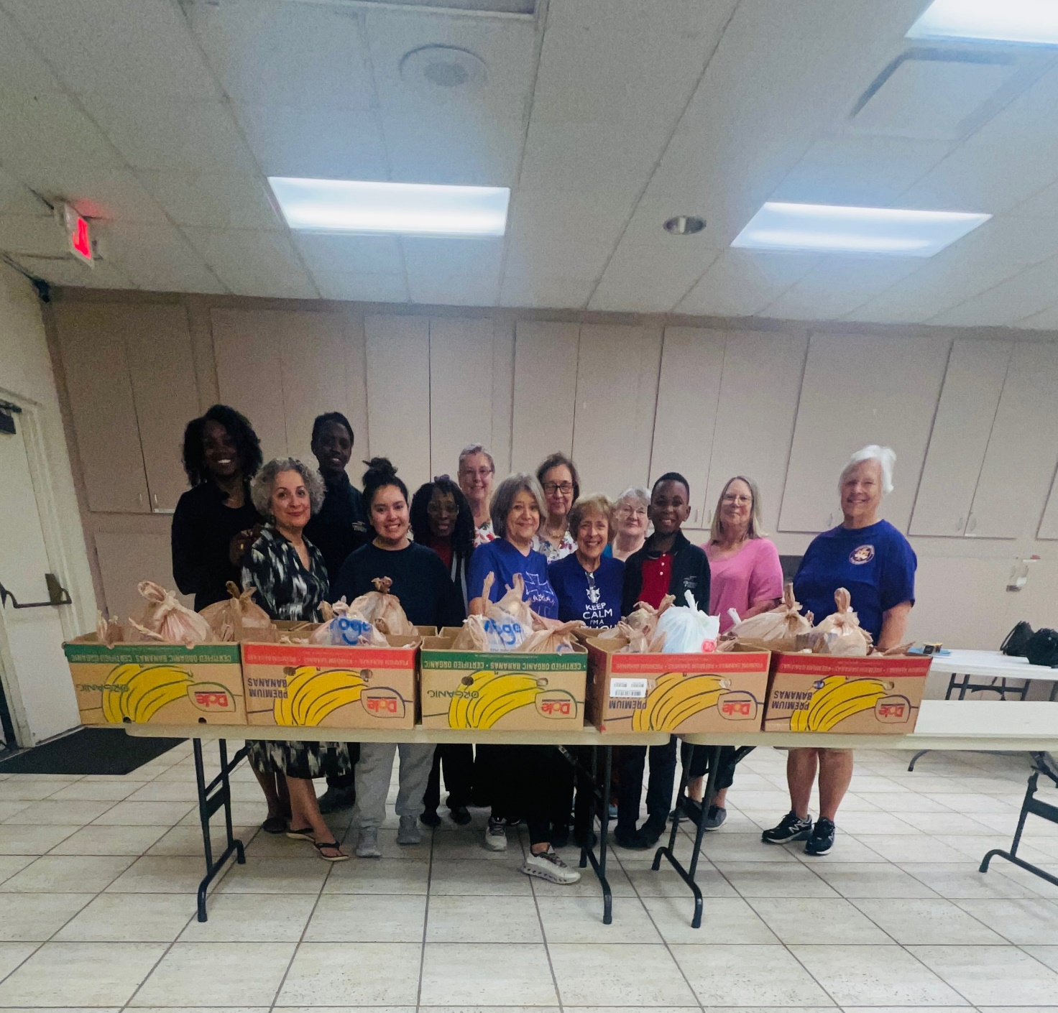
March 3

New Member Reception – February 15, 2025

CGS hosted a reception for members who are new to one of the 5 courts in the district namely #2065-St. Edward’s, #2308-St. James, #2597-Prince of Peace, #2680-Christ the Redeemer, and #2731-Christ the Good Shepherd. We welcomed 4 new members and enjoyed each other’s company. All members received a small gift with prayer cards and candy compliments of District Deputy Christine. Thank you to all the volunteers who made this welcoming of new members possible!
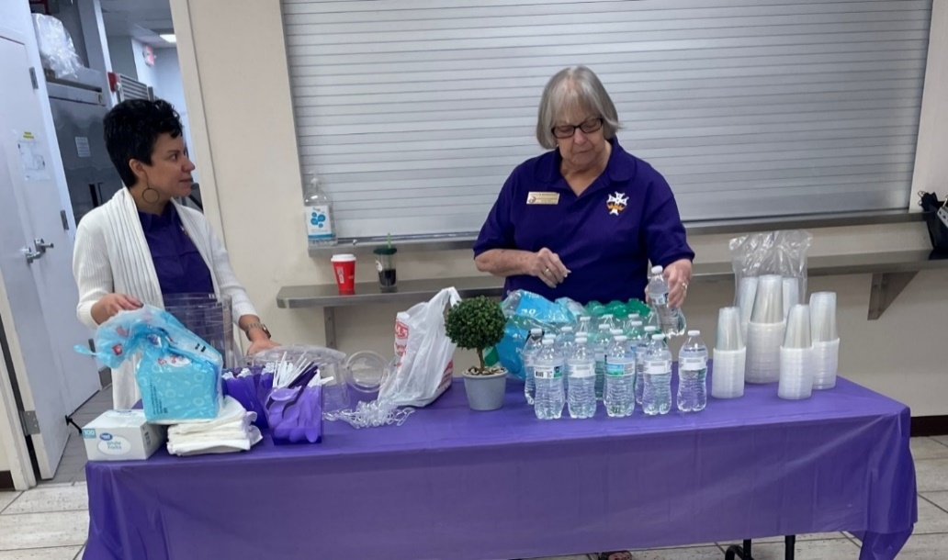

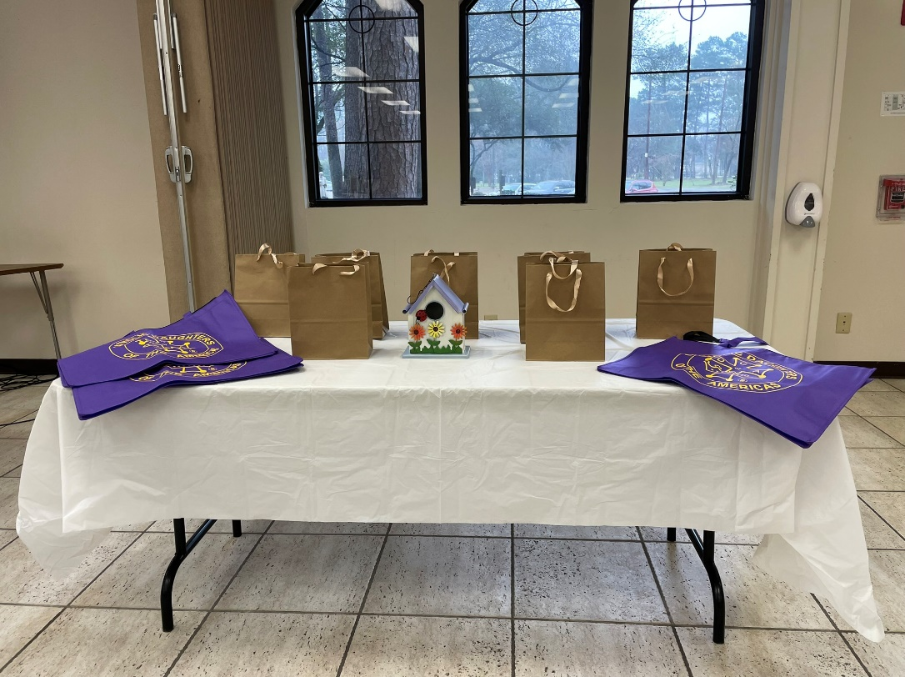

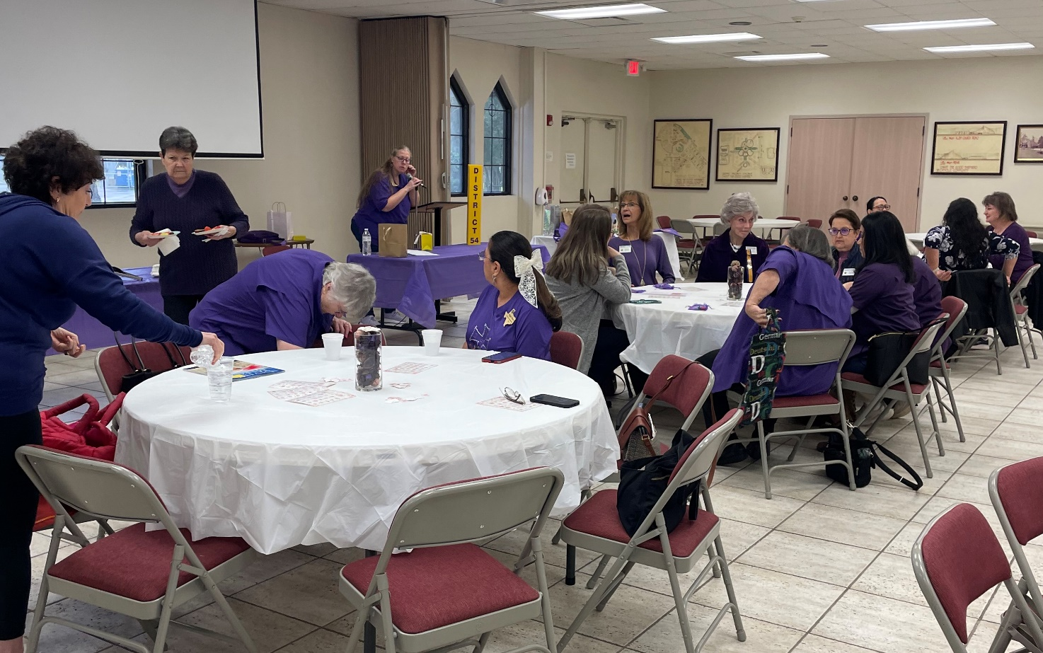

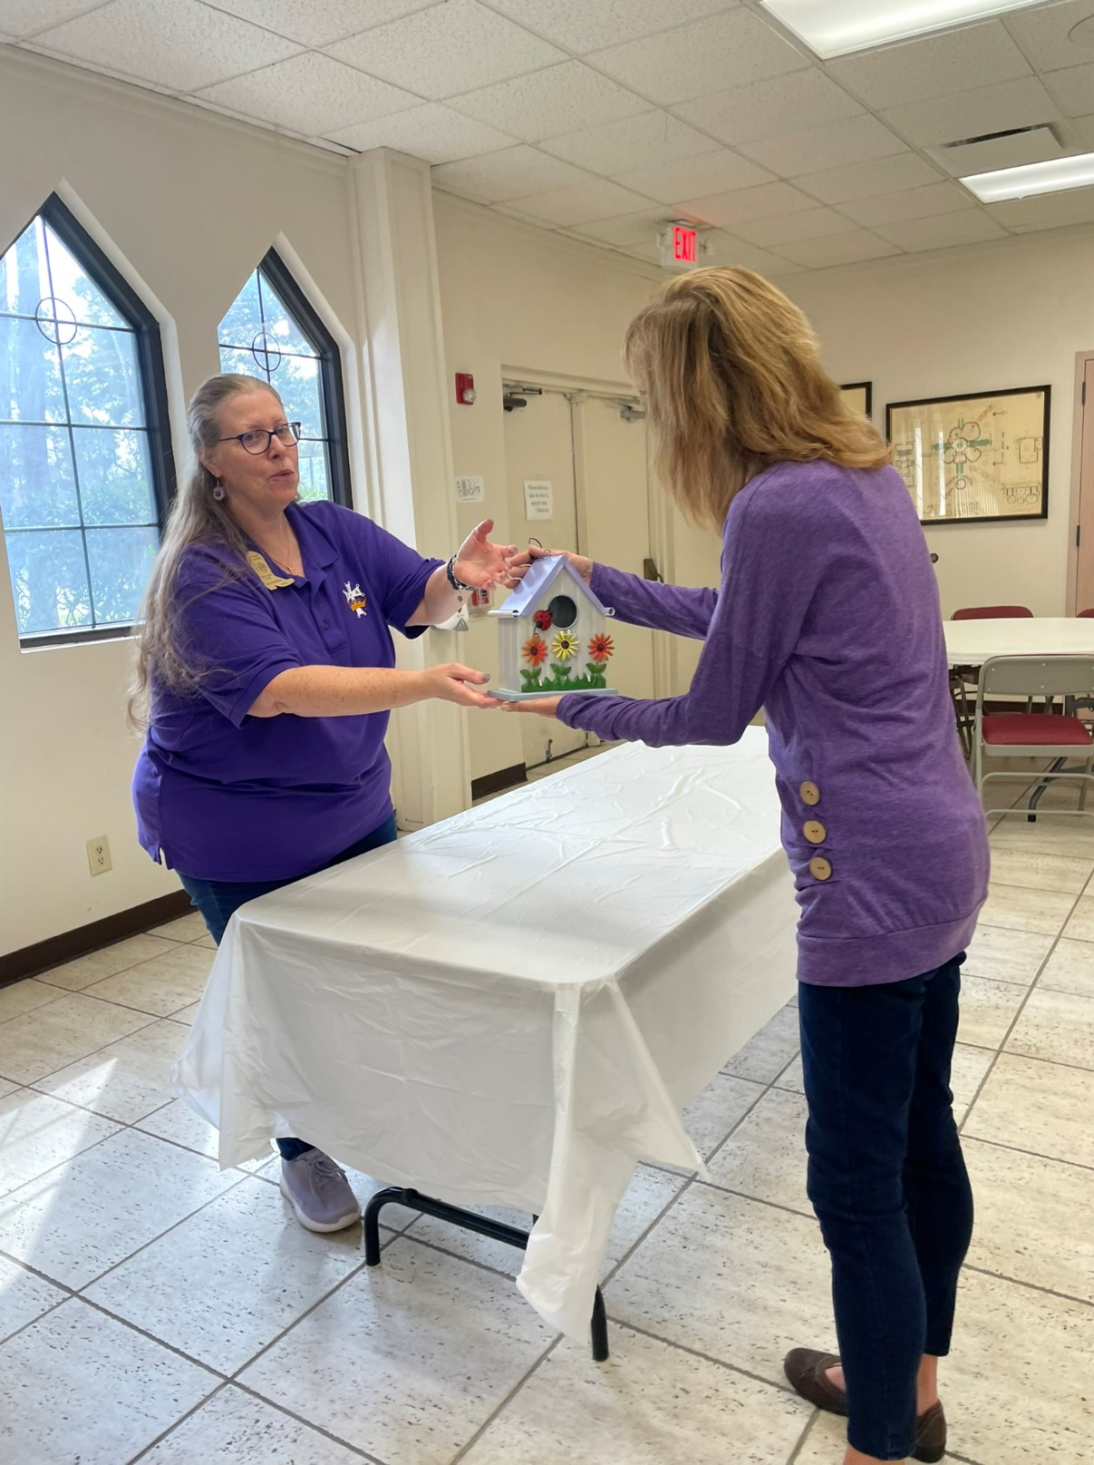

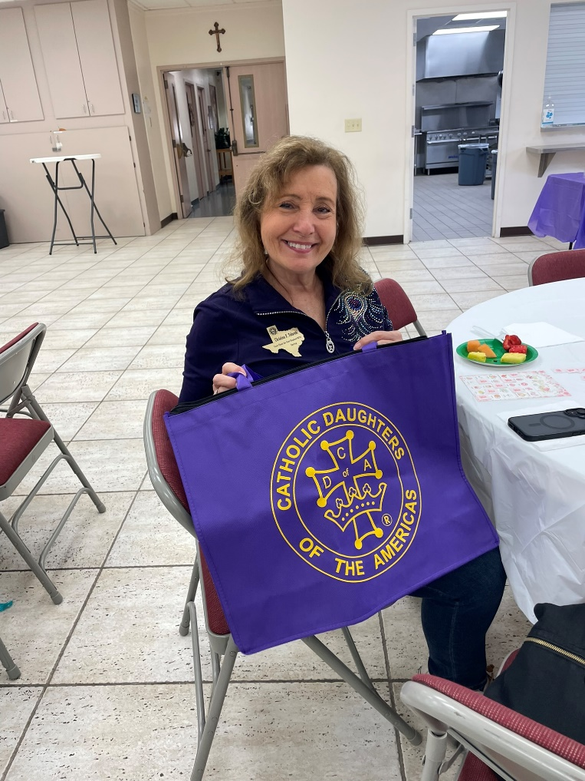
New Member Reception (continued)

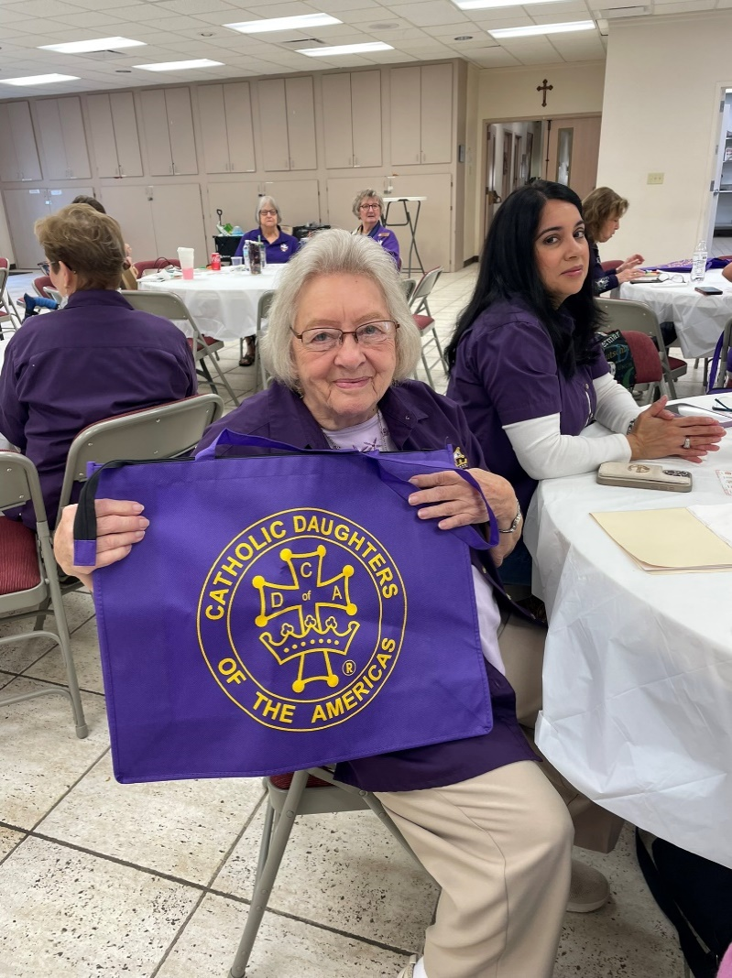

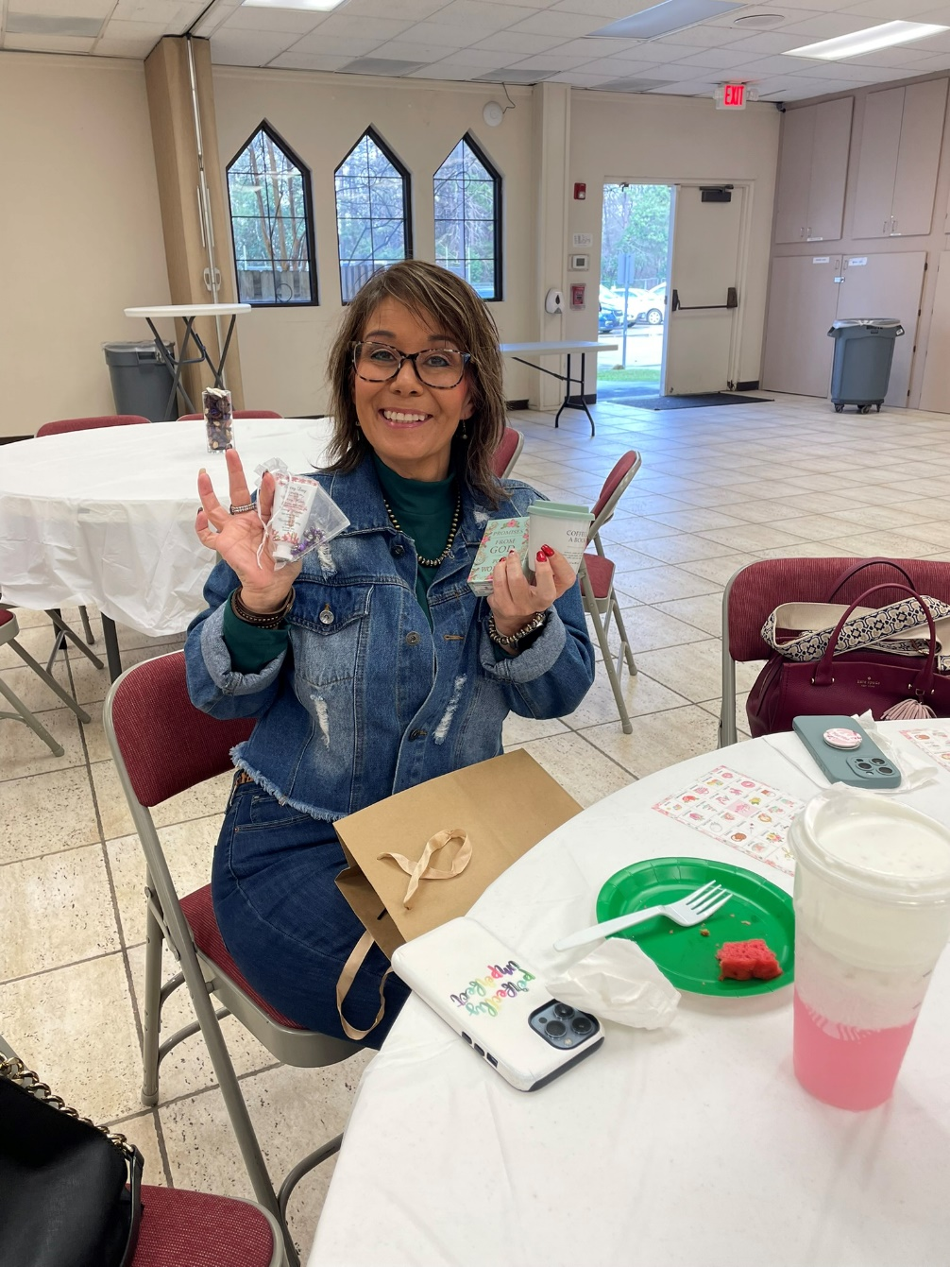



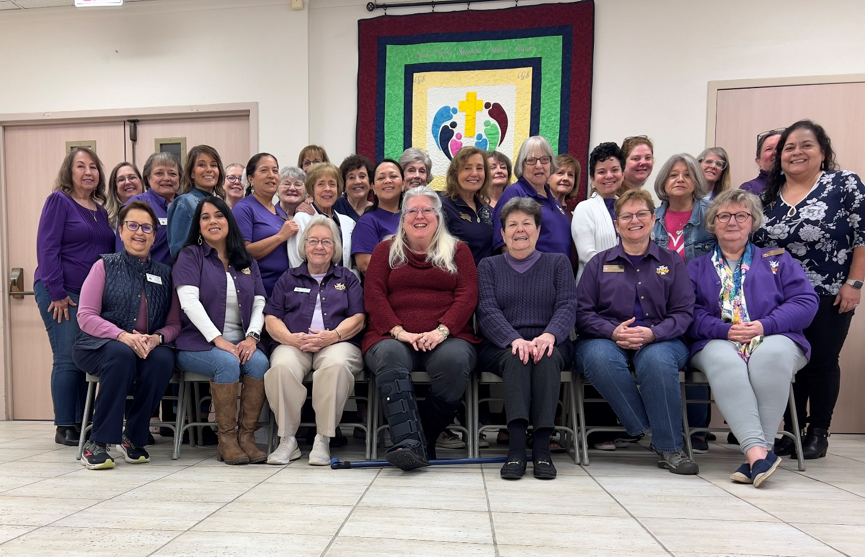

Collection of Baby Items – February 22 & 23, 2025
CGS supports Loving Choice Pregnancy Center. As part of this effort, CDA members at CGS collected baby items after all the masses this weekend for newborns who were spiritually adopted. Many thanks to all those in the parish who donated baby items and the volunteers who collected 2 carts full of items to deliver to the pregnancy center. Happy birthday to the babies!!!

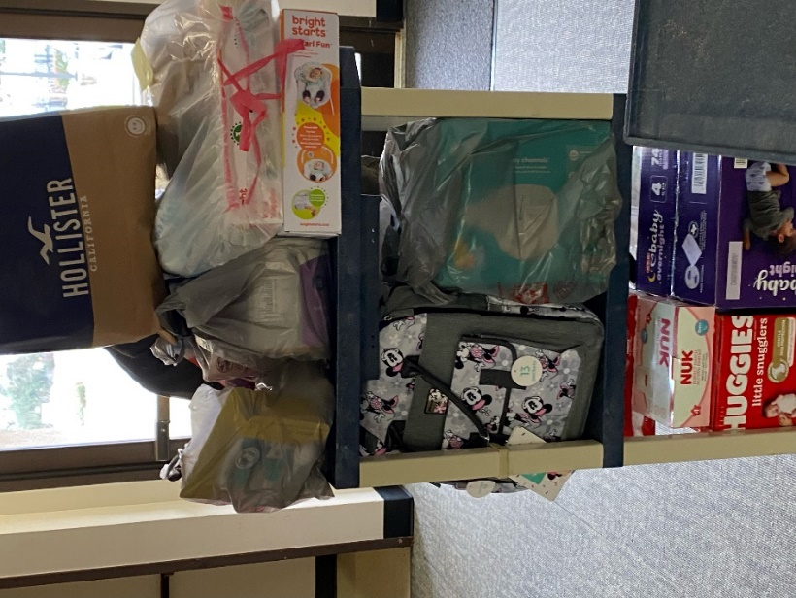




Junior CDA Organization Meeting – February 27, 2025

We officially have enough girls to form a JCDA court! At the time of this writing, we have 27 young ladies who have joined exceeding the minimum of 15 members to move forward. All the membership applications were submitted, which was a huge milestone. GroupMe will serve as the mode of communication for members and parents. Annual dues are $15 per member with a max of $50 per family. Members are voting on a group name. Officers are listed below.
- President – Sunem Rodriguez
- 1st Vice President – Brianna Nguimdo
- 2nd Vice President – Shannon Nguimdo
- Secretary – Leah Roth
- Reporter – Gabriella Monge
Special thanks to Karen Doolittle, Quetzy Reyes, and Christine Maniscalco for their help in making these come to fruition. ---Sade Effiong
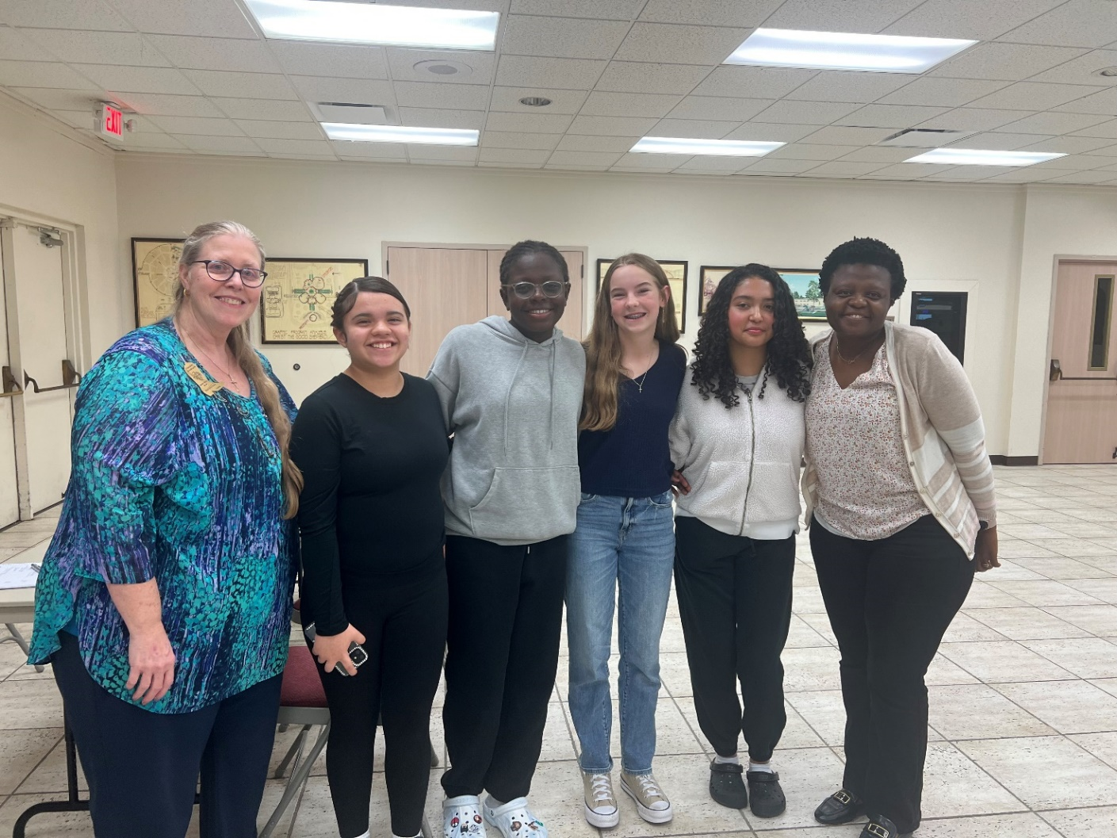
From left to right: District Deputy Christine Maniscalco, Sunem, Brianna, Leah, Gabriella, Shannon’s mother (proxy)

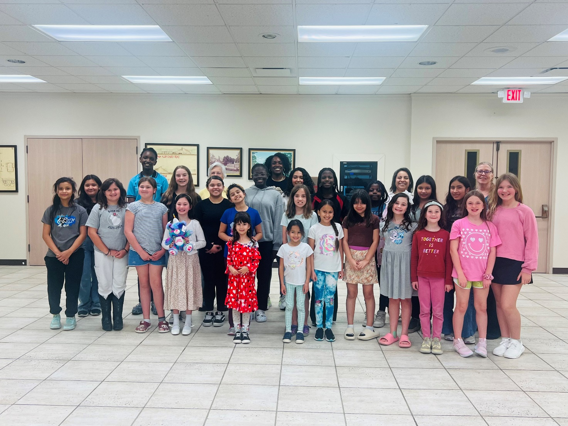
Fish Fry Friday – March 14, 2025
During the Fish Fry Dinners hosted by the Knights of Columbus on Fridays, CDA members provide desserts with a request for donations. For this week, a St. Patrick’s Day theme was used.
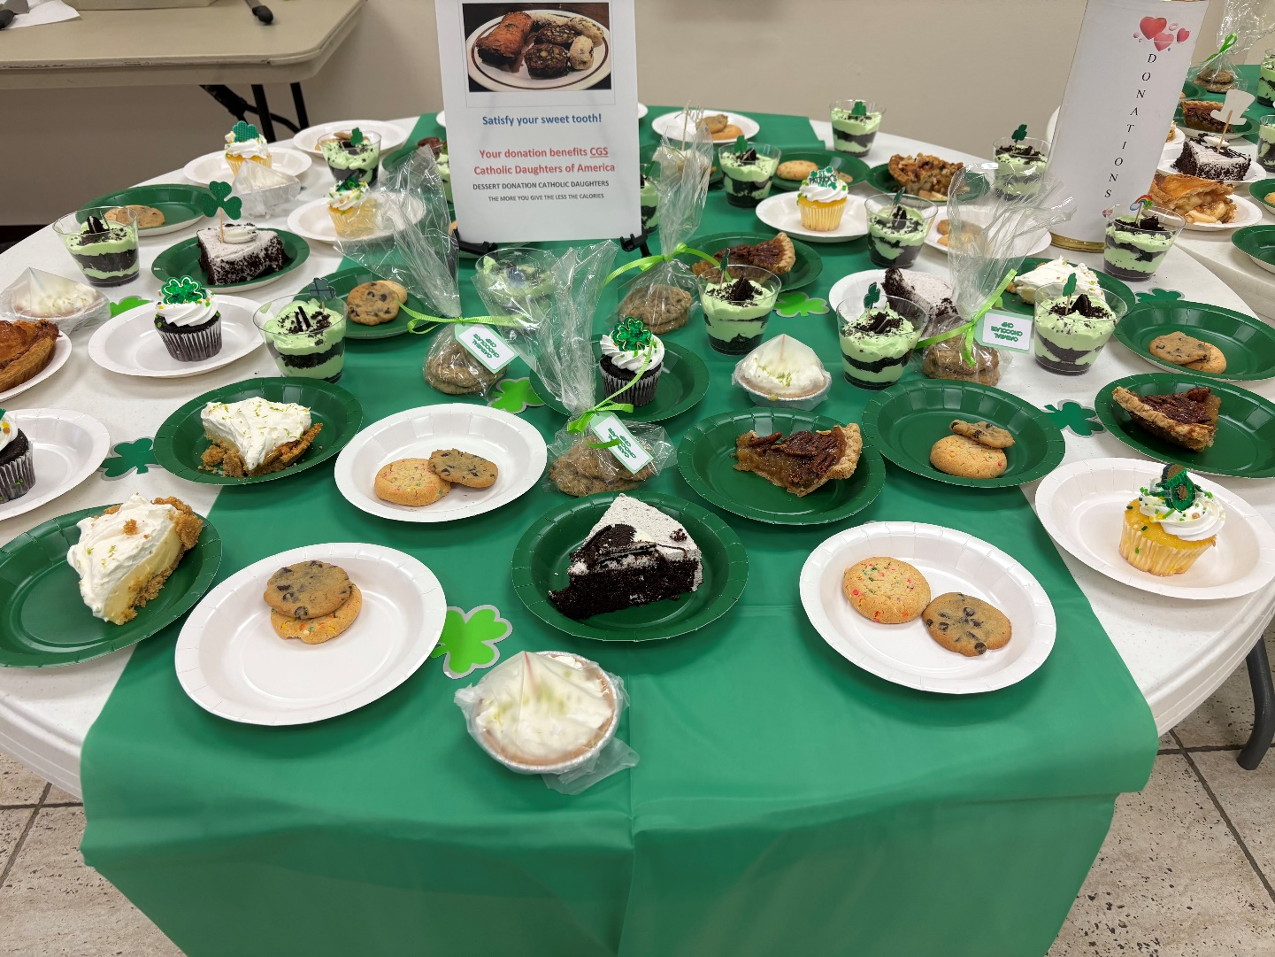




April Meeting & New Member Installation – April 3, 2025
During the April CDA meeting, new member Laura Aguirre joined our CDA group. Welcome, Laura!!!
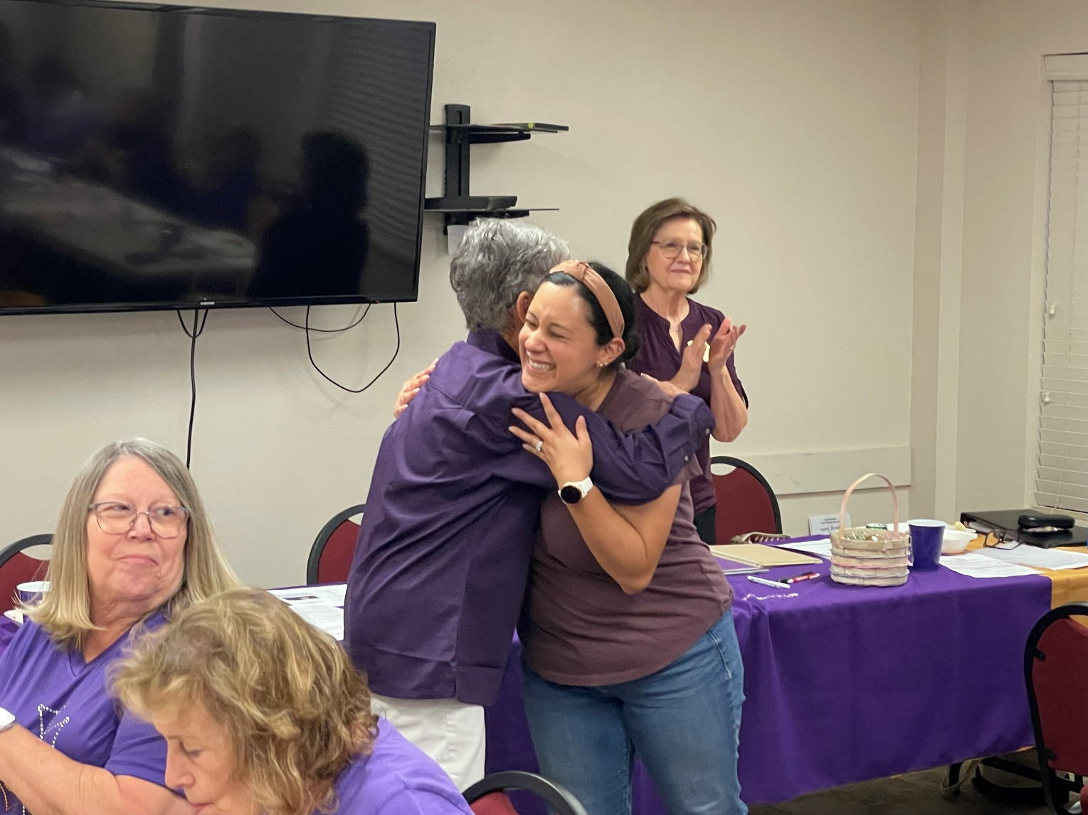



Mass Cards
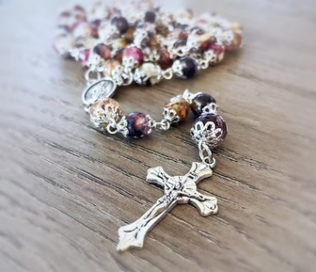
CDA sells mass cards to provide scholarship funds for relatives of CDA members. Scholarships can be used for attendance at college or a catholic high school. Mass cards can be purchased for $5 from CDA members at any community weekend or by contacting Mary Louise Roberts either via email or by phone at (281)813-4074. She is willing to meet you at the church or at Houston Catholic. Consider buying mass cards for birthdays or other special occasions!

Praying the Rosary
On the days of the CDA monthly meetings, members join
at 6pm by the Marian windows to pray the rosary.

Legislative Updates
Issues & Action
Are you interested in any of the topics listed in the screenshot below? To learn more about these issues in relation to church teachings, visit the USCCB website: https://www.usccb.org/topics

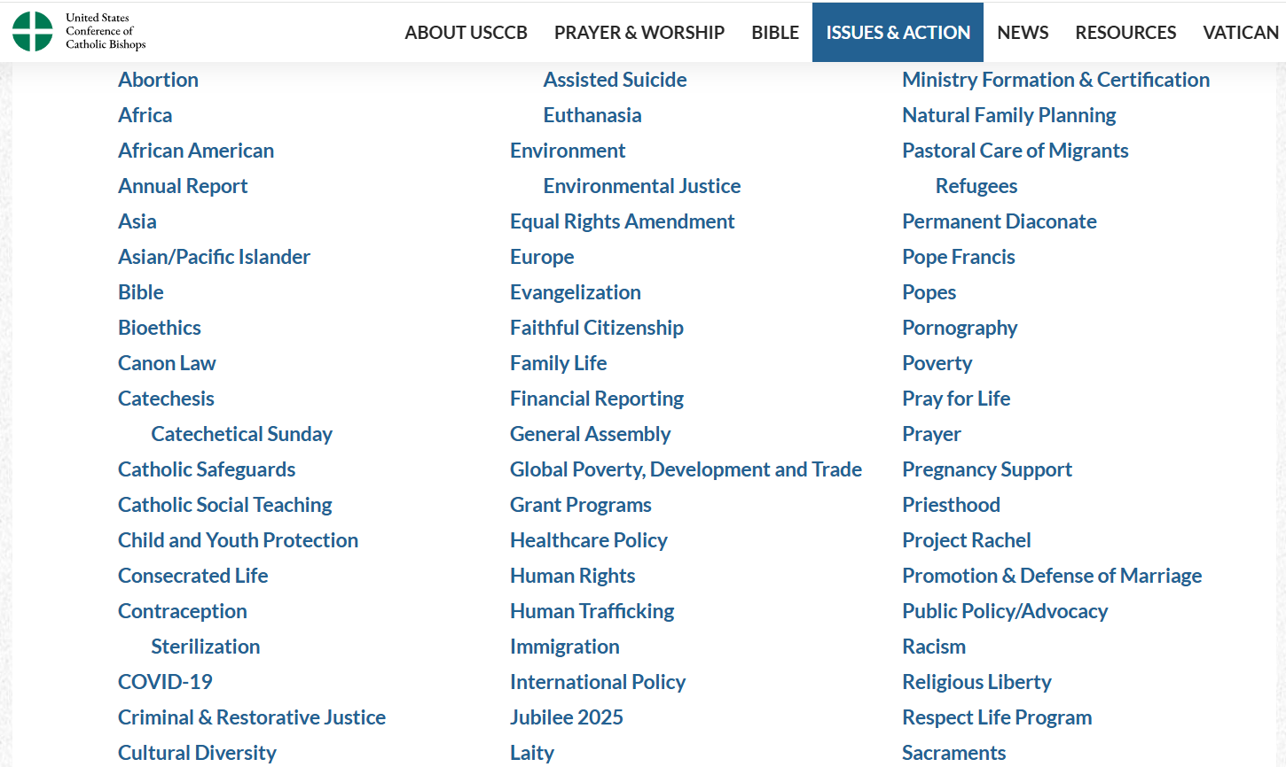
CDA National Legislative Link:
https://catholicdaughters.org/circle-of-love#tabContent_2505669

Local, State, & National CDA News
Local Events
- Emerging Grace Ministries Executive Director Tina Stahl visited the March meeting as a guest speaker to discuss human trafficking and how members can support this campus for victims. Please contact (936)337-1103 for more information. Mari Castaño is willing to take any donations to Tina.
State News
- Biennial Texas State Convention on April 23-27 at the Sheraton Dallas Hotel. Visit the Texas CDA website for more information:
https://texascda.org/2025-convention-home
National & International News
- Pray for Leaders – As always, pray for our elected officials and leaders.
- Pilgrimages – Pope Francies declared the year of 2025 to be a jubilee year. Some planned pilgrimages are listed below.
  - Florida State Pilgrimage to Italy – May 23 through June 3, 2025
https://www.lpjp.org/trips/12-day-italy-pilgrimage---florida-cda-%26--holy-spirit-catholic-church
  - Pilgrimage to Greece and Turkey – October 2025
Call (833)944-8242 or email booking@lpjp.org
  - New York Pilgrimage to Italy – November 3 through 14, 2025
https://www.lpjp.org/trips/12-day-italy-pilgrimage-the-jubilee-of-rome-2025-cda-ny
- Charities & Ongoing Projects - CDA supports several national charities and projects such as Habitat for Humanity, Apostleship of the Sea, Catholic Relief Services, Disaster Relief Fund, Human Life International, and Missionaries of Charity. For a full list visit the website: https://catholicdaughters.org/national-projects-and-charities


Birthdays Anniversaries

April
Ann Molloy – 4/13 Yvette Gonzalez – 4/28
Gizelle Williams – 4/13 Diana Samson – 4/29
Mary Jane Brewster - 4/23 Tracey Perez – 4/30
Sade Effiong – 4/25
Lillian Kainer – 4/26
Joyce Taylor Smith – 4/27
Rita Thomason – 4/27
Priscilla Hargraves – 4/29
Suellyn Sweeney – 4/29

May
Cathy Baratti – 5/13 Tabitha Madrid – 5/1
Ramona Scarlett – 5/18 Jean Sanfelippo – 5/1
Vicky Simental – 5/22 Mary Jane Brewster – 5/4
Karen Doolittle – 5/29 Olivia Magness – 5/6
Josie Zanco – 5/30 Candice Tyrrell – 5/6
Maggie Barrera – 5/28
Maria Clancy – 5/31
June
Maggie Zanco – 6/5 Sheryl Andrews – 6/3
Missy Landry – 6/6 Lori Maldonado – 6/5
Diana Samson – 6/7 Jackie Vail – 6/8
Jan Beall – 6/9 Peggy O’Neil – 6/12
Gloria Riley – 6/13 Quetzy Reyes – 6/13
Dawn Leal – 6/17 Ramona Scarlett – 6/16
Lorena Ortiz – 6/25
Ellie Petersen – 6/29



Newsletter Editor: Marinela Castano
Please submit corrections or feedback to mari.castano@comcast.net

