 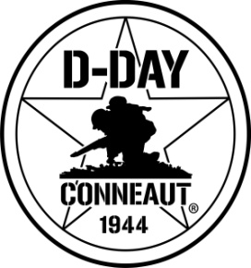

**Amboy Rifle Club / D-Day Raffle**

50% of the profits from this raffle will go to support the D-Day Ohio event.

**Only 1,000 tickets sold. Tickets $10 each (plus a small service fee for online purchases). Winner will be drawn Aug. 18, 2018 or when all tickets are sold. Pictures shown are for reference only. Out of State winner required to pay for firearm transfer.**

**18 years old or older to purchase a ticket and must pass back ground check. Disqualified if unable to pass a back-ground check and another ticket will be drawn.**

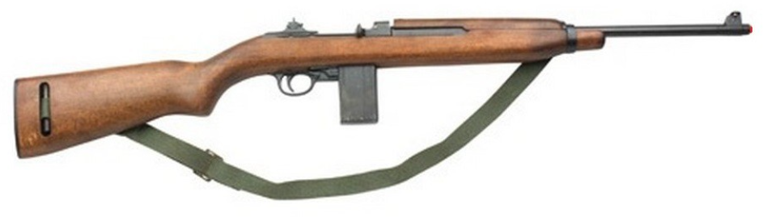

**This is an authentic 1943, not a replica, used, 30 caliber M1 Carbine rifle.**

**Rules:**

* **Only 1,000 tickets will be sold.**
* **Tickets are a $10 donation per ticket.**
* **The raffle winner will be drawn Aug. 18, 2018, or when all tickets are sold.**
* **Raffle void where prohibited.**
* **You must be at least 18 years old and a legal resident of the United States to purchase a ticket.**
* **The firearm is not transferable meaning the person designated on the ticket must claim the firearm.**
* **Winner of the firearm must comply with all local and federal firearm purchasing and owning regulations. All Federal Bureau of Alcohol Tobacco and Firearms (BATF) rules apply and by claiming a firearm prize the winner agrees to provide all information necessary for the transfer of the firearm.**
* **Winning Firearm transfer will be done through a Federal Firearms Licensed (FFL) dealer and all applicable Federal and State laws will apply, including the state laws for the legal residence of winning ticket holder.**
* **Winner will be responsible for any applicable Federal, State and local taxes.**
* **Raffle is for this M-1 Carbine rifle only. No cash option will be made available.**
* **If the winner is legally or otherwise unable to receive the rifle, a new winner will be chosen by random.**
* **The Amboy Rifle Club and D-Day Ohio are not responsible for any warranty claims on the rifle. The winner is responsible to assure their safety for use of this firearm.**
* **The Amboy Rifle Club and D-Day Ohio limits any and all liability to the purchase price of the ticket purchased.**
* **D-Day Ohio is not responsible or liable for raffle of this firearm.**
* **All ticket donations are final. No refunds will be issued for tickets.**