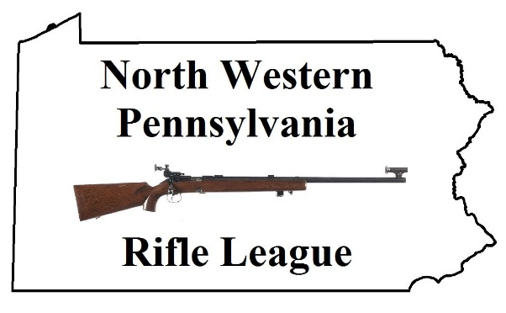
North Western Pennsylvania
Rifle League
Round 1
January 8 Albion vs Corry / Amboy @ BYE
January 15 Corry @ BYE / Amboy vs Albion
January 22 Amboy vs Corry / BYE @ Albion
January 29 Corry vs Albion / Amboy @ BYE
February 5 BYE @ Corry / Albion vs Amboy
Round 2
February 12 Corry vs Amboy / Albion @ BYE
February 19 Albion vs Corry / BYE @ Amboy
February 26 Corry @ BYE / Amboy vs Albion
March 5 Amboy vs Corry / BYE @ Albion
March 12 Corry vs Albion / Amboy @ BYE
Round 3
March 19 BYE @ Corry / Albion vs Amboy
March 26 Corry vs Amboy / Albion @ BYE
April 2 Albion vs Corry / BYE @ Amboy
April 9 Corry @ BYE / Amboy vs Albion
April 16 Amboy vs Corry / BYE @ Albion

