9 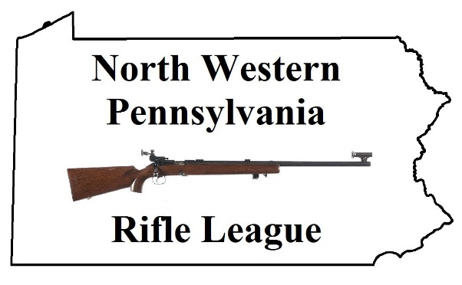

|  |  |  |
| --- | --- | --- |
|  | **North Western Pennsylvania  Rifle League** |  |

***Round 1***

**January 6 Albion @ Corry /** Amboy @ BYE

**January 13** Corry @ BYE **/ Amboy @ Albion**

**January 20 Amboy @ Corry /** Albion @ BYE

**January 27 Corry @ Albion /** Amboy @ BYE

**February 3** Corry @ BYE  **/ Albion @ Amboy**

***Round 2***

**February 10 Corry @ Amboy /** Albion @ BYE

**February 17 Albion @ Corry /** Amboy @ BYE

**February 24** Corry @ BYE **/ Amboy @ Albion**

**March 3 Amboy @ Corry /** Albion @ BYE

**March 10 Corry @ Albion /** Amboy @ BYE

***Round 3***

**March 17** Corry @ BYE **/ Albion @ Amboy**

**March 24 Corry @ Amboy** / Albion @ BYE

**March 31 Albion @ Corry /** Amboy @ BYE

**April 7** Corry @ BYE **/ Amboy @ Albion**

**April 14 Amboy @ Corry /** Albion @ BYE