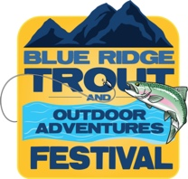
2022 TROUT FEST VENDOR/EXHIBITOR SURVEY
PLEASE EMAIL YOUR COMPLETED 2022 TROUT FEST VENDOR/EXHIBITOR SURVEY to blueridgetroutfest@gmail.com.
You do not have to identify your company unless you choose to do so. We want to improve next year and this will help us accomplish that. Thank you … Bob Borgwat, event coordinator (bborgwat@gmail.com)

1. Will you please rate your overall experience?
Excellent _____ Good_____ OK_____ Bad_____
2. Please let us know how we can make your experience even better next year.
__________________________________________________________________________________________
__________________________________________________________________________________________
__________________________________________________________________________________________
__________________________________________________________________________________________
3. Please describe what worked well (instructions, set up, communication, take down, etc.)
__________________________________________________________________________________________
__________________________________________________________________________________________
__________________________________________________________________________________________
__________________________________________________________________________________________
4. Please describe what did not work well.
__________________________________________________________________________________________
__________________________________________________________________________________________
__________________________________________________________________________________________
__________________________________________________________________________________________
5. How did you hear about the Blue Ridge Trout Festival?
Friend ___ Advertising ____ Facebook ___ Poster/Rack Card ____ Web Site ____ Other ____
6. Would you participate again next year?
Yes _____ No _____ Maybe ____

________________________________________________________________________________________
Company Name (OPTIONAL)

