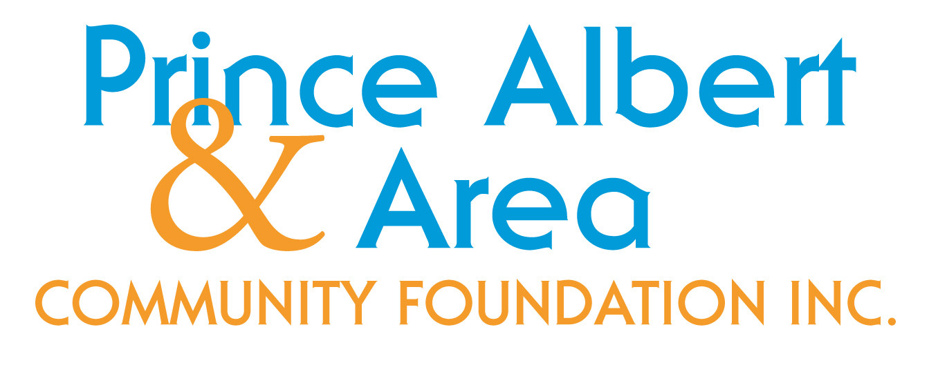
NEWSLETTER March 2020
D

Irections, Goals and Actions - Global struggles to cope with COVID-19 are shared by all of us. We appreciate the exceptional co-operation between business, government, the social sector and all our neighbours.

PARTNERSHIP WITH COMMUNITY
FOUNDATIONS OF CANADA
AND RBC

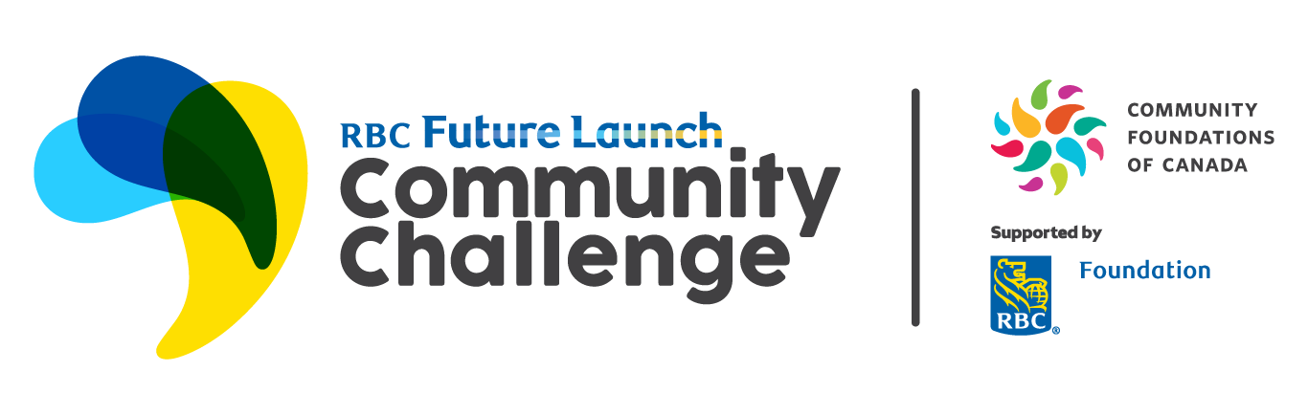 RBC Future Launch Community Challenge

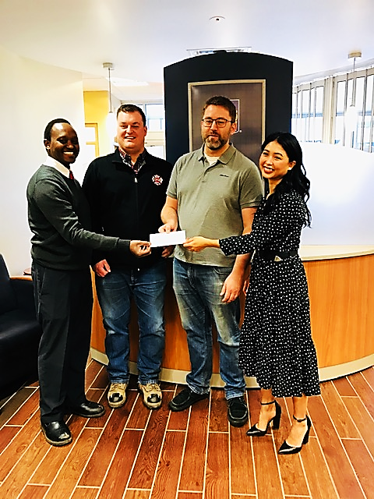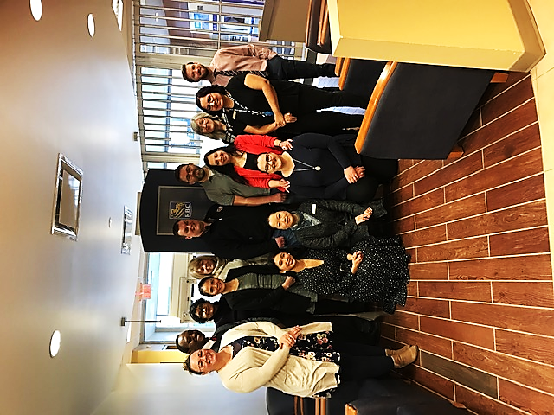
Joseph Kiunga, PAACF Joined by RBC Team, Prince Albert
Tim Siebert, Clint Knutson, Birch Hills
Mirabel Uligan, RBC

  - The “Community Reset” project in Birch Hills began on Feb 28th. The project offers conflict mediation and reconciliation training to families and organizations in the community. The training is directed towards leading people through personal conflict as well as leading people through conflict in the role of mediator.

PARTNERSHIP WITH COMMUNITY
FOUNDATIONS OF CANADA WITH SUPPORT FROM THE GOVERNMENT
OF CANADA

- This collaboration has three broad areas for impact:
  - Peace - Supporting girls, women and trans* people as they build lives free from gender-based violence;
  - Power - Shifting economic, political, and social power, as well as power over one’s own body, towards increased equality between genders;
  - Planet - Strengthening participation, leadership, and climate justice for girls, women and trans* people
as they build more sustainable futures.
- The Pilot Fund for Gender Equality is a first learning opportunity, as community foundations and local organizations come together to explore ways to support leadership in the women’s movement and ways to advance gender
equality in communities across Canada.
*26 community foundations from coast to coast to coast are participating in the Pilot Fund. In Prince Albert, a
short-term Pilot project is being implemented by Catholic Family Services of Prince Albert.

DONOR EARNINGS – DONATION FROM GUSTAFSON FAMILY FUND
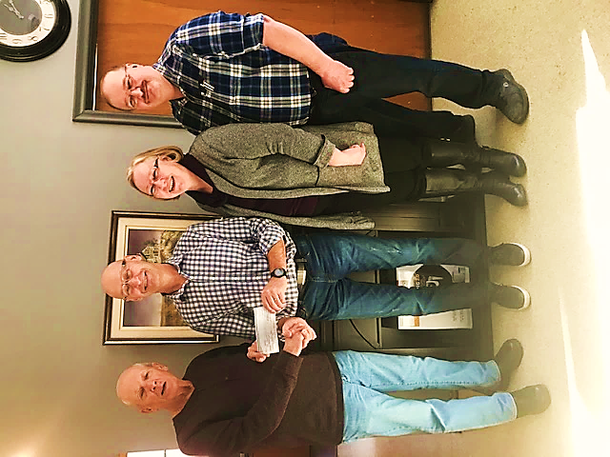
Twenty years ago, the Prince Albert and Area Community Foundation (PAACF) was just starting. With support from Conexus (then Prince Albert Credit Union), the Millennium Fund was established: no-interest loans to make an initial donation/investment with the foundation.
As the founding president of PAACF, Barb Gustafson, and her husband Grant were part of the Millennium Fund members, donating $2000 each and establishing a family fund. With some additional donations over the years since then, those invested donations are now paying off. Community foundation donations are invested, not spent. The earnings on those initial donations are then distributed to local charities. The Gustafsons have chosen to donate the current earnings from their family fund, $2000, to SHARE.
This is the second time they have supported SHARE with the earnings from the
PAACF fund. Jim McKnight, PAACF Robin Knutsen , SHARE Barb & Grant Gustafson

PRINCE ALBERT & AREA COMMUNITY FOUNDATION INC.
P.O. Box 291 Prince Albert SK S6V 5R5 306-764-9108
pafoundation@sasktel.net www.pafoundation.ca

Mission of PAACF – To encourage philanthropy and fund charitable activities that will
contribute to an improved quality of life in our region.

