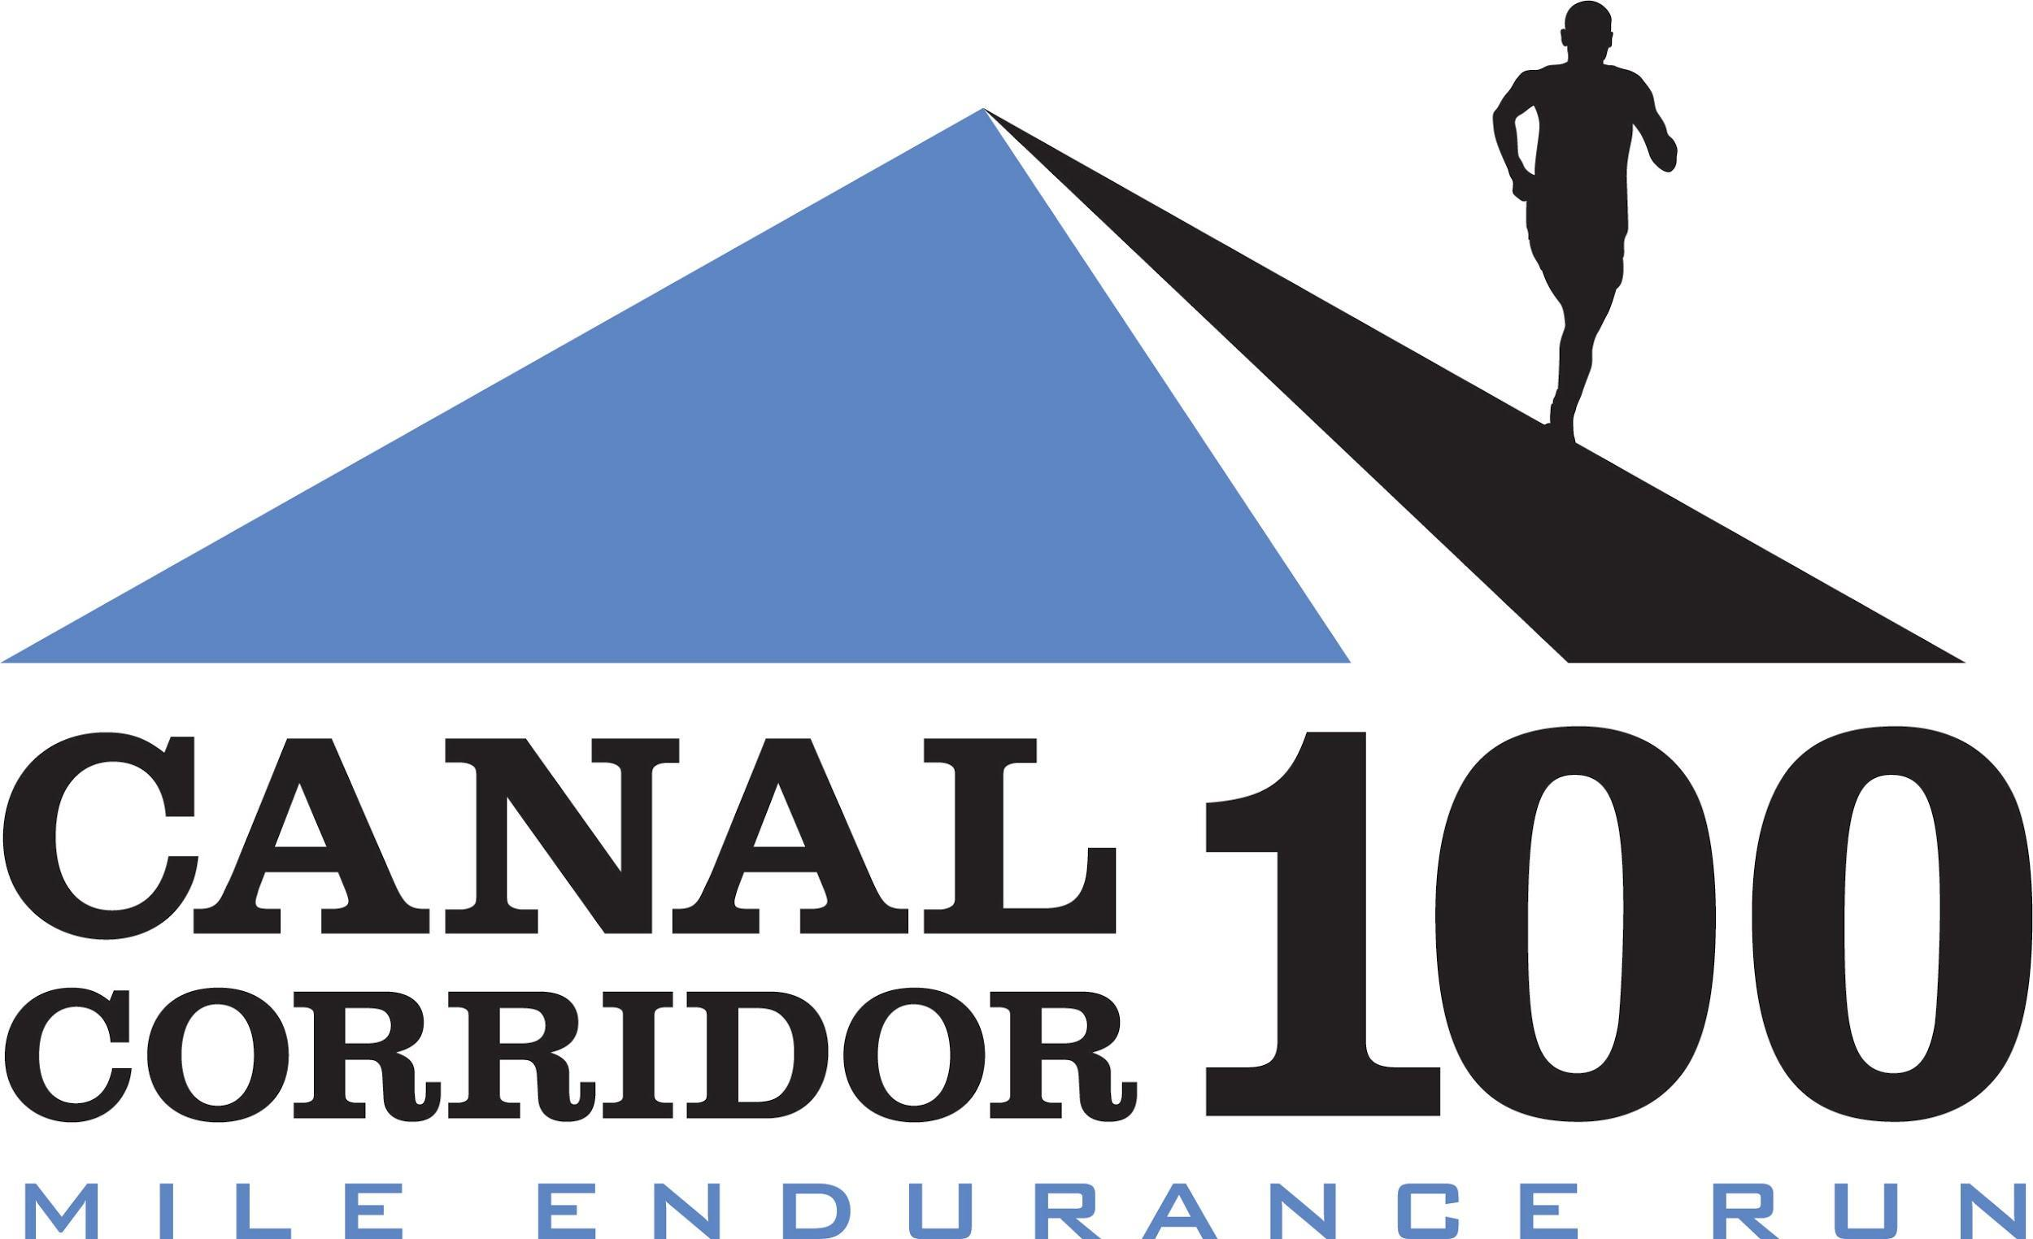

2021 CREW GUIDE v2

Welcome! As experienced crew, we know what it feels like wandering around a strange town following your runner and forgetting to take care of yourself, don’t do it!! You are an integral part of getting your runner to the finish line, and we are here with some information to help you make it fun and safe!

We have included some information here to help you navigate with suggestions for points of interest, restaurants, grocery stores, and gas stations. Crewing is hard work!

Things to Note:

* Aid Station Food and Goodies are prioritized for runners, but feel free to keep yourself going by asking aid station volunteers for a bite.
* Dogs and Children are allowed. However, unattended children will be given kazoos and espresso. Unattended dogs may go missing because we love them and will take them home for ourselves. Please be respectful that this is a race environment. It will be a long day, we recommend keeping the kids with and without fur at home.
* Please respect staff, volunteers, and rangers.
* No alcohol. No littering. Period.
* Also, be careful to keep your distance from others even though we’re outdoors due to COVID-19. The Summit County Health Department will likely be alerted if people are gathering in really close quarters and we want everyone to be safe and healthy.

Runners are responsible for their crew and their crew’s compliance with our rules. Crew can access their runners and provide aid within 100 yards of any aid station (manned or unmanned EXCEPT for Lock 29 and the Southern Turnaround, which are off limits for crew and pacers). Crew CANNOT ride a bike alongside their runner. It’s fine if you bike from aid station to aid station, but please stay clear of runners and do not pace your runner. Please note that there are many places along The Towpath where crew can see their runner, but only the area around the aid station is an allowable place to receive aid. A violation of these rules will result in disqualification of the runner.

**CONDUCT SYMPTOMS ASSESSMENT PRIOR TO TRAVELING TO THE RACE, THE NIGHT BEFORE AND THE MORNING OF THE RACE**

Participants in outdoor activities in a shared social space should conduct symptom assessments prior to engaging in outdoor recreational activities to minimize the transmission of COVID-19. Symptoms include the following:

● Cough

● Shortness of breath or difficulty breathing

● Fever

● Chills

● Muscle pain

● Sore throat

● New loss of taste or smell

Symptomatic individuals should stay at home and perform daily symptom assessments before interacting with others.

**SYMPTOMS THAT DEVELOP DURING THE RACE**

If you develop COVID-19 symptoms, immediately return home, isolate and/or seek medical care if you develop symptoms during the event.

**SCHEDULE OF EVENTS**

Packet pickup and check in at Missing Falls Brewery Aid Station (520 S. Main St, Suite 2511-24, Akron, OH 44311) on Friday October 8, 2021 from 11:00am-7:00pm.

Race Starts at 5:00 AM on Saturday, October 9, 2021 in Akron, Ohio.

There is a 30 hour time limit.

The finish line is back in Akron, Ohio. The race ends at 11:00am on Sunday October 10, 2021.

Friday, October 8

11:00am – 7:00pm : Check-in

6:00pm: tour of start/finish and Missing Falls aid station

7:00pm : Deadline for Drop Bags

Saturday, October 9

STARTING LINE – Akron, Ohio ALL RUNNERS MUST CHECK IN AT START LINE

3:30am – 4:30am: Runner Drop Bag pickup for Late Arrivals

5:00am SHARP: Mass Start

FINISH LINE – Missing Falls Brewery

Sunday, October 10

1:00am: Missing Falls Brewery closes for a few hours.

5:00am: Missing Falls Brewery opens for brunch!

11:00am: Race Closes / Awards

**CUTOFF:** 30 hours

**DIRECTIONS TO THE START/FINISH & PARKING**

The start/finish is located in the parking lot in front of Missing Falls Brewery, Canal Place, 540 S. Main Street, Suite 112, Akron, Ohio 44311. There is plenty of parking in the Canal Place complex right along our race route. We’ll be directing traffic into the parking area as early as 4:00am.

Along the route, please be mindful of using parking spaces and to not obstruct traffic or park “off road.”

**MEDICAL**

Aid stations have basic first aid supplies but cannot administer first aid. In the event of an emergency, they will call 911.

**PACERS**

Runners are responsible for their pacers conduct. Only one pacer per runner at any given time. Pacers may start at mile 46.26 (Crystal Springs) and every fully manned aid station after mile 46.26. Please note that the Towpath provides numerous access opportunities for pacers and crew to see their runner. However, pacers and crew may only assist their runner within 100 feet of aid stations. The Towpath is also bikeable, but runners CANNOT use a cyclist as a pacer. Note that runners may use a bicyclist as their crew. The difference is that a bicyclist acting as a pacer follows closely behind or in front of their runner – this is prohibited and will result in disqualification of the runner. A bicyclist who is crewing should handle their runner within 100 feet of an aid station, but may not closely follow.

Pacers cannot start at the Clinton Trailhead because it is unmanned and cannot join their runner at any unmanned aid station. If pacers are unable to keep up with their runner for whatever reason, the pacer needs to stop at the next aid station. The race is not responsible for transporting pacers. Pacers cannot mule (carry things) for their runner. Pacers may not give their runner any aid, clothing, food, water unless it is an emergency situation, in which case the runner may be disqualified. The role of a pacer is for safety, not for aid or gaining an advantage over fellow participants. Runners are only allowed one pacer at a time. Pacers may have food at the aid stations. Pacers are expected to review, sign and submit a waiver to participate. Waivers will be available at all manned aid stations starting at Mile 46.26.

**AID STATIONS**

Full service aid stations will typically include Heed, water, Coke, ginger ale, 7up, Mtn. Dew, orange juice, Athletic Brewing (Upside Dawn or Run Wild), ice, Hammer Nutrition gels (tropical, espresso available after mile 50) and Spring (Long Haul and Canaberry, Speednut w/ caffeine after mile 50), PB&J, bananas, oranges, watermelon, M&Ms, chips, pretzels, salted potatoes, fruit cups, peanuts, jelly beans, pickles, mini Paydays, and fig newtons. After 6:00pm, we’ll have ramen, coffee and other hot foods for nighttime fueling. All full aid stations will have menstrual products (tampons and pads) on the table for any runner or pacer in need. Each fully manned aid station will also have Hammer Nutrition endurolytes available. Please have your runner bring their own collapsible cup, handheld or bladder for hydration.

**AID STATION DESCRIPTIONS**

**MANCHESTER ROAD TRAILHEAD**: Mile 4.5 and 65.8

Amenities: unmanned water drop, restroom, crew access

Coordinates: 41.0236, -81.55072

Address: 2740 Manchester Road, Akron, OH 44314

**WOLF CREEK**: Mile 8.8 and 61.5

Amenities: full aid, restroom, crew access, pacer access going north

Coordinates: 41.003814, -81.607699

Address: 33 Snyder Ave, Barberton, OH 44203

**VANDERHOOF ROAD TRAILHEAD**: Mile 11.08 and 59.19

Amenities: unmanned water drop, restroom, crew access

Coordinates: 40.97811, -81.60534

Address: 2445 Vanderhoof Road, New Franklin, OH 44203

**FRANKLIN**: Mile 13.5 and 56.7

Amenities: full aid, restroom, crew access, pacer access going north

Coordinates: 40.947637, -81.617644

Address: 2328 Center Rd, New Franklin, OH 44216

**CLINTON TRAILHEAD**: Mile 15 and 55.2

Amenities: unmanned water drop, restroom, crew access

Coordinates: 40.92854, -81.63013

Address: 2749 North Street, Clinton, OH 44216

**CANAL FULTON – ST. HELENA’S:** Mile 19 and 51.2

Amenities: full aid, restroom, crew access, pacer access going north, drop bag access, timing mat

Cutoff: 8:40pm

Coordinates: 40.88777, -81.59698

Address: 123 Tuscarawas St NW, Canal Fulton, OH 44614

*Please note that parking may be difficult during the day because a kids soccer event is happening in St. Helena Heritage Park on Saturday!*

**CRYSTAL SPRINGS**: Mile 23.8 and 46.26  
Amenities: full aid, restroom, crew access  
Coordinates: 40.846238, -81.537079

Address: 4503 Erie Ave NW, Canal Fulton, OH 44614

**ERNIE’S BIKE SHOP**: Mile 26.79 and 43.48  
Amenities: unmanned water drop, restroom, crew access  
Coordinates: 40.811720, -81.528669  
Address: 135 Lake Ave NW, Massillon, OH 44647

**SKYLAND AVE (Sippo Trail):** Mile 31.37 and 38.89

Amenities: full aid, restroom, crew access, drop bag access

Cutoff: 5:15pm (runners headed north/east)

Coordinates: 40.81455, -81.58685

Address: 2069 Skyland Ave NW, Massillon, OH 44647

**SOUTHWEST TURNAROUND**: Mile 35.13

Amenities: Timing mat, unmanned water drop, NO crew, NO restrooms

**MISSING FALLS BREWERY**: Mile 0, 70.05 and 100

Amenities: full aid, restroom, crew access, pacer access for runners headed north, access to your parked car, drop bag access, timing mat at aid station(!)

Cutoff: 2:10am (runners headed north)

Coordinates: 41.0705, -81.52658

Address: Canal Place, 540 S Main St #112, Akron, OH 44311

**MEMORIAL PARKWAY TRAILHEAD**: Mile 72.94 and 96.89

Amenities: full aid, restroom, crew access, pacer access for runners in both directions

Cutoff: 10:15am (runners headed south)

Coordinates: 41.10433, -81.5281

Address: 499 Memorial Parkway, Akron, OH 44310

**SECOND SOLE AKRUN**: Mile 76 and 94.1

Amenities: full aid, crew access, pacer access for runners in both directions, portapotty

Cutoffs: 4:00am (runners headed north); 9:25am (runners headed south)

Coordinates: 41.13471, -81.54946 (note that parking and aid station are behind Second Sole Akrun)

Address: 1466 N Portage Path, Akron, OH 44313

**BOTZUM**: Mile 78.5 and 91.6  
Amenities: unmanned water drop, restrooms, crew access

Coordinates: 41.159215, -81.574364  
Address: 2928 Riverview Rd, Akron, OH 44313

**IRA TRAILHEAD**: Mile 80.05 and 89.78

Amenities: full aid, restroom, crew access, pacer access for runners in both directions, drop bag access

Cutoffs: 5:15am (runners headed north); 8:05am (runners headed south)

Coordinates: 41.18369, -81.58208

Address: 3801 Riverview Road, Peninsula, OH 44264

**DEEP LOCK QUARRY**: Mile 84.3 and 85.9  
Amenities: unmanned water drop, crew access (please do not block the Towpath!), NO restrooms  
Coordinates: 41.232287, -81.551611

Address: 5779 Riverview Rd, Peninsula, OH 44264

**LOCK 29 turnaround:** Mile 84.91  
Amenities: unmanned water drop, restrooms (other end of parking lot), NO crew  
Coordinates: 41.24291, -81.55046  
Address: 1648 Mill Street W, Peninsula, OH 44264

**RACE DAY COMMUNICATION**

We started a slack channel specifically for crew and runner support this year. If you sign up, you’ll be able to communicate with race organizers and other runners’ crew with your questions. To sign up, please give us your email address (or have your runner sign you up) at packet pickup. Make sure to download the slack app prior to the race start!

**RUNNER TRACKING**

Runners must wear a timing chip around their ankle, which will read their progress at Canal Fulton, the Southern Turnaround, Missing Falls, Second Sole and the Northern Turnaround at Lock 29. The link to track your runner is available here: <http://onlineraceresults.com/race/view_race.php?race_id=73916#racetop>

**LAST MINUTE SUPPLIES**

Visit our sponsor Second Sole Akrun at 1466 N Portage Path, Akron, OH 44313 for nutrition, hydration and gear needs. Their staff is packed with talented runners who know The Towpath and running gear inside and out. They are also located at the Second Sole Akrun aid station location of our course and are supplying Muir Energy Gels, Heed hydration, and all the supplies for the aid station. <https://www.facebook.com/secondsoleakrun/>

**MAPS**

The course map and aid stations are available [here.](https://www.google.com/maps/d/u/0/edit?mid=1c86jHmzoAlfFPULH0xWP_QEUk6z2Lyid&usp=sharing)

**WEATHER**

Daily average temperatures on October 9:

* High: 60 Record: 86
* Low: 45 Record: 31
* Day average: 53

Sunrise/Sunset Times for October 9 & 10

* Sunrise: 7:31am
* Sunset: 6:54 pm

**LODGING**

**Courtyard by Marriott, Akron** **Downtown** is the closest option to the start/finish (probably around 5 minutes away, but be aware of construction detours). 41 Furnace Street, Akron, OH 44308. We have a group rate of $129/night here from October 8-10. Last day to book is September 11, 2021. <https://www.marriott.com/event-reservations/reservation-link.mi?id=1622219908927&key=GRP&app=resvlink>

There’s a **Hilton, Hilton Garden Inn** and **Sheraton** within a reasonable driving distance to the start/finish as well.

**PRE-RACE MEAL SUGGESTIONS**

**Missing Falls Brewery (RACE HEADQUARTERS!)**

* [www.missingfalls.com](http://www.missingfalls.com)
* 540 S Main St #112, Akron, OH 44311
* Remember that they’ll also have brunch on Sunday starting at 7:00am

**Sushi Katsu** (around the corner from Second Sole, entrance in back of building)

* 1446 N Portage Path, Akron, OH 44313

**Mustard Seed Market** (great for breakfast, brunch, lunch, and dinner. A local favorite)

* <https://www.mustardseedmarket.com/locations/highland-square/>
* VEGAN/VEGETARIAN friendly
* Takeout ONLY right now. Restaurant closed as of 7-1-2020

**Lock 15 Brewing** (excellent food and great beer right along the Towpath!)

* <https://www.lock15brewing.com/>
* 21 W. North St., Akron, OH 44304

**Luigi's Pizza**

* 105 N Main St, Akron, OH 44308
* Cash only!

**ON COURSE AREAS OF INTEREST**

|  |  |
| --- | --- |
| 1. Missing Falls |  |
|  | Restaurants:   * Missing Falls * R.Shea Brewing (around the corner from Missing Falls) * Lock 15 Brewing * NOMZ <https://www.nomzeatz.com/> * Luigi’s Pizza <https://luigisrestaurant.com/>   Coffee   * Akron Coffee Roasters: 30 N High St, Akron, OH 44308 <https://www.akron.coffee/>   Grocery Stores:   * ALDI: 772 S Main Street Akron, OH 44311 * Market District 2687 State Rd, Cuyahoga Falls, OH 44223 * Mustard Seed Market: 867 W Market St, Akron, OH 44303 |
| 2. Manchester Road |  |
|  | Restaurants:   * Magic City Brewery <http://magiccitybrewingcompany.com/>   Grocery Stores + Supplies:   * Marc’s: 360 E Waterloo Road * Giant Eagle: 484 E Waterloo Road |
| 3. Canal Fulton  (Cherry Street) |  |
|  | Restaurants:   * Peace Love & Little Donuts (DO NOT MISS!!)   2378 Locust St S, Canal Fulton, OH 44614  Supplies:   * Brimstone Bikes & Brimstone Adventures   133 Canal St S, Canal Fulton, OH 44614 |
| 4. Skyland Ave |  |
|  | Restaurants:   * Bison Street Burgers & Brews: 1409 Bison Ave NW, Massillon, OH 44647 * Kraus’ Pizza: 1917 Lincoln Way NW, Massillon, OH 44647 * Cherry Road Winery: 1575 Bison St NW, Massillon, OH 44647   Supplies:   * Buehlers Fresh Foods Massillon: 2226 Lincoln Way W, Massillon, OH 44647 * Dollar General:   254 Federal Ave NW, Massillon, OH 44647   * Ernie’s Bicycle Shop:   135 Lake Ave NW, Massillon, OH 44647 |
| 5. Crystal Springs | ** You can park at the Towpath Cabinn   * 4462 Erie Ave NW, Massillon, OH 44647   Say hi to Mike, he is a BT50k Runner. Crystal springs trailhead is .25 miles north. |
| 5. Second Sole |  |
|  | Restaurants   * R.Shea Brewing: 1662 Merriman Rd, Akron, OH 44313 * Merchant Tavern: 1824 Merriman Rd, Akron, OH 44313 * Portage Crossing Shopping Center with Restaurants and Grocery:   + Market District: 2687 State Rd, Cuyahoga Falls, OH 44223   + Aladdin’s (Mediterranean) * Valley Café (breakfast!): 1212 Weathervane Ln, Akron, OH 44313 |
| 6. Ira |  |
|  | Restaurants:   * Winking Lizard (bar/restaurant):   1615 Main St Peninsula, OH 44264  Nearby areas Of Interest in the Cuyahoga Valley National Park:   * Beaver Marsh Boardwalk   3801 Riverview Rd, Peninsula, OH 44264   * Countryside Farmers Market (Saturday from 9-noon)   <https://countrysidefoodandfarms.org/>   * Brandywine Falls   8176 Brandywine Rd, Sagamore Hills, OH 44067 |