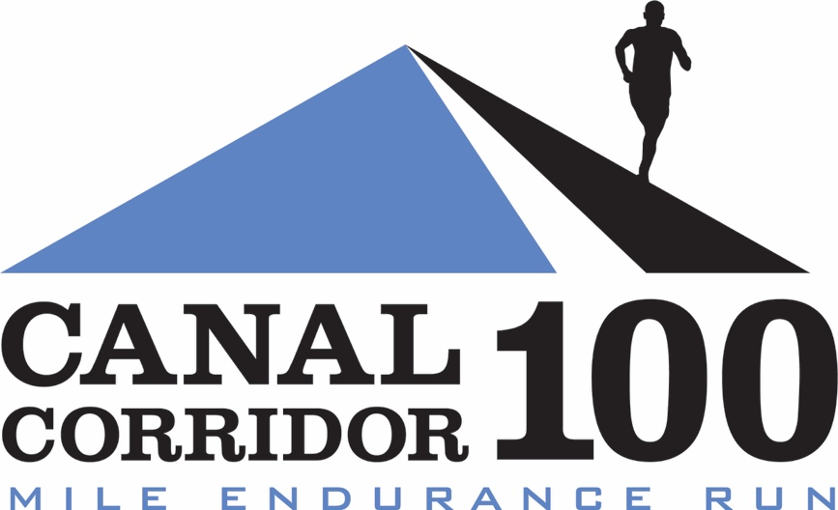

2020 RUNNERS MANUAL V.2

Established in 2017, Canal Corridor 100 Mile Endurance Run starts and finishes in downtown Akron, Ohio and takes runners through portions of the exceptionally beautiful Towpath Trail in the Cuyahoga Valley National Park, Akron and Canton. The course is FAST, FLAT and SCENIC and suitable for anyone looking to complete their first 100 miler or a seasoned ultrarunning veteran seeking to set a personal record. Aid stations are staffed by experienced ultra runners who know how to cater to the needs of endurance athletes.

With strict COVID-19 safety rules in place and plans to enforce those rules, we believe we can safely hold this year’s Canal Corridor 100 Mile Endurance Run because we can avoid being a “gathering” of 10 or more people. As discussed below, it will be different, but if we work together we can keep each other safe.

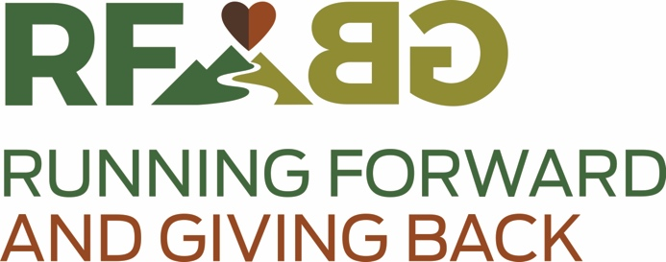

Running Forward, Giving Back and Run To Share, two Ohio 501(c)(3) nonprofits, host and manage high-quality running events to organize the community around giving back to the people and places of Northeast Ohio. Our motto is run hard, be thankful, give more than you take.

Our events encourage runners from all over the map to experience the outdoors in a supportive, encouraging social setting while feeding the local economy and giving back to local nonprofits. Through our events just in the last year, we have contributed over $42,000 of funds to the following small, local charities:

- Ohio & Erie Canalway Coalition
- Summit Metroparks Foundation
- Cleveland Metroparks Trails Fund
- Medina Battered Women’s Shelter
- Girls With Sole
- Conservancy for Cuyahoga National Park
- Bath Parks
- Canalway Partners
- Edwins Leadership & Restaurant Institute
- Bessie’s Angels
- East Cleveland Park Association
- Running2bWell
- Herren Project
- Feeding Medina County
- Friends of Crowell Hilaka
- Running Dog

Our races feature the quality of a for-profit event (chip race timing, certification and sanctioning, race directing and volunteer staffing, runner support and aid, medical and therapeutic services, race swag) coupled with the unrelenting mission to build up those in the worst conditions and situations among us within Northeast Ohio. In addition, we strive to highlight local, small businesses along the routes of our races.

RULE #1: NO HATE

Seriously. There are a bunch of rules we have to abide by to keep this event safe and smooth, but the most important one is that we expect that no one involved with our race will communicate hate or act on hate. This is a race intended to be about community. We love you all. We hope that you will treat others and yourself with the same love and respect.

COURSE DESCRIPTION

The start/finish line is at Missing Falls Brewery in downtown Akron, Ohio. The course runs along The Towpath Trail following the Ohio & Erie Canalway. The Towpath is a crushed limestone trail that occasionally yields to asphalt or concrete walkway. The start is in downtown Akron, Ohio and runners will travel south on the Towpath to Navarre, Ohio, approximately 35 miles, then returns north. You can obtain aid from the start/finish line – mile 68.7 - (and at your closely-parked car) at this point as well. After departing the Missing Falls Brewery aid station the second time, runners will head north on The Towpath through the Summit Metroparks and into the Cuyahoga Valley National Park all the way to Peninsula, Ohio before turning around to return to Akron, Ohio. There are aid stations approximately every 5-7 miles apart throughout the course.

REFUNDS

We recognize that the Governor’s phased approach to reopening is a dynamic one that may result in stricter measures or even a decision that the event cannot be held. Due to that circumstance, we will give runners registered as of April 29, 2020, the option to obtain a full refund of the amount paid to the race (not including the ultrasignup processing fee) if you make that request by May 3, 2020 by emailing Emily at eacollins04@gmail.com. For runners who remain registered after May 3, 2020, or for runners who register today (April 30, 2020) or later, if we are unable to hold the event due to a governmental order, revocation of our permits or another issue related to health, safety and welfare of runners, volunteers and members of the public, then we will allow you to either defer your entry to the following year, plan to participate in our contingency date of September 12-13, 2020, or request a refund of the amount remaining after we account for this year’s expenses.

CONDUCT SYMPTOMS ASSESSMENT PRIOR TO TRAVELING TO THE RACE, THE NIGHT BEFORE AND THE MORNING OF THE RACE

The State of Ohio mandates that participants in outdoor activities in a shared social space conduct symptom assessments prior to engaging in outdoor recreational activities. Symptoms include the following:

- Cough
- Shortness of breath or difficulty breathing
- Fever
- Chills
- Muscle pain
- Sore throat
- New loss of taste or smell

Symptomatic individuals should stay at home and perform daily symptom assessments before interacting with others.

SYMPTOMS THAT DEVELOP DURING THE RACE

If you develop COVID-19 symptoms, immediately return home, isolate and/or seek medical care if you develop symptoms during the event. We will have local EMS available if you’re in need.

PACKET PICKUP & THE STARTING LINE

Instead of packet pickup, we will mail you each your packets two weeks prior to the event. Your packet will include a runners mask that we encourage you to carry in your own pack (or around your neck) or share with a crew member for any interactions at aid stations or elsewhere along the course. In your packet, your bib will indicate your start time. Runners will start in 1 minute waves with three runners per minute with the fastest predicted finish times starting first to ensure the least amount of passing on the course. You must wait in your car until 5 minutes before your start time. At 5 minutes before your start time, runners can line up as indicated by taped or chalked Xs behind the start line. Masked volunteers will move you toward the start line. If you miss your start time, you must wait to the end of assigned times to start.

CAP ON ENTRIES

We’re capping the event at 170 runners who will start their race in waves over the course of an hour.

AID STATIONS

Limited contact aid stations will include “boxed lunch” style service – call it out from the proper, marked distance and we’ll send you off with your requests. Volunteers may pour hydration (water, electrolyte, soda) into a runner’s bottle, cup or bladder that a runner holds or sets down for filling. We’ll also have a self-serve water cooler and hydration cooler on a separate table that will be wiped down frequently by volunteers.

Aid station volunteers will be kept to at a max two per shift behind the table, and will be wearing protective gear. Runners and crew must maintain a 6 foot distance from aid station and course marshall volunteers. We’ll help you with this through either markings, locating metal or plastic chairs at approximately 12 foot distances apart, and using double width tables between aid station volunteers and yourselves. Runners and crew CANNOT go behind the aid station tables.

“FULL AID”

Food: Aid stations will have limited prepackaged food that you will be able to call out and we’ll place each item in a bagged lunch for you. We’ll have large signage alerting you to the options well before each aid station, but here’s our planned list:

Muir Energy gels, PB&J (uncrustables), banana, donuts, pretzels, chocolate chip cookies, grapes, peanuts, M&Ms, chips, orange, fig newtons

After 6:00pm, we’ll have pizza prepared at Missing Falls Brewery, breakfast tacos prepared by Taco Tanto’s, ramen and coffee available in individual cardboard or foil wrapping and cups for nighttime fueling.

Hydration: Heed, water, coke, ginger ale, 7up, orange juice, ice – all served via a cupless, touchless system (bring your own collapsible cup, handheld or bladder and hold it out for a volunteer to pour or get self-serve hydration).

Medical: Local EMS will be available if you’re in need.

NO TOUCH

The State of Ohio requires that non-contact sports abide by a “no touch rule” where individuals must avoid physical contact with others or other close contact occurring before, during and after the event.

AID STATION DESCRIPTIONS

MANCHESTER ROAD TRAILHEAD: Mile 4.52 and 64.08
Amenities: full aid, restroom, crew access, pacer access going north
Coordinates: 41.0236, -81.55072
Address: 2740 Manchester Road, Akron, OH 44314

VANDERHOOF ROAD TRAILHEAD: Mile 11.04 and 57.55
Amenities: full aid, restroom, crew access, pacer access going north
Coordinates: 40.97811, -81.60534
Address: 2445 Vanderhoof Road, New Franklin, OH 44203

CLINTON TRAILHEAD: Mile 14.91 and 53.61
Amenities: unmanned water drop, crew access
Coordinates: 40.92854, -81.63013
Address: 2749 North Street, Clinton, OH 44216

CANAL FULTON – ST. HELENA’S: Mile 18.90 and 49.70
Amenities: full aid, restroom, crew access, pacer access going north
Coordinates: 40.88777, -81.59698

HIGH MILL TRAILHEAD: Mile 23.96 and 44.64
Amenities: full aid, restroom, crew access
Coordinates: 40.84575, -81.53236
Address: 4489 High Mill Ave NW, Massillon, OH 44647

JOHN GLENN GROVE TRAILHEAD: Mile 31.96 and 36.63
Amenities: full aid, restroom, crew access
Coordinates: 40.75167, -81.52815
Address: 9394 Warmington Street SW, Navarre, OH 44646
Cutoff: 6:00pm for runners headed North

Navarre Turnaround at Center Street: Mile 34.30
Amenities: No aid except water & smiles. Timing mat.

MISSING FALLS BREWERY: Mile 0, 68.40 and 100.28
Amenities: full aid, restroom, crew access, pacer access for runners headed north, access to your parked car
Coordinates: 41.0705, -81.52658
Address: Canal Place, 540 S Main St #112, Akron, OH 44311
Cutoff: 3:00am (Sunday) for runners going North

MEMORIAL PARKWAY TRAILHEAD: Mile 72.05 and 97.23
Amenities: full aid, restroom, crew access, pacer access for runners in both directions
Coordinates: 41.10433, -81.5281
Address: 499 Memorial Parkway, Akron, OH 44310

SECOND SOLE AKRUN: Mile 75.11 and 94.16
Amenities: full aid, restroom, crew access, pacer access for runners in both directions
Coordinates: 41.13471, -81.54946 (note that parking and aid station are behind Second Sole Akrun)
Address: 1466 N Portage Path, Akron, OH 44313

IRA TRAILHEAD: Mile 79.20 and 90.07
Amenities: full aid, restroom, crew access, pacer access for runners in both directions
Coordinates: 41.18369, -81.58208
Address: 3801 Riverview Road, Peninsula, OH 44264
Cutoff: 6:45am (runners headed North); 9:45am (runners headed South)

Lock 29 Turnaround: Mile 84.63
Amenities: water stop, timing mat, no crew!
Address: 1648 Mill Street W, Peninsula, OH 44264

RESTROOMS

At the start line and at every aid station, we will have portapotties and handwashing stations devoted to the race. Please use social distancing at the portapotties and handwashing stations. We’ll mark off distances to help you with this since you may be a little mindless.

SOCIAL DISTANCING ON THE COURSE

While this will be addressed in part by the start waves, Canal Corridor 100 Mile Endurance Run is run on the Towpath, which is wide enough for social distancing to be practiced. When passing a runner or member of the public on the towpath, runners must use the full width of the Towpath in making a pass. No slipstream running is allowed. Any runners in violation will be reminded by volunteer course marshalls and may be disqualified and ejected from the race by the Race Directors. Similarly, if a runner’s crew does not exercise social distancing, the runner will be held responsible and may face a warning, disqualification and/or ejection from the race.

DROP BAGS AND CREW

We cannot allow drop bags this year. If you have special needs related to nutrition or hydration or aid, please bring a crew member to assist you along the course. We will provide a complete list of nutrition and hydration products in your packet so that you can plan your race. You may access your vehicle at the Missing Falls aid station at mile 68.4.

SCHEDULE OF EVENTS

June 27, 2020: deadline to register
June 30: packets will be mailed to each runner
July 11 @ 4:45am: first 5 minutes of runners checks in and lines up
@ 5:59am: last runners start the race
July 11-12 @ finish line: awards will be issued as finishers come in. Please do not linger at the finish line.

CUTOFF: 30 hours calculated from the time you start (an 18:00 pace finishes in 30 hours)

DIRECTIONS TO THE START/FINISH & PARKING

The start/finish is located in the parking lot in front of Missing Falls Brewery, Canal Place, 540 S. Main Street, Suite 112, Akron, Ohio 44311. There is plenty of parking in the Canal Place complex right along our race route. We’ll be directing traffic into the parking area as early as 4:00am, but please understand that you CANNOT gather in the parking area or at the starting line. Please stay in or with your vehicle until it is your turn to line up at the starting line 5 minutes before your assigned start time.

From Cleveland
Take I-77 South to Main St/Broadway, Exit 22A. Turn left on Broadway. Turn left on Thornton St. Turn right on S Main St. Missing Falls Brewery is on the left.

From Youngstown, Kent and other points east
I-76 West to Main St/Broadway, Exit 22A. Exit right on to Broadway. Turn left on Thornton St. Turn right on S Main St. Missing Falls Brewery is on the left.

From Canton and points south
I-77 North to Main St/Broadway, Exit 22A. Exit right onto Broadway. Turn left on Thornton St. Turn right on S Main St. Missing Falls Brewery is on the left.

From Stow/Hudson via Route 8 South
Exit at Perkins Street. Turn right on Perkins/59. Follow to High Street and turn left. Turn right on Selle Street (go slow or you’ll miss it!). Turn left on Main Street. Continue to Missing Falls Brewery on the right.

From Medina and other points west
Take I-77 South to Main St/Broadway, Exit 22A. Turn left on Broadway. Turn left on Thornton St. Turn right on S Main St. Missing Falls Brewery is on the left.

PACERS

Runners are responsible for their pacers and their pacer’s compliance with our COVID-19 rules. Only one pacer per runner at any given time. Pacers may start at mile 50 (Canal Fulton). Please note that the Towpath provides numerous access opportunities for pacers and crew to see their runner. However, pacers and crew may only assist their runner within 100 feet of aid stations. The Towpath is also bikeable, but runners CANNOT use a cyclist as a pacer. Pacers cannot start at the Clinton Trailhead because it is unmanned. If pacers are unable to keep up with their runner for whatever reason, the pacer needs to stop at the next aid station. The race is not responsible for transporting pacers. Pacers cannot mule (carry things) for their runner. Pacers may not give their runner any aid, clothing, food, water unless it is an emergency situation, in which case the runner may be disqualified. The role of a pacer is for safety, not for aid or gaining an advantage over fellow participants. Runners are only allowed one pacer at a time. Pacers may have food at the aid stations. Pacers are expected to download, review, sign and submit a waiver to participate. Waivers must be received by July 9 and pacers must check in at the aid station where they start.

CREW

Runners are responsible for their crew and their crew’s compliance with our COVID-19 rules. Crew can access their runners and provide aid within 100 feet of any aid station. Crew CANNOT ride a bike alongside their runner. Crew cannot partake in the food at aid stations. Please note that there are many places along The Towpath where crew can see their runner, but only the area around the aid station is an allowable place to receive aid. A violation of these rules will result in disqualification of the runner. A Crew Guide is available.

COURSE MARKINGS

The entire course is marked in confidence pink flags and surveyor ribbon attached to clothes pins at least every mile. If you don’t see a confidence ribbon or flag in the course of a mile, you are either off course or someone has tampered with our markings. Arrow signs with the Canal Corridor 100 logo will be placed along the course where needed. There will be a strip of reflective tape on each marker to aid you in navigating at night time. The Towpath is already well marked by permanent signage of several park systems. However, there are a few tricky spots that we’ll use signage for.

LEAVING THE COURSE

You must inform an aid station captain that you are leaving the course. No riding in cars or other means of transportation is allowed during the event. Runners must re-enter the course exactly where they left it. The parking lot at the start/finish is accessible to runners (even though off-course) at mile 68.4. Please cross the timing mat before going to your car and then re-cross on your way out to continue your race.

MAPS

The course map and aid stations are available here.

WEATHER

Daily average temperatures on July 11:
- High: 82 Record: 97
- Low: 61 Record: 42
- Day average: 72

Sunrise/Sunset Times for July 11 & 12
- Sunrise: 5:59am
- Sunset: 9:02pm

LODGING

Courtyard by Marriott, Akron Downtown is the closest option to the start/finish (probably around 5 minutes away, but be aware of construction detours). 41 Furnace Street, Akron, OH 44308. https://www.marriott.com/hotels/travel/cakdt-courtyard-akron-downtown/

BLU-tique Hotel, Downtown Akron is actually even closer and appears to be accepting reservations for July 2020, but they shut down at the beginning of the pandemic. It’s a boutique jazz-themed hotel that costs what a boutique hotel costs. https://www.blu-tique.com/

There’s a Hilton, Hilton Garden Inn and Sheraton within a reasonable driving distance to the start/finish as well.

The Aurora Inn Hotel is a 40 minute drive from the start/finish and is an excellent option that is offering Canal Corridor 100 guests a great rate of $110 per night if you call and mention our race name. They have excellent food, a relaxing and beautiful pool that they are doing their best to open under Ohio’s Responsible Restart guidance, and could be a perfect setting post race if you don’t want the drive to the start. https://aurorainnohio.com/

LAST MINUTE SUPPLIES

Visit our sponsor Second Sole Akrun at 1466 N Portage Path, Akron, OH 44313 for nutrition, hydration and gear needs. Their staff is packed with talented runners who know The Towpath and running gear inside and out. They are also located at the Second Sole Akrun aid station location of our course and are supplying Muir Energy Gels, Heed hydration, and all the supplies for the aid station. https://www.facebook.com/secondsoleakrun/

