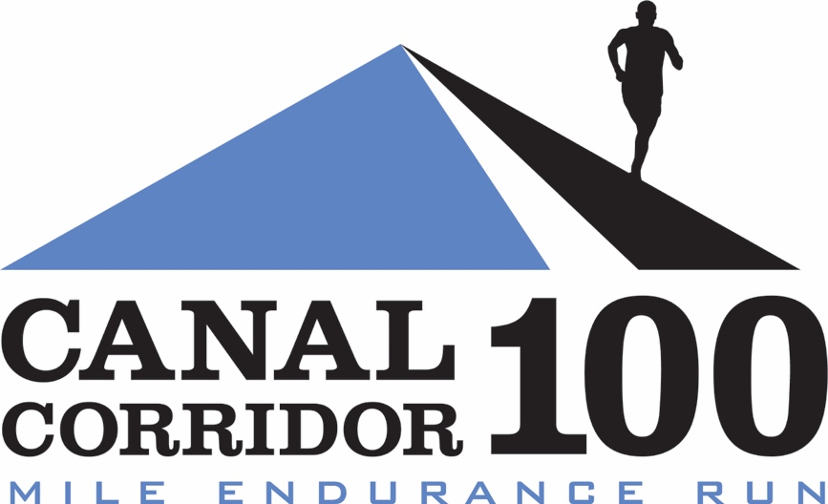

Established in 2017, Canal Corridor 100 Mile Endurance Run starts and finishes in downtown Akron, Ohio and takes runners through portions of the exceptionally beautiful Towpath Trail in the Cuyahoga Valley National Park, Akron and Canton. The course is FAST, FLAT and SCENIC and suitable for anyone looking to complete their first 100 miler or a seasoned ultrarunning veteran seeking to set a personal record.

Aid stations are staffed by experienced ultra runners who know how to cater to the needs of endurance athletes.

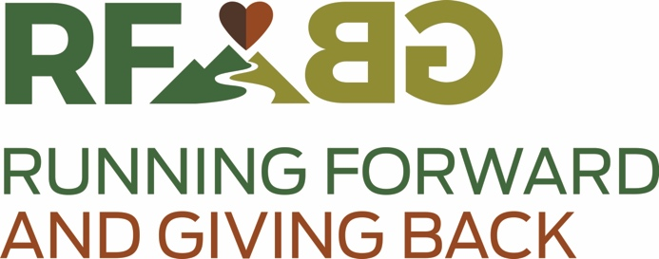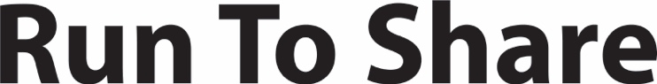

Running Forward, Giving Back and Run To Share, two Ohio 501(c)(3) nonprofits, host and manage high-quality running events to organize the community around giving back to the people and places of Northeast Ohio.

Our events encourage runners from all over the map to experience the outdoors in a supportive, encouraging social setting while feeding the local economy and giving back to local nonprofits. Through our events just in the last year, we have contributed over $42,000 of funds to the following small, local charities:

- Ohio & Erie Canalway Coalition
- Summit Metroparks Foundation
- Cleveland Metroparks Trails Fund
- Medina Battered Women’s Shelter
- Girls With Sole
- Conservancy for Cuyahoga National Park
- Bath Parks
- Canalway Partners
- Edwins Leadership & Restaurant Institute
- Bessie’s Angels
- East Cleveland Park Association
- Running2bWell
- Herren Project
- Feeding Medina County
- Friends of Crowell Hilaka
- Running Dog

Our races feature the quality of a for-profit event (chip race timing, certification and sanctioning, race directing and volunteer staffing, runner support and aid, medical and therapeutic services, race swag) coupled with the unrelenting mission to build up those in the worst conditions and situations among us within Northeast Ohio. In addition, we strive to highlight local, small businesses along the routes of our races.

To do that with the excellence that the people of Northeast Ohio deserve, we need your support for the Canal Corridor 100.

Canalway Captain – sponsor the entire race - $2,500

- Your logo and/or company name placed prominently on all promotions and publicity, including print ads; press releases; participant & volunteer t-shirts; banners at the race start, finish and and at the pre-race events; on our social media; and on awards.
- Hyperlink to your website from ours

Lock Manager – sponsor the signage marking the route and detailed directions - $500

- Your logo and/or company name placed prominently on participant & volunteer t-shirts; signage along race route, including every aid station and directional sign; and on our social media.
- Hyperlink to your website from ours.

Mulekeeper – sponsor the medical and police presence to keep people safe and moving - $150

- Your logo and/or company name placed prominently on participant & volunteer t-shirts; banners at the pre-race events; and on our social media.
- Hyperlink to your website from ours.

Gristmill - sponsor an aid station - $100

- Your logo and/or company name placed prominently at an aid station and on our social media.
- Hyperlink to your website from ours.

