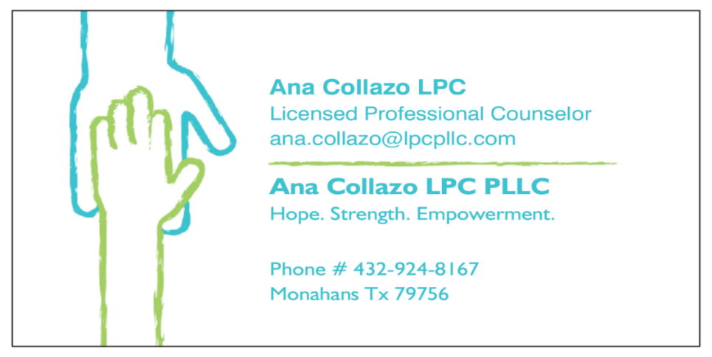
Risks and Benefits Counseling for adolescents/child can have benefits and risks. Working through difficult emotions can sometimes lead to an increase in difficult behaviors before the adolescent/child is able to utilize new skills or fully integrate their experiences. On the other hand, counseling has been shown to have benefits for individuals who go through it. Therapy can lead to better relationships, solutions to specific problems, significant reductions in feelings of distress and improved self-esteem. But there are no guarantees of how an adolescent/child will respond.
432-924-8167
anacollazolpcpllc.com - Website
ana.collazo@lpcpllc.com-Email
PO BOX 127
Monahans Texas 79756

Informed Consent for
Adolescent/Child Therapy Services

Confidentiality Counselors who work with adolescents/children have the difficult task of protecting the adolescent’s/child's right to privacy while at the same time respecting the parent's or guardian's right to information. Therapy is most effective when a trusting relationship exists between the counselor and the adolescent/child. Privacy is especially important in securing and maintaining that trust. At times, the parent/caregiver may even participate in the sessions. However, to ensure a child’s privacy we will not provide detailed information to the parent/caregiver regarding what the child shared unless the child provides consent. Instead, general themes, ideas and recommendations will be provided as well as support and encouragement to the parent/caregiver.
Immediate discussion with the parent or guardian will include:
Child discusses intentions or plans or actions of self harm.
Child discusses intentions or plans or actions of harm to others.
Child discusses others have harmed them in some way.
Revoking Consent Both you and your child/adolescent may end the counseling relationship at any time, without penalty or prejudice. While free to discontinue services at any time, it is preferable to have a closing session or phone call, to ensure the adolescent/child understands that counseling is ending and to provide an appropriate closure to the experience. You may also have the right to refuse or discuss modifications of any of my counseling techniques or suggestions that you believe may be harmful.
Please check mark which services you consent for your child to receive if they so choose to participate:
- Individual Counseling Sessions (one on one sessions with counselor)
- Group Counseling Sessions (Group sessions working on different subject i.e. social skills, coping skills, communication skills)
- Assessment and diagnostic evaluation (counselor will assess if symptoms of depression, anxiety, ADHD, suicide risk, PTSD and any other possible mental health concerns by questionnaire and discussion)
- Treatment planning (Plan with goals developed with student and counselor of items student may want to work on and will be reviewed and discussed with parent)
Acknowledgment and Consent By your signature below, you are indicating that you read and understood this consent form or that any questions you had about this consent form were answered to your satisfaction. Consent for Treatment of Minors: I/we consent that my adolescent/child under the age of 18, _________________________________ (name of child) may receive counseling services at Transformative Leadership Academy.This form is in effect until _______________________ (date) or until 12 months after the consent was given. Consent can be revoked at any time. I affirm that I am the legal guardian of (name of child/adolescent) ______________________________________ Date of Birth (child/adolescent)_________________________________________. Parent or Guardian’s name (please print) _________________________________________________ Parent or Guardian’s Signature
Ana Collazo LPC
Ana Collazo LPC PLLC

