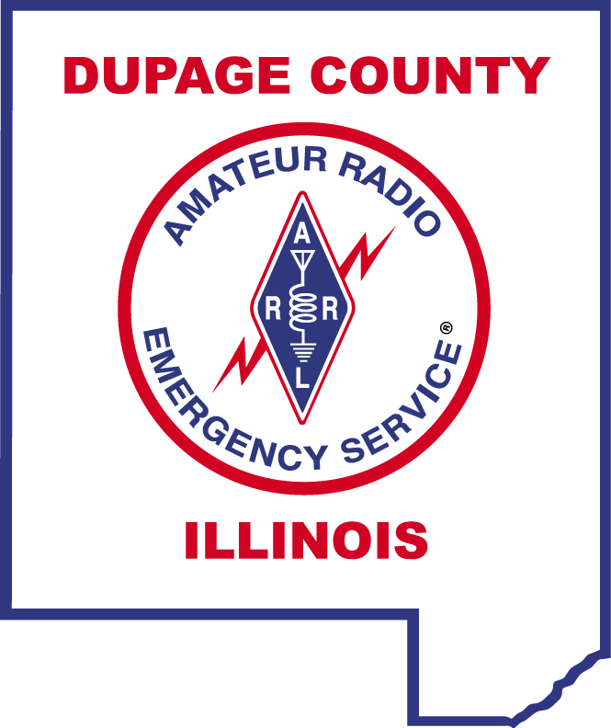

DUPAGE COUNTY EMCOMM NET SCRIPT

20-FEB-2018

Attention all amateur radio stations monitoring this frequency. The current time is 7:00 P.M. and this is the DuPage County EmComm Net facilitated by the DuPage County Amateur Radio Emergency Service.

This is (Call Sign), my name is (First Name), and I am located in (City). I will be the Net Control Station for this evening’s net. This is a directed net, so please address all subsequent communications to the Net Control Station.

We will pause now for any station with emergency traffic. If you have emergency traffic, please identify yourself now and state the nature of your emergency.
PAUSE FOR URGENT OR EMERGENCY TRAFFIC

We would like to thank Lisle EMA for hosting this net on their repeater. The purpose of this net, held on the first and third Tuesdays of each month, is to allow participants to test their amateur radio equipment to insure their ability to access an emergency net in the event of a communications emergency. On the first Tuesday of each month, we will host the regular voice EmComm net. On the third Tuesday of each month, we will host the digital EmComm net.

When checking-in, please call the Net Control Station and give your call sign slowly and phonetically, your name, location, whether you are mobile, base, or portable and if you have traffic for the net. Please call now.
ACCEPT AND LOG CHECK-INS

If you must leave the net early, please advise Net Control before you leave.
We will now continue this evening’s net with those stations indicating they had traffic to pass.
RECOGNIZE STATIONS INDICATING THAT THEY HAD TRAFFIC FOR THE NET
PASS ANY TRAFFIC FROM NET CONTROL

The DuPage County EmComm Net is now ready to accept any late check-ins. Late check-ins wishing to participate in tonight’s net please call the Net Control Station. This is (Call Sign), Net Control Station for the DuPage County EmComm Net.
ACCEPT LATE CHECK-INS

We will now continue tonight’s net with the monthly ICS-213 (ARES Version) practice message. This practice reinforces team members’ ability to pass formal message traffic. Please standby.
READ THE ICS-213 (ARES VERSION) PRACTICE MESSAGE
If anyone has questions on the practice message as broadcast, please call the Net Control Station. Please email a copy of this ICS-213 message to Dave KF9IO at martaban@comcast.net.

If you would like to be included on our email list, please send an email to k9ew@arrl.net.

We will now close this evening’s net with a roll call check-out procedure utilizing only your call sign. When you hear your call sign called by the Net Control Station, please acknowledge by repeating your call sign back.
CONDUCT ROLL CALL CHECK-OUT

There being no further scheduled traffic, we will now close the net and release this frequency back to regular amateur radio use.

This is (Call Sign), Net Control Station for the DuPage County EmComm Net.

