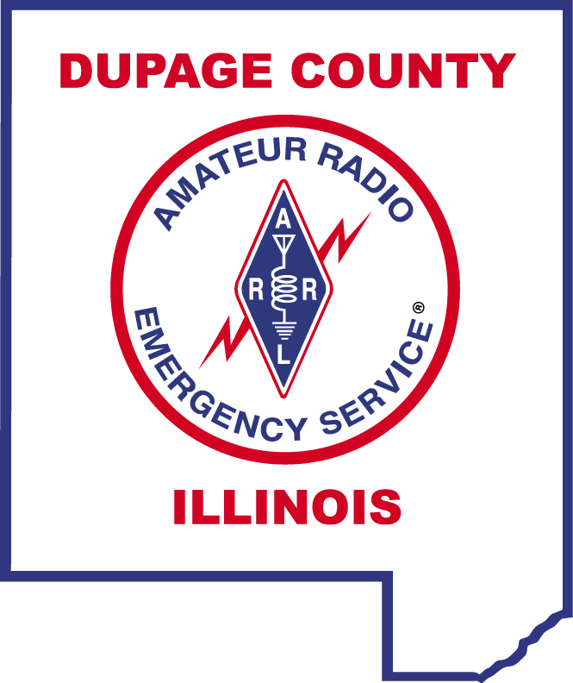 DUPAGE COUNTY AMATEUR RADIO EMERGENCY SERVICE® 

ARES® REGISTRATION FORM

NAME:

CALL SIGN:

LICENSE CLASS:

MAILING ADDRESS:

CITY, STATE, ZIP:
EMAIL ADDRESS:
HOME PHONE:

WORK PHONE:

CELL PHONE:

Check the bands and modes that you can operate:

MODE | HF | 6 METERS | 2 METERS | 222 MHz | 440 MHz | D-STAR
SSB
CW
FM
DATA
PACKET
OTHER
MOBILE
HANDHELD

Can your home station be operated without commercial power? Yes [ ] No [ ]

Signature_____________________________________ Date ______________

Mail completed form to:
DuPage County Amateur Radio Emergency Service
PO Box 88266,
Carol Stream, IL 60188-5204

https://dupagecountyares.org/
FSD-98 (Revised)

