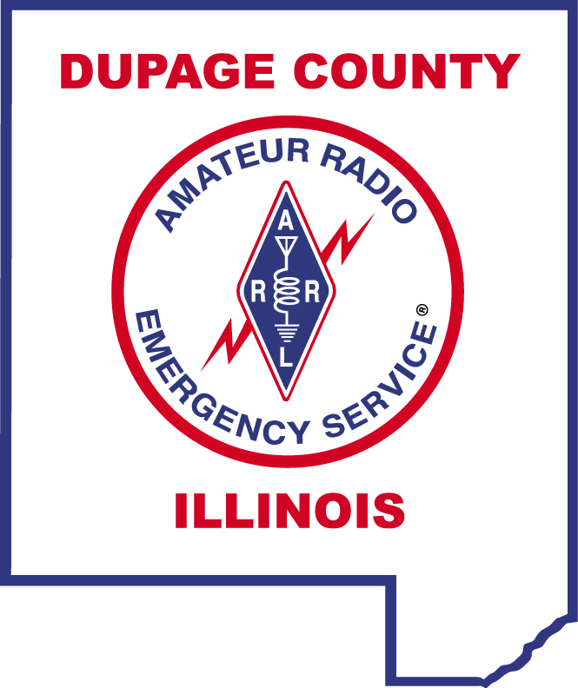

DUPAGE COUNTY EMCOMM NET SCRIPT

18-MAY-2020

Attention all amateur radio stations monitoring this frequency. The current time is 7:00 P.M. and this is the DuPage County EmComm Net facilitated by the DuPage County Amateur Radio Emergency Service.

This is (Call Sign), my name is (First Name), and I am located in (City). I will be the Net Control Station for this evening’s net. This is a directed net, so please address all communications to the Net Control Station.

We will pause now for any station with emergency traffic. If you have emergency traffic, please call now.
PAUSE FOR URGENT OR EMERGENCY TRAFFIC

The purpose of this net, held on the first and third Tuesdays of each month, is to allow participants to test their amateur radio equipment to insure their ability to access an emergency net in the event of a communications emergency. On the first Tuesday of each month, we will host the regular voice EmComm net. On the third Tuesday of each month, we will host the digital EmComm net.

When checking-in, please call the Net Control Station and give your call sign slowly and phonetically, your name, location, whether you are mobile, base, or portable and if you have traffic for the net. Please call now.
ACCEPT AND LOG CHECK-INS

If you must leave the net early, please advise Net Control before you leave.
We will now continue this evening’s net with those stations indicating they had traffic to pass.
RECOGNIZE STATIONS INDICATING THAT THEY HAD TRAFFIC FOR THE NET
PASS ANY TRAFFIC FROM NET CONTROL

We will now continue tonight’s net with the monthly ICS-213 practice message. This practice reinforces team members’ ability to pass formal message traffic. Please standby.
READ THE ICS-213 (ARES PRACTICE MESSAGE

If anyone has questions on the practice message as broadcast, please call the Net Control Station.

If you are registered with Winlink, email a copy of this ICS-213 message using Winlink to EC Dave KF9IO at kf9io@winlink.org. Otherwise email it to kf9io@arrl.net.

The DuPage County EmComm Net is now ready to accept any late check-ins. Late check-ins wishing to participate in tonight’s net please call the Net Control Station. This is (Call Sign), Net Control Station for the DuPage County EmComm Net.
ACCEPT LATE CHECK-INS

If you would like to be included on our email list, please send an email to k9ew@arrl.net.

The DuPage County Amateur Radio Emergency Service, in a joint effort with the DuPage County Office of Emergency Management and the Wheaton Community Radio Amateurs will conduct the DuPage County Weather Net. This net will be activated on the 2nd and 4th Tuesday at 1900 hours on a frequency 444.475 MHz, positive offset, PL 114.8. The net is open for all licensed amateurs.

We will now close this evening’s net with a roll call check-out procedure utilizing only your call sign. When you hear your call sign called by the Net Control Station, please acknowledge by repeating your call sign back.
CONDUCT ROLL CALL CHECK-OUT

There being no further scheduled traffic, we will now close the net and release this frequency for regular amateur radio use.

This is (Call Sign), Net Control Station for the DuPage County EmComm Net, closing the net at (hhhh) hours local time.

