HOW TO RECEIVE A MESSAGE IN THE PEER-TO-PEER MODE
- Open the Winlink Express application
- Select Packet P2P in the Open Session box
- You are now ready to receive Peer-to-Peer messages
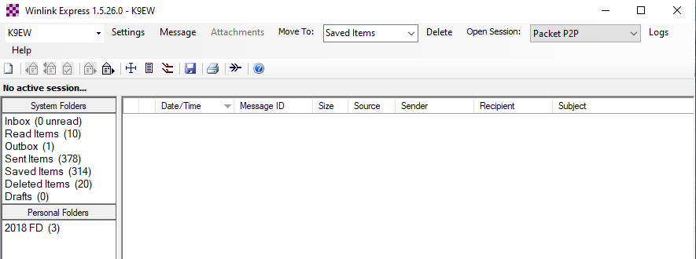

HOW TO SEND A MESSAGE IN THE PEER-TO-PEER MODE
- Open the Winlink Express application.
- Select Packet P2P in the Open Session box
- Click Message / New Message
- The Enter a new message window should open as seen below
- Type the callsign of the receiving station in the To field
- Type the Subject
- Type the message to be sent
- Select Peer-to-Peer in the Send as box
- Click Post to Outbox
- Click Open Session (Packet P2P)

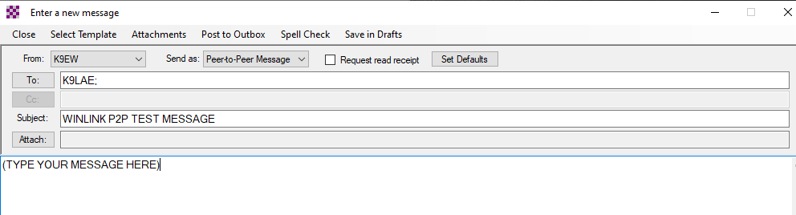

- The Packet Peer-to-Peer Session screen should open, and the TNC will be initialized.
- When you see Ready, click Start and the message will be sent to the receiving station.
- If the receiving station has any email in their Outbox for your station, you will receive that email.
