**Silver Lake Takes Stake in Software Provider EverCommerce**

Deal values the company at nearly $2 billion, according to a person familiar with the deal

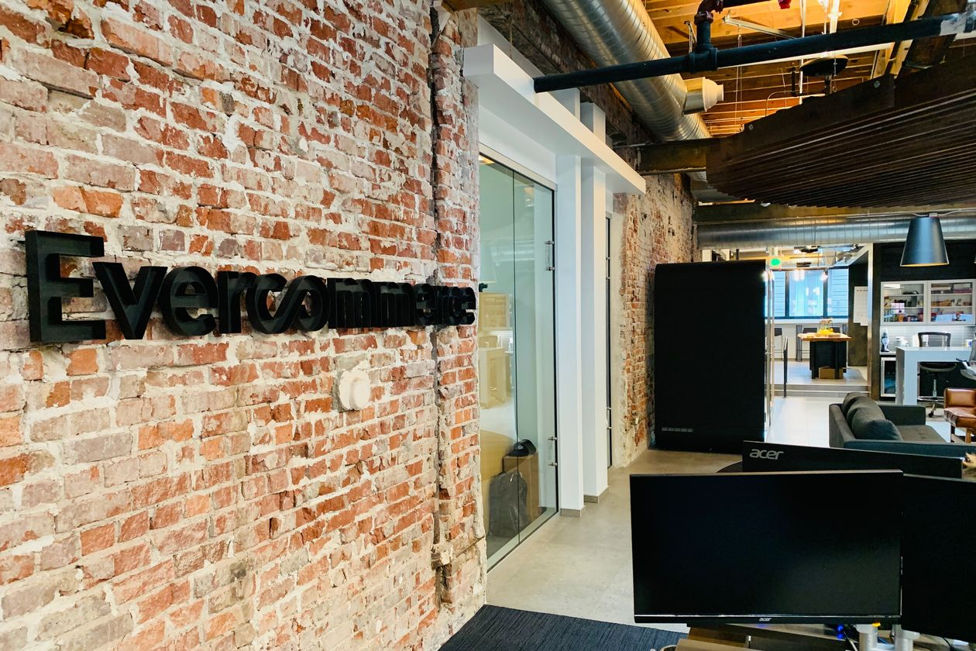

EverCommerce's headquarters in Denver PHOTO: EVERCOMMERCE

*By* *Laura Cooper*

July 22, 2019 9:00 pm ET

Private-equity firm Silver Lake Management is taking a stake in EverCommerce, in a deal that would value the services-focused software company at nearly $2 billion, according to a person familiar with the situation.

Silver Lake is acquiring a minority stake in Denver-based EverCommerce, alongside existing stakeholder Providence Strategic Growth, the growth-equity arm of buyout firm Providence Equity Partners. Providence originally backed EverCommerce in 2016, when the company focused on payments and business software and was known as PaySimple.

Since that time, the company has grown through 34 acquisitions and is now known as EverCommerce. It provides a range of software services and payment processing for more than 200,000 small to medium-size businesses, primarily across sectors that span home- and health-care services, as well as fitness and wellness providers. Its products help with business functions such as marketing, business management and customer retention, and its clients range from carpenters to yoga studios to small physician offices.

EverCommerce expects to generate more than $500 million in revenue and over $100 million in earnings before interest taxes, depreciation and amortization by the end of 2019, the person added.

Although Silver Lake is taking a minority stake as part of the deal, Providence Strategic Growth [will remain the majority shareholder](https://www.wsj.com/articles/paysimple-gains-new-partner-in-providence-strategic-growth-1476992135?mod=searchresults&page=1&pos=6&mod=article_inline). The former is financing the deal out of its Silver Lake Alpine Fund, a new fund that focuses on noncontrol, privately negotiated structured equity and credit investments in technology, technology-enabled and related growth companies.

Silver Lake has experience backing financial technology companies, particularly in the payments sector. In 2010, the firm invested in Mercury Payment Systems LLC, which it [sold to Vantiv Inc.](https://www.wsj.com/articles/DJFLBO0020140512ea5cmzzbk?mod=searchresults&page=1&pos=19&mod=article_inline) for $1.65 billion in 2014. The firm is also a backer of Chinese financial technology company Ant Financial Services Group.

**Write to** Laura Cooper at [laura.cooper@wsj.com](mailto:laura.cooper@wsj.com)