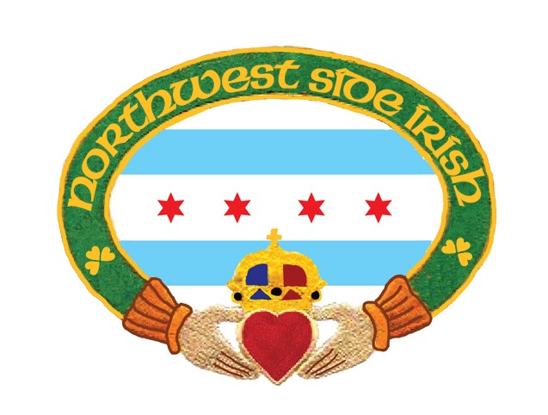

SPONSORSHIP LETTER

Northwest Side Irish St. Patrick’s Day Parade – Sunday March 11, 2018
Corporate Sponsorship - Sponsorship Request Form

The Northwest Side Irish 15th Annual St. Patrick’s Day Parade
This reflects our 16th year as an organization and our 15th annual parade.
A list of prices for Sponsor Packages may be found on the sheet attached.

Sponsorship Opportunities - Sponsorship is available at many levels. Sponsorship purchases can be tailored to meet your company's interest and needs. A member of our sponsorship committee will be willing to assist you with your participation. Many companies, while unable to participate through substantial sponsor investment, may choose to contribute to our community event through in-kind products and services. Please Note: Gift cards as well as physical products are welcome and will be recognized as a sponsorship on our website. Thank you!

These gifts are highly valuable and greatly appreciated as they increase the overall value of events to participants and volunteers and help offset expenses. We welcome your creative suggestions for in-kind donations to events and assure you that your generosity will be acknowledged. This family-oriented Parade has become a favorite of Northwest Side residents, as well as families throughout the Chicago area. Since its inception in 2003, this annual event has grown to attract thousands of spectators and over 2000 participants that march in the parade.

The St. Patrick’s Day Parade Committee was founded for the purpose of bringing citizens of Chicago’s northwest side area a celebration of Irish involvement in the American experience. Hundreds of volunteers are required to put on this spectacular St. Patrick’s Day Parade. If you or your organization would like to volunteer to help with any portion of the event, please contact – Elizabeth Murray-Belcaster at 773-678-7026 or Nicole Belcaster 773-678-4112

Please indicate your choice of Sponsorship Package on the following page. Use the bottom portion to record your sponsorship information.
SPONSORSHIP PACKAGES:

Diamond Sponsor: $10,000.00 to $25,000.00
- 2 Trolleys that will seat 70 guest + 70 guest tickets for the official NWSI after party celebration with reserved seating
- Review Stand and After Party Public recognition and banner placement at both venues
- 6 Parade sponsor banner across the parade route
- Main Stage banner at the official NWSI after party
- Business website link on front page and on sponsorship page
- Media and publication recognition
- 10 grand prize raffle tickets
- 10 general raffle prize tickets

Shamrock Sponsor: $5,000.00+
- Trolley that seats 35 guests + 35 guest tickets for the Official NWSI after party celebration with reserved seating
- Review Stand Banner and recognition
- 6 Parade sponsor banners across parade route
- After party stage banner and recognition
- Business website and linked to www.Northwestsideirish.org for one year
- Media and publication recognition

Emerald Sponsors: $2,500+
- Trolley that seats 35 guests for the parade
- 4 Parade Banners across parade route prior to the parade
- Business name displayed on parade posters and advertising
- 10 after party admissions to Official NWSI celebration
- Business web site linked to www.northwestsideirish.org for one year

Platinum Sponsors: $1,000+
- Parade Sponsor Sign, 2 ft. x 3ft. posted along parade route
- Business web site linked to www.northwestsideirish.org for one year
- 5 after party admissions for the Official NWSI celebration

Gold: $500+
- Parade Sponsor Sign, 2 ft. x 3ft. posted along parade route
- Business web site linked to www.northwestsideirish.org for one year

Silver: $250+
- Business web site linked to www.northwestsideirish.org for one year
- Banner recognition

Friends of the Parade: $150+
- Business name listed on website.

For more details on sponsorship please contact Nicole Belcaster at 773-678-4112
Please complete below and return no later than February 28, 2018
Name: _______________________________________

Phone: _______________________________________

Address: _____________________________________

Email: _______________________________________

Sponsorship Package: ________________________________________

Signature: ________________________________________________

Please email a copy of your application to NORTHWESTSIDEIRISHNWSI@GMAIL.COM

Please mail your check to:

NWSI 2018 Parade
7519 N. Nora Niles, Illinois 60714

If you have any questions, please contact Nicole Belcaster nicolebelcaster@gmail.com or 773-678-4112 or visit our website at: www.northwestsideirish.org

Please complete form and return no later than February 28, 2018
Payment must be made in full

The Northwest Irish Parade is a celebration of faith, family, and heritage on the Northwest side of Chicago. Now in our 15th year, the Northwest Side St. Patrick's Day Parade Committee has grown. The Committee was founded with the goal of bringing the Chicago’s Northwest side area a celebration of Irish involvement in the American experience.

Last year’s parade was a tremendous success, as our friends and families have greatly expanded.
The Northwest Side Irish Parade Foundation is requesting Sponsorships to fund our 15th Annual St. Patrick’s Parade and celebration of Celtic & Gaelic customs and traditions. This is our 15th parade but will mark the 16th year of the Northwest Side Irish as an organization. The marketing opportunities for the Northwest Side Parade Guide distributed to over fifty thousand people including Parade-day participants, and the multiple events that led up to the parade are very exciting. NWSI has thousands in the community participate in the parade, a gallant endeavor by all. We’ll have more surprises for the Northwest Side this year and with a little luck maybe we’ll even beat last years’ attenance record.

Friends of the Northwest Side St. Patrick's Parade can support the event through a variety of fundraisers. Sponsorships ranging from a $5.00 raffle ticket to Parade Corporate Sponsorships through the $2000.00 level help us underwrite the cost of staging, promotional materials, and security. We also have a $20.00 cash grand prize raffle ticket. We are available to discuss sponsorship opportunities with you at your convenience. We look forward to hearing from you and hope that you can support this great event and local charities fund raiser.

Northwest Side Irish Parade Foundation is dedicated to the preservation, furtherance and promotion of American Irish Celtic & Gaelic traditions and histories, which benefits the general public and our local communities. We welcome all ethnic friends and family to join the Irish in celebration; it is after all a celebration of friends and families here on the Northwest Side of Chicago. For everyone that is Irish and Irish at heart!

The NWSI 2018 Official After Party will take place immediately after the parade at Immaculate Conception Church at 7271 W. Talcott Avenue. The cost for the event is $10.00 per person, plus an additional $5.00 wrist band for those partaking in alcoholic beverages and children 10 and under $5.00. The cost includes corned beef and cabbage dinner, beer wine (wrist band holders only) and soda and Eli’s Cheesecake. Children will be provided hot dog, chips and a beverage. The cost also includes live entertainment including the Emerald Society Band and many of our Irish Dance groups. We have face painting and balloons for the kids as well all included in your cost at the door. Tickets for the NWSI Official After Party can be purchased in advance by contacting nicolebelcaster@gmail.com

The sole purpose of Northwest Side Irish is to promote our Irish Heritage, through organizing and managing the parade. We also take great pride in raising awareness and funds for extended community efforts and charitable organizations. We have raised funds and awareness for many charitable communities over the past seven years. Misericordia, Muscular Dystrophy, Chicagoland Food Depository and Dixon Center for Veterans and Military Community Services are just a few. Veterans and Military Families have always had a special place with the parade as our founder Daniel Murray is an Army Veteran and co-Founder Elizabeth Murray Belcaster has been working with veterans and military families for the past ten years.

Lastly, and most importantly, we would like to thank the families and businesses that have supported the celebration over the past fourteen years. Our festivities would not be possible without your support. We have raised awareness for local charities and look forward participating in more worthy causes in the near future. We at the Northwest Side Irish are always on the lookout for a good deed. Feel free to contact us with any suggestions you might have.

Finally, let's all remember; let's make this Northwest Side’s St. Patrick's Day Parade FUN!

