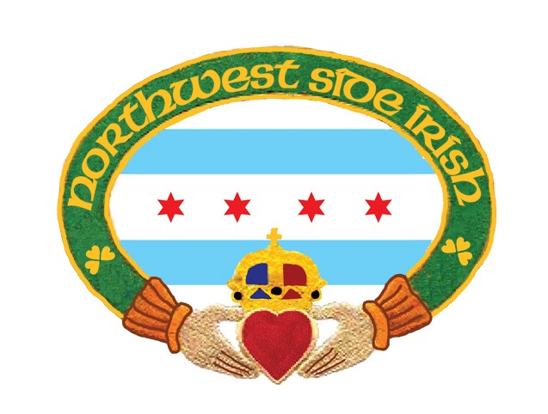
Dear Friends and Neighbors:
On behalf of the Northwest Side Irish we would like to thank you for your cooperation and participation to the Northwest Side Irish Friends and Family St. Patrick’s Day parade. We have had great cooperation from the surrounding neighbors and community businesses and we thank you for the continued support!
After meeting with the City of Chicago Mayor’s Office of Special events, our 16th District Commander and affiliated policing community we wanted to remind our friends and neighbors that March 17, 2019 is the date of the NWSI Friends and Family St. Patrick’s Day Parade. We will kick off the parade at 12:00pm beginning at Onahan School running south on Neola to Northwest Highway, north on Northwest Highway ending at Harlem Avenue. Assembly for the parade will begin as early as 9:00 am. For those who live on the parade route we would like to remind you that parking notices will be posted and we will ask that you move your vehicles in a timely manner. If you reside or do business along the parade route or the parade route staging area there will be “NO PARKING” signs posted a couple of days in advance. Northwest Side Hwy will be shut down from Nagle and Northwest Highway to Harlem and Northwest Highway.
We will have two check in locations for our parade participants. All parade participants will be directed from the check point to their designated placement on the route. There will be two check in points provided to participants in the parade. One at Onahan School for those assembling at Onahan and the other at NWHWY and Napoleon for those assembling on NWHWY. Instructions will be handed out to all participants a few days prior to the parade specific to safety and distribution of goods to the spectators on the route.
The parade has been a safe community friendly event and it is our utmost priority to keep the surrounding environment safe and friendly for the families and businesses that have supported our efforts over the past eight years. We take great pride in the compliments that come our way on behalf of this effort. Much of the family friendly environment comes from the community we live in. Our neighbors and businesses have been the strength and success of the event and we thank you for your support and hope this is an enjoyable event for your family and friends as well. Here are some important safety notes for your review.
Follow the directions from the NWSI Marshals and Chicago Police Department
- Keep children and adults behind the assigned barricades or designated curbside areas
- Do not step into the streets to pick up handouts/candy etc. safety is our number one priority
- No distribution of any alcoholic beverages. No drinking of alcohol on the public way.
- 9:00 am street closure: Cars parked along the parade route will be towed Enforcement for vehicles along the route will begin at 7:00 am the morning of the parade.
This is enforced by the 16th District Police Department
Sincerely,
Daniel E. Murray, President NWSI
Elizabeth Murray-Belcaster, Parade Coordinator
www.northwestsideirish.org

