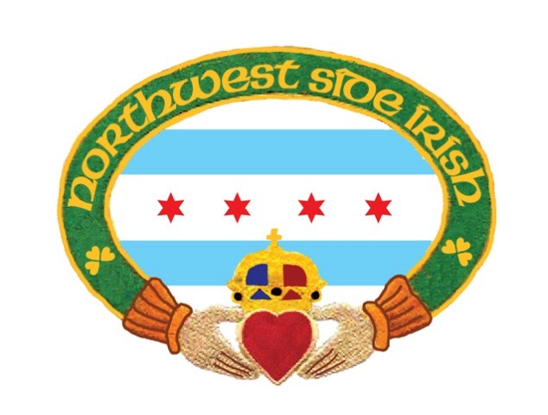

**2019 1st NWSI Parade Route Holiday- PUB CRAWL**

**Date: Saturday December 7, 2019**

**Check in Locations:**

**Iron Horse Ale House:**

**6158 N Northwest Hwy, Chicago, IL 60631**

**MoDaileys:**

**6070 N Northwest Hwy, Chicago, IL 60631**

**12:00-4:00PM**

**$25.00 Per Ticket**

**NUMBER OF TICKETS: ______________________**

**INDIVIDUAL TO CONTACT: __________________________________________________________________**

**TELEPHONE: ______________________________________________________________________________**

**EMAIL: ___________ __________________________________________________________________________**

**SIGNATURE: _______________________________________________________________________________**

**\*\*This event is 21 and over PLEASE sign the form in agreement of the legal age.**

**Any questions please contact** [nwsiparade@northwestsideirish.org](mailto:nwsiparade@northwestsideirish.org)

**Deadline for Tickets is November 30, 2019**

**RETURN THIS FORM**

**Along with your payment**

**Please Make Checks payable to:**

**Northwest Side Irish**

**7519 N. Nora Street**

**Niles, Illinois 60714**