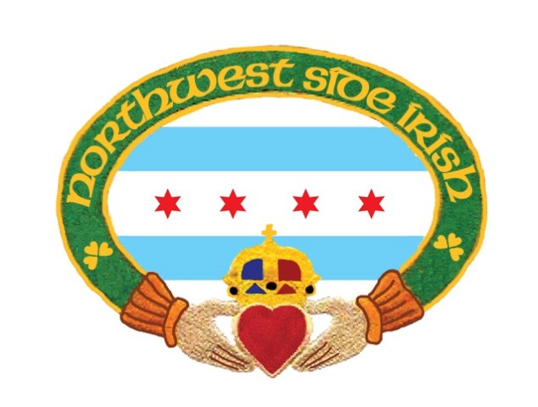

2020 17th Annual Friends and Family St. Patrick’s Day Parade
Application for Participation

Date: Sunday March 15, 2020
Kick Off Location: 6633 W. Raven (Onahan School)

Assembly Time………. 10:00 am
Step Off………………..12:00 pm

NAME OF ORGANIZATION_________________________________________________ ____

Type of entry: ____ marching ____ vehicle ______ trolley
(Please Check ALL that apply. If more than 1 vehicle, please specify.)

NUMBER OF PERSONS IN UNIT: ______________________VEHICLES: ____________________________

INDIVIDUAL TO CONTACT: __________________________________________________________________

ADDRESS: ___________________________________________________________________________________

TELEPHONE: ______________________________________________________________________________

EMAIL: ___________ __________________________________________________________________________

For Trolley reservation please contact nwsiparade@northwestsideirish.org or call 773-678-4112
Deadline for Trolley reservation via NWSI is March 1, 2020

RETURN THIS APPLICATION
Along with your $75.00 Application Fee
Please Make Checks payable to:
Northwest Side Irish
7519 N. Nora Street
Niles, Illinois 60714

