Ocean Grove

offers a peaceful atmosphere in beautiful surroundings.

God’s majestic creation can be seen at the Ocean

and His presence is so real in a community

and retreat center dedicated to Him.

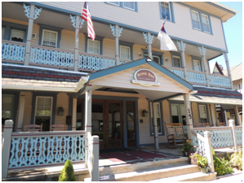

Grove Hall

extends a warm invitation to enjoy

their comfortable, restful and pleasant retreat accommodations.

They offer nice bedrooms, a large dining room,

commercial kitchen, and a cozy living room

along with an additional meeting area and

two beautiful wrap-around porches.

Walking distance to the Ocean,

as well as to Ocean Grove’s historical buildings

and quaint shops.



**Ladies’ Retreat**

**May 21 & 22, 2021**

**Ocean Grove, NJ**