Ocean Grove

offers a peaceful atmosphere in beautiful surroundings.
God’s majestic creation can be seen at the ocean
and His presence is so real in a community
and retreat center dedicated to Him.

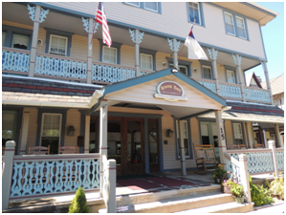

Grove Hall
extends a warm invitation to enjoy their
comfortable, restful and pleasant retreat accommodations.
They offer nice bedrooms, a large dining room,
commercial kitchen, and a cozy living room
along with an additional meeting area and
two beautiful wrap-around porches.

Walking distance to the Ocean,
as well as to Ocean Grove’s historical buildings
and quaint shops.

Ladies’ Retreat
May 19 - 20, 2023
Ocean Grove, NJ

