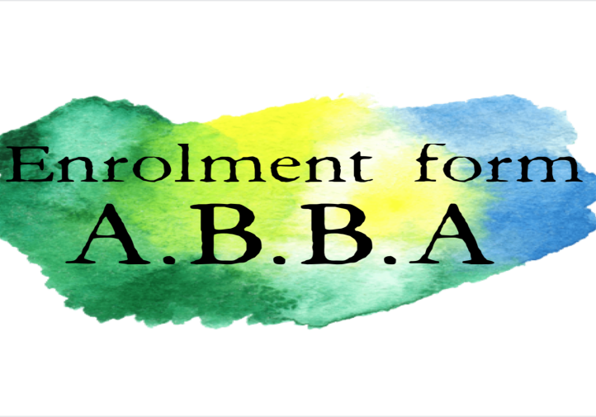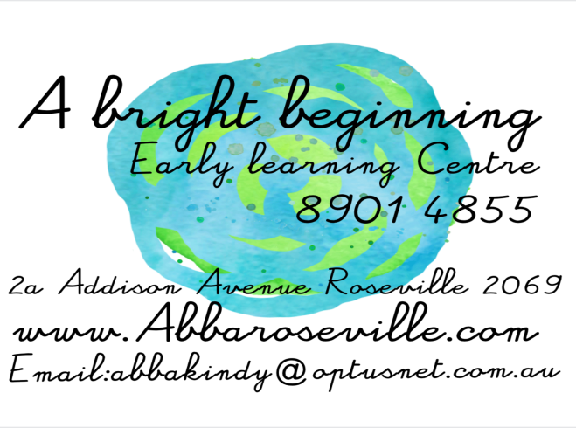

Child Details
Surname _____________________________ Given names ________________________________________
Other / former names known by___________________ (CRN) Child _ _ _ _ _ _ _ _ _ _
Address ____________________________________________________ State ________ Postcode ________
Home phone ____________________________ DOB ___________________________ Sex M/F ________
Child’s position in family ___________________________ Place of birth _______________________________
Child lives with: Both parents ____ father ____ mother ____ guardian ____ other adult ____
Days required: Monday ____ Tuesday ____ Wednesday ____ Thursday ____ Friday ________
Parent Details | Mother Father

CRN

DOB

Surname

Given names

Other names known by

Home address

Occupation

Employer name

Work address

Days and hours
of work

Work phone

Home phone

Mobile phone

Email address
Most appropriate way for ABBA to communicate with you: | Email, phone (tick box above for best no.)  Please tick if you consent to your email address being used to connect you with the A Bright Beginning ELC online parents group, and for the distribution of newsletters. |  |  | Email, phone (tick box above for best no.)  Please tick if you consent to your email address being used to connect you with the A Bright Beginning ELC online parents group, and for the distribution of newsletters.
Sibling’s name / DOB
(For ABBA Management – do not complete)
Days booked: M T W TH F Long/short day Enrolment fee $__________
Deposit $__________ Medicare Immunisation History Statement? ___________
History ____________ Evidence of birth details sighted ___________ Arrangement Form completed & signed ____
Child Care Subsidy Confirmation _______________Commencement date __________
Revised July 2018 Ref C.S.R.2004, NCAC QPG 2005

Medical History
Child’s Medicare number: _______________________________
Are you a member of a Health Fund Yes/No Name of Health Fund __________________________________
Membership Number ________________________ Type of Cover: Hospital / Dental / Ambulance
Child’s doctor |  | Address |  |  | Phone no
Child’s dentist |  | Address |  |  | Phone no
Does your child suffer from or has had (please circle):
Aids, Asthma, Bronchitis, Chickenpox, Convulsions, Diabetes, Diphtheria, Eczema, Epilepsy, Glandular Fever, Impetigo, Measles, Meningitis, Mumps, Rubella, Scarlet Fever, Whooping Cough
Any other medical conditions we should know about?
Is your child on regular medication? Yes/No If Yes what? ___________________________________________
Case plan formulated by doctor __________________________________________________________________________________________
Does your child have any allergies, dietary restrictions, speech delay, vision impairment, any known medical and/or behavioural problems? If so please detail:

Medication will only be administered if it is in the original container with the original label and instructions that can be clearly read and before the expiry or use by date. Additionally, if the medication has been prescribed by a medical practitioner:
- The label must contain the child’s name and
- Parents must provide any verbal or written instructions provided by the medical practitioner.
Education and Care Services National Regulations Regulation 95

Any medication, including non-prescription medication like nappy creams and paracetamol, must be authorised by parents or an authorised nominee on our “enrolment” form. Education and Care Services National Regulations Regulation 93

In my absence, should my child suffer any emergency, illness or accident whilst in the care of ABBA, the licensee, nominated / certified supervisor or his/her delegate shall be entitled to seek such urgent medical, dental, hospital treatment or ambulance service or assistance from the person or body nominated hereunder as deemed necessary for my child. I agree to pay all costs associated with such treatment. I consent to First Aid being administered by a staff member who is the holder of a current First Aid Certificate and to use required products as deemed required by staff to carry out first aid

______________ ___________________________ ___________________________
Date Mother/Father/Guardian Mother/Father/Guardian

In the event of my child having a fever and the inability of ABBA staff to contact either parent or an authorized person listed below I consent to the staff administering Panadol according to the correct dosage and interval of time as indicated.
______________ ___________________________ ___________________________
Date Mother/Father/Guardian Mother/Father/Guardian

I authorise the staff to use a nappy cream________ provided by myself when as required when changing my child’s nappy. I authorise the staff to apply _____________ cream on my child when as required when changing my child’s nappy ______________ ___________________________ ___________________________
Date Mother/Father/Guardian Mother/Father/Guardian

I authorise the staff to use a cream of my choice ________ provided by myself to be applied as required on my request to my child as directed by me.
______________ ___________________________ ___________________________
Date Mother/Father/Guardian Mother/Father/Guardian

Immunisation Has your child been immunised? Yes/No
Have you provided a Medicare Immunisation History Statement? Yes/No
My child has not been immunised because

I understand that in the event of an outbreak of a vaccine preventable disease at ABBA, the management has to notify the Department of Health and if my children are not immunised that they may be excluded from attendance for such time as the Department of Health deems necessary.
______________ ___________________________
Date Mother/Father/Guardian

Authority to drop off / collect child
I authorise the staff of ABBA to allow my child to be collected from or returned to ABBA by any of the following persons:
Name | Relationship | Address | Phone
Emergency Contact Details
In the event of an emergency and the staff‘s inability to contact a parent, emergency phone numbers – preferably family members or close friends - must be provided.
Name | Relationship | Address | Phone
______________ ___________________________
Date Mother/Father/Guardian

Are there any Custodial orders pertaining to the enrolled child? Yes/No
Child’s family circumstances: including those affecting residence or contact with parents
Date of issue: Certificate copy held at ABBA Yes/No
Custodian:
Persons denied access and Not to Collect the child
Name | Relationship | Address | Phone

Enrolment Agreement
By signing below, I agree to pay the required fees as set out in the conditions of this enrolment, and understand that I must give four weeks’ written notice upon termination of my child leaving ABBA. I understand that fees must be paid for all days my child is booked in, regardless of periods of absence and public holidays.

I consent to my child being taken out of the centre due to the centre requiring to be evacuated and being relocated in the event of an emergency.
For photos and video footage to be taken of my/our child for Service use and staff training purposes (Footage will not leave the Service) | YES | NO
For photos and video footage of my/our child to be used in Learning Stories, and to be shared with other families that attend the Service | YES | NO
For photos and video footage of my/our child to be used for student training purposes (Photos and video footage may leave the Service for students to present to lecturer and class for viewing and marking) | YES | NO
For photos and video footage of my/our child to be used on Service website, social media and other internet purposes, such as advertisement and used in organisation’s resources | YES | NO
Do you ONLY give permission for photos and video footage of your child to be taken for your own personal viewing and to receive copies | YES | NO

I/We give permission for this child to: Participate in outings to places of interest (permission slip will have to be signed before allowing your child to leave the Service) | YES | NO
Have SPF30+ sunscreen applied prior to sun exposure (If not, please provide a letter releasing the Service of any Liability) | YES | NO
Have Band-Aids or sticking plasters applied when necessary | YES | NO
Have staff apply Nappy Cream/Paste (supplied by parents) | YES | NO
Have staff apply Teething Gel (supplied by parents) | YES | NO
Have staff apply Insect Repellent (supplied by parents) | YES | NO

______________ ___________________________
Date Mother/Father/Guardian

Privacy Disclaimer
We acknowledge and respect the privacy of its clients. The enrolment information that is collected assists us to meet our legislative obligations and to provide the best level of education and care for your child. By completing this form, you have consented to this information being collected. The information will be used by educators/staff members and relevant government authorities. You have the right to access and alter personal information concerning yourself or your child in accordance with the Privacy Act 1988 and our Privacy and Confidentiality Policy.

ABBA Supplementary Information Sheet

Child’s Name:
- Has your child had any previous preschool experience? Y / N If Yes – details please
- Do you foresee any separation anxiety? Y / N If Yes – please discuss strategies with ABBA management.
- How would you best describe your child’s temperament?
- What time does your child usually go to bed at night?
What time does your child usually get up in the morning?
- Do you have any special bedtime routines? Y / N If Yes – details please
Does he/she take a favourite toy or blanket to bed?
Does your child utilise a comforter or have a bottle to sleep with?
- Has your child stayed with anyone other than a relative? Y / N If Yes – details please
- Does your child have any food preferences or dislikes? Y / N If Yes – what are they?
- Do you have any concerns about your child’s eating or sleeping habits?
- What method do you utilise to manage difficult behaviour?
- How do you feel that your child gets along with other children?
- What do you think are important things for your child to learn at ABBA?
- Are there any individual toileting needs you would like us to be aware of?
- Does your child have any fears that we should be aware of?
- Please outline your parenting philosophy.
- Any additional information you feel would be beneficial to us? E.g. likes, dislikes, skills, extra curricular activities.
Could you tell us what resources and experiences children use in their physical play at home?

