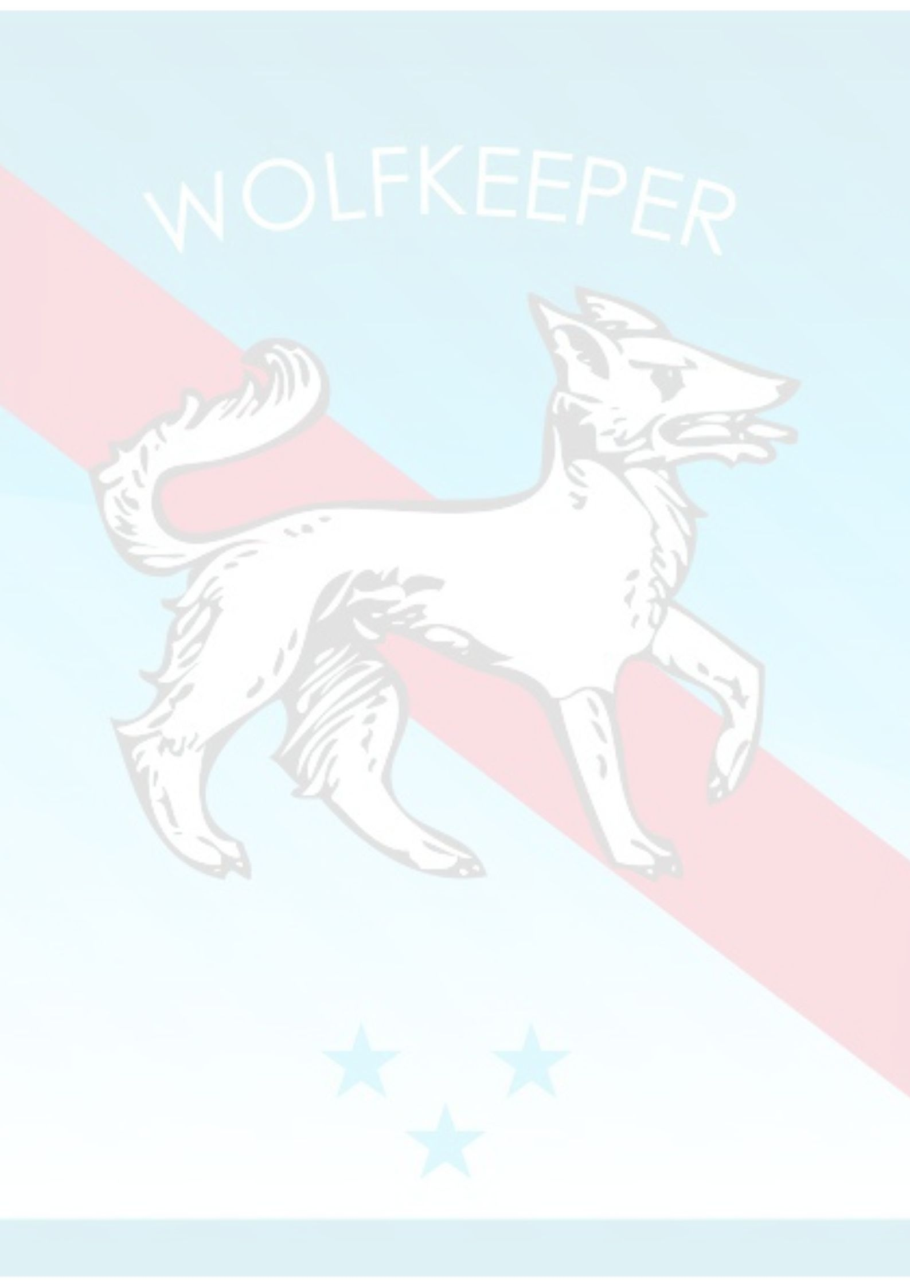


Disclaimer

_____ 1.WK requires that a bath for your pet be purchased and done before he/she
returns home after a boarding stay of two nights or more. Disinfectants are used in our cleaning
process and newspaper is used for bedding – dogs may become soiled in a kennel environment.
It is not uncommon for the cleanest dogs to eliminate in their kennel even if they are being walked regularly.
_____ 2. I understand that a bath does not include brushing, toe nail trimming, etc.; however, a
Professional grooming may be requested for an additional charge.
_____ 3. I understand that WK does not allow toys of any kind to be left with my pet.
Edible items such as biscuits, Rawhide, etc. are permissible. I understand any such items will not
be returned.
_____ 4. I understand and agree that WK does not allow bedding. If necessary
it will be supplied.
_____ 5. I attest that to my knowledge my pet has no physical problems/or has been exposed to any diseases or illness in the past 30 days.
_____ 6. I understand and agree that my dog must be up to date on shots. I also understand WK requirements may be more stringent than my veterinarians. I authorize WK to give any vaccinations required. I also agree to assume financial responsibility for any
vaccinations given.
_____ 7. I understand that leaving a dog in a kennel is like leaving a child in school. Colds, coughs, viruses, etc. may occur. I am aware in such case, WK will have a veterinarian
treat my dog. I also understand that I am responsible for all vet charges incurred during or after
my stay.
_____ 8. I understand that weight loss in a boarding facility is not uncommon even if a dog is eating normally.
_____ 9. I understand and agree that the Bordatella vaccination is required by WK to help
in the prevention of kennel cough; however, it is much like a flu-shot and does not guarantee
that a dog will not contract kennel cough.
_____ 10. I understand that WK enforces a very strict Noon Check Out and that if I do not
pick up my dog until after 12:00 noon, I must pay for that day of boarding.
_____ 11. I understand that if my dog is left beyond my stated boarding date, it is my responsibility to notify WK. If WK is not notified within 10 days, they will be
forced to relocate my pet to a local shelter and consider it abandoned.
_____ 12. Any open ended boarding stays require two-week payment in advance and owners are
responsible to keep their bills current on a weekly basis.
_____ 13. I understand that any medication being left with my dog must be counted out and only the amount needed for my pet’s stay be left along with full written instruction.
_____ 14. I understand that should I provide my own food, WK requires it to be in an airtight sealed container labeled with my dog's name in a size large enough for my dog’s stay. This eliminates underfeeding or overfeeding – no food will be saved and returned.

Signature:_________________________________________________________

Wolfkeeper University | 312-933-1528 | Fax: 888.316.4454 | te@wolfkeeperu.com

