AUSTRALIAN AMERICAN ASSOCIATION
GOLD COAST DIVISION
79th ANNIVERSARY OF THE
BATTLE OF THE CORAL SEA COMMEMORATION SERVICE
SATURDAY, 1st MAY 2020
9:30AM FOR 9:45AM

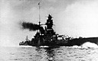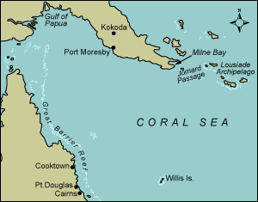

INVITATION:
AAA-GCD MEMBERS AND GUESTS TO ATTEND CORAL SEA COMMEMORATION SERVICE
LOCATION: THE CENOTAPH, CAVILL PARK
CAVILL AVENUE, SURFERS PARADISE
PARKING: BRUCE BISHOP CAR PARK
RECEPTION: SURFERS PARADISE RSL FOLLOWING COMMEMORATION SERVICE
RSVP: REQUIRED BY WEDNESDAY APRIL 28, 2021 to BILLIE JO 0416 290 412 OR FAYE 5579 8080.

