AUSTRALIAN AMERICAN ASSOCIATION –
GOLD COAST DIVISION NEWSLETTER

NEWSLETTER.

December,2018.
President’s message:
Hello Fellow Members and Friends,
Hard to believe November flew by but time was taken up with the organizing of our Thanksgiving event that took place at the Sofitel Hotel Broadbeach on 22nd November 2018. You will see in some of the photos taken by Keith Shackley the room looked absolutely stunning, tables settings were
very befitting thanks to Devina whom I worked with on the preparations from the hotel. I have written a little synopsis for you to recapture the evening or if you missed out maybe make it next time?
We had drinks upon arrival with our talented musicians playing in the background and there was the mix and mingle with the guests – what a way to start the evening.
Our emcee Mr Gino Moro did a great job and the show got underway with various toasts made by Dr Ian Clark, Mr Howard Campbell and grace was said by Mr Keith Shackley. Chef carved the whole turkeys until they disappeared and on each table an abundance of food for family style was mashed potatoes, baked pumpkin, green beans, corn kernels and peas, Amery Burleigh’s family stuffing,
gravy and cranberry sauce! So, so much it was overwhelming.
As President I read an article that I found what I believe was very enlightening about Thanksgiving and the meaning and some other factors that even some of the expats weren’t aware of including only using male turkeys! Following on was our Life Member Billie Jo McCann’s famous pumpkin pie a la mode as they say in the USA (with ice-cream) with tea, coffee and chocolates to finish with.
We were very fortunate to have had many donations given to us for our raffle prizes from wines, car washes, flower voucher, SUNS AFL back pack, lunch and a dinner in room 81 at the Sofitel. Our lucky winners seemed very appreciative for the goodies they got to take home. There was also a door prize that of the

flower centre piece on each table and if you had the lucky dot on your chair it was yours to have! One of our lucky winners donated her flowers to our staunch member Raelene Schaeffer who is currently in hospital and one of the other winners was our stoic heroine Kathleen Frith who had attended but had already left for the evening. Not to miss out she was given her flowers at the recently held Meet and Greet and are hers to enjoy. Our musicians presented a potpourri of favourite American songs to end the evening such as New York, Chicago, San Francisco and the likes and everyone had a bit of a sing along before closing out for another Thanksgiving I
PO Box 504 Mermaid Beach Qld 4218
Phone: 07 55798080
Website being revised
believe we can say was a night to remember for another year and worth all the effort.
Thanks to all those who participated in the program and assisted in making the evening a success and to those who attended hopefully you enjoyed it , sorry to those who could not be there you were missed.
One matter I am very proud to announce that one other aspect of the evening we had six (6) new members sign up to the AAA-GCD three of whom are expats, one Austrian and of don’t forget the Aussies! Welcome to those new members we look forward to your joining us in the near future. A Meet and Greet was held on Wednesday 28 th November at the SYC and it was great to see some old faces returned since back on the Gold Coast and also some of our new members in attendance.

In closing for the year 2018 as President and on behalf of the AAA-GCD Committee we wish to express our thanks for your ongoing interest and may you and your families have a very Merry Christmas and a Happy and Healthy New Year.

Faye Brutlag, President
AAA- Gold Coast Division

Photos from Thanksgiving 2018
Table decorations can be seen. Kathleen Frith with Keith Shackley and Keith Carroll both Committee.
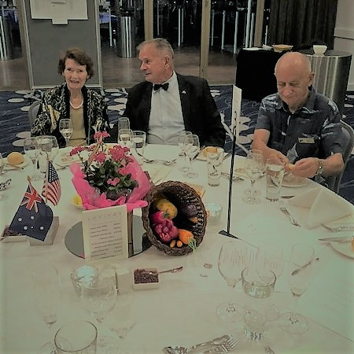
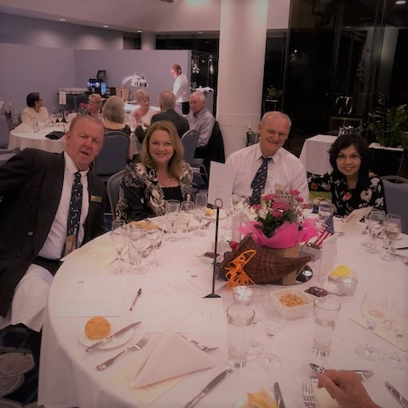
David Reardon and Diane, Adolfo Mathews and Yen

Colin Atkinson on guitar & Wil Sargenson on key board provide some great music for the dinner.
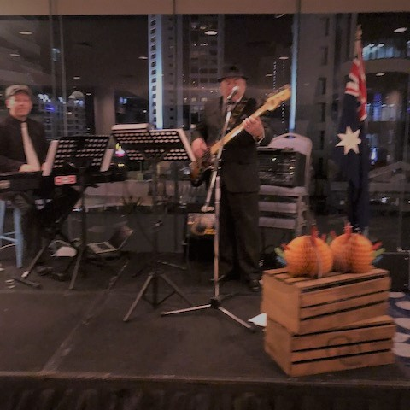

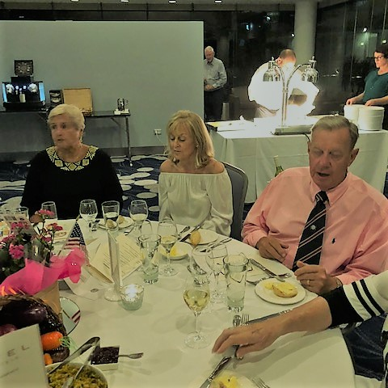
From the recent Meet & Greet
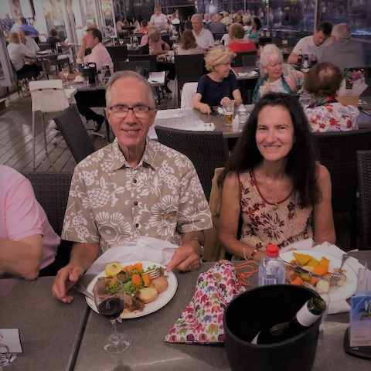
Jim Miceli and Marguerite Marks

President Faye & Wanda Fitzgerald chat to new members.
