AUSTRALIAN AMERICAN ASSOCIATION –
GOLD COAST DIVISION NEWSLETTER

NEWSLETTER.

October,2018.
President’s message:
Hello to All AAA-GCD Members,

As you are probably aware the AGM of the Australian American Association Gold Coast Division was held recently on 26th September where the membership on that occasion elected me as your President for the forthcoming year.
Let me elaborate as you wonder who is this person that is your new President. I have lived on the Gold Coast since 2006 and was an initial committee member and then elected to Secretary and held that position until two years ago. My husband in the meantime was President for the two years prior to our stepping back from major obligations with AAA-GCD but have always remained members and regular attendees of the various functions over the past years.
In a time where everyone has many obligations in life and volunteering with any affiliation to a special interest can be time consuming and not always easy to jump in with both feet. Let me tell you that I did a lot of soul searching before committing to this position but did not want to see our very special group and affiliation with the USA and Australia be diminished. I have taken on this role with full commitment and hope that even though it might sound like effort to attend one or another of the functions we arrange I want you to think how important this base is for ex pats and Aussies with some connection let’s not have this Association disappear.
I am hoping that with my taking on this position for the coming year that I can interest you in at least attempting to attend one or two of the more important functions that we, by the constitution of the AAA must have, and that being Australia Day, Battle of Coral Sea, 4th July and Thanksgiving and how hard is that to consider when you can say memorable occasions and festive times as well.

PO Box 504 Mermaid Beach Qld 4218
Phone: 07 55798080
www.aaagcd.com.au
At this point in time please be considering our next event that of Meet and Greet at Southport Yacht Club from 5pm on 24th October followed by Thanksgiving on 22nd November. A reminder of the date and location is included in this Newsletter. More detailed information will be forthcoming but meanwhile at least mark the dates on your calendar and check with friends and neighbours or any expats who might be interested in attending.
I close on this note that during the coming year as your President I will endeavour to promote our cause and reason for existing as the AAA-Gold Coast Division and that you might find a time or function that will entice you to follow up and see what and who is connected with our Gold Coast family of ex pats, relationships like mine of half and half Aussie and USA just interested in a friendly fellowship of people with like mind and interests.
Thank you again for electing me as your representative for this year and look forward to meeting you in the near future.

Faye Brutlag, President
AAA- Gold Coast Division

Photo from Meet & Greet
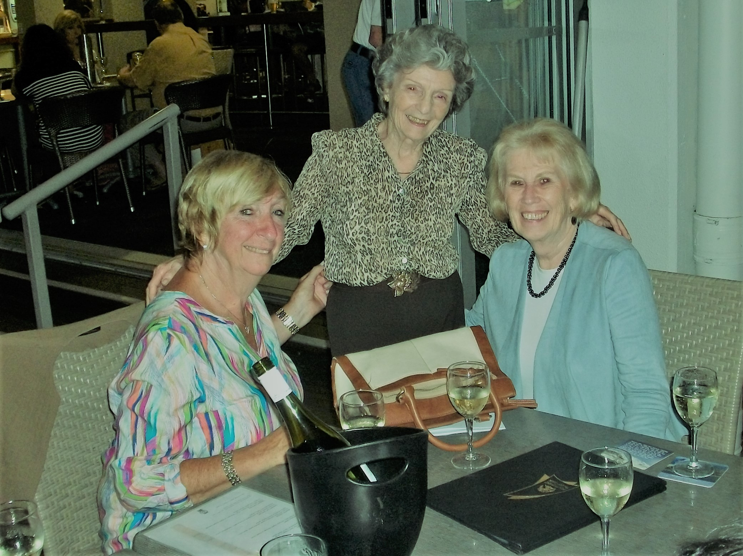

Our newly elected President Faye with Billie Jo and a past president Georgia Cook, enjoying a chat.

From our Secretary:
Annual General Meeting 2018.
At the Annual General Meeting held on 26 September, a new committee was elected.

President: Mrs Faye Brutlag
Vice Pres.: Mr Keith Shackley RFD
Secretary: Mrs Billie Jo McCann
Treasurer: Mr Howard Campbell
Committee: Mr Keith Carroll, Mr Fred Hamblen.

A highlight of the business of the meeting was the award of a Life Membership to Mr Keith Shackley RFD. Since Keith was overseas, the award will be presented to him at a function to be held in the near future.
As there was no nomination for the position of Secretary for this Division, Billie Jo accepted a nomination from the floor. However, it would be greatly appreciated if someone would come forward to fill the position of Secretary. Billie Jo will take Minutes of the committee meetings if necessary but would be greatly helped if someone else would come onto the committee to be Secretary and work with the new President in arranging the functions of the Division. Ring: 0416 290 412 for more info.
Another Award: Our Treasurer, Howard Campbell has been awarded a Moncrieff Community Award for 2018, to recognize his years of service to the Australian-American Association, Gold Coast and for his services to other organizations here on the Coast. He received his framed certificate from Minister Steve Ciobo at a civic function held in September. Congratulations, Howard.

Federal Conference: The Federal Conference for AAA will be held in Perth this year, hosted by the WA Division. Both Faye and Keith will go as delegates.
COMING EVENTS
October 24 Meet & Greet SYC 5.00 -7.00 pm
November 22 Thanksgiving Sofitel
See Flyer
November 28 Meet & Greet SYC 5.00 -7.00 pm

December/January ? Christmas Party

January 26 Australia Day Celebrations

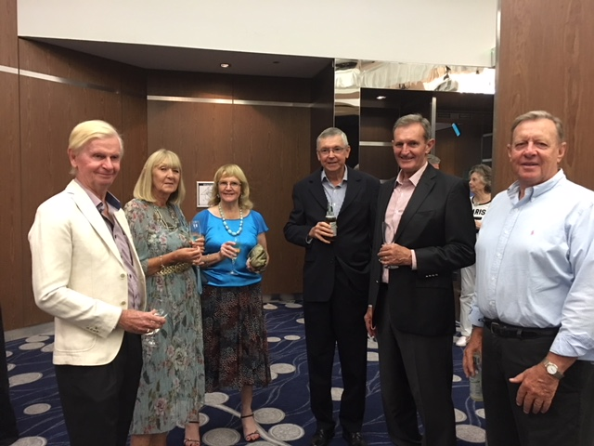
Gino Moro and guests chat prior to Thanksgiving Dinner 2017.
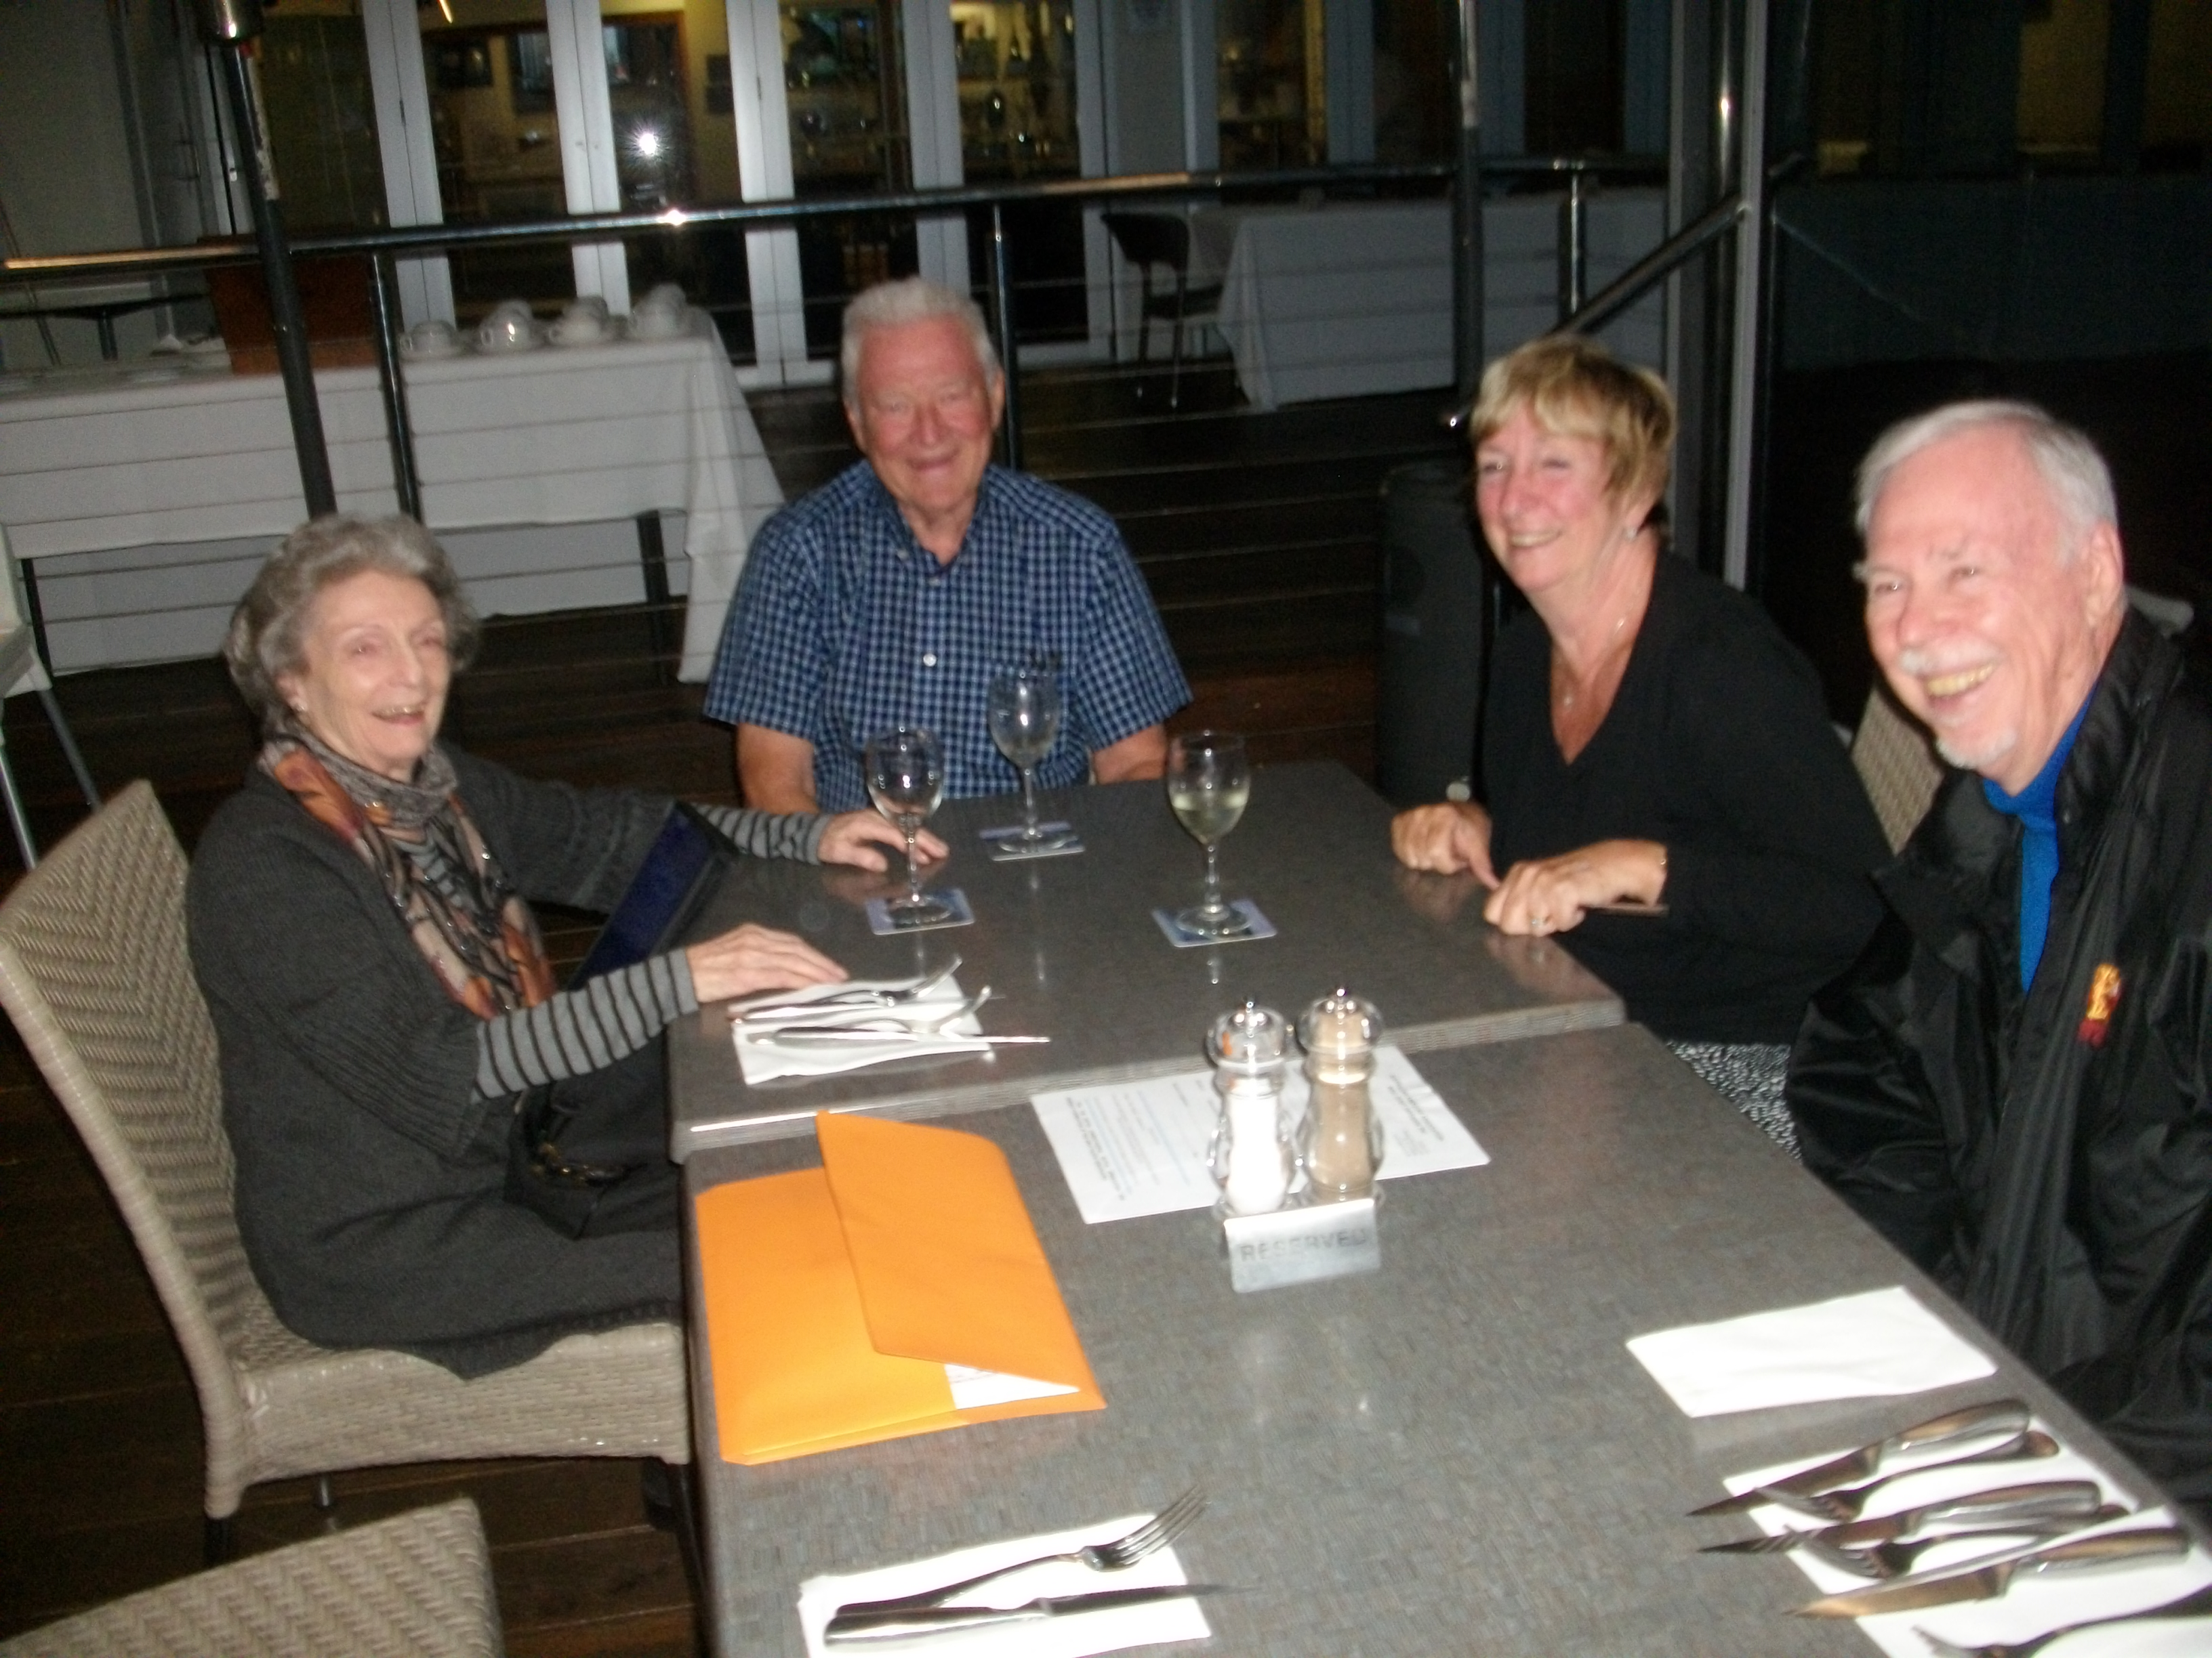
Our treasurer Howard Campbell with other committee members, President Faye, Past President Billie Jo and Past President Rodney Brutlag.

Keith Shackley, Keith Carroll and Kathleen Frith, charter member, past - VP, Treasurer, committee.
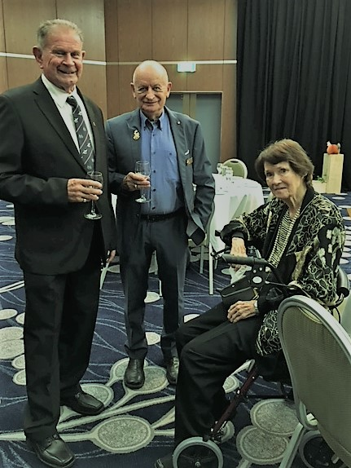

Hope to see you at one of our functions!

